Wildland Fire Decision Support System: Tehipite Fire (August 28, 2008)
Response Level 1-3

Fire Information
Fire Name | Tehipite Fire
Location | Latitude: 36.54-17N  Longitude: 118.47-55W
Start Date/Time | 07/14/2008 5:30 PM
Containment Date/Time
Control Date/Time
Declared Out Date/Time
Current Size | 1603 (9/1/2008), 1192 acres
Cause | Lightning
Geographic Area | South Ops California, NPS Pacific West Region
Land Ownership / Administrative Unit | Sequoia & Kings Canyon National Parks  Sierra National Forest
Protecting Agencies Involved | Sequoia & Kings Canyon National Parks  Sierra National Forest
Fire Management Unit | Sierra Crest Fire Management Unit – Consists entirely of the designated wilderness, almost entirely contained within a much larger matrix of wilderness managed by the NPS and USFS. All of the South and Middle Forks of the Kings River are designated as Wild and Scenic. Geographically deep glacial canyons divided by rocky alpine ridges characterize the FMU. It is worth noting that nearly 50% of the FMU consists of rock, water, or similar features that dramatically limit fire spread. Fire spread between sub-drainages is rare, and is hindered by extensive rock and other natural features such as rivers and wet meadows.  Fire Management Unit #3 High Country-Fire Use, Sierra NF  Extends from Junction ridge in the south to the Sierra NF/Yosemite NP boundary in the north and includes the Sierra NF portions of the Monarch, John Muir, Dinkey Lakes, Kaiser, and Ansel Adams wildernesses, approximately 620,000 acres. It is characterized by high alpine lakes and meadows, rugged granite peaks and ridges, mature timber on the western slope of the Sierra Nevadas, and rugged river canyons that flow westward towards the San Joaquin Valley. Major geographic features are the San Joaquin and Kings river drainages.
Fire Number | CA-KNP-0020
Financial Code | 8557-ECN8-E11, PPECN8

Assessment
Map | See WFDSS and attached map.
Topo | See WFDSS and attached map.
Image | See WFDSS and attached map.
Values | See WFDSS and attached map.
Admin | See WFDSS and attached map.
Fire Weather Forecast | High pressure centered over the great basin will keep temperatures well above normal today and Saturday with low humidities. There will be a slight chance of afternoon and evening thunderstorms over the high country of the southern sierra nevada through Sunday. Otherwise dry conditions will prevail across the district. An upper level trough of low pressure will bring a cooling trend for the first half of next week as an onshore flow develops.
Current/Forecasted Fire Danger | 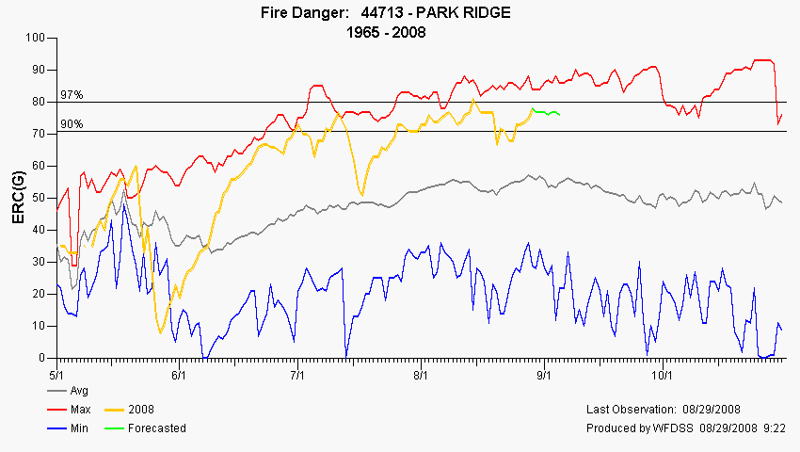
Weather Outlook | 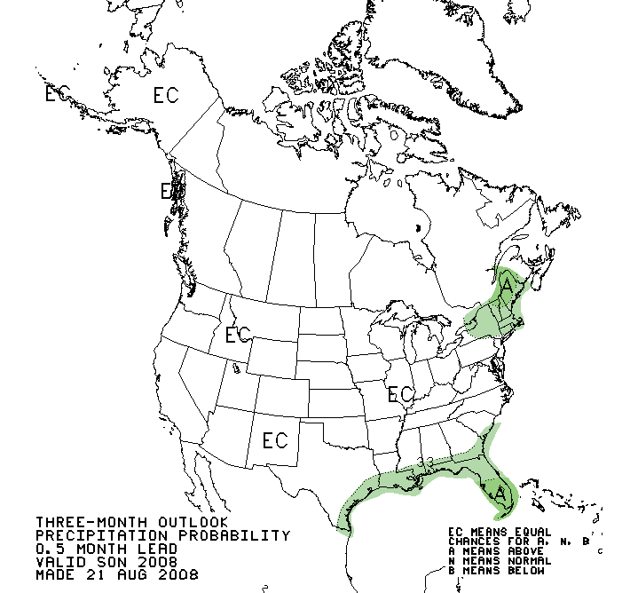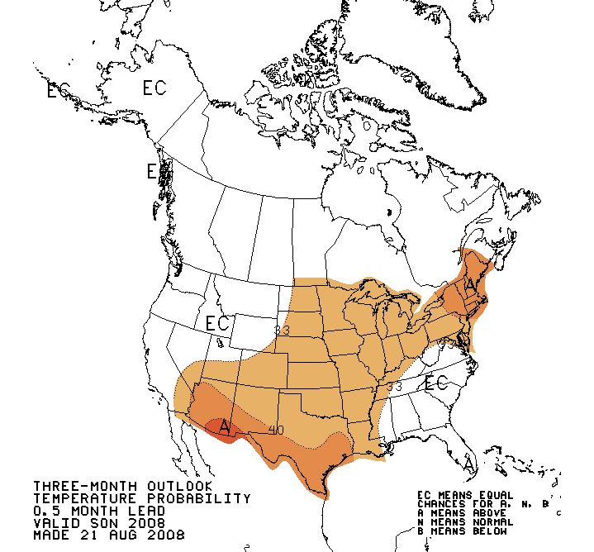
Fuels | Mixed conifer and live oak, best described as fuel models 8, 9 and 10  See WFDSS.
Hazards and Safety Concerns | Human Factors  The risk to visitors can be mitigated by keeping the Tehipite Valley and Blue Canyon trail closed at the agency boundary and Simpson Meadow. The trail closure has been coordinated with the Sierra National Forest.  Operations  There is currently a negative risk/benefit to staffing the fire perimeter on any flanks at this time due to rolling material, cliffs, and steep terrain. Values at risk are not commensurate with firefighters engaging the fire on the ground. No viable safety zones and anchor points constrain any actions in the current planning area.  Travel  Driving to access points, hiking in the area. Nature of fuels and the ability to hike cross county  Environmental Factors  Aviation Operations  All helicopter missions will be weighed on a risk/benefit basis. Helispots in the area are limited and those available are not usable by all types of helicopters.  Other (list)
Resource Availability | High, South OPS – PL3, National PL-3.

Short-Term Fire Behavior | The fire can be expected to be primarily influenced by terrain winds. Daytime spread will be predominantly upslope and up canyon. Single and group tree torching are probable. Spotting distances up to ¼ mile are possible. Expect complete consumption of the large diameter fuels. (9/02/2008)
Source | On site observations.
ROS/Fire Intensity | Perimeter spread at the head of the fire will be 2-4 chains per hour in fir-dominated fuels and 3-6 chains per hour in pine-dominated fuels. Flame lengths will range from <1’ under closed canopy fir stands to 4’ in pine-dominated stands.
Medium Term Fire Simulation | See attached FARSITE map.
Fire Spread Probability | See WFDSS analysis:
Value Inventory | - Private inholdings  - Johnson meadow cabins  - Deer meadow cabin  - Air Quality  - Cultural resources  - Painted Rock (rock art) (mitigation completed – 8/16)  - Tehipite cabin (burned – prior to 8/16)  - Little Tehipite cabin  - Blue Canyon cabin  - Rockshelter cache (mitigation completed and burned around – 8/16)  - Stone House rockshelter (mitigation completed – 8/16)  - Bedrock mortar site #1 (mitigation completed – 8/16)  - Bedrock mortar site #2 (mitigation completed – 8/16)  - Little Tehipite mine entrance w/structure  - Ore processing pit – stone construction (believe burned around – 8/16)  - Administrative sites  - Grizzly Falls picnic area  - Crown Valley guard station  - Trails SNF 53 miles.  - Log stringer bridges SNF 4 total. Estimated replacement value $100k.  - Signs SNF 43 total. Estimated replacement value $17k.
Rapid Assessment of Values at Risk (RAVAR)
Stratified Cost Index (SCI) | Not applicable on DOI lands, will be updated when the fire moves on to USFS lands.

Objectives
Strategic Fire Management Objective(s) | - Permit lightning caused fires to play, as nearly as possible, their natural ecological role within the wilderness.  - Fire management activities, including management ignited prescribed fire, will be accomplished in a manner that is compatible with wilderness management policy and objectives.  - Consider the use of wildland fire to maintain or restore the characteristics and components of the historic fire regime.  - Manage wildland fires through the selection of appropriate management response.
Incident Objectives | - Keep fire east of wilderness boundary between middle fork and north fork of Kings River.  - Keep fire north of the South Fork of the Kings River.  - Avoid dropping retardant in areas that would compromise water quality, generally 300 feet of either side of streams and cultural sites.  - Control public access to Tehipite Valley, Crown Valley trail, Spanish Lakes, Blue Canyon Trail, Woodchuck trail.  - Keep costs commensurate with values at risk and natural resource benefits gained.  - Prevent non-native species introduction into the Wilderness.  - Provide quality and accurate information and education to the interested and effected public.  - Keep fire and fire activities from adversely effecting cultural resources.  - Coordinate tactical operations to avoid air quality impacts with the San Joaquin Air Pollution Control District (SJVAPCD)  - Zero injuries to firefighters and public.
Management Requirements | - Provide for firefighter and public safety.  - Comply with agreed to documentation and reporting requirements Appendix 1 for the SJVAPCD.  - Contact Agency Administrator’s Representative regarding ground disturbing activities as related to natural, riparian and cultural resources.  - Use of mechanized equipment, mechanical transport of materials/personnel, or helispot construction requires approval from the appropriate line officer.  - On USFS lands use minimum impact suppression tactics.  - On NPS lands, comply with minimum requirement/minimum tool guidelines in the SEKI Fuels and Fire Management Plan.

Course of Action
Planning Area | Beginning at the confluence of the Middle and South Forks of the Kings River, go north along the western wilderness boundary to the north fork of the Kings river; east along the north fork to Crown Basin/Kettle ridge, then east-southeast to Wind Ridge. From Windy Ridge head southeast to South Fork Kings River then follow the river downstream to the confluence with the Middle Fork Kings River.
Course(s) of Action | - When fire crosses onto Sequoia National Forest lands expand unified command.  - Monitor and implement actions as described in the Management Action Points (MAP). Primary monitoring method will be occasional aerial monitoring (combination of periodic fixed-wing, rotor or Infrared).  - Area protection for private or point source protection  - Implement perimeter control as necessary  - Perimeter control and reduced smoke emissions were considered, but discarded because actions require a significant commitment of T1 crews and air resources that have low probability of success and are high risk actions not supported by the need to protect other values at risk.
Management Action Points | MAP-0: Monitoring  MAP-1: Middle Fork to Tombstone Ridge  MAP-2: Tombstone Ridge  MAP-3: Middle Fork Kings  MAP-4: Crown Creek  MAP-5: Boundary Creek  MAP-6: KNP/North SNF Boundary  MAP-7: Blue Canyon  MAP-8: Deer/Johnson Meadow Cabin Protection add crown valley guard station  MAP-9: Rodgers Creek Delete  MAP-10: Fire Behavior Thresholds  MAP-11: Monarch Boundary  MAP-12: John Muir Boundary  MAP-13: Junction Ridge  MAP-14: South Fork Kings River  MAP-15: Scepter Creek Delete  MAP-16: Mountain Meadow/Upper Crown Creek Delete  MAP-17: Crown Valley guard station Delete
Mitigation Actions | See Management Action Point sheets below.
Resources Needed to Manage the Fire | In addition to the resources identified in the chart below, an Unified Incident Command and access to an aircraft for mapping and monitoring support. The estimated cost is $1,520,000 for 75 days with the anticipated season ending event occurring about 11/15.

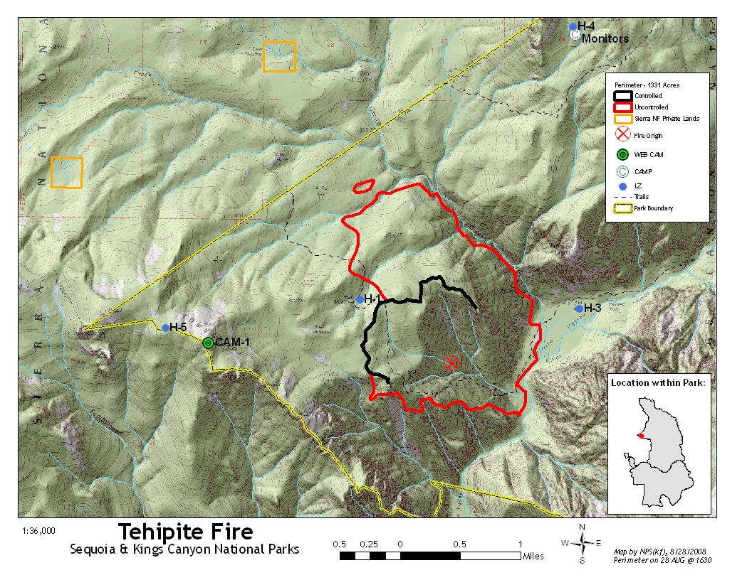
MAP-0: Monitoring | Staff some location outside the fire perimeter with a minimum of two FEMOs.
Management Actions | Monitor fire perimeter growth, fire behavior, fire effects, collect smoke observations, onsite weather observations, and request once daily spot weather forecast. Mapping flight for acres burned and perimeter to meet air quality requirements at a minimum of once a week or when daily fire growth of more than 100 acres.
Resources Recommended | Operations: 2 FEMO  Planning:  Logistics: 1 HEL3.
Estimate time to complete (days) | 75 days
Estimated Costs | $1200/day
Actions with Date Completed | On going, monitors have been on location 14 days to date.
References | Swap personnel in the field once every seven days. Field personnel meet Wilderness ethics guidelines, bear management requirements, receive briefing prior to deployment, debriefing from onsite personnel, and provide radio updates to Ash Mountain Fire.

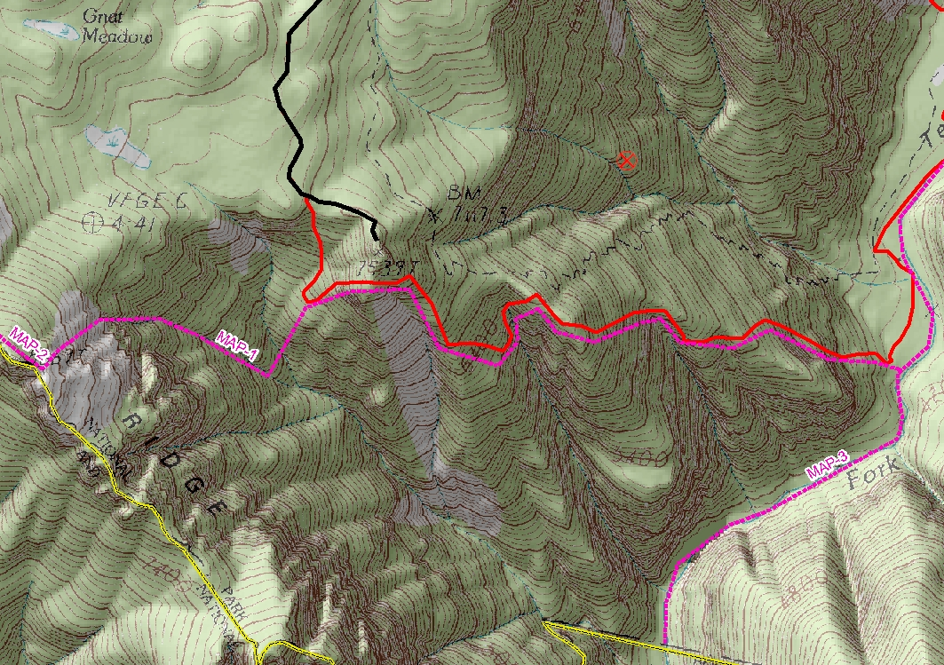
MAP-1: Middle Fork to Tombstone Ridge | Runs from the fires edge in the Middle Fork of the Kings River northwest along the uncontained fire perimeter to the western most point then due west to Tombstone Ridge, until it reaches the west end of MAP-2 near Tombstone Ridge at an elevation of 8669 ft.
Management Actions | Notify the SNF, High Sierra District FMO when the fire crosses any portion of MAP-1.  Notify the park cultural resource specialist.
Resources Recommended | Operations: 1 ARCH, 1 FFT1, 1 FFT2  Planning:  Logistics: 1 HEL3.
Estimate time to complete (days) | 1 days
Estimated Costs | $7000
Actions with Date Completed
Reference | Park Archeologist has photos. Cabin location is based on a 20+ year old verbal description and the exact location is undefined, could be either on SEKI or SNF. Fire activity and risk management at the time will be used to determine the level of the response undertaken, whether site survey and/or protection.

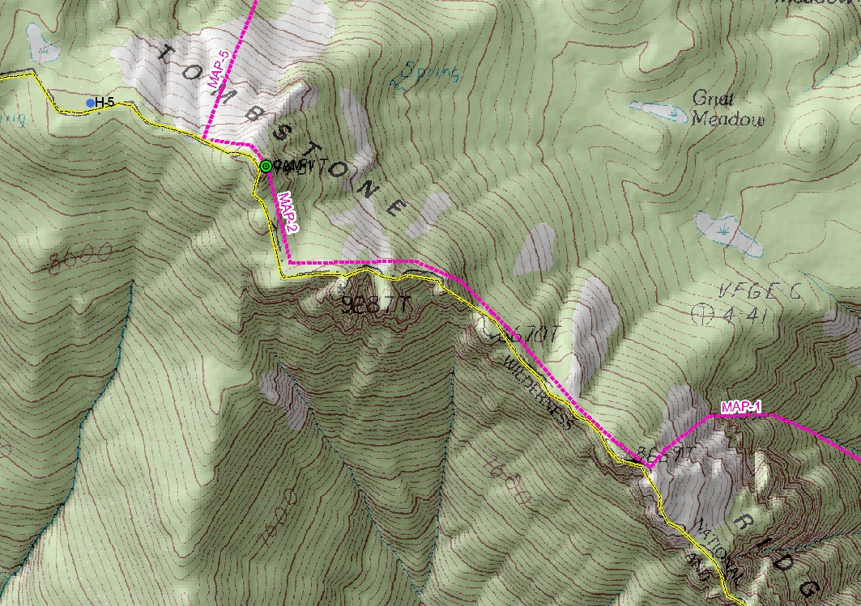
MAP-2: Tombstone Ridge | Runs along the agency boundary on top of Tombstone Ridge from MAP-1 north to MAP-5.
Management Actions | Notify the SNF, High Sierra District FMO when the fire crosses any portion of MAP-2.  Implement unified command structure for interagency management of the fire.  Kings Canyon NP and Sierra NF fire staff will determine appropriate radio frequency use and dispatch center protocols for the fire.  Develop a new revised IAP.
Resources Recommended | Possible additional overhead positions needed.
Estimate time to complete (days) | 1-2 days
Estimated Costs | $600/day – on going
Actions with Date Completed
References

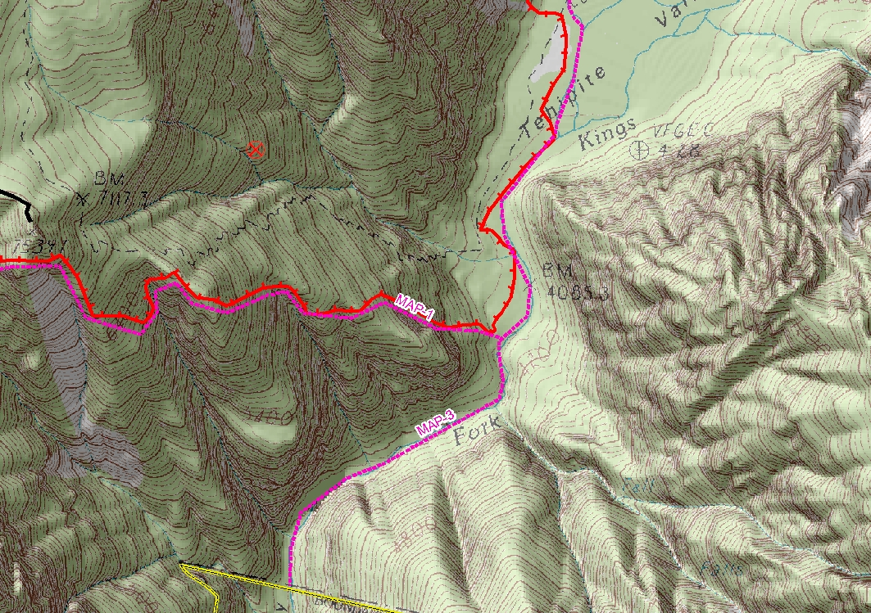
MAP-3: Middle Fork Kings | Runs from the SNF/KNP boundary in the Middle Fork of the Kings River, north up the Kings River, to the confluence of Crown Creek.
Management Actions | Notify the SNF, High Sierra District FMO, SQF, Hume Lake District FMO, and the KNP, Kings District Ranger when the fire crosses any portion of MAP-3.  Update the planning process to include areas of Silver Spur ridge and south. Define the criteria for incorporating the SQF within the incident command structure.
Resources Recommended | Operations:  Planning: 1 GIST, 1 DPRO  Logistics:
Estimate time to complete (days) | 1-2 days
Estimated Costs | $1000
Actions with Date Completed
Reference

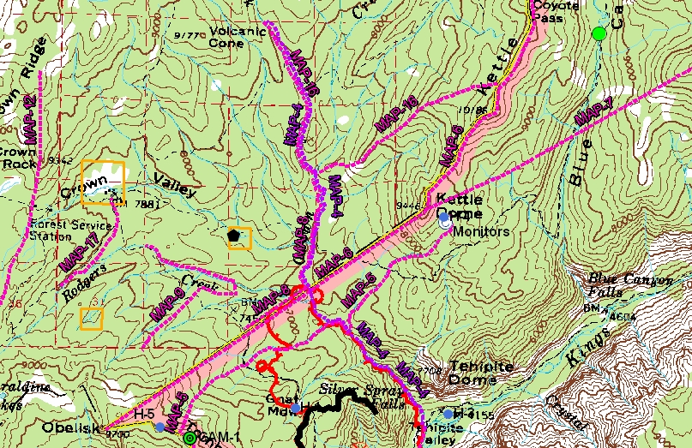
MAP-4: Crown Creek | Starts at the confluence of Crown Creek and the Middle Fork of the Kings River, and follows Crown Creek to the north and its headwaters.
Management Actions | Reassess the location of the Tehipite Fire monitors and their camp.
Resources Recommended | Operations:  Planning:  Logistics: 1- HEL3
Estimate time to complete (days) | 1-2 days
Estimated Costs | $2500
Actions with Date Completed
References | H-4 can be compromised by either smoke or fire in the area eliminating opportunity to extract from that site. Relocate the fire monitors if necessary before the fire reaches H-4.

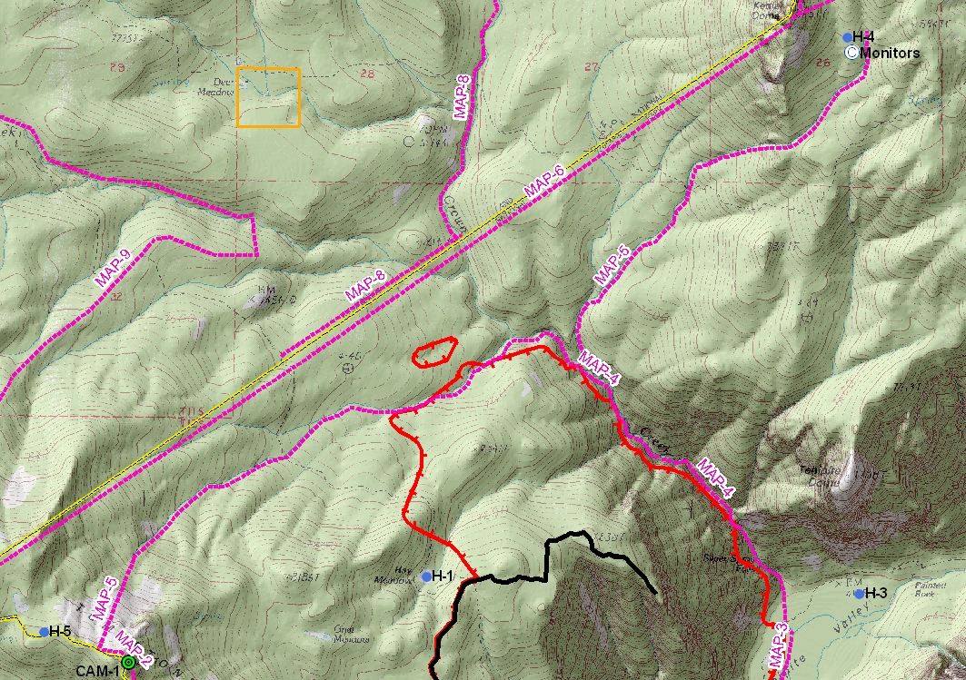
MAP-5: Boundary Creek | Runs from Tombstone Ridge east following a no-name creek (referred to as West Boundary Creek) to Crown Creek, then crosses Crown Creek and follows a no-name creek (referred to as East Boundary Creek) and terminates just east of H-4 on the east side of Kettle Dome.
Management Actions | Notify the SNF, High Sierra District FMO when the fire crosses any portion of MAP-5.  Update fire spread projections to define timing for fire movement on to the Sierra NF.
Resources Recommended | Operations: None  Planning: 1 FBAN or LTAN  Logistics:
Estimate time to complete (days) | 1 day(s)
Estimated Costs | $500
Actions with Date Completed | Update fire behavior projection and new FSPro run. Projected to be on the Sierra NF on 9/3/200. DBartlett-8/29/2008
Reference

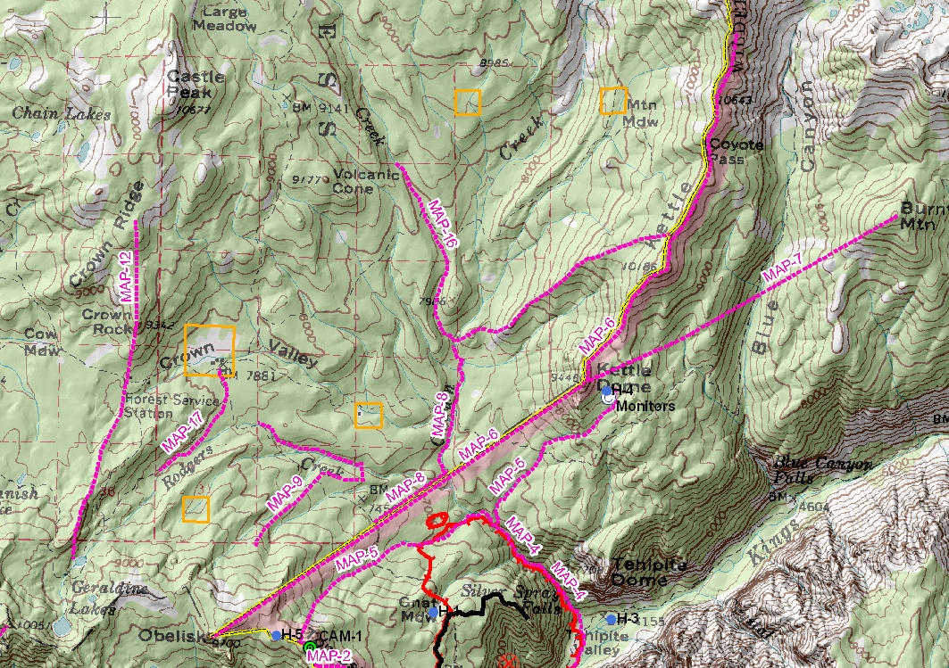
MAP-6: KNP/North SNF Boundary | Runs from the Obelisk east following the agency boundary line to Kettle Dome, and then continues to follow the agency boundary along Kettle Ridge to just due west of the end of the Blue Canyon Trail in Coyote Pass.
Management Actions | Notify the SNF, High Sierra District FMO when the fire crosses any portion of MAP-6. Implement unified command structure for interagency management of the fire. Kings Canyon NP and Sierra NF fire staff will determine appropriate radio frequency use and dispatch center protocols for the fire. Issue revised IAP.
Resources Recommended | Operations: 1 ICT3  Planning:  Logistics:
Estimate time to complete (days) | 1 day
Estimated Costs | $500
Actions with Date Completed
References

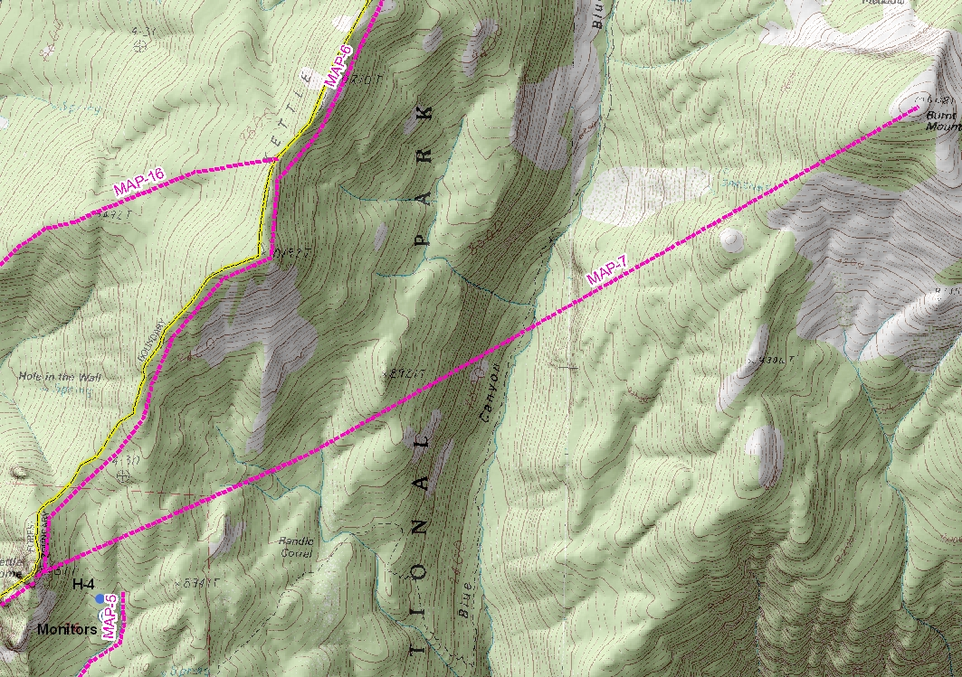
MAP-7: Blue Canyon | Runs from Kettle Dome on a straight line northeast to Burnt Mountain.
Management Actions | Notify the Kings District Ranger and the park cultural resource specialist when the fire crosses any portion of MAP-7.  Define protection options with the park cultural resource specialist for protection of the historic structure in Blue Canyon
Resources Recommended | Operations: 1 ARCH, 1 FFT1, 1 FFT2  Planning:  Logistics: 1 HEL3.
Estimate time to complete (days) | 1-2 days
Estimated Costs | $7000
Actions with Date Completed
Reference | Park Archeologist has photos. Fire activity and risk management at the time will be used to determine the level of the response undertaken, whether site survey and/or protection.

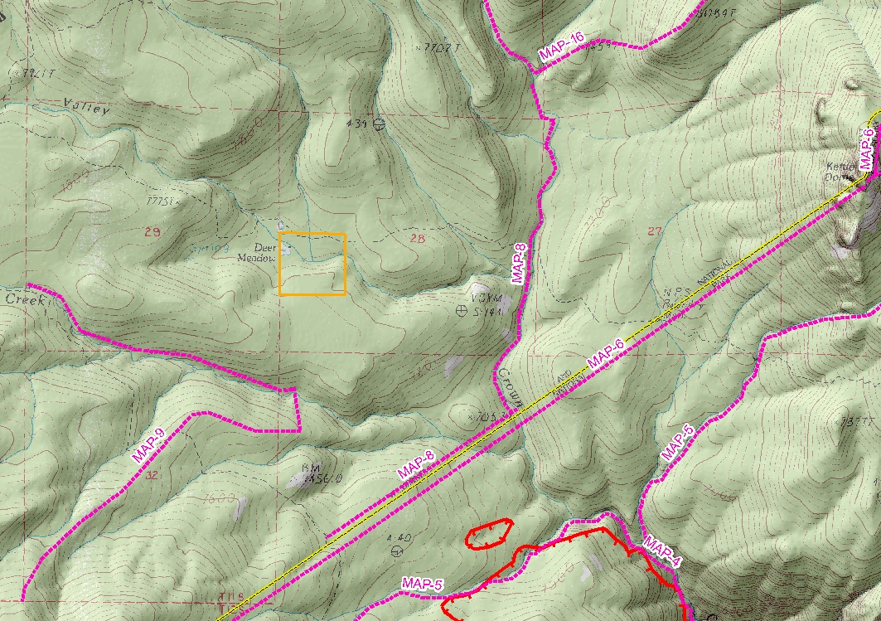
MAP-8: Deer/Johnson Meadow Cabins, Crown Valley Guard Station Protection | Fire crosses KNP - SNF Boundary between Crown Creek and Middle Fork trail.
Management Actions | Implement point source protection by using suppression and/or protection tactics to slow or stop fire spread into Deer and Johnson meadow cabin areas; and the Crown Valley guard station.
Resources Recommended | Operations – 1 DIVS, 1 SOF2, 2 FOBS, 2 CRW1  Planning -  Logistics –, 1 SCMG, 1 ORDM, 1 FACL, 1 HEL2, will need to establish a Spike Camp in the wilderness to support operations on the ground, set-up and resupply to be done by pack string. Need 3 days advance notice to begin spike camp setup.
Estimate time to complete (days) | 8 days
Estimated Costs | $347,200
Actions with Date Completed | Deer meadow cabin wrapped and fuels reduction completed, 9/3.
Reference | Contact SNF, High Sierra FMO for site maps and assessment information.  Follow aquatic species protection measures, Appendix #2  Arch mitigation - Avoid scraping fireline within 10 feet of trails.
DELETE
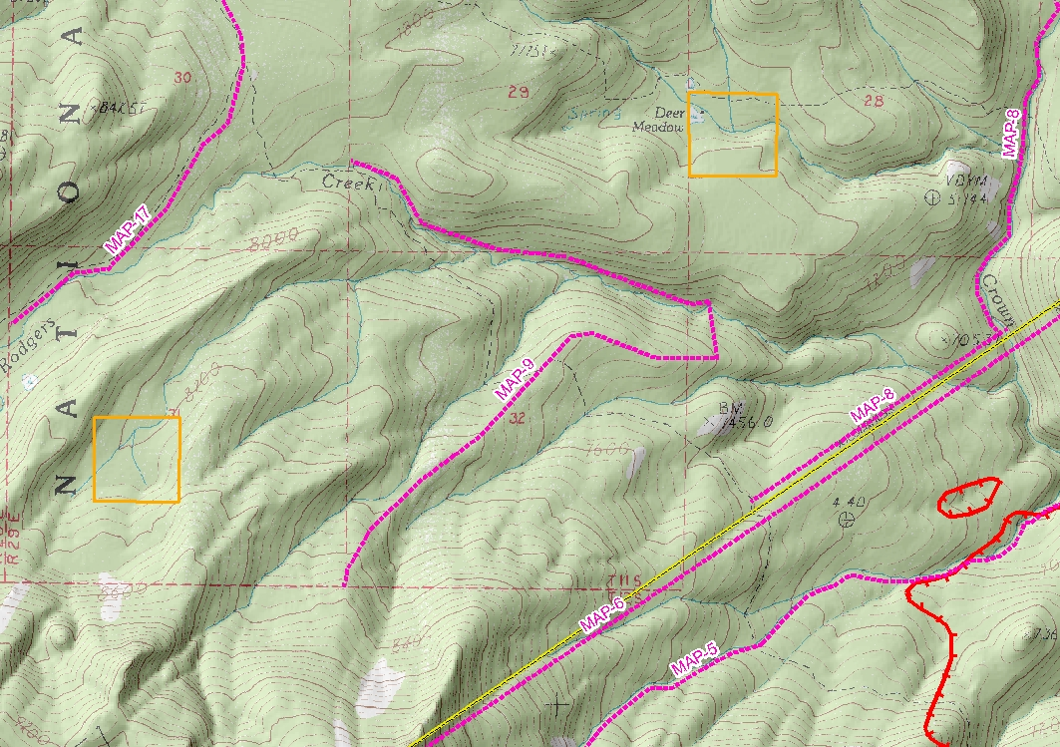
Management Actions | .
Resources Recommended | Operations –  Planning -  Logistics –
Estimate time to complete (days)
Estimated Costs
Actions with Date Completed
References

Insert FLAMMAP output here

MAP-10: Fire Behavior Thresholds | Under the fire behavior scenario of very dry conditions, FFM 3-4, eye-level winds at 10 miles per hour; unacceptable fire effects may result and conditions are anticipated for more than a single burning period.
Management Actions | Notify SJVAPCD to impending smoke event. Use aviation resources to cool hot spots along perimeter in direction of anticipated fire spread. Analyze for opportunities to minimize growth with handcrews.
Resources Recommended | Operations – 1 ATGS (w/platform), 2 HEL1, 1 DIVS, 1 SOF2, 4 CRW1  Planning -  Logistics –
Estimate time to complete (days) | 4 days
Estimated Costs | $358,000
Actions with Date Completed
References | The alignment of slope, wind and vegetation may result in “active” (crown) fire spread may result in acreage gains greater than 100 acres.  Incorporate aquatic species protection measures, Appendix #2  Arch mitigation - Avoid scraping fireline within 10 feet of trails.

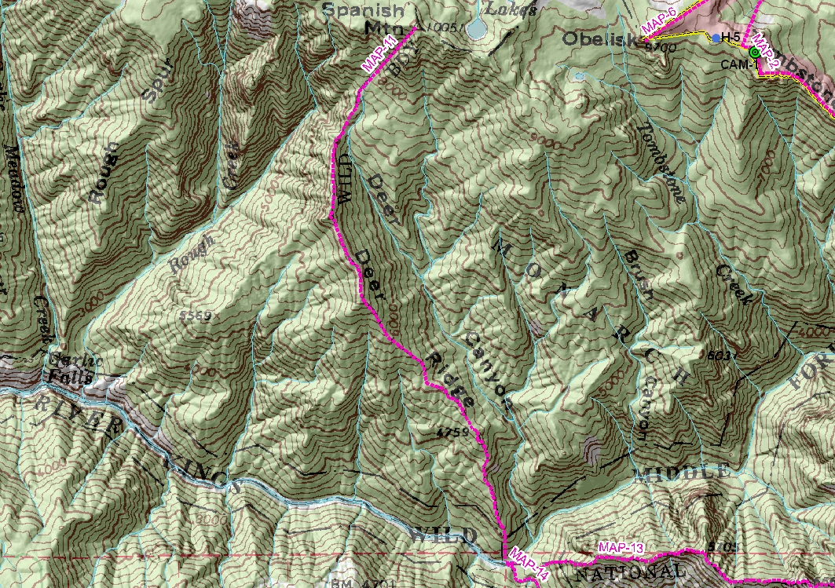
MAP-11 Monarch Boundary | Fire crosses wilderness boundary at Deer Ridge before September 30.
Management Actions | Consider constructing indirect line from Weisman Springs to Middle Fork of Kings River.  Develop Management Action Point for burning operations on indirect line.
Resources Recommended | Operations – 1 DIVS, 1 SOF2, 1 DOZ2, 3 CRW1  Planning -  Logistics –
Estimate time to complete (days) | 3 days
Estimated Costs | $38,100
Actions with Date Completed
References

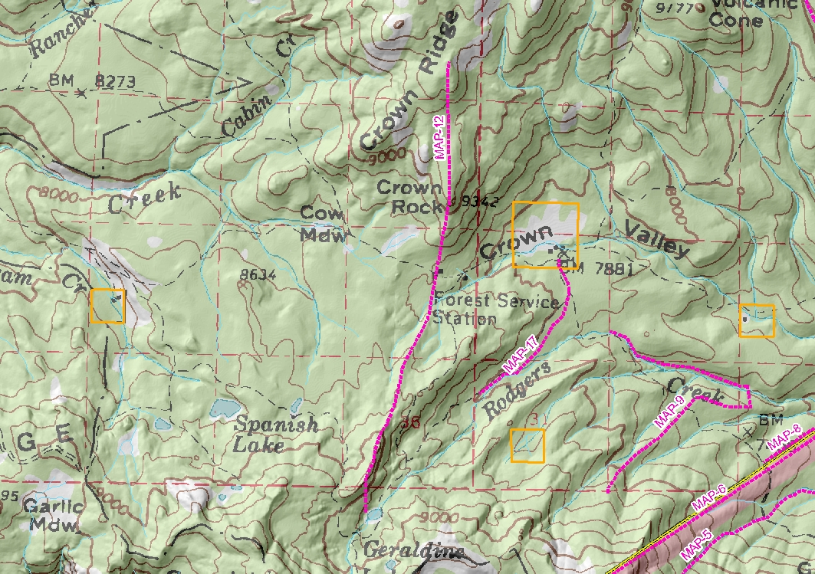
MAP-12: John Muir Boundary | If fire crosses line from Geraldine Lakes to Crown Ridge before September 30.
Management Actions | Construct check lines to prevent fire movement to the west until after September 30.
Resources Recommended | Operations – 3 CRW1, 1 DIVS, 1 SOF2, 2 FOBS  Planning -  Logistics – 1 FACL, 1 BCMG, 1 ORDM, 1 Packtrain, 1 Spike Camp, 2 HEL2
Estimate time to complete (days) | 7 days
Estimated Costs | $496,200
Actions with Date Completed
References | Arch mitigation - Avoid scraping fireline within 10 feet of trails.  Incorporate aquatic species protection measures, Appendix #2.

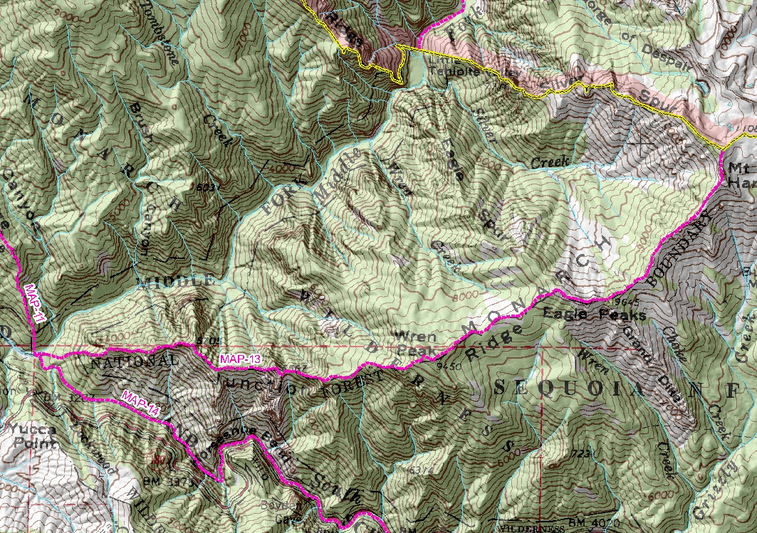
MAP-13: Junction Ridge | Fire crosses Junction Ridge at the confluence of the South Fork and Middle Forks of the Kings River east to Mount Harrington.
Management Actions | - Enter into unified command with Sierra National Forest and Sequoia & Kings Canyon National Parks.  - Install additional remote camera to monitor fire in the Monarch wilderness.  - Notify the public via web, media, and other necessary means.
Resources Recommended | Operations –  Planning -  Logistics –  Other – 1 PIO2, 1 TCSP (camera installation)
Estimate time to complete (days) | 1 Day
Estimated Costs | $1,500
Actions with Date Completed
References

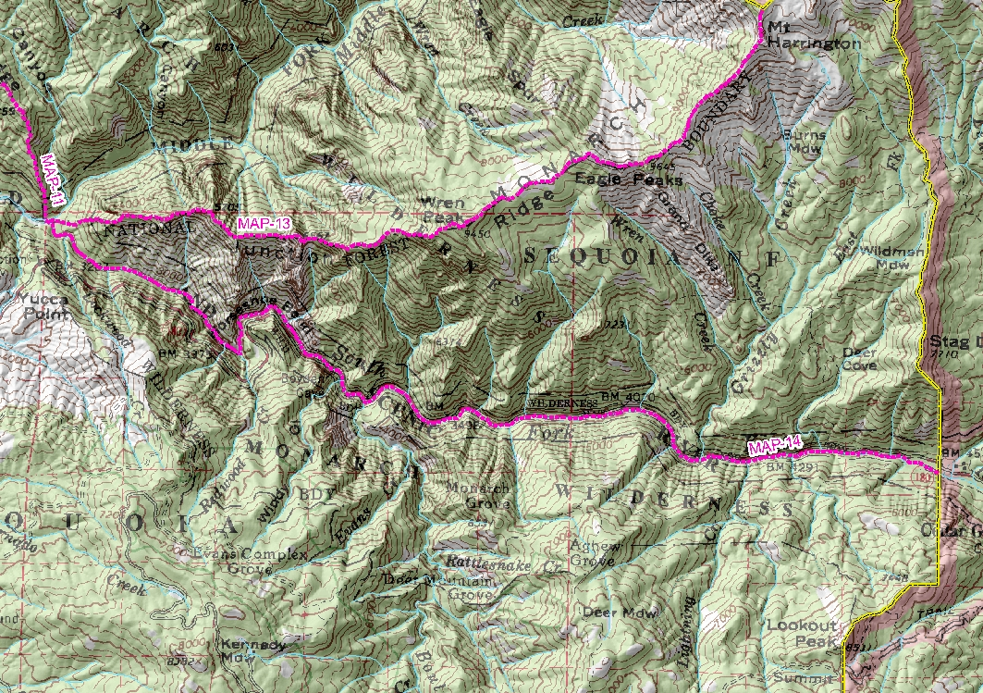
MAP-14: South Fork Kings River | South Fork of the Kings River to the park boundary.
Management Actions | Keep fire to the north of the South Fork of the Kings River by utilizing fire and holding actions.  Mitigate public safety concerns as needed along the Hwy. 180 corridor.
Resources Recommended | Operations – 1 DIVS, 2 CRW1, 3 ENG3  Planning -  Logistics –
Estimate time to complete (days) | 2 Days
Estimated Costs | $54,000
Actions with Date Completed
References
DELETE
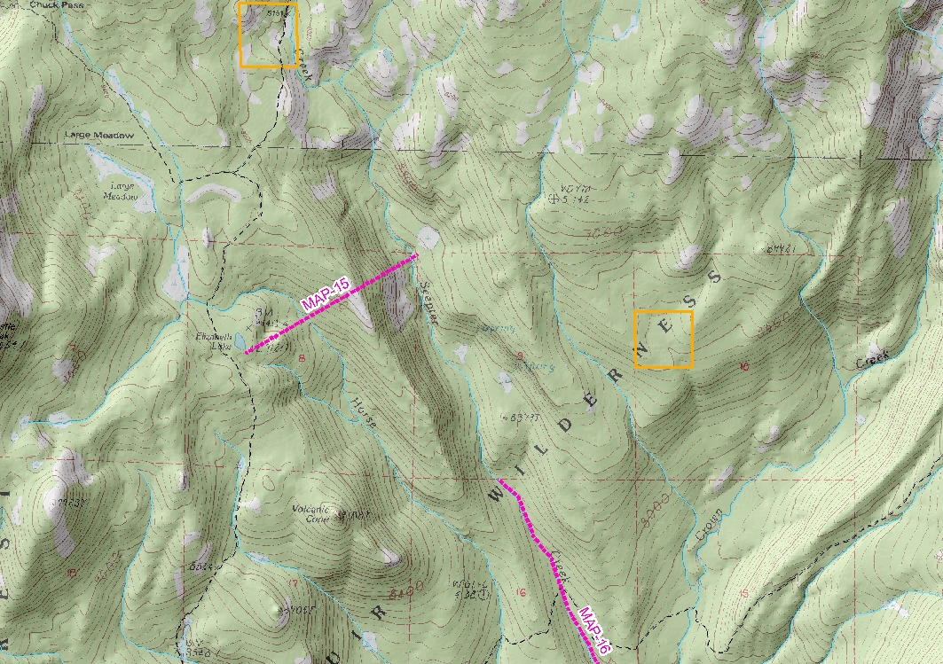
Management Actions
Resources Recommended | Operations –  Planning -  Logistics –  Other -
Estimate time to complete (days)
Estimated Costs
Actions with Date Completed
References
DELETE
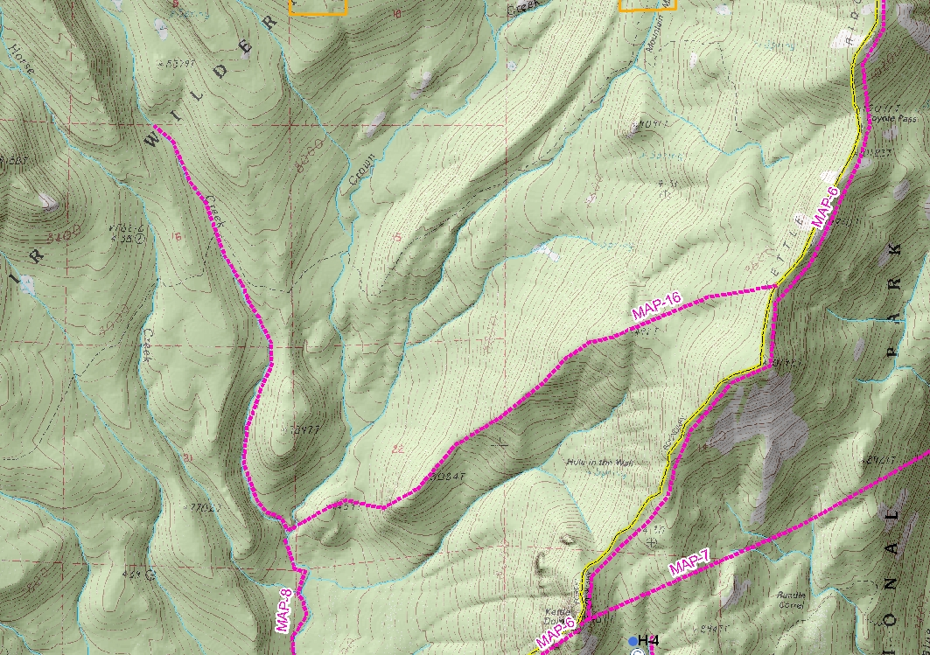
Management Actions
Resources Recommended | Operations –  Planning -  Logistics –
Estimate time to complete (days)
Estimated Costs | None
Actions with Date Completed
References
DELETE
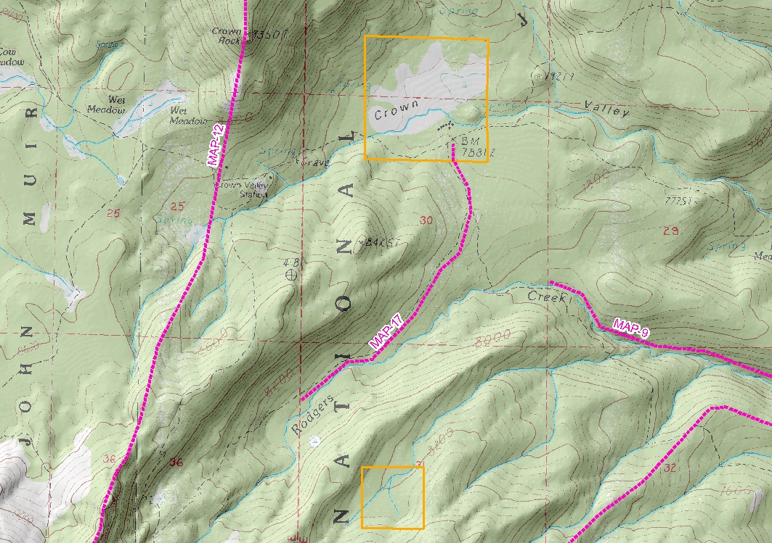
Management Actions
Resources Recommended | Operations –  Planning -  Logistics –
Estimate time to complete (days)
Estimated Costs
Actions with Date Completed
References

Estimated Costs | Cost to date is $598,000 (8/31/2008) and is projected to be $1,520,000.  Historical  Comb (2005) $137/acre managed with an IMT2 and a total fire size of 9000+  Roaring (2006) $85/acre managed with an IMT3 and a total fire size of 1643  Burnt (2001) and a total fire size of 2152 acres  Burnt (2006) and a total fire size of 627 acres
SCI-Stratified Cost Index
Historic
Calculated
Contingency Actions | Utilize the road system outside the wilderness, engines, handcrews and aerial support to contain fire spread to the west and south.  North and east allow fire to progress to rock.

Validation
Medium Term Simulation | See attached FARSITE map. This FARSITE analysis validates timing for the management action points once the fire ?.
Relative Risk Assessment | Moderate. See attached charts.
Fire Spread Probability | See WFDSS analysis:  FSPro indicated a 50% probability that the fire will reach any MAP within 30 days. It also showed an 80% chance that the fire will stay within the wilderness boundary with no suppression action.  Average Arrival Time indicates
Value Assessment | N/A
RAVAR | N/A
Resource Availability | High, National PL 3, South OPS PL 3 (20080828)
Incident Complexity Analysis | This fire is recognized as a Complexity Level 3 incident based on

Decision Summary
Response Decision | Implement the Course of Action.
Response Decision Rationale | There is a low probability that the fire will exit the John Muir, Monarch and Sequoia – Kings Canyon Wildernesses. There is a 40-60% probability that on-the-ground actions will required associated with protection of private in holdings in the John Muir Wilderness as fire spread approaches them. Spatial and temporal conditions are favorable for managing the fire as described in the Course of Action.  The Reference Cost includes all Management Action Points, however there is a low probability that that all MAP actions will be necessary. Smoke management has been considered but projected fire growth  The Reference Cost is 50% less than estimated historical suppression cost projected. Smoke management has been considered, but the selected Course of Action limits aviation operations and firefighter exposure to terrain, fuel, snags, environmental and biological hazards.
Reviewed and Recommended By | Dave McCandliss, High Sierra District Fire Management Officer, Sierra National Forest | David Bartlett, Fire Management Officer, Sequoia & Kings Canyon National Parks
Signature(s) and Date
Reviewed and Approved By | Ed Cole, Forest Supervisor, Sierra National Forest | Craig Axtell, Superintendent, Sequoia & Kings Canyon National Parks
Signature(s) and Date
Periodic Assessment

Periodic Review
National Preparedness Level | Regional Preparedness Level | Cost to date | Size to date | Selected Course of Action  remains valid (Y or N) | By |  | Date | Time
Remarks:
Final Review
The elements of the selected alternative were met on:

Date: |  |  |  |  |  | Time:
By:
 |  | Agency Administrator
Appendix 1:
San Joaquin Valley Unified Air Pollution Control District (SJVAPCD)
Documentation and Reporting Requirements

Submit Wildland Fire Use Smoke Management Summary (SMS) to the SJVAPCD electronically via e-mail to: prescribed-burn@valleyair.org (this meets Smoke Management Plan requirements). While the Tehipiti Fire is active, coordinate with the SJVAPCD on the need to revalidate the Smoke Management Summary.

Participate daily in the 1:00 pm conference call with updates on Tehipiti Fire activity.

While the Tehipiti Fire is active, report to the SJVAPCD on fire growth, as information becomes available or if smoke impacts begin to occur, but NOT LESS than every seven days and/or on a timeframe negotiated between the SJVAPCD and the agency. This includes submitting the Emissions Reporting Form to the SJVAPCD Compliance and Air Quality Analysis Departments electronically via e-mail to: prescribed-burn@valleyair.org.

Collaborate with the SJVAPCD during the development phase of the Wildland Fire Decision Support System (WFDSS) documentation. Notify the SJVAPCD when the completed WFDSS is available on the Sierra Wildland Fire Reporting System website at http://ssgic.cr.usgs.gov/swfrs.

At any time, either the Agency or the SJVAPCD may initiate the Fire Emission Dispersion Advisory (FEDA) depending on the conditions of the fire. The purpose of this form is to predict and/or confirm changing weather conditions that may affect the smoke dispersal from the Tehipiti Fire.

Within 90 days of the Tehipiti Fire being declared inactive and/or out, or no later than December 31: Complete Post WFU Evaluation Form and submit to the SJVAPCD electronically via e-mail to: prescribed-burn@valleyair.org. It is acceptable to combine multiple wildland fire in one report.

By February 1 of Each Year: Include Tehipiti Fire acres burned in annual report and submit to the SJVAPCD (SJVAPCD RULE 3160, section 4.2).

Appendix2: Aquatic Species Protection Measures

Please incorporate the following aquatic species protection measures into you fire plans for the Tehipite fire incident.

Equipment Cleaning:
All fire equipment utilized to extract water from streams and lakes (i.e. helicopter buckets, draft hoses, screens, portable tanks, and portable and backpack pumps) should be thoroughly rinsed to remove mud and debris and disinfected with a chlorine solution (one part bleach to 32 parts water, or stronger) followed by a thorough rinse with clean water. Rinsing equipment with disinfectant solutions should occur prior to deployment. If this is not possible during initial attack operations (first 24 hours), it should be completed by the next fueling cycle.

Monitoring:
A UTM record of extraction sites and deployment sites should be documented and reported to the District or Forest Fisheries Biologist. The record will include origin of response aircraft and whether equipment had been cleaned prior to deployment.

RCO #4, Standard and Guide #115:
During fire suppression activities, consider impacts to aquatic and riparian dependent resources. Where possible, locate incident bases, camps, helibases, staging areas, helispots, and other centers for incident activities outside of RCA's or CAR's. During pre-surpression planning, determine guidelines for suppression activities, including avoidance of potential adverse effects to aquatic and riparian dependant species as a goal.

Riparian conservation areas (RCAs) are designated along streams and around water bodies and are areas for specific management direction and analysis (USDA 2004). The following widths apply for RCAs within the project area:

• Perennial Streams: 300 feet on each side of the stream, measured from the bank full edge of the stream
• Seasonally Flowing Streams (includes intermittent and ephemeral streams): 150 feet on each side of stream, measured from the bank full edge of the stream
• Streams in Inner GorgeInner gorge is defined by stream adjacent slopes greater than 70 percent gradient: top of inner gorge
• Special Aquatic FeaturesSpecial Aquatic Features include: lakes, wet meadows, bogs, fens, wetlands, vernal pools, and springs
or Perennial Streams with Riparian Conditions extending more than 150 feet from edge of streambank or Seasonally Flowing streams with riparian conditions extending more than 50 feet from edge of streambank: 300 feet from edge of feature or riparian vegetation, whichever width is greater
• Other hydrological or topographic depressions without a defined channel: RCA width and protection measures determined through project level analysis

Dispersed camp site locations:
• Camp at least 100 feet away from meadow, stream and lake edges.
• Avoid camps locations that contain numerous burrows (e.g. rodent holes) since these serve as habitat for the Yosemite toad.
• Follow all “Leave No Trace” policies.
• For long term campsites, set up latrine and washing/greywater stations at least 300 feet from water or meadow habitat in an approved location.

Helicopter landing Sites:
Avoid landing in meadows occupied with Yosemite Toad.
Appendix 3:
Acres/Cost by date

Date | Acres | Cost |  | Date | Acres | Cost



