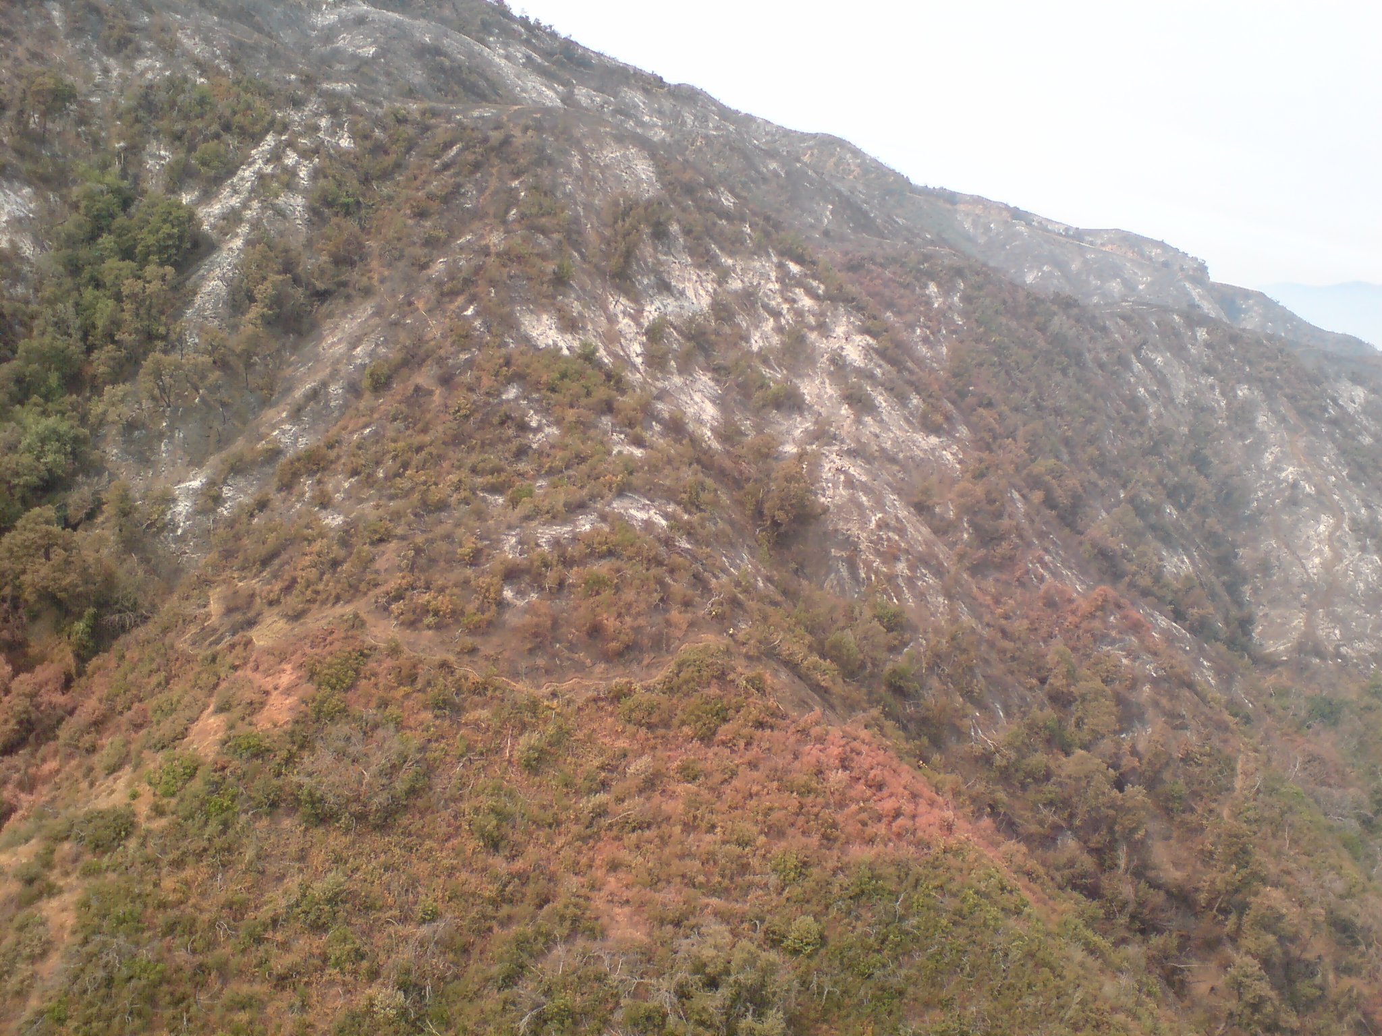
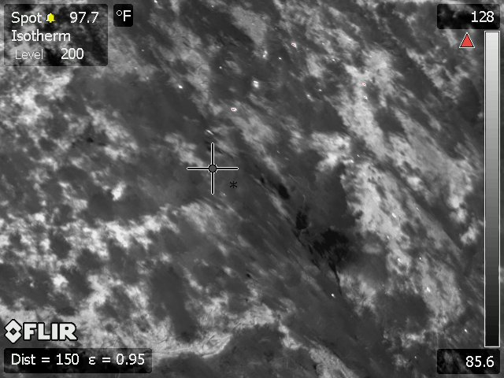
Morris Fire Infrared Photo #3 Aug. 30, 2009 @ 1000

