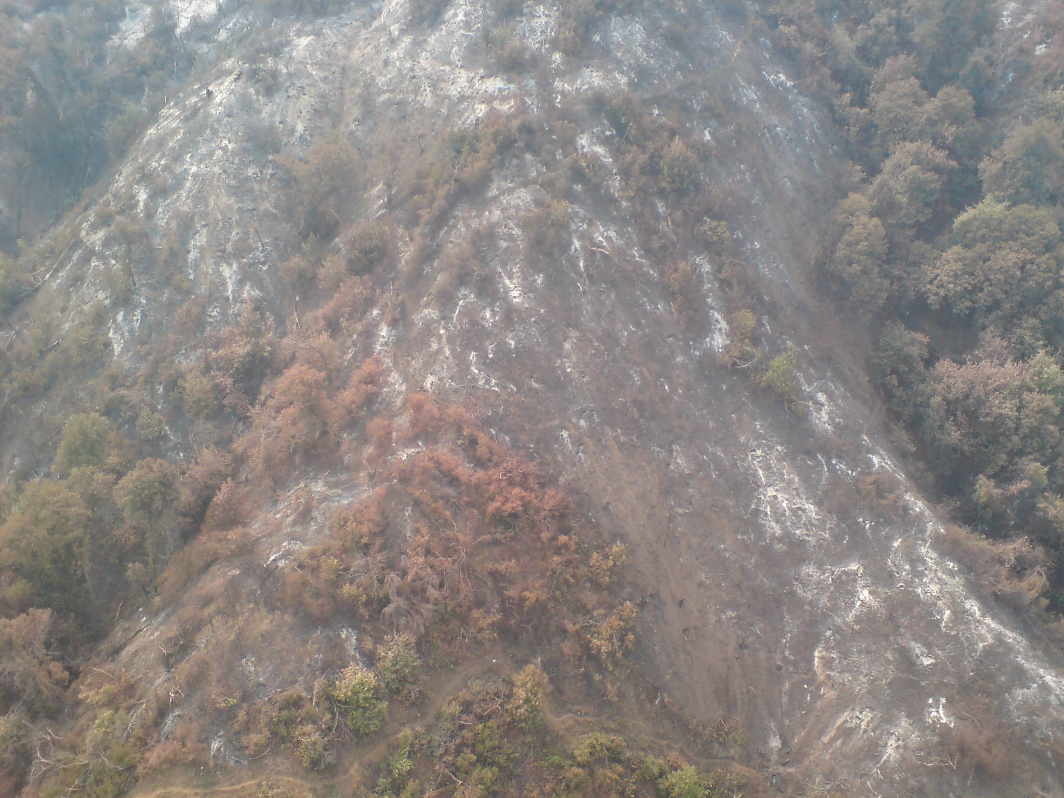
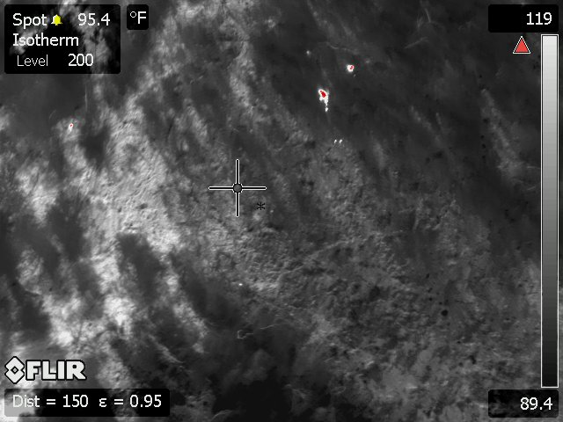
Morris Fire Infrared Photo #6 Aug. 30, 2009 @ 1000

