ADDENDUM TO THE SPS V3.1.2 USER’S GUIDE

Using the new Selective Buffer Option in SPS V3.2
When utilizing the Automatic Digitizing feature in SPS, a buffer of a predetermined radius is applied to all GPS paths within a specified region, automatically creating a polygon representing the effective “treated area” by the heavy equipment used in site preparation.

The new “Selective Buffer” option allows the user to customize this automatic buffering process. By defining certain activity of the heavy equipment as travel, and not actual work, with a threshold speed limit and time limit, the user can create a more precise treated area polygon by excluding what is deemed to be travel activity and only including what is actual work.

An example: if travel has been defined for the selective buffering option as 2.75 km/h and 300 seconds, then activity performed by the unit will be determined to be “work” if its speed does not exceed 2.75 km/h for 300 consecutive seconds. All work activity will then be buffered when using the automatic digitizing tool, and travel activity will not be buffered as treated area polygons.

In order to use the Selective Buffer, its option in Project >> Settings must be set (Buffer Settings page) before you import any .slv files. Check the box that says “Utilize Selective Buffering with Automatic Buffer Tool” to activate it. In addition, appropriate values for your heavy equipment must be entered in the “Travel Speed Limit for Selective Buffering” and the “Consecutive Seconds to Constitute Travel for Selective Buffering” boxes that reflect your definition of travel for the equipment.

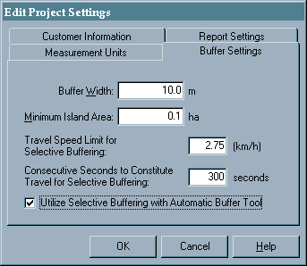
NOTE: these values are used to determine, during import, if the GPS paths are allowed to be buffered when using the Automatic Digitizing tool. Once an .slv file has been imported using a certain set of parameters, changing the parameters in your settings will not affect the already-imported GPS data – it will only apply to subsequently imported .slv files. As well, if the “Utilize Selective Buffering with Automatic Buffer Tool” option is turned off during import, turning it back on after import will not affect the already-imported GPS data – all GPS paths for that file will be buffered by the Automatic Digitizing tool.

When using the Automatic Digitizing tool, ensure that the “Utilize Selective Buffering with Automatic Buffer Tool” option is again selected if you want SPS to selectively buffer. Turning this option off will cause all selected GPS paths to be buffered, even though the option may have been on during import.

NOTE: utilizing the Selective Buffering feature requires significantly increased resources and time for both the import and automatic digitizing processes to complete. If it is not necessary for you to use this feature, then it is recommended that it be turned off during import and automatic digitizing so as not to degrade performance of these operations.

In summary:
- When the Selective Buffering feature is not enabled, all selected GPS paths are buffered (just like all automatic buffering was done in previous versions of SPS).
- When the Selective Buffering feature is enabled, only those parts of the selected GPS paths that do not constitute travel will be buffered when using the automatic digitizing tool.
- For the Selective Buffering feature to be applied to your GPS data, ensure that it is activated before the data is imported as well as before you use the automatic digitizing tool. If it was not activated before your .slv file was imported, then you can remove its GPS data from your project, turn the option on, then re-import the data again. This same procedure could be done if your definition of what constitutes travel changes.
- Selective Buffering is more resource-intensive and time-consuming than normal automatic buffering. Expect it to take longer when it is turned on, or turn it off if there is not a big difference in treated area sizes compared to normal automatic buffering.

Displaying an Attribute Field from a Map Layer as a Label in SPS V3.2

It is now possible to display values from a base map layer’s attributes as a label on the main map. Most ArcInfo Coverages and Shapefiles have attribute tables within them that store additional data for each of the spatial features.

To change the current attribute field that is being displayed, right-click on the layer’s entry in the Map Layers window and select the “Change Label Field” option from the pop-up menu list.

The “SPS Map Layer Labels” form will then appear. A list of all available attribute fields for the selected base map layer will be displayed.

Click on the attribute field you wish to use and then click the ‘OK’ button to commit the change. Select the ‘[None]’ entry if you do not wish to use one of the fields as a label on the map.

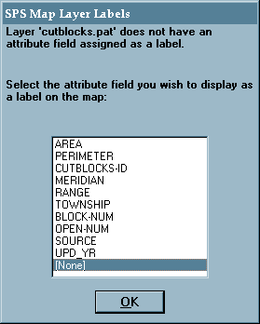

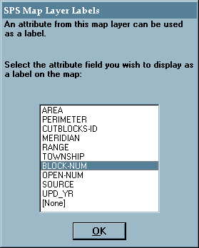

To toggle the visibility of the map layer labels on or off, click the “Labels Visible” box. You may choose to not display the labels for a layer because it can increase the time required to re-draw the map every time the map is updated.

Note: if the “Features Visible” box is unchecked, the labels for the layer will not be visible, regardless of the state of the “Labels Visible” box.

