30 – ORGANIZATION

Table of Contents Pages

30 – ORGANIZATION 92
Northern California 92
Southern California 93
31 – Cal EMA FIRE AND RESCUE REGIONAL MAP 94
32 – Cal EMA FIRE AND RESCUE REGIONAL ASSISTANT CHIEF MAP 95

30 – ORGANIZATION

Northern California
Dispatch Channels

Sacramento Headquarters CAL FIRE
Operations Northern California
National Interagency Fire Center
Modoc ECC
Modoc MDF
Lava Beds BNP
Lower Klamath LKR

Redding ECC
Shasta-Trinity SHU
Shasta-Trinity SHF
Whiskeytown WNP
Howard Forest ECC
Mendocino MEU
Fortuna ECC
Six Rivers SRF
Humboldt-Del Norte HUU
Hoopa HIA
Humboldt Bay HBR
Redwood NP RWP

St. Helena ECC
Sonoma-Lake Napa LNU
Morgan Hill ECC
Santa Clara SCU
Oroville ECC
Butte BTU
Yreka ECC
Klamath KNF
Siskiyou SKU
Felton ECC
San Mateoanta Cruz CZU
Woodacre ECC
Marin County MRN
Red Bluff ECC
Tehama-Glenn TGU
Mendocino ECC
Mendocino MNF
Golden Gate NP GNP
SacramentoRefuges SWR
Hawaii HVP
Pt. Reyes RNP
Camino ECC
Eldorado ENF
Tahoe Mgt TMU
Amador-El Dorado AEU
Susanville ECC
Lassen LNF
Lassen NP LNP
Lassen-Modoc LMU
Northern BLM NOD

Plumas ECC
Plumas PNF
Grass Valley ECC
Tahoe TNF
Nevada-Yuba-Placer NEU
Operations Southern California

Southern California
Dispatch Channels
Sequoia Kings ECC
Sequoia Kings Canyon NP
Orange County ECC
Orange County ORC
Kern County ECC
Kern County KRN
Perris ECC
Riverside RRU
Central California ECC
Sequoia SQF
Central CA BLM CND

Santa Barbara ECC
Santa Barbara County SBC
Los Padres ECC
Los Padres LPF
Vandenberg AFV
Channel Islands CNP
Pinnacles NM PIP
Angeles ECC
Angeles ANF
Santa Monica Mtn SMP
Monte Vista ECC
Monte Vista MVU
Cleveland CNF
Madera-Mariposa Merced ECC
Madera-Mariposa MMU

National Interagency Fire Center
Operations Southern California

Fresno Kings ECC
Fresno-Kings FKU
Stanislaus ECC
Stanislaus STF
San Bernardino ECC
San Bernardino BDU

Yosemite ECC
Yosemite YNP
Sierra ECC
Sierra NF
Tulare ECC
Tulare TUU

Ventura County ECC
Ventura County VNC
Los Angeles ECC
Los Angeles County LAC

Sacramento Headquarters CAL FIRE

San Luis Obispo ECC
San Luis Obispo SLU
San Andreas ECC
Tuolumne-Calaveras TCU
Federal ECC (SBCC)
CA Desert CDD
Joshua Tree JTP
Death Valley DVP
San Bernardino BDF
Mojave MNP
Owens Valley ECC
Inyo INF
Owens Valley OVD
Monterey ECC
San Benito-Monterey BEU

31 – Cal EMA FIRE AND RESCUE REGIONAL MAP

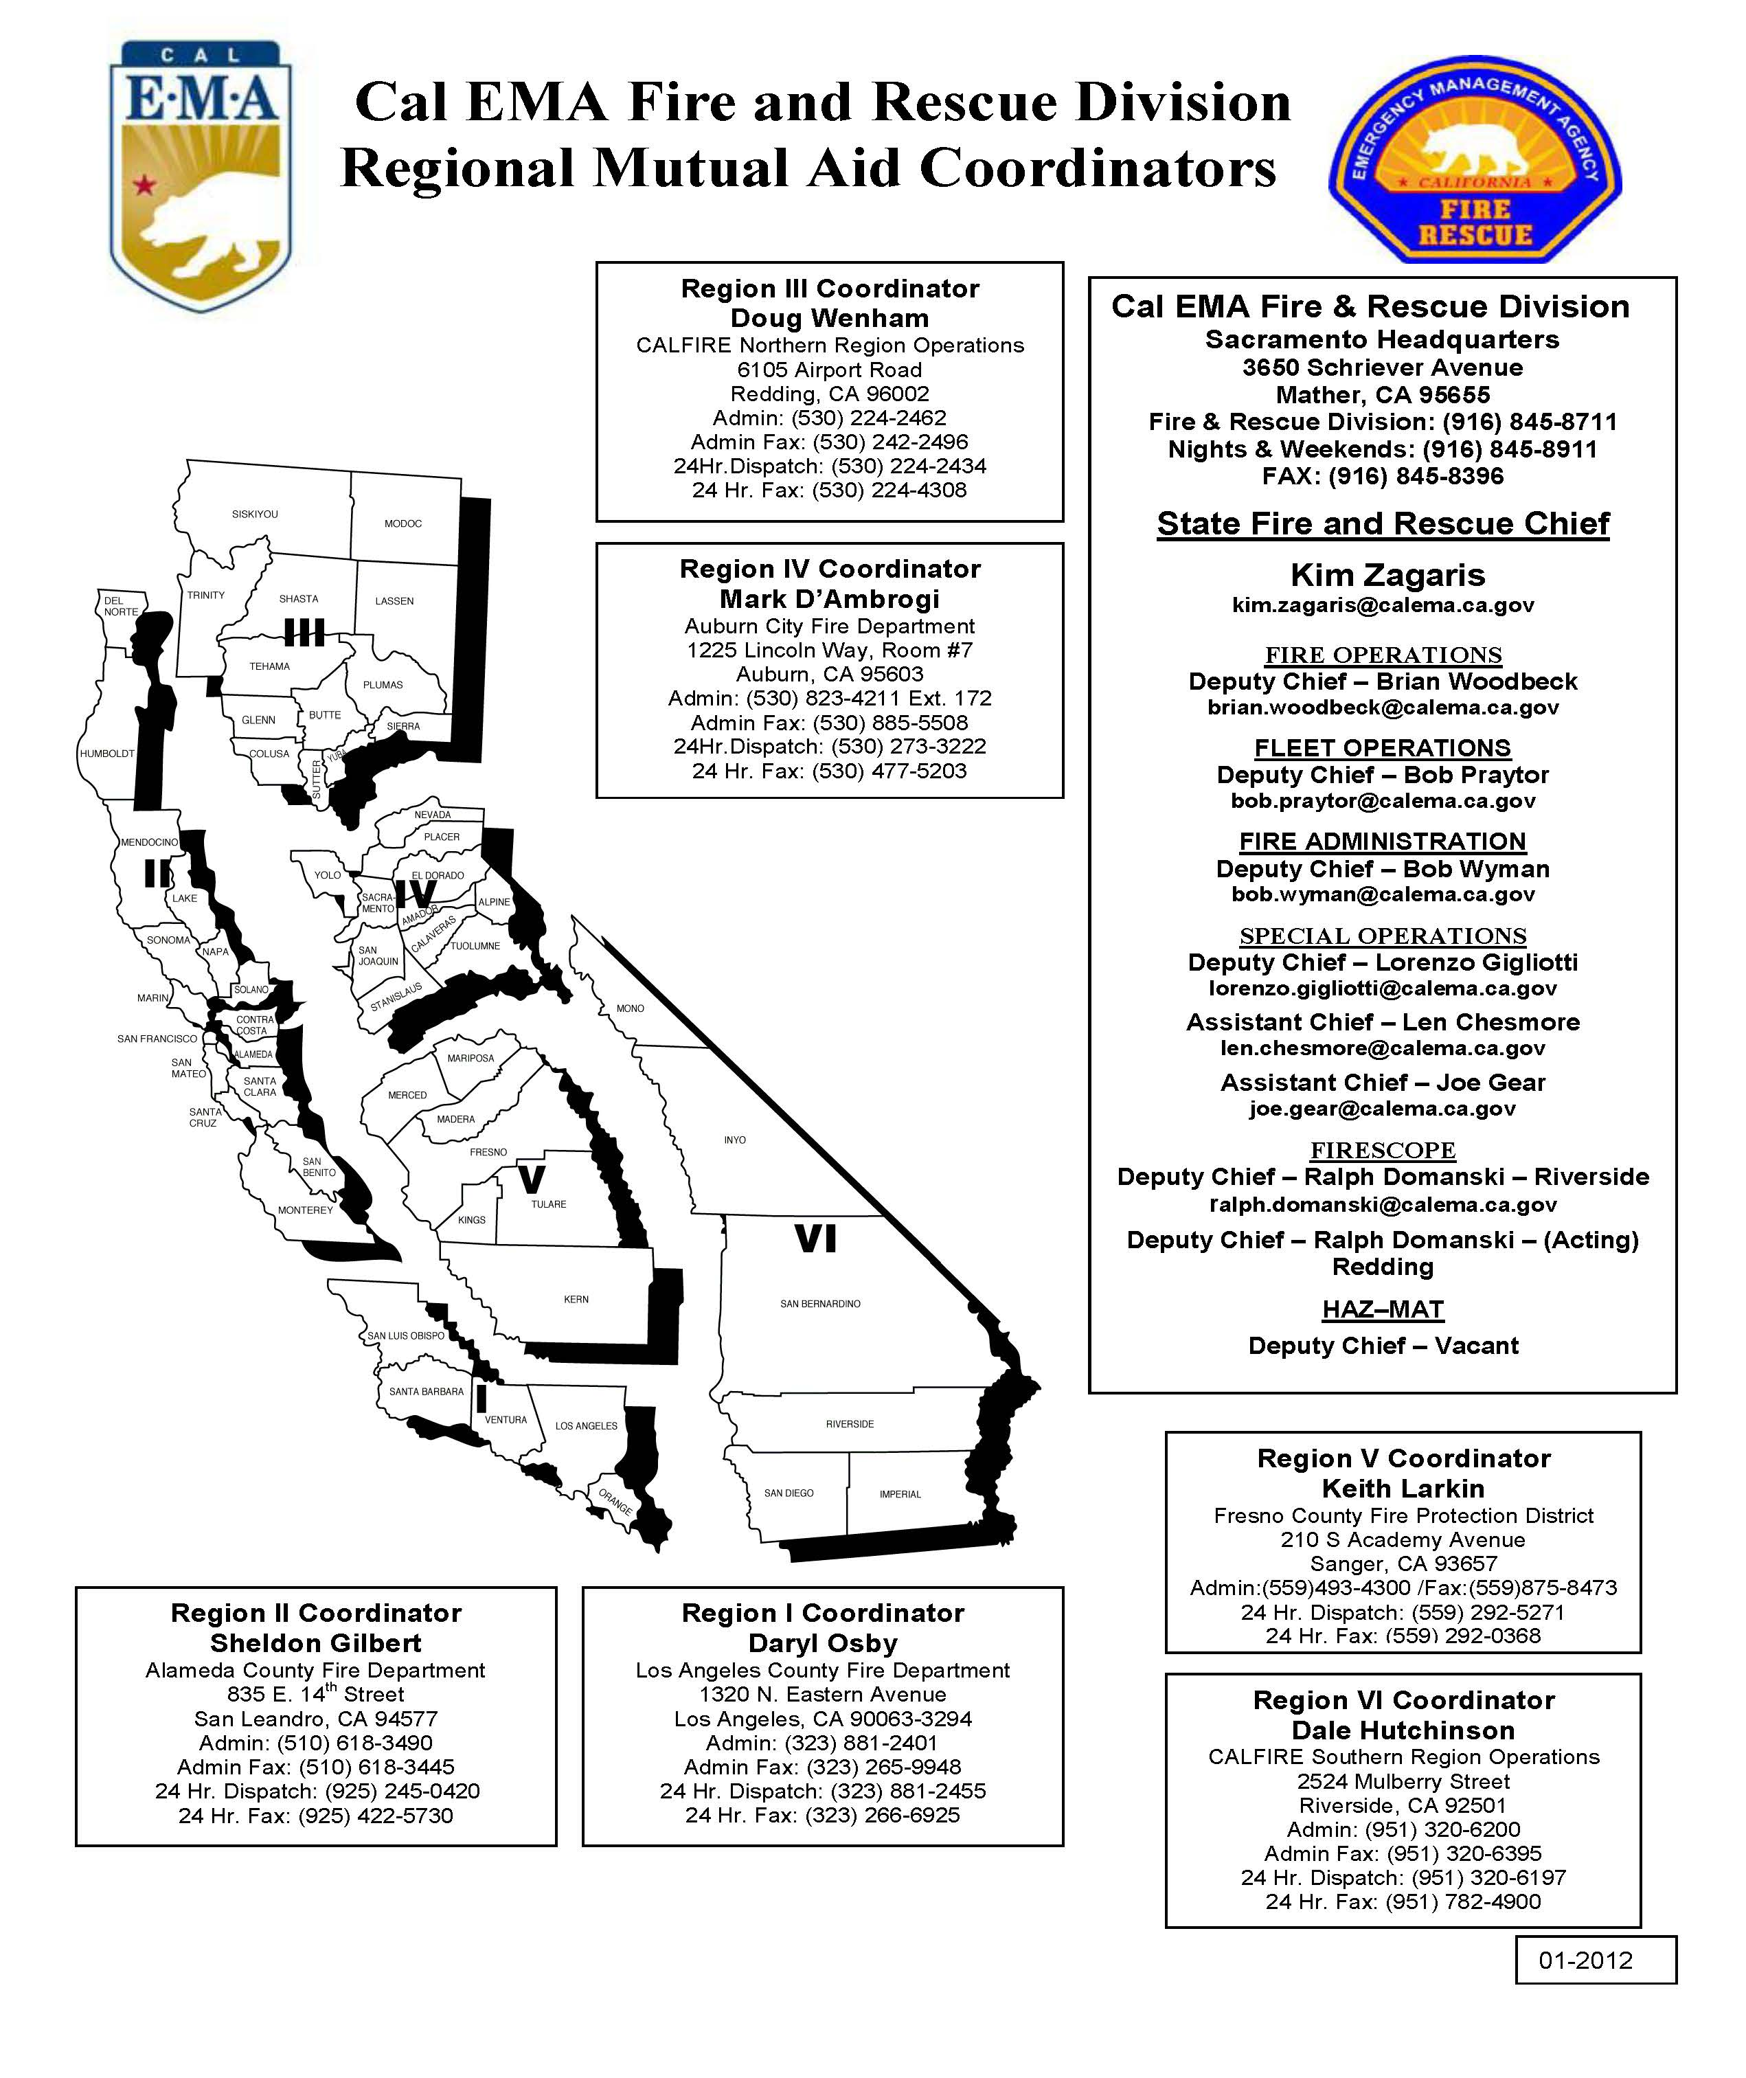

32 – Cal EMA FIRE AND RESCUE REGIONAL ASSISTANT CHIEF MAP

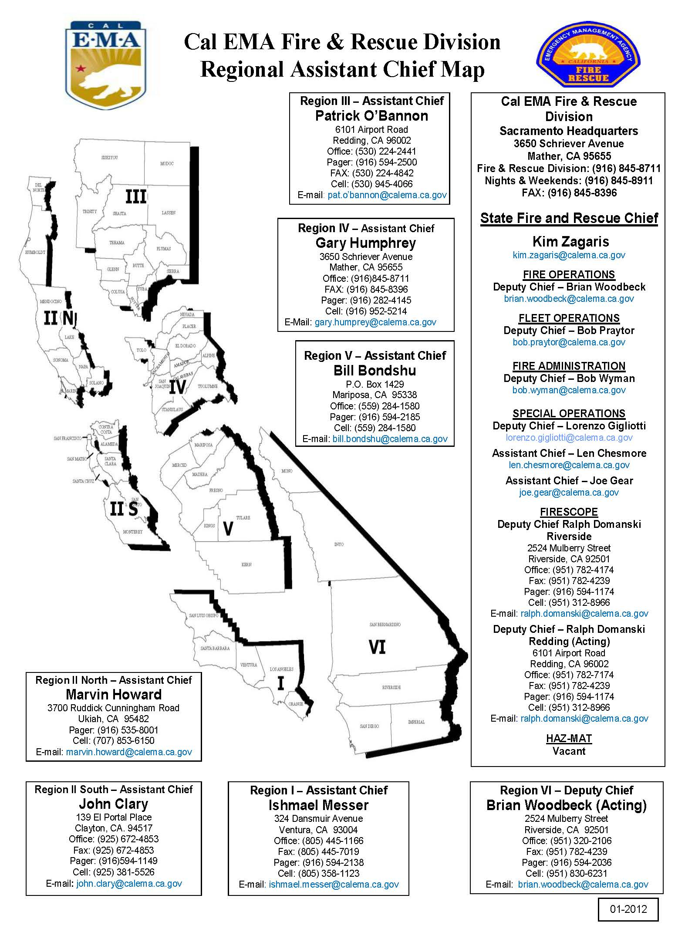

THIS PAGE INTENTIONALLY LEFT FOR NOTES

