
HOOSIER NATIONAL FOREST
PRESCRIBED FIRE ORGANIZER

NEPA Project:
Burn Unit
Size:
Complexity:
County:
Burn Lat/Long:
Helispot Lat/Long:
Burn Boss:
Date:
NOTIFICATIONS
(From BOX and Unit Card Element 9C)
Name | Phone Number | Initials/Time
EMERGENCY DIRECTIONS
Closest 911 Address:
GO/NO-GO CHECKLIST

PRELIMINARY QUESTIONS |  |  |  | YES | NO
- Have conditions in or adjacent to the ignition unit changed, (for example: drought conditions or fuel loadings), which were not considered in the prescription development?
If YES go to item B below if NO, proceed to question C below.
- Has the prescribed fire plan been reviewed, and an amendment been approved; or has it been determined that no amendment is necessary?
If YES, go to question C. If NO, STOP: Implementation is not allowed. An amendment is needed.
- Has the experience, qualifications, internal/external pressures, and fatigue levels of the implementation team has been evaluated, and identified concerns have been satisfactorily mitigated? (Note: use USFS Risk Calculator Mobile Application, IRPG Risk Management Process, Tailgate Safety Sheet, or similar tool to structure the assessment)
If YES, proceed with Go/No-Go checklist below. If NO, STOP: Confer with AA and do not proceed with implementation until concerns are addressed.
YES | NO | GO/NO-GO
 |  | Have ALL permits and clearances been obtained?
 |  | Have ALL required notifications been made?
 |  | Have ALL the pre-burn considerations and preparation work identified in the prescribed fire plan been completed or addressed and checked?
 |  | Have ALL required current and projected fire weather forecasts been obtained and are they favorable through ignition, holding and mop-up/control phases of the project?
 |  | Are ALL the participating Agreements with other agencies or landowners current?
 |  | Have all Cave, Karst and Heritage features been identified, flagged, prepared, and made known to all burn personnel?
 |  | Are ALL prescription parameters met?
 |  | Are ALL smoke management specifications met?
 |  | Are ALL planned operations personnel and equipment on-site, available, and operational?
 |  | Has the availability of contingency resources applicable to today’s implementation been checked and are they available? If MODERATE or HIGH complexity, are those contingency resources required to respond within 30 minutes available and in position to meet that timeframe?
 |  | Have ALL personnel been briefed on the project objectives, their assignment, safety hazards, escape routes, and safety zones?
If all the questions were answered “YES” proceed with a test fire. Document the current conditions, location, and results. If any questions were answered “NO”, Do not proceed with the test fire: Implementation is not allowed.
 |  | After evaluating the test fire, in your judgement can the prescribed fire be carried out according to the prescribed fire plan and will it meet the planned objectives?
Burn Boss Signature: |  |  | Date:
CHECKLIST

1000-hr Fuel Moisture ≥ 17%
Distribute Handouts (project map, org chart, communications plan to everybody; medical plan, contingency map, other info to IWI IC and contingency resources)
Resource concerns mitigated (archeological, karst, monument, etc)
Smoke Management
Contingency Plan
Wildfire Conversion (contingency IC)
Escape Routes & Safety Zones
Safety and Medical Plan
Questions / Comments
PPE Check
Go / No Go

RESOURCE NOTES

Resource Objectives
RX Fire Operations | - Provide for public and firefighter safety.  - Minimize negative impacts of smoke to traffic, neighbors, and the public.  - Protect structures and other property from fire.  - Provide training opportunities for firefighters.  - Provide for research opportunities.
Hazards
Traffic Signs Location
Water Sources Location

Briefing Outline

- Burn Organization and Assignments
- Inquire Regarding Task Books and Qualifications Including ATVO.
- Organizational Chart/Personnel Assignments
- Equipment Assignments
- Other Resources
- Prescribed Fire Objectives and Prescription
- Description of Burn Area
- Review Map of Burn/Topographical Features/Acreage
- Values at Risk
- Problem Areas
- Fuel Type (Inside and Outside the Unit)
- Roads/Access
- Water Sources
- Natural/Manmade Barriers
- Cave, Karst, and Heritage Features
- Expected Weather and Fire Behavior
- Wind Direction and Speed
- Relative Humidity
- Temperature
- Fuel Moisture
- Atmospheric Stability
- Predicted Changes
- Communications
- Procedures
- Frequencies/Channels
- Burn Crew
- Dispatch
- Cooperators
- Others
- Ignition Sequence
- Test Burn
- Ignition Equipment (Type, Number, etc.)
- Pattern and sequence of Firing (Map)
- Fire Behavior Prescription
- Holding Plan
- Minimum tool list for UTV’s/personnel
- Contingency Plan
- Slop Over vs. Escape
- Assignments/Organizational Chart
- Wildfire Conversion
- Strategy
- Tactics
- Contingency and IWI IC
- Safety and Medical Plan
- Inspect Personal Protective Equipment
- Lookouts, Escape Routes, and Safety Zones
- Hazards (Footing, Natural, Manmade, Smoke, etc.)
- Potential Problems
- Other (First Aid Kits, Medical Issues, etc.)
- Emergency Evacuation Plan
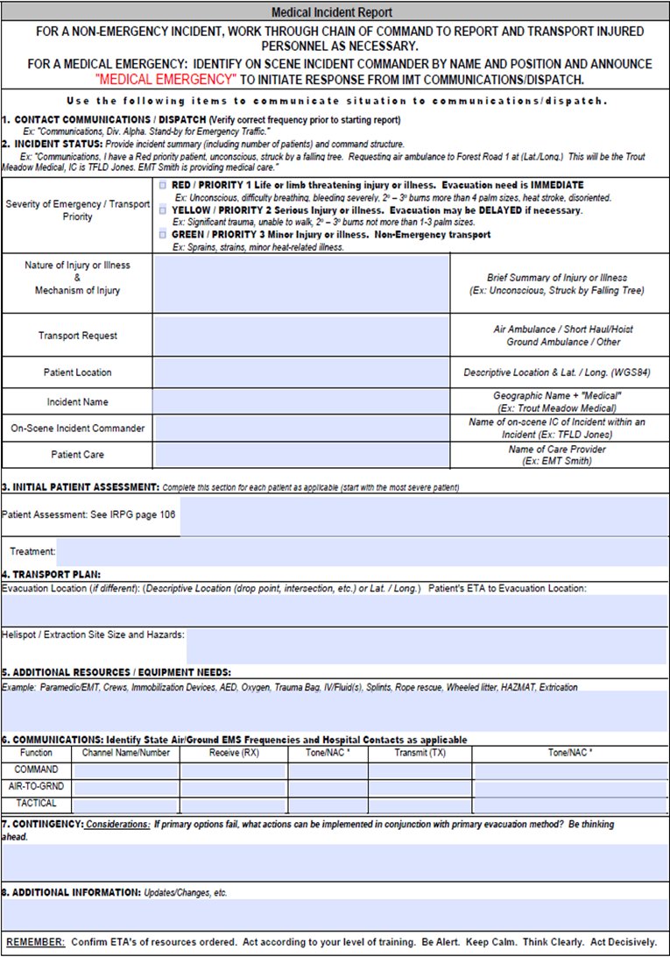
COMMUNICATIONS PLAN

Channel | Alias | Rx Frequency | Rx Code Guard | Tx Frequency | Tx Code Guard
1 | DIRECT | 169.97500 | 131.8 | 169.97500 | 131.8
2 | HOUSTON | 169.97500 | 131.8 | 164.12500 | 141.3
3 | PAYNETOWN | 169.97500 | 131.8 | 164.12500 | 103.5
4 | GEORGIA | 169.97500 | 131.8 | 164.12500 | 110.9
5 | SPEARS | 169.97500 | 131.8 | 164.12500 | 151.4
6 | MARCHAND | 169.97500 | 131.8 | 164.12500 | 123.0
7 | COMMON 1 | 163.71250 | None | 163.71250 | None
8 | COMMON 2 | 168.61250 | None | 168.61250 | None
9 | R9 FIRE | 166.56250 | None | 166.56250 | None
10 | IDNR CAR | 159.24000 | None | 159.24000 | None
11 | IDNR TALK | 159.40500 | None | 159.40500 | None
12 | IDNR FIRE | 159.22500 | None | 159.22500 | None
13 | MUT AID | 154.28000 | None | 154.28000 | None
14 | WX BLOOM | 162.45000 | None | 000.00000 | None
15 | AG-11 | 168.96250 | None | 168.96250 | None
16 | AIRGUARD | 168.62500 | 110.9 | 168.62500 | 110.9

EMERGENCY CONTACTS

Individual | Office Phone | Mobile Phone/Other
Hoosier Dispatch
IICC – | 812-547-9262
IICC – Maggie Schuetter | 812-547-9245 | 812-483-3486
IN-HOF
F. Sup. – Mike Chaveas | 812-276-4739 | 812-278-6365
DR – Chris Thornton | 812-547-9232 | 812-489-1023
FMO – Daron Reyolds | 812-547-9247 | 769-610-5681
Brownstown R.D. | 812-275-5987
Tell City R.D. | 812-547-7051
Ryan Otto – TC Eng. Capt. | 812-547-9254 | 812-608-0488
Bill Mullins – Fuels Tech. | 812-547-9252 | 812-454-4001
Jason Hunt - FEO | 812-547-9252 | 812-797-7928
Matt Carrell – TC Firefighter | 812-547-9255 | 812-240-1243
Shawn Woodbury – AFMO. | 812-276-4729 | 812-454-2786
Paul Fountain – BT Eng. Capt | 812-276-4724 | 812-583-5391
Lauren Zack – BT Firefighter | 812-276-4735 | 219-688-1937
Ethan Loeche – BT Firefighter | 812-276-4776 | 812-593-3458
Logan Scherschel – Fuels | 812-276-4723 | 812-675-9878
Jeremy Kolaks - Planner | 812-276-4722 | 812-279-0848
Local: Fire Dept. / County / EMA
Brown | 812-988-6655
Crawford | 812-338-3616
Dubois | 812-482-6777
Jackson | 812-358-2141
Lawrence | 812-275-3316
Martin | 812-247-3726
Monroe | 812-349-3332
Orange | 812-723-2417
Perry | 812-547-7068
IN-INS
FC1 - Darren Bridges | 765-792-4654 | 812-830-8518
FC2 – Mark Huter | 765-792-4654 | 317-437-3388
Central Dispatch | 812-837-9536
National Weather Service
Indianapolis | 1-800-499-2133 | 317-856-0367
Louisville | 1-800-292-5588 | 502-962-6426
Regional Office (In case of injury)
Steve Miller – Reg. Director |  | 414-308-6861
Joe Alyea – Geo Area Director |  | 989-305-1227
John Fry – Ass. Dir. FAM Ops |  | 304-704-9196
Matt Malesic – Fire Planner |  | 724-263-0007
Brian Schaffler - Fuels |  | 803-561-4000
IN CASE OF ESCAPE (to Reg. Forester no later than 12 hrs)
1.) Dist. Ranger → Forest Sup. → Regional Forester → FAM Director
MONITORING
Conduct immediately post burn.

In Your Opinion, Did Burn Meet Objectives? (PLEASE MARK)
YES: |  | MARGINAL: |  | NO:
Why /Comments:
CONTROL ISSUES | Number |  | Size Range |  | Closest Drop Points
Spots
Slops
SMOKE | Number |  | Agency or Private? |  | Locations?
Complaints
 | Number |  | Type (road, residence, school, etc.) |  | Locations
Impacts
Was fuel model selection compatible with fire behavior?
Yes or No, please elaborate:
Other comments or feedback on operations/observations/post fire needs?
POST PROJECT EVALUATION

Comments/recommendations for rehab or next burn
Objectives
Site Prep/ resource exclusions checked.
Crew Organization / size
Ignition Pattern / Plan
Holding
Communication
Smoke
Public relations
Equipment
Mop-Up
Time Estimates for Burn completion
Post Burn Resource Needs: Line Rehab

POST BURN CHECKLIST
ON SITE
Pump(s) Retrieved
Equipment Returned and Loaded
Return Travel Arranged, Work-Rest Mitigated
Signs Pulled and Loaded
Post Notifications Made
Perform AAR (on page 10)
Checks, Fill Fuel Tanks, Torches, Ready for Next Assignment or Next Day.
Wash invasive seeds from vehicles and equipment if going to another unit, otherwise, at station. Use high pressure/velocity air and water.
AT STATION
Next Operational Period Readiness
Coordinate Rehab/BMP Needs Through Appropriate Resource Specialist and Fire Implementation Staff
Forward Finalized Org Chart to Dispatch for IQCS Entry
Gather documentation from dispatch (burn plan appendix H) and other sources including general and spot forecasts, weather obs., notifications, org chart, radio log, smoke report, agreements, AA go/no-go, and this completed organizer. Submit completed burn plan folder according to hardcopy guide in BOX to Fuels Specialist.
AFTER ACTION REVIEW

RX Fire Name:
Date:
AAR Leader:
- Were objectives met?
- What did we do well?
- Were there differences between the plan and what actually happened?
- What do we do the next time to improve?
- Equipment Issues?
COMMENTS:
- Is anything broken or not working properly?
Equipment | Problem |  |  | Who’s Fixing?
Organizer Completed By: |  |  |  | Date:
Authority Delegated To: |  |  |  | Date:
Delegated Signature: |  |  | Burn Boss Signature:
Fire Called Out By: |  |  |  | Date:
UNIT ACTIVITY LOG PAGE 2

TIME | MAJOR EVENTS
WEATHER AND UNIT ACTIVITY LOG PAGE 1
Document significant happenings throughout the Rx fire. Examples include: Smoke, Fire Behavior, Spot/Slop Overs, Progression, Release of Resources, Etc.

On-Site Weather and Fire Behavior
Time | Temp | RH | Wind | Sky | PIG ≤ 60
FL: | ROS: |  | Flame Zone Depth:
FL: | ROS: |  | Flame Zone Depth:
FL: | ROS: |  | Flame Zone Depth:
FL: | ROS: |  | Flame Zone Depth:
FL: | ROS: |  | Flame Zone Depth:
FL: | ROS: |  | Flame Zone Depth:
FL: | ROS: |  | Flame Zone Depth:
FL: | ROS: |  | Flame Zone Depth:

Activity Log
TIME | MAJOR EVENTS
Continue Log on PREVIOUS PAGE

