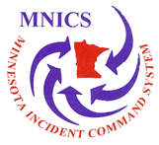

MNICS TEAM B
INCIDENT MANAGEMENT TEAM
Greg Peterson, IC
---------------------------------------------------------------------
TO:

FROM: Kevin O’Brien, FSC2
218-365-3157

DATE: Sunday, September 4, 2011

NUMBER OF PAGES: _______

---------------------------------------------------------------------

TOPIC: ACCRUAL/OBLIGATIONS
Pagami Creek Fire
MN-SUF-110519

