**Fire Behavior and Long-Term Assessment**

Long-Term Fire Behavior, Fire Weather, and Risk Assessment

Pagami Creek Fire

Superior National Forest

September 3, 2011

**Prepared by: John Barborinas LTAN**

**Executive Summary**

The Pagami Creek Fire was detected on August 18, 2011, located just north of Pagami Creek, approximately 15 miles east of Ely, Minnesota in the Boundary Waters Canoe Area Wilderness (BWCAW) on the Superior National Forest.

In general, the fire activity and daily growth has been low, with a one day (August 26th) of extreme fire behavior from a wind driven run of 1.2 miles. As of September 2nd, the Pagami Creek Fireis approximately 137 acres and continues to burn in mixed Boreal Forest and Lowland Conifer, Bog and Fen Forest types at 1500’ elevation.

Without further suppression actions, the fire has the potential to remain active until the end of the fire season. Significant results from this assessment include:

* Seasonal severity is above the 90th %tile and is expected to remain above average through mid October. Live fuels will continue to cure, resulting in overall increased fire behavior potential.
* Current drought is abnormally high and expected to persist. Precipitation since April 1 is at 70% of normal which is near the 15th %tile of historical records.
* With an elevated BUI, fire growth can be expected when FFMC nears 88. With forecasted high winds and low relative humidity, expect large growth potential on days with FFMC at 90 and above. The Pagami Creek Fire moved over one mile towards the south over natural barriers under similar conditions on August 26th.
* Expect 5 large growth potential days (winds > 10 MPH and RH < 35) until the end of the fire season. These are usually associated with frontal passage. For this time of year, historic winds show most probable direction and highest speeds from the southeast to west (clockwise). The potential still exists for outflows from thunderstorms in the vicinity of the fire which could produce strong, gusty, and erratic winds.
* Projected spread direction towards values at risk in the near term is generally towards the northeast. Longer term (14 days), the greatest potential to reach the planning area boundary is towards the east near Insula Lake.
* During the remainder of this abnormally dry late fire season, nearly 3 inches of precipitation over a long duration (at least 1 week) will be required to comfortably put an end to this fire.

This document presents a summary of long-term fire behavior predictions and a risk assessment to be used to support fire management and operational decision making of this incident.

**Table of Contents**

**Page**

**Introduction 3**

**Observed and Current Fire Behavior 4**

**Long Term Weather Trends / Seasonal Severity 7**

**National Wildland Significant Fire Potential Outlook 9**

**Long Term Weather Outlook 10**

**Wind Analysis 12**

**Probability of Season End 13**

**Fire History ` 15**

**Analysis Tools Used to Predict Fire Spread 16**

**Fire Simulation Probability (FS Pro)**

**Fuel Model Description**

**Calibration of FS Pro**

**Limitations and Assumptions**

**Near Term Fire Behavior Results**

**Introduction**

The Pagami Creek Fire was detected on August 18, 2011, located just north of Pagami Creek, approximately 15 miles east of Ely, Minnesota in the Boundary Waters Canoe Area Wilderness (BWCAW) on the Superior National Forest.

In general, the fire activity and daily growth has been low, with a one day (August 26th) of extreme fire behavior from a wind driven run of 1.2 miles. As of September 2nd, the Pagami Creek Fireis approximately 137 acres and continues to burn in mixed Boreal Forest and Lowland Conifer, Bog and Fen Forest types at 1500’ elevation.



Map of Pagami Creek Fire Location in BWCAW and nearest RAWS.

Weather, fuels, and long-range forecasts for the Kawishiwa Ranger District area of the Superior National Forest, as well as local expertise were used in this assessment. Fire Family Plus, and several of the WFDSS fire behavior tools including Near Term Fire Behavior (NTFB), and Fire Spread Probability (FSPro) were used to determine the probability of the Pagami fire’s spread. Weather data from the Ely (16 miles ESE) and Fredberg (2.5 NNE) stations was used to assess historical trends. Fire progression was monitored and perimeter updates were documented using GPS. This document summarizes the results of these analyses and monitoring actions.

The fire is burning in mixed patches of Pine (Jack and White), Spruce/Fir, and Aspen/Birch. Understory vegetation is primarily Spruce/Fir with mixtures of deciduous shrubs and ground cover ranging from litter under heavy cover to low shrubs and lichen in the open patches. Observed fuels included needle cast, reindeer moss, sphagnum moss, dead and downed woody debris, leather leaf and lab tea. The understory was observed as balsam fir and hazel brush with some scattered small white pine and white and black spruce. The overstory included 50% mature jack pine, 25% white and black spruce, 15% red pine, and 10% white pine. The 1000 hour fuels were measured at 13-15 % moisture content (from moisture probe).

The surface vegetation this year is showing indications of stress with leaves showing red and yellow coloring, especially on the shallowest soils.

Black spruce is also present in swamps and more open bogs that have transitioned into available fuels with the above average drought conditions. These areas could continue to transition into potentially aggressive fuels as the vegetation cures with dry conditions or killing frosts.

**Observed and Current Fire Behavior**

The Pagami Creek Fire was first discovered on August 18, 2011 at 1615 hours by a Superior National Forest spotter in a DeHavilland Beaver. The fire showed open flame on the edge of a boggy area and was estimated at 1/10 acre. The fire received some precipitation on August 19 (.03”) and 21st (.12” at Fernsberg RAWS). Temperatures from 8/17 – 8/21 were in the 70-80 degree range with minimum relative humidity values in the low to mid 30% range with wind speeds 6-12 mph. There was very little fire growth or activity during this time period with estimated size at ¼ acre.

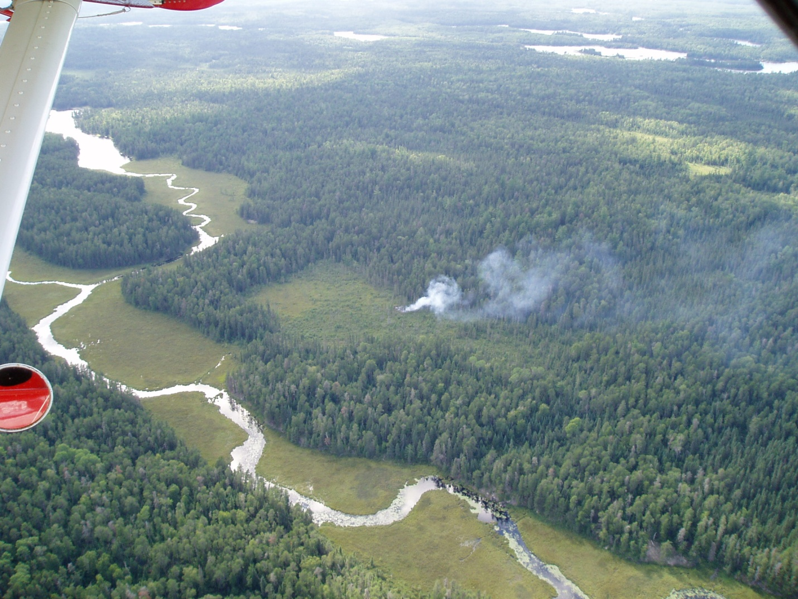

Looking NW at the Pagami Creek Fire on August 20th, 2011

On August 25th, the area received very light precipitation and the temperatures were in the low 80s, RH was in the 30s to upper 50s, wind speeds were around 8 mph. Fire behavior had picked up and was starting to move out of the bog into an upland conifer stand creeping with open flame to ½ acre. Winds were forecasted to shift from SW to NW and increase in speed through the afternoon.

On the morning of August 26th, a 2 person squad reached the fire and reported it at 1 ¼ acres and smoldering. By 1300, the temperature rose to 84 degrees, RH dropped to 47%, and winds were 1-3 mph shifting with high winds aloft. Observed flame lengths were ½ - 1 foot with rates of spread at 1-3 chains per hour and occasional torching of mid-story balsam fir. By 1400, approximately 40% of the perimeter was active with 1-2’ flame lengths, occasional torching and spotting up to 200 feet. Winds were NW, 2-5 mph in sheltered fuels, gusting to 10 mph. Smoke was rising to about 500 feet before the wind laid the column over towards the SSW. By 1645, the fire had spotted south over Pagami Creek and was actively burning in numerous spots, 30-50 acres in size, with group torching and short crown runs in heavy timber, and remained active into the evening.

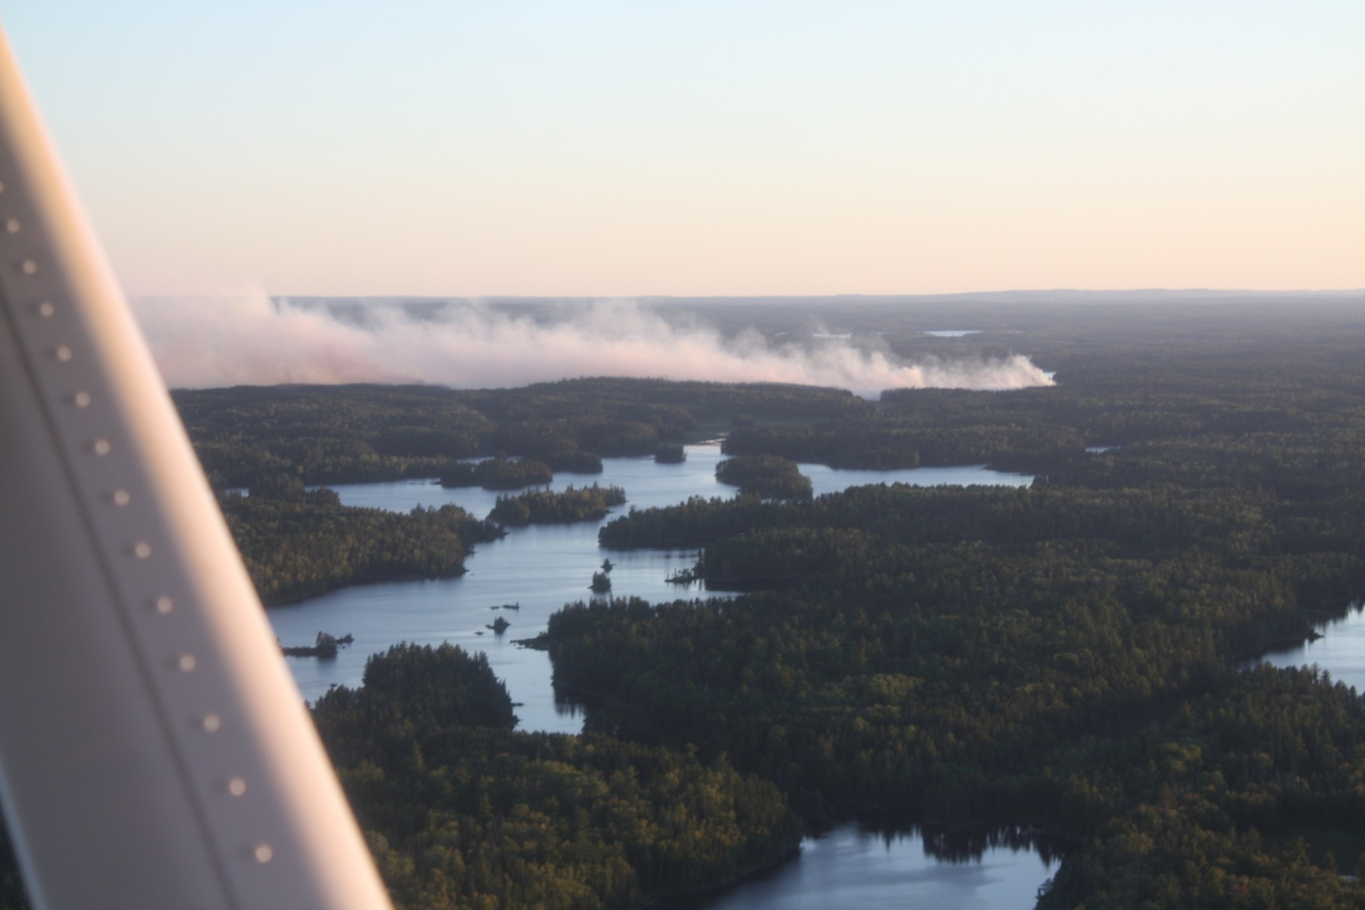

*Looking SW over Lake 1 at the Pagami Creek Fire moving south in the BWCAW on August 26th at 1900 hours.*

**Long-Term Weather Trends/Season Severity**

Dry fuel conditions continue in the Ely area. Burn Unit Index (BUI) and Drought Code (DC), and Duff Moisture Code (DMC) values are in the 90th to 97th percentile for the Ely RAWS. Indices for 2006 are shown for comparison purposes as conditions seem to be tracking similarly. Calculated 1000-hour moisture values at Ely are just below average for this time of year.

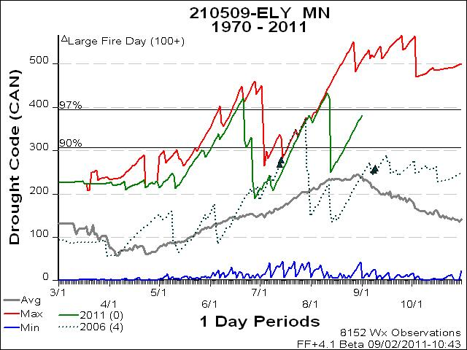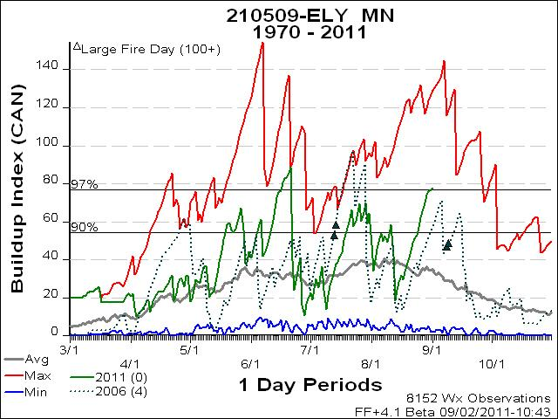

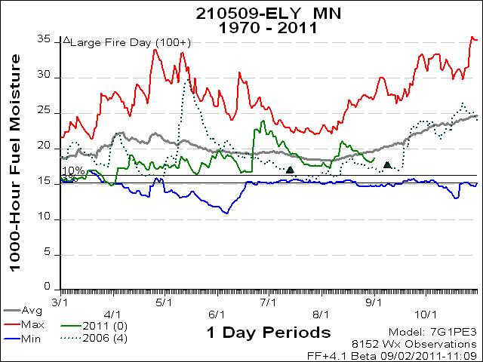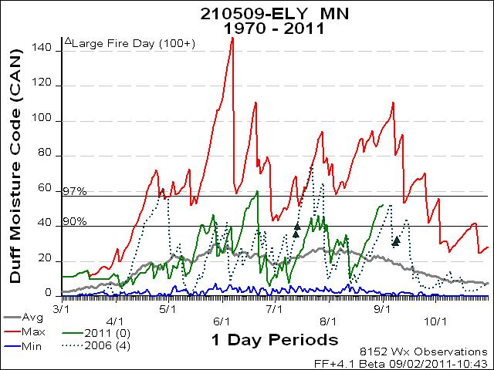

The U.S. Drought Monitor dated August 30th (below) shows that northeast Minnesota is currently experiencing abnormally dry conditions and is expected to persist through the end of fire season.

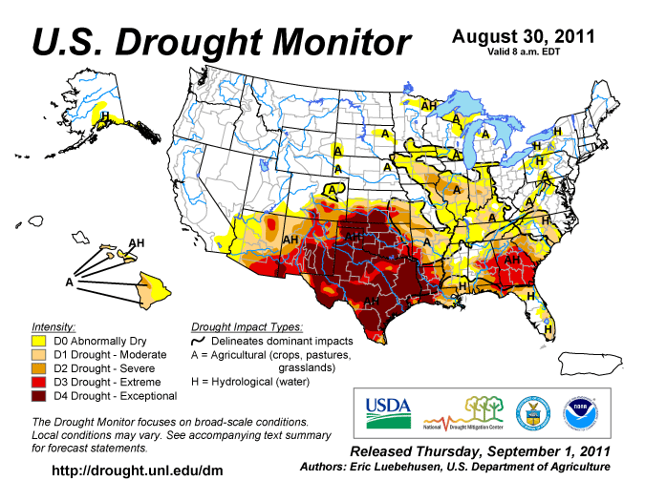

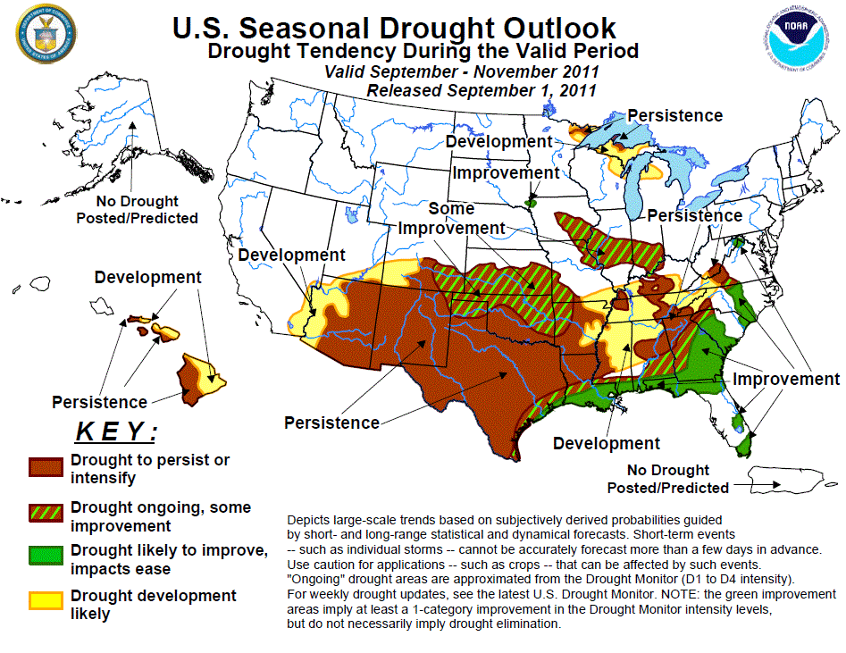

The area around the Pagami Creek fire has received 70% of normal precipitation over the last 90 days (“% of Normal Precipitation” Map below). The amount of precipitation received this year is only in the 2-15%tile compared to historical records (“Precipitation Ranking” Map below).

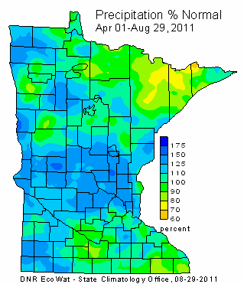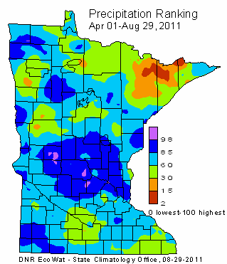

The Minnesota State Climatology Office makes extensive use of "ranking" maps when depicting precipitation totals and snow depths. A ranking map (also known as a "percentile" map) compares an observed meteorological condition with conditions reported throughout the long-term climate record. This allows the condition to be described using historical context. A location ranked at zero means that the condition is the lowest found in the historical record; a ranking of 100 indicates the highest on record. A ranking at the 50th percentile (also known as the "median") specifies that the observed condition is in the middle of the historical distribution; with half of all years in the past exceeding the current condition, and half of all years falling below the current condition.

**National Wildland Significant Fire Potential Outlook**

Eastern Area: Above normal significant fire potential is forecast for the northern Great Lakes through early October. Below normal precipitation occurred across this area through the mid to late summer months, and fire potential increased during this time period with fuels drying out and fire danger indices increasing. Warmer than normal temperatures are expected to persist into October over the Great Lakes. This area will return to normal significant fire potential in mid-October.

**Long Term Weather Outlook**

The National Weather Service’s Climate Prediction Center predicts above average temperatures and below normal precipitation throughout northeastern Minnesota through September 17. Predictions through the end of September are for above near average precipitation in the fire area.

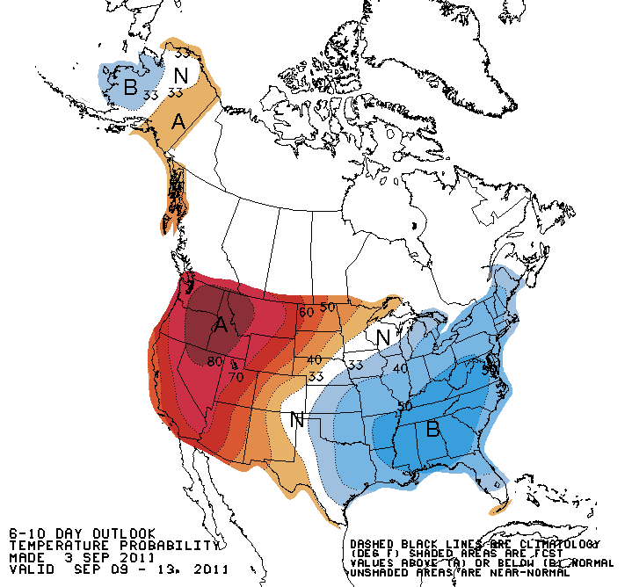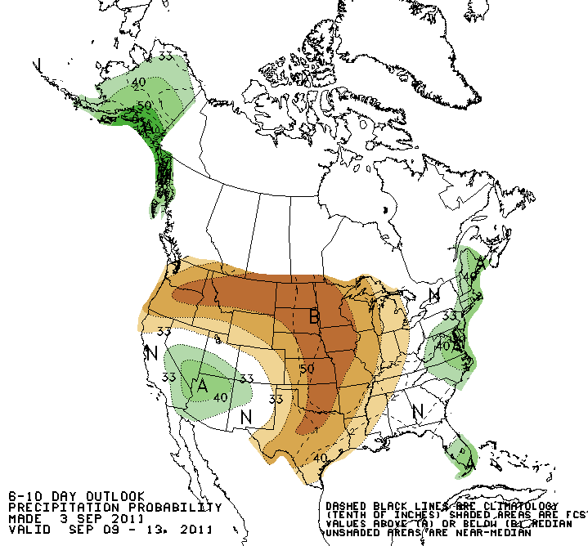

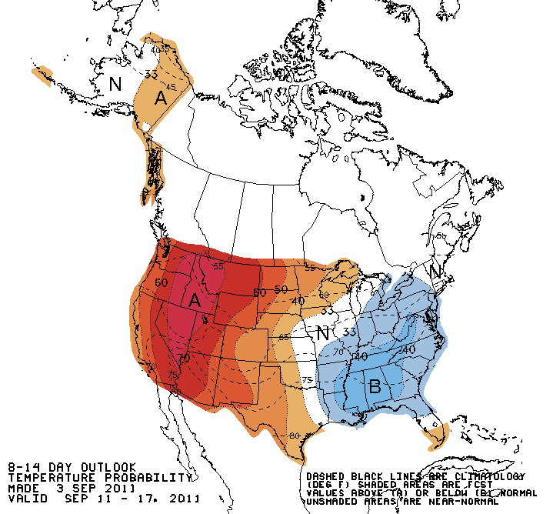 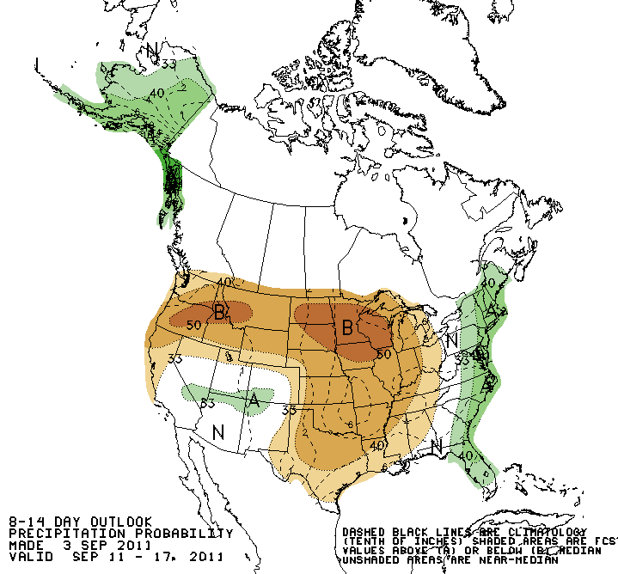

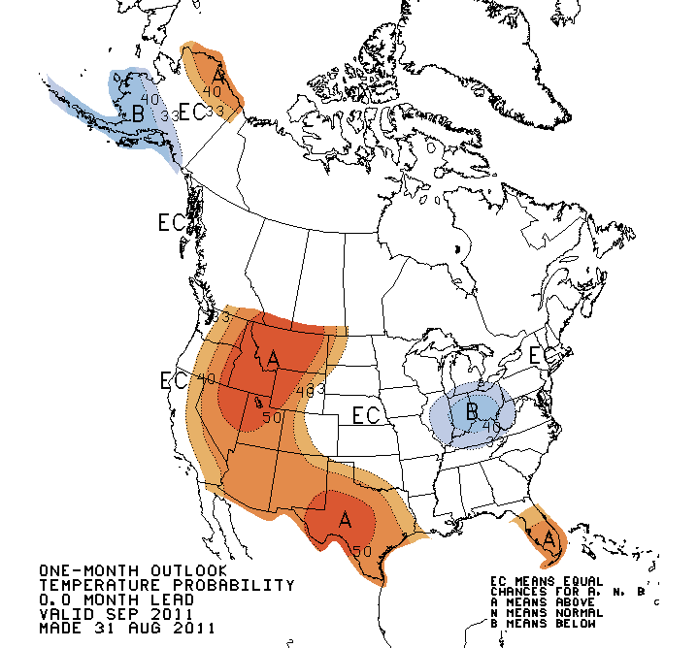

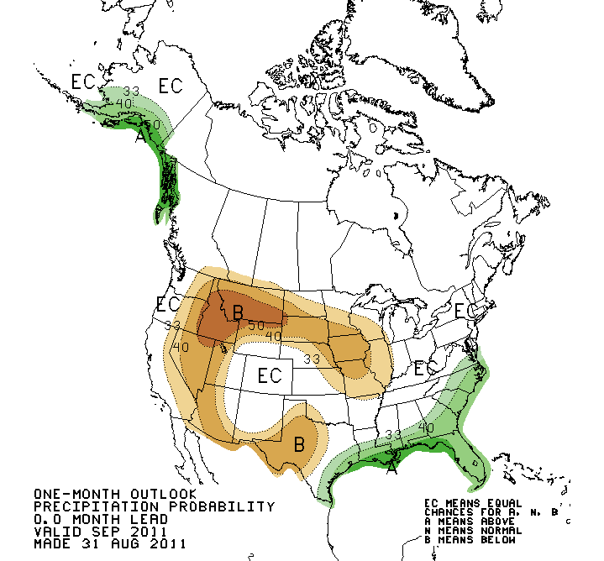

**Wind Analysis**

An analysis of winds was conducted using historical weather data from the Ely RAWS to determine the most likely direction of fire spread.

Historical data analysis indicates that wind direction at the Ely RAWS during the burn period is typically from the southeast through northwest (clockwise). Note that RAWS stations have limitations when predicting winds at the localized level. The wind roses below were analyzed for 1200-1500 time periods for the months of September and October.

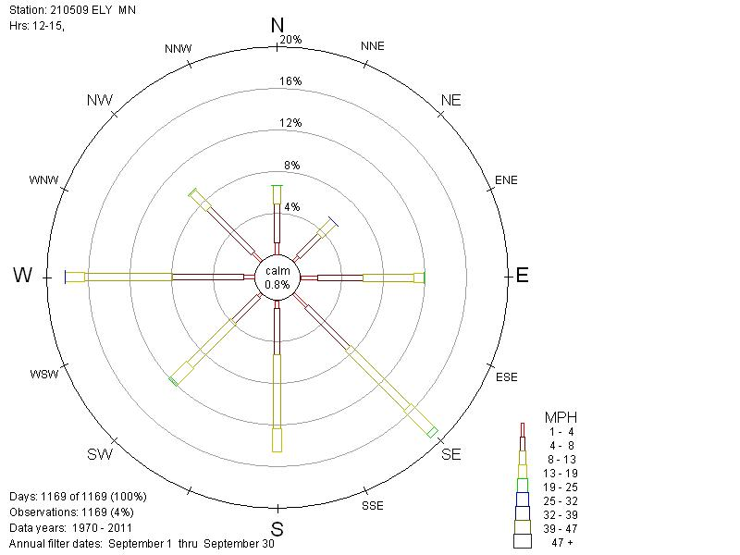

September Wind rose

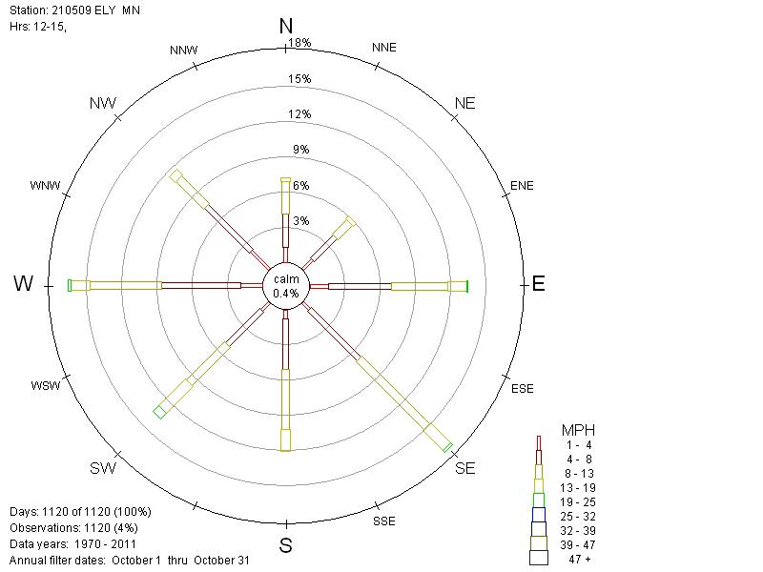

October Wind rose

**Probability of Season-Ending Event**

Season Ending Events

Existing season ending event (term) files for the Superior National Forest were reviewed and evaluated. These term files used the criteria of 2 inches or more of precipitation over a 5 day period, along with an analysis of fire danger indices, to determine the annual season ending event date. The fire weather records for Ely were updated to obtain data through 2010 and evaluated.

Season Ending Probabilities by Date

|  |  |  |  |  |
| --- | --- | --- | --- | --- |
| **Date 🡪** | **Aug 15** | **Sept 1** | **Sept 15** | **Oct 1** |
| **MN_SUF_standing.trm** | 43% | 68% | 83% | 93% |
| **bwcaw_v6.trm** | 29% | 52% | 69% | 85% |

Additional weather events analyzed

Several weather event scenarios were developed and analyzed after consultation with local Fire Management Officers and Fuels Specialists to assist in determining the fire potential until the end of the fire season. Fire Behavior Analyst, Doug Miedtke provided critical threshold and data input information for these scenarios.

Event Scenarios

1. Fire growth potential continues through end of fire season 10/31/2011
   1. Criteria: **Daily min. RH <= 35% AND Daily Wind Speed >= 10 MPH**
   2. Results: 172 events/2183 total days = 4.6 events per year or 8% chance
2. Fire growth potential continues through end of fire season
   1. Criteria: **Precip. <= .25” (5 days) AND Daily Max. Temp. >= 65 degrees**
   2. Results: 25 of 37 (68%) years an event occurs meeting criteria (12yrs=no event)
   3. Results: In event years, 54 total events/24 years = 2.2 events per year.
3. Chance of an end to fire season and average date this occurred historically
   1. Criteria: **Daily Drought Code (DC) Index >= 200**
   2. Results: 887 days/2183 total days = 41%.
   3. Results: Average date that DC <= 200 is September 21
4. Season end probability this year
   1. Criteria: **2.75” of precip. (7 days) needed to reduce DC from current 383 to 200**
   2. Result: 25% chance by 10/2; 50% chance by 10/21

**Fire History**

Fire history records from 1970-2008 indicate there have been approximately 6 fires per year in the late fall season (September and October). Only 3 of these fires occurring in the fall have been large fires:

Famine 9/9/2006 4044 acres

Redeye 9/9/2006 1792 acres

Fraser 8/30/1970 1075 acres

These large fires have grown significantly in one burn period and taken short runs on other days. The Famine fire spread 2 miles and Redeye Fire spread 3.5 miles in one burn period.

Fire Family Plus was used to summarize fire history data (1970-2011) for the area. The graphs below summarize the information.

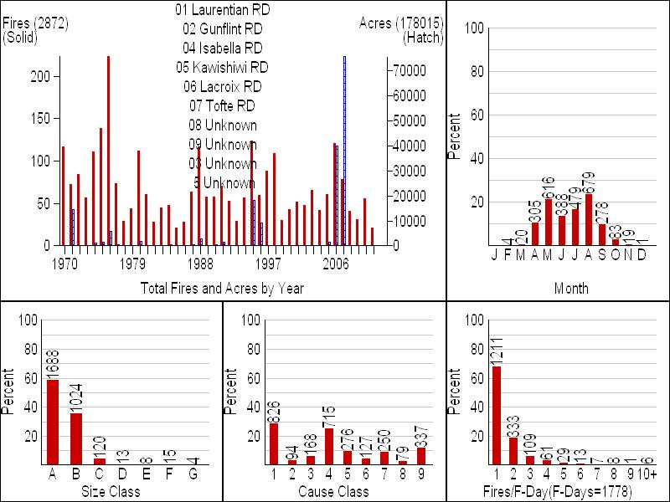

**Analysis Tools Used to Predict Fire Probabilities and Fire Spread**

**Predicting the probability of fire spread**

Fire Spread Probability (FSPro) was one analysis tool used for the Pagami Creek incident long term assessment. This model generates concentric rings of probability of a fire burning based upon historic weather, fuels, and existing fire location. There are a number of limitations and assumptions associated with FSPro. Specifically, it is critical to understand that **FSPro results show probability contours NOT daily progression perimeters**. Other limitations and assumptions are discussed at the end of this section.

**Fire Spread Probability (FSPro) Results**

FSPro analyses were completed and consisted of a 14 day run with a control line barrier. The forecasted weather from the Incident Meteorologist was used for the first 3 days of both FSPro analyses. Beyond 3 days, historical weather data was used from the Ely RAWS. This analysis was based on an extensive series of calibration analyses of the fire’s behavior, especially on August 26th. Further adjustments were made to analyses as necessary.

An FSPro analysis was completed on September 1st, for the time period of September 1st through September 14 (14 day run). The Ely RAWS was used for fuel moistures and wind. This run is only valid through September 14, 2011, at which time it should be determined if future analyses are needed.

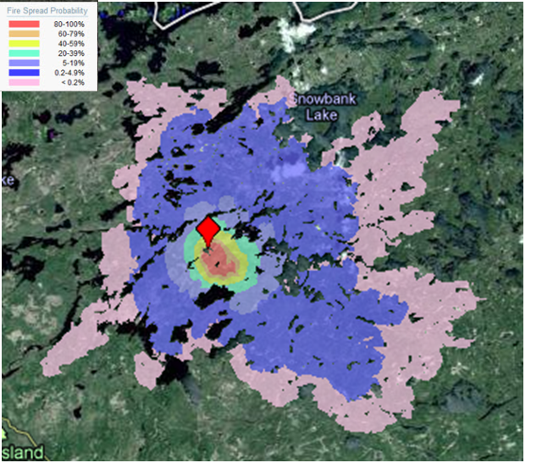

Pagami Creek Fire FS Pro run 9/4-9/17/2011 with first 3 days of forecast (gridded) weather and next 11 days with historic weather and wind from Ely RAWS (1990-2010). Live fuel moistures were adjusted to current representative values and burn periods ranged from 2-8 hours per day by percentile weather conditions. Crown canopy adjustments were made to the landscape during prior calibrations to better represent crown fire potential. Incident hand line is used as barrier to fire spread. Latest perimeter is still current and was used as ignition (entire perimeter assumed active).

**Pagami Creek Incident WFDSS Fuel Model Descriptions.**

LANDFIRE Refresh 2008 1.1.0 Fuel Model data were used with adjustments for canopy characteristics. The table below describes the two dominate fuel models found (>10%) in the analysis area.

|  |  |  |
| --- | --- | --- |
| LANDFIRE Fuel Model | Scott and Burgan (2005) Fuel Model | Representative  Vegetation Type |
| 165-very high load, dry climate timber-shrub | TU5 | Timber/Shrub Mix |
| 161-low load, dry climate timber-shrub-grass | TU1 | Timber/Shrub/Grass Mix |

**Calibration of FSPro**

The FSPro model was calibrated to better simulate actual ground conditions. The calibrations were base on the fire run that occurred on August 26th. The following attributes were adjusted for calibration:

* Burn Period
* Wind Speed
* Spotting Probability
* Canopy Cover
* Canopy Base Height
* Canopy Bulk Density
* Live Fuel Moistures
* Crown Fire Method

**Limitations and Assumptions of FSPro:**

* FSPro uses the same underlying fire models as Behave Plus, FARSITE, and Flam Map. The assumptions and limitations of those models are also inherent in FSPro (e.g., uniform fuels, etc).
* The model probability spread assumes no suppression action has been taken on any portion of the fire. FSPro operator may manually input barriers to simulate line construction, natural barriers, etc.
* Limited fine-scale temporal variability in weather. This means that the weather is constant for the entire day (1 ERC value and related fuel moistures, 1 wind speed and wind direction).
* The peak burning period is assumed because the ERC, fuel moisture, and wind are obtained at that time.
* There is no correction of fuel moisture for elevation or aspect (forthcoming).
* Winds and fuel moistures are independent.
* No climate change prediction is available (assumes historic climate).
* The extremely rare event may or may not be represented by the simulation.
* The resulting burn probability maps are easily misinterpreted as a fire progression, such as in Near Term Fire Behavior (FARSITE). **FSPro results show probability contours NOT daily progression perimeters!**
* Model should not be used for tactical decision making.
* Model output is contingent upon model input and modeler expertise. FSPro can only be as accurate as the data used as inputs to the model. The following two data sources should be and were critiqued:
  + **Landscape:** Needs to be up to date (often the landscape will need to be edited to provide realistic modeling results); use of the landscape editor might be needed [see Stratton, 2009]. On the Pagami Creek incident, the landscape files were edited during calibration to better represent actual field conditions.
  + **RAWS:** One or two can be selected and need to be representative of the analysis area for both ERC values, as well as wind values. On the Pagami Creek Incident, several weather stations were analyzed with one being selected as mostrepresentative. Ely RAWS was used to represent fuel moisture and wind conditions on the Pagami Creek fire. Live fuel moistures were adjusted to better reflect actual fuel conditions on the incident. Various tools were used to determine live fuel moistures, including local knowledge and sampling.

**Near Term Fire Behavior Results**

Near Term Fire Behavior (FARSITE) analyses were used to predict potential fire growth under various weather conditions towards values at risk in the fire area. These analyses were utilized during the development of Management Action Points (or lines) in the long term strategic operational plan.

The results shown below are examples of a 2 day potential spread under extreme wind conditions with low relative humidity.

Also included is a 4 day analysis that was completed on September 1st using forecasted weather.

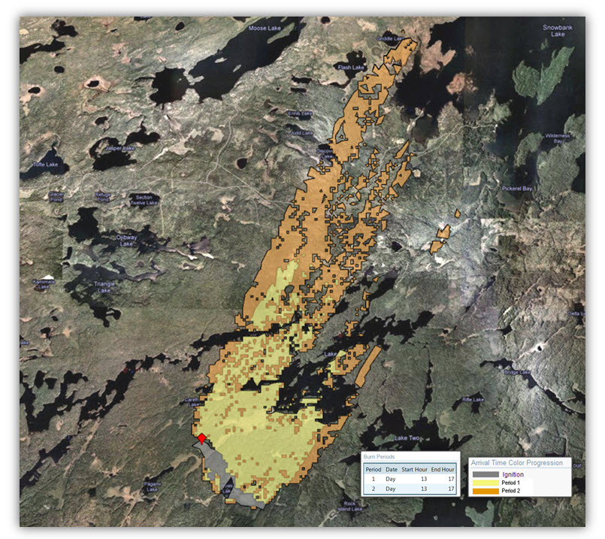

High Wind Event Projection – to simulate a 2 day spread event under relatively dry conditions with 30 mph southwest winds. Relative Humidity of 20% was used in this simulation with a 4 hour burn period each day. The current fire perimeter was used as the ignition with a barrier representing the control line on the north end of the fire. Initial fuel moistures used were 6, 8, 12, 70, and 130 (1, 10, 100 hour dead, live herb, live woody) and conditioned for 7 days prior to this simulation with no measurable precipitation during the period. Although minimal precipitation has been received in the fire area from 8/30 through today, 9/1, with more forecasted over the next 2-3 days, if the fire remains active, this simulation represents the relative potential of this fire over the next month after a prolonged drying trend of 5-7 days followed by the high wind event.

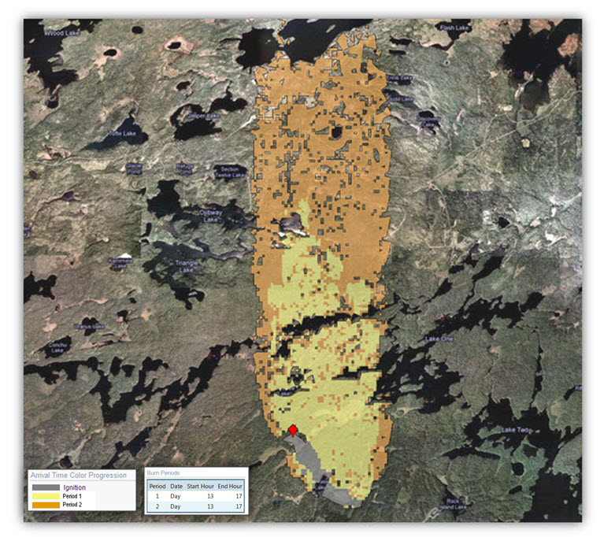

High Wind Event Projection – Near Term Fire Behavior (FARSITE) in WFDSS was used to simulate a 2 day spread event under relatively dry conditions with 30 mph south winds. This may be associated with a frontal passage and if dry, could result in rapid spread rates towards the north. Relative Humidity of 20% was used in this simulation with a 4 hour burn period each day. The current fire perimeter was used as the ignition with a barrier representing the control line on the north end of the fire. Initial fuel moistures used were 6, 8, 12, 70, and 130 (1, 10, 100 hour dead, live herb, live woody) and conditioned for 7 days prior to this simulation with no measurable precipitation during the period. Although minimal precipitation has been received in the fire area from 8/30-9/1, with more forecasted over the next 2-3 days, if the fire remains active, this simulation represents the relative potential of this fire over the next month after a prolonged drying trend of 5-7 days followed by the wind event.

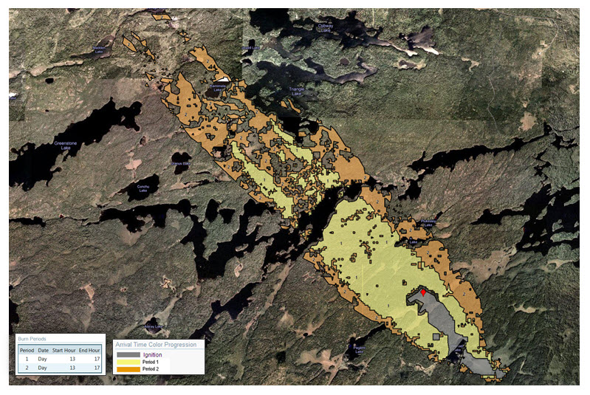

High Wind Event Projection – Near Term Fire Behavior (FARSITE) in WFDSS was used to simulate a 2 day spread event under relatively dry conditions with 30 mph southeast winds. This may be associated with a frontal passage and if dry, could result in rapid spread rates towards the northwest. Relative Humidity of 20% was used in this simulation with a 4 hour burn period each day. The current fire perimeter was used for ignition; a barrier represents the control line on the north end of the fire. Initial fuel moistures used were 6, 8, 12, 70, and 130 (1, 10, 100 hour dead, live herb, live woody) and conditioned for 7 days prior to this simulation with no measurable precipitation during the period. Although minimal precipitation has been received in the fire area from 8/30-9/1, with more forecasted over the next 2-3 days, if the fire remains active, this simulation represents the relative potential of this fire over the next month after a prolonged drying trend of 5-7 days followed by the high wind event.

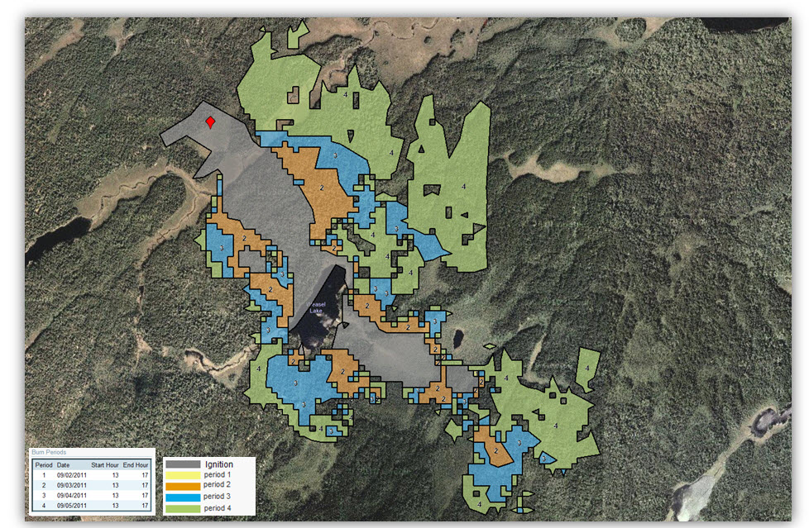

Near Term Fire Behavior 4 day (9/2-9/5) analysis: Used forecast gridded weather and wind from Ely RAWS observations and 4 hour burn period each day. Live Fuel Moistures adjusted to most representative conditions of 70 for live herbaceous and 130 for live woody. Assumes that current fire perimeter used for ignition is active with barrier on north end (fire control line). Canopy adjustments included in landscape from previous calibrations to better represent potential crown fire.

**Expected Fire Behavior and Predicted Fire Growth**

If average to above average weather patterns continue, expect fire to continue burning with low to moderate fire behavior, fire intensity, spread rates, and daily growth for the next two weeks. If fuels continue to dry out, the potential for high to extreme fire behavior will increase with any frontal passage or thunderstorm outflows in the area. Rates of spread have been extremely low the past few days with the recent moisture, but will increase rapidly as fuels continue to dry out.

Given a high growth day; sustained winds over 10 MPH with higher gusts, relative humidity below 30, and a Haines Index of 6 or high, anticipate a potential movement of the fire of ½ - 2 miles per day generally towards the northeast, and up to 4 miles a day under extreme wind conditions with mid to long range spotting.

With an elevated BUI, fire growth can be expected when FFMC nears 88. With forecasted high winds and low relative humidity, expect large growth potential on days with FFMC at 90 and above. The Pagami Creek Fire moved over one mile towards the south over natural barriers under similar conditions on August 26th.

Expect 5 large growth potential days (winds > 10 MPH and RH < 35) until the end of the fire season. These are usually associated with frontal passage. For this time of year, historic winds show most probable direction and highest speeds from the southeast to west (clockwise). The potential still exists for outflows from thunderstorms in the vicinity of the fire which could produce strong, gusty, and erratic winds.

With continued above average weather conditions and proposed suppression operations, the fire is expected to continue to move east, south, and west and reach 500 to 1000 acres in the next 2 weeks.

With proposed aerial ignition and containment within existing natural barriers, the fire size should increase to 2000 – 3000 acres in the next 2 weeks.

If a rare event/extreme weather condition occurs in the next 2 weeks, anticipate a potential increase in fire size to 5,000 to 7000 acres primarily in a northeasterly to southeasterly direction (with a frontal passage).

The greatest potential for fire to move outside of the planning area is to the east near Insula Lake.