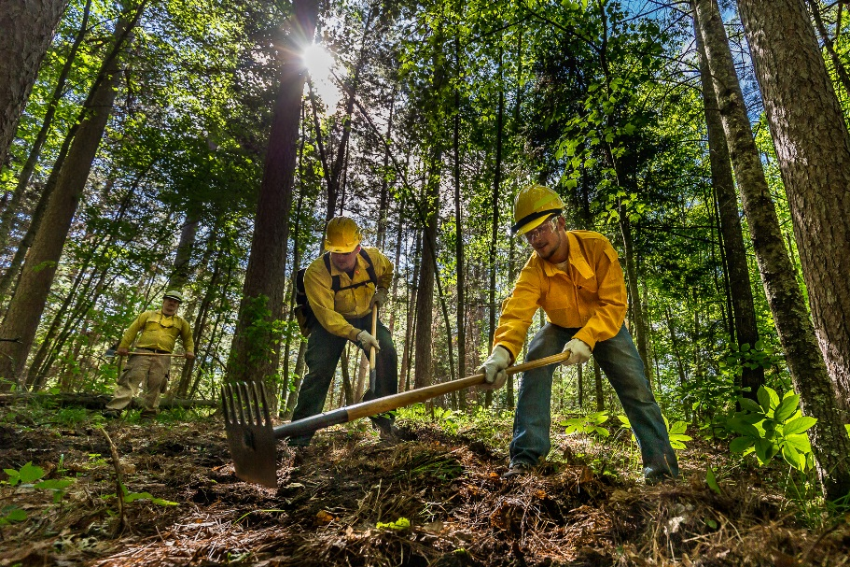
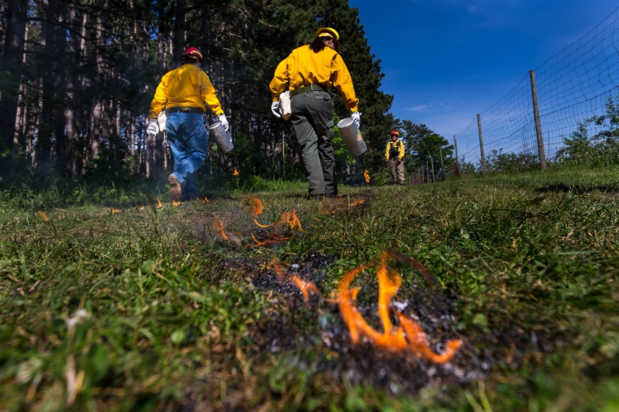
Photo Credit: Mark Erickson
Public Information Officer
I

WILDLAND FIRE ACADEMY
JUNE 6-10, 2016
Minnesota INCIDENT MANAGEMENT TEAM
Mike Aultman, INCIDENT COMMANDER

Wildland Fire Academy
June 6 - 10, 2016
MN Incident Management Team
Mike Aultman

COMMAND

In-briefing was received at Itasca Community College by Todd Manley MNICS Training Coordinator, and Jeff Mayer Advanced Minnesota Academy Coordinator on June 5th at approximately 1530. The Delegation of Authority was received from Todd Manley and Jeff Mayer and signed by MN Incident Management Team IC Mike Aultman and IC trainee Brian Jenkins.

Academy classes began on May 6th and consisted of 34 separate classes which ran over the course of the week. During the course of the week, 25 trainees were utilized to fill the positions on the IMT. These positions ranged from Status Check-in to Type II Incident Commander. On June 8th and 9th personnel from Itasca County agencies attended the Command and General Staff meeting, Planning meeting, and Morning Briefing.

As of 0900 on Friday June 10th the estimated costs for equipment, team/instructor time, and mileage/perdiem is $350,000.00.

The Delegation of Authority was transferred back to area at 1700 Friday June 10th 2016.

What went well:
- The continued use of the IMT proved beneficial to the coordination of the Academy. Based on complexity indicators such as number of personnel and length of assignment, the Academy meets many of the indicators of a Type II.
- The use of parking flaggers in the morning reduced congestion and parking issues over the course of the week.
- The short haul exercise went well and was a good demonstration of the process. Considerable discussion occurred prior to the exercise regarding the risk management of the exercise and the possible use of a live patient. The communication flow amongst the team was good and allowed for the team to work through the issues regarding the risk management of the exercise.

Opportunities for improvement:
- Bring the class boxes to MIFC to go through prior to the Academy to ensure that all material needed for the respective classes are available. Possibly have the instructors go through the boxes at MIFC prior to the academy to ensure they have the materials they need.
- Instructors need to provide an outline for all field classes, giving locations and activities by day.
- Suggest 2 Division Supervisors or Division Supervisor trainees to be attached to operations.
- Match classrooms to class sizes.
- Fans or air conditioners needed for classrooms, especially Liberal Arts building.
- Plot and post the Code of Conduct in each classroom to help facilitate the review with the students.
- Dedicate tactical channels for the Incident Within an Incident and L-280 classes, and don’t have them programmed into the radio package to be scanned. This would help eliminate confusion about “exercise” or real emergency traffic.
- Ensure that MNICS team protocols for an incident within an incident are shared and incorporated into the Incident Within an Incident class scenarios.

…..Brian Jenkins & Mike Aultman

SAFETY / MEDICAL

Assigned Tasks:
- A safety message was prepared for the IAP and communicated to the instructors at the daily operational briefings.
- Medical unit conducted medical incident briefings for 391 students in 13 classes.
- Monitored classroom and field course activities to ensure that safe practices were being followed.
- Worked with Logistics and Liaison to ensure that vehicles were following posted speed limits and parking in approved areas. CCM crew members directed incoming vehicles to parking areas. A vehicle speed indicator sign was set up to slow traffic.
- Established a medical unit room in Davies Hall so that all personnel assigned to the academy had access to basic medical care.
- Prepared the medical plan and briefed all instructors on it so that everyone was aware of the procedures to be followed in a medical emergency.
- Emergency Response Procedures document was provided for IAP so that everyone was aware of procedures to follow in the event of severe weather, fire, or terrorist threat events.
- All assigned resources were briefed on expectations of conduct for all assigned personnel not only during operational periods but also during off-duty periods.
- No serious injuries or accidents were reported at the time this document was prepared. Three hydration issues were addressed by the medical unit.
- The medical unit resource ordered an EMT and an off road utility vehicle to provide quick response to medical incidents occurring at training sites in the field.

Recommendations:
- Spend more time pre-planning and coordinating events affecting field courses so that class instructors and the overhead team are fully supportive and informed.
- Have class rosters with students’ and instructors’ contact information readily available to aid in locating missing individuals.
- 2 UTV’s, one with transport capability, or 1 UTV and one truck/SUV.
- Minimum of 4 medical personnel, (qualified MEDL, MEDL-t, two FEMT, or a PEMT)
- Map of campus unit for medical unit.

…Jeff Rengo & Ron Guck

LIAISON

Many trainees involved with the IMT had an opportunity to work with some very experienced trainers. Trainees worked on their tasks books with some completing and being recommended for certification. A recommendation would be to have trainees participate in the Fire Academy IMT to gain experience before they are called up for an incident, if possible.

One prevention task assigned to the Liaison staff was to visit the area Hotels that had our students staying there. The Hotels received a hand-out that contained some brief information explaining the Academy, along with Liaison contact information if there was a problem with a student. Follow up visits were conducted daily. Any issues with student conduct were reported and issues were dealt with.

For the saw operations class, a Land Use Agreement was negotiated and signed by the owner of the property. The land owner was very cooperative and had suggestions for future projects. A potential project was identified by the saw class on some property owned by Blandin. After a site visit with the Blandin Forester, it was determined that they did not want that trail opened up. This contact will help with future coordination and collaboration for projects on that property. An area of improvement could be working with area property owners earlier to create these land use agreements. The County Land Department should be contacted about future use of their property.

We had great cooperation with the City of Grand Rapids Police Department and Fire Department.

….David Snetsinger

INFORMATION

Members of the Public Information Officers team met on Sunday June 4, 2016 to set up the information desk at Itasca Community College and participate in the Incident Management Team meeting. PIO members staffed the information desk throughout the week. Tasks included: An initial news release announcing the event; daily updates posted to the mnics.org website and distributed to a media list; QR codes updated with the daily class schedule; posts to social media (Twitter and Facebook). PIO members also conducted media tours, took photos, prepared talking points and provided liaison assistance with Itasca Community College, the University of Minnesota Northern Research & Outreach Center (UMN-NROC), Advanced Minnesota and the general public.

Highlights of What Went Well
- Many photos were captured throughout the week with two professional photographers, one on the PIO team and a special guest
- The Academy is a great PIO trainee opportunity
- PIO trainees gained social media experience
- Daily updates were posted through the use of QR codes, which provided consistency
- There was ample opportunity to connect with other agencies (Itasca Community College, UMN-NROC and Advanced Minnesota)
- Excellent interaction with other IMT sections was helpful to accomplishing the information function
- The Academy provided an excellent opportunity for task book completion

Ways to Improve
- Approval process required prevented timely distribution of daily updates
- Work to improve signage for Information Center location
- PIOs need to stay with visiting media even when accompanied by other personnel

Notes for Next Year
- Have roadside banner changed to include UMN-NROC logo.
- Develop a process for instructors to submit their hands-on/field activity schedule prior to the start of the Academy. This may benefit other IMT sections besides Information.
- Send schedule of activities ahead of time to the media.

….Christi Powers

FINANCE

- Recorded time for academy instructors and IMT members
- Maintained a general expense record of academy related expenses
- Provided training opportunities two COST/TIME unit leader
- No student/local vendor payment issues needed to be resolved
- No personnel needed comp for injury assistance

Recommendations:
- Clear direction that all instructors would be checking in, doing CTRs and checking out (demob) in initial letter or ahead of time. Academy will be run as an incident.
- Identify unique codes that track expenses, MUR’s and personnel time for State employees (CC2) who are instructors or members of the IMT.
….John Kelly

LOGISTICS

The Academy was held at the Itasca Community College (ICC). The campus had plenty of room to support all of the classes, support trailers and supply area with room for field exercises on adjoining property of the U of M and Trout property.

The Logistic section was operating with Facilities, Ground Support, Communications and Supply units fully staffed by qualified individuals. The academy was scheduled from Monday 6/6/2016 thru Friday 6/10/2016 with setup taking place Friday and Sunday prior to the event. An operational briefing was held at 0700 each day and tactics and planning meetings every afternoon. Shift tickets and CTR’s were completed to provide training opportunities.

What went well?
- Early planning, and having the full team engaged two weeks before the start of the academy.
- Having a CCM camp crew really helped with food and parking.
- Contracting with Lefty’s for the large tent worked great for an extra feeding area
- Having a food unit leader solved all the problems from the previous year.
- Linking our lock with trout’s helped with access issues.
What did not go well?
- Not getting the instructors needs forms until the last minute impacted our ability to prepare for the start of the academy.
- Not having a cache van or a large preorder caused a lot of running back and forth from academy and fire cache.
- Local purchase continued to be a problem throughout the academy, having an account set up that we could charge to or someone on site that can run up town on short notice.
….Jay Lauer

OPERATIONS

- 841 students and over 100 instructors were involved in this Academy. 32 classes were offered this year. (S-133, S-131, S-290, EVOC, FI-110 & an Incident within an Incident classes were given 2 times this week). Students and Instructors were from: MN, WI, CA, IA, AZ, ND, MO, MT, ID and WV. Agencies represented are: BIA, USFS, MNDNR, USFWS, NPS, CCM and various Fire Departments throughout the state, other Cooperator’s, Contractor’s & the general public.

- Lead Instructors were requested to attend the 0700 briefing each day and pick up an IAP. Most lead instructors attended the briefings. OSC2 met with all the instructor’s throughout this week & attended various classes as time permitted. All concerns were addressed with the class Instructor’s as they were brought to my attention. SOF2 & IC were kept in the loop on various changes throughout the week.

- The Communications plan was used in the IAP as required. OSC2 assigned Tac frequencies (after checking with COML) on a daily basis as needed if field exercises took place as requested by the Lead Instructor’s. Radios were cloned @ the beginning of the class & worked well throughout the week.

- Interfacing with all the C & G personnel took place throughout the Event.

- General messages were requested to be signed by the Lead Instructor’s for accountability reasons and a 24 hour lead time was also requested by the IMT.

- No OSC2 trainee was available to be used @ this event. This position should have a trainee along with all the C & G positions. If an OSC2 trainee could not be found in the entire state of Minnesota, from all state or federal agencies, one should be pulled in from the R9 priority training list as long as their expenses are covered by their home agency.

- An Incident within an Incident class did Medical Emergencies procedures throughout the week. The class was well received by all students & the instructor’s did an excellent job. Thursday a major aviation planned event took place using multiple aircraft. More details of this event is listed under the Air Operations section.
Things that went well:
Classes were well organized, good attendance of Instructors @ the morning briefings, good classroom layout, all PPE use in the field was enforced by the class instructor’s, good communications took place between the IMT & the Instructor’s.
All classes were held in one building which was excellent.
All Instructor’s involved with this Academy did an outstanding job & a thank you goes out to all of them.
Needs improvement:
I feel that an IAP should be created for each day (or a new one mid week). The benefits of this would be: it could capture changes for the upcoming daily events, weather would be updated (hard copy) each day, frequency changes (set up a couple of freq’s for the Incident within an Incident scenarios), the Planning section trainee & Operations trainee (if they have them) could work on the process & putting all the parts of the plan together for each day. The Wildfire Academy brochure (the sheet that has the class dates on it) should be included in the IAP also in the future.
Separate TAC frequencies should be set aside for an actual Medical Emergency for next year. This year we ran a bunch of “mock” medical events & there was some confusion weather or not it was real or mock incident.
Do not have the saw class operating their saws outside the windows of the S-261 class. They were working on their final test & the saws were running during this time & it was hard to hear the instructors of the class.
CTR collection from the Instructor’s needs to be worked on. Many Instructor’s taught many different classes during the week & that was very hard to capture. Is there a better way to try to track costs?

…..Kurt Schierenbeck

Air Operations

What we did:
- Briefed/familiarized approximately 250 people (students, team members, visitors) on aviation operations.
- Air Operations participated/assisted in the Academy’s Initial Attack Drill utilizing Air Attack 1, Fire Boss T-852, and a Type 3 Helicopter, 19BH.
- Conducted an All Risk Aviation Exercise that involved DNR Forestry, Enforcement, MN State Patrol, and LifeLink III aircraft. This included a short haul demonstration, with a risk assessment review and implementation of the risk mitigations.
- Facilitated an after action review of the All Risk exercise with all parties involved.
- S-219, S-271, and S-270 classes were briefed on helicopter operations, as well as an overview of the PSD & Helitorch.
- Utilized 4 trainees in Air Operations (ASGS, HEB2, ABRO, and HMGB Trainees).

What worked well:
- During the ‘Incident within an Incident class’ an All Risk Aviation Exercise conducted that involved DNR Forestry, Enforcement, MN State Patrol, and LifeLink III.
- New location was used for the helibase (should be the standard location moving forward).
- Coordination with U of M staff on use of facilities and grounds. U of M staff was a great help to our operation.
- Having the grass mowed adjacent to the helibase to meet the needs of the classes for hands on training.
- Having a dedicated Aircraft Base Radio Operator (ABRO)
- Having the two port-a-johns and hand wash station at the helibase.

What could we improve on:
- Have a daily IAP to allow for changes.
- An agency printer/copier available at ICP for the team.
- Have a SITL/GIS position staffed and available to the incident, at least initially.
- Dedicated Helibase manager.
- Coordination with airport traffic for aviation exercises. Notams’, etc.

….Dustin Nelson & Doug Lloyd

PLANS

Incident Schedule
0630 IMT reports in to ICP
0700 Operational Briefing
1200 Command and General Staff meeting
1700 Planning Meeting/Evening briefing

Assigned tasks
check-in team and instructors to establish records in E-Isuite for finance tracking.
Developed a single week long Incident Action Plan week prior to Academy
Collect, verify, and file course attendance records
Distribute non-field lunch tickets – switch this to Logistics in 2017
Coordinate the training records for trainees assigned to the IMT
Develop and distribute phone listings as appropriate thru IAP
Provide for E-ISuite capability

Recommendations for 2017 Academy
Since this is a planned event, more of the incident resources and functional needs should be identified and completed prior to the incident.

Perhaps a reprint of the week long IAP after significant number of corrections/changes have occurred (mid-week).

Since IAP 204s were organized by building/classroom, adding a class listing matrix similar to what is provided in the Academy brochure will help identify daily class changes.

If instructor names, classroom location assignments, and student roster numbers are desired for ICS 204’s, that information should be provided for IAP creation at least 1 week prior to Academy.

The morning briefing was not successful as an information exchange to Instructors. Attendance of instructors to morning briefing was very light, due to conflicts with classroom preparation and informal student interactions that occur before the classes. Instructors for “field” sessions should be encouraged to attend the AM briefing – wouldn’t be necessary for office only instructors.

Have a “Field” Instructor breakout with Logistics and Operations following AM brief to solidify day and next day’s plans for field exercises and sack lunch requests.

Have copies of the Academy brochure to distribute prior to incident.

….Paul Olson

SITUATIONS / GISS
We did not have SITL, GISS or plotter on site, this required all map orders (team and class) be to submitted 10 days prior to incident.

Were able to use the plotter at Grand Rapids DNR HQ to produce extra copies as needed.

Attempt will be made to include all maps as ArcGIS Map Packages to the closeout packages, this should help with updating 2016 map products for 2017. Olson to add some drop points to saved maps.

….Paul Olson

RESOURCES
Complete IAP, 215, 215A before Academy Week.

Standard ICS 215 was ineffective as a planning tool. Poster sized class listing matrix from the Academy brochure worked better.

Clarify with instructors and IMT expectations of who needs to check in and Demob.

…..Chris Mursu

COMPUTER SPECIALIST – ITSS
Had (1) qualified ITSS and (1) trainee on incident for setup, dropping to trainee only beginning Monday morning. Incident could have other ITSS(t) on site if available.

ITSS set up E-ISUITE on Sunday.

Highest IT support demand is Monday and Wednesday mornings. ITSSs can play other roles during day or attend classes.

ITSS needs to be the single point of contact between the College IT and the Academy. The College IT was inundated with various requests, which could have been handled by the ITSS. User needing IT support were requested to send a TEXT with name, room number and issues to ITSS’s phone – he could either solve or re-direct to ICC staff.

Inform ICC IT where computer classes are held and give them admin right on the computers so they can install and manipulate the software.. This will free up the ICC staff and simulates an incident where students will have to install/uninstall the software.

Some class require software to be installed on the instructor’s machine. On the Academy side, this needs to be noted as early as possible. On the College side, this needs to occur by first day of class.

Some software (ROSS) needs ports to be opened in the firewall in order to be used. This needs to be noted by the Academy and the information forwarded to ICC IT.

E-Isuite needs to see the Internet when launched on both server and clients. IMT uses static IP addressing so the switch or wifi router needs a hard wire Internet connection at the ICP.

…. Joe Johnson

2016 Minnesota Wildfire Academy (MN-MNS-716055)
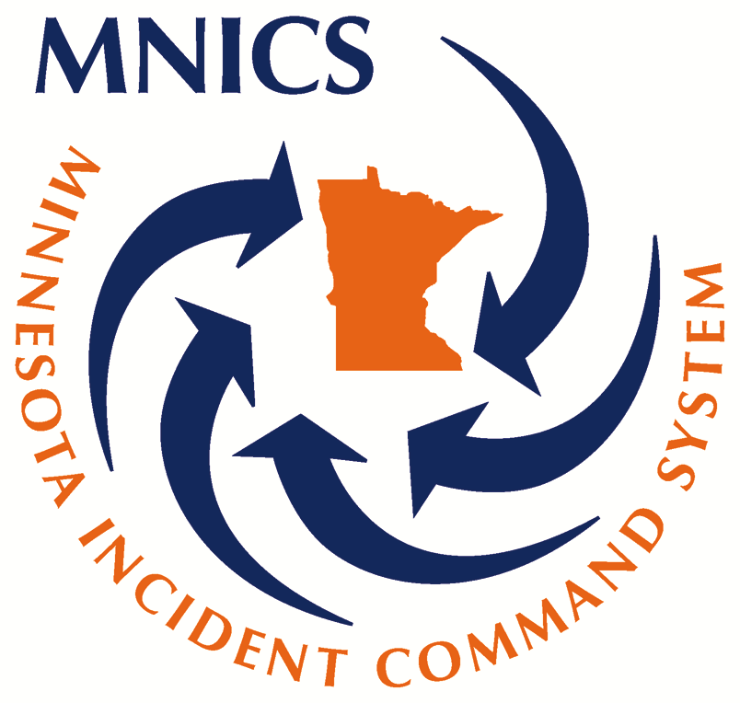
June 5, 2016 to June 10, 2016
Comments & Recommendations
- Academy provided an excellent opportunity for trainees to hone their skills, while working on Position Task Book
- Academy Coordinator did an excellent job by providing quality courses and opportunities for IMT trainees
- Inclusion of a Training Specialist (TNSP) on the IMT allowed Academy Coordination to focus on the academy needs
- Utilize the Eastern Area Priority Trainee List to identify more trainees for the Academy IMT
Matt Dillon, Incident Training Specialist (TNSP)
(610) 420-9911 Cell

Trainees by Position
Name | Position | Agency | * End PTB Rating | % of PTB Complete | Total Days Assigned
Bombeck, Ronald | MEDL | State | 2 | 91 | 8
Bourquin, Elizabeth | SCKN | State | 6 | 100 | 2
Calder, Nancy | COST | State | 2 | 59 | 5
Carlson, Robert W | MEDL | State | 2 | 98 | 6
Edelman, Donna | COST | State | 2 | 53 | 6
Edelman, Donna | TIME | State | 1 | 100 | 6
Eisenrich, Wendy | RADO | FS | 2 | 100 | 8
Engrav, Timothy J | PIO2 | FS | 2 | 25 | 5
Erickson, Markus | PIO2 | State | 1 | 100 | 6
Gaalaas, Karl J | MEDL | State | 2 | 91 | 8
Halvorsen, Marlyn J | LOFR | State | 2 | 71 | 6
Jenkins, Brian S | ICT2 | FS | 2 | 46 | 8
Johnson II, Joseph D | ITSS | State | 6 | 100 | 6
Larson, Juanita | RADO | State | 5 | 0 | 5
Lauer, Edward J | LSC2 | State | 2 | 100 | 8
Monroe, Lyn M | ABRO | State | 2 | 100 | 3
Mursu, Chris R | RESL | FWS | 6 | 100 | 6
Nelson, Dustin | ASGS | State | 2 | 98 | 6
Olsen, Shawn | HEB2 | State | 5 | 0 | 6
Pollard, Matthew T | RCDM | State | 1 | 100 | 6
Powers, Christi A | PIOF | State | 2 | 56 | 7
Rengo, Jeff | SOF2 | State | 2 | 29 | 8
Robertshaw, Becky | ORDM | FS | 2 | 81 | 8
Schlitz, Michael | SCKN | State | 1 | 100 | 5
Schumacher, Stephen | SCKN | FWS | 1 | 100 | 5

Trainees by Agency
 | Minnesota DNR | USDA Forest Service | US Fish & Wildlife | Grand Total
Command | 4 | 2 |  | 6
Finance | 3 |  |  | 3
Logistics | 6 | 2 |  | 8
Operations | 3 |  |  | 3
Plans | 3 |  | 2 | 5
Total | 19 | 4 | 2 | 25

* END PTB RATING
- The trainee has successfully performed all tasks in the PTB for the position.
- The tasks have been performed in a satisfactory manner. However, opportunities were not available for all tasks (or all uncompleted tasks) to be performed and evaluated on this assignment. An additional assignment is needed to complete the evaluation.
- The trainee did not complete certain tasks in the PTB in a satisfactory manner and additional training, guidance, or experience is recommended.
- The individual is severely deficient in the performance of tasks in the PTB for the position and additional training, guidance, or experience is recommended prior to another training assignment.
- Trainee/Trainer did not complete the training documentation package with the Training Specialist.
- Trainee completed PTB, but requests an additional assignment.

