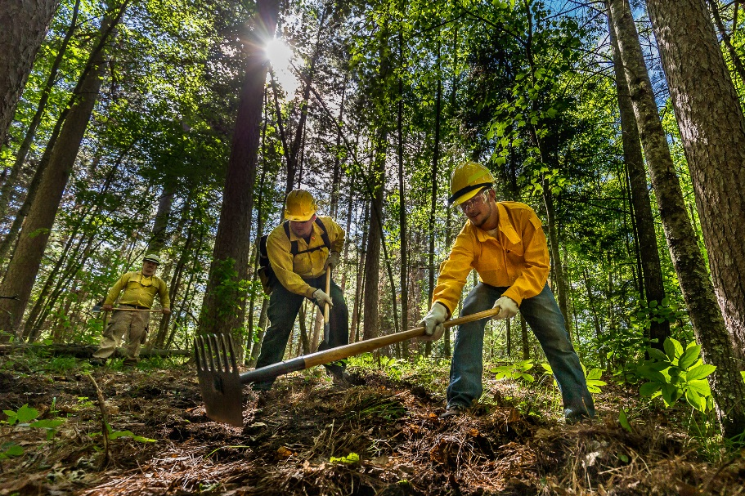
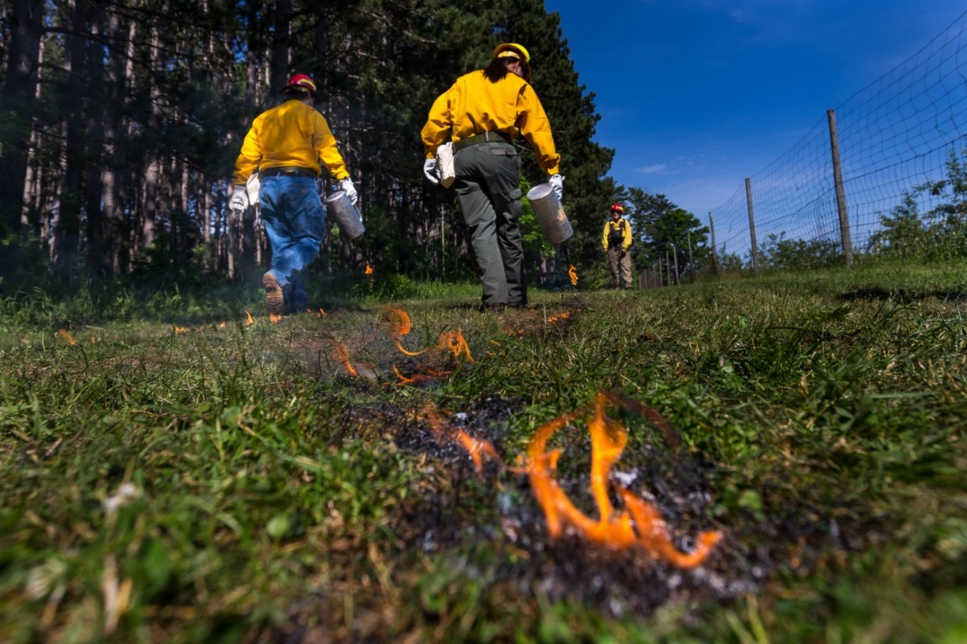
Photo Credit: Mark Erickson
Public Information Officer
I

WILDLAND FIRE ACADEMY
JUNE 5-9, 2017
Minnesota INCIDENT MANAGEMENT TEAM
Mike Aultman, INCIDENT COMMANDER

Wildland Fire Academy
June 5 - 9, 2017
MN Incident Management Team
Mike Aultman

COMMAND
In-briefing was received at Minnesota incident fire center by Todd Manley MNICS Training Coordinator June 2th at approximately 0900. The Delegation of Authority was received from Todd Manley and signed by MN Incident Management Team IC Mike Aultman.

Academy classes began on June 5th and consisted of 31 separate classes which ran over the course of the week. Total Classroom Contact Hours (#students x course hours) totaled 13,447 hours and class registration was 76% of capacity (actual students/potential students: 793/1046).

There were 793 course registrations with a total of 550 different students that attended the Fire Academy. Participants from Minnesota included individuals from MN DNR (numerous Divisions), Chippewa and Superior National Forests, Voyageurs NP, Numerous Tribal entities and BIA, Numerous USFWS Units, Numerous MN Fire Departments, The Nature Conservancy, Conservation Corps of MN & IA, Camp Ripley and MN Dept of Transportation. Out of state participants came from WI DNR, Ottawa NF (MI), Chequamegon-Nicollet NF (WI), Pisgah NF (NC), Shawnee NF (IL), Mark Twain NF (MO), Big Cypress National Preserve (FL), USFWS – South Dakota and others.

There were 77 instructors that led the 31 courses offered. Instructors came from MN DNR, USFS (CPF, SUF, CNF), BIA/Tribal, NPS, Michigan DNR, MN HSEM, Advanced Minnesota and All Hazard Medical Solutions.

During the course of the week, 21 trainees were utilized to fill the positions on the IMT. Sections with trainees Plans 6, Logistics 6, Operations 1, Air operations 3, Finance 2, Liaison 1, Public Information 1 and safety 1. Of the 44 positions assigned in the IMT 6 also assisted as classroom instructors. 4 of the IMT members were also students at the academy. The command and general staff also assisted in 4 additional classes as subject matter experts.

As of 1630 on Thursday June 09th the estimated costs for equipment, team/instructor time, was $315,650.00.

The Delegation of Authority was transferred back to MNICS at 1700 Friday June 9th^{th} 2017.

What went well:
- The continued use of the IMT proved beneficial to the coordination of the Academy. Based on complexity indicators such as number of personnel and length of assignment, the Academy meets many of the indicators of a Type II.
- The use of parking flaggers in the morning reduced congestion and parking issues over the course of the week.
- The short haul exercise went well and was a good demonstration of the process. Considerable discussion occurred prior to the exercise regarding the planning process used for this exercise. Integrating the team into this exercise for the short haul on Tuesday and again on Thursday tested the team’s Incident Emergency Plan (IEP) and the team’s performance in the implementation of the plan.
- The communication flow amongst the team was good and allowed the team to respond to the issues that arose from the poor registration process.
- The Teams ITSS section in plans work well with Itasca community college in the loading of computer software needed to run each class.
- Dedicated tactical channels for the incident within an incident class and all other classes that requested them proved to be a good communication plan
- Placing the code of conduct in all classrooms was a success.
- Operations course summary chart created by Mike Rice OSC2(t) work out very

Opportunities for improvement:
- The class instruction boxes need to be housed at MIFC to allow the team time to go through these prior to the Academy to ensure that all material needed for the respective classes are available. Possibly have the instructors go through the boxes at MIFC prior to the academy to ensure they have the materials they need.
- Instructors need to provide an outline for all field classes, giving locations and activities by day.
- Suggest 2 Division Supervisors or Division Supervisor trainees to be attached to operations.
- Match classrooms to class sizes and technology needed in the class.
- Fans needed for classrooms, especially Liberal Arts building, and the air conditioning needs to be activated on Sunday to cool the rooms off before students arrive.
- There needs to be a process where the prerequisites are checked before students are accepted into the class.
- Two planning meetings for the team one 4 weeks prior to academy the second two weeks prior and final meeting the Friday before.
- The Instructor needs list will need to be given to Logistics and Operations at the meeting two weeks before academy.
- Lead instructors need to take advantage of the opportunity to review the contents of their instructor bins before academy.

…Mike Aultman

SAFETY / MEDICAL

Assigned Tasks:
- A safety message was prepared for the IAP and communicated to the instructors at the daily operational briefings.
- Medical unit conducted medical incident briefings for 793 students in 31 classes.
- Monitored classroom and field course activities to ensure that safe practices were being followed.
- Worked with Logistics and Liaison to ensure that vehicles were following posted speed limits and parking in approved areas. CCM crew members directed incoming vehicles to parking areas. Identified lower parking area before dorms for Engines, Crew Carriers, and other large Agency vehicles. A vehicle speed indicator sign was set up to slow traffic.
- Established a medical unit room in Davies Hall so that all personnel assigned to the academy had access to basic medical care.
- Prepared the medical plan and briefed all instructors on it so that everyone was aware of the procedures to be followed in a medical emergency.
- Emergency Response Procedures document was provided for IAP so that everyone was aware of procedures to follow in the event of severe weather, fire, or terrorist threat events.
- All assigned resources were briefed on expectations of conduct for all assigned personnel not only during operational periods but also during off-duty periods.
- No serious injuries or accidents were reported at the time this document was prepared.
- As per last year’s medical accident/injury issues hydration and tick bite prevention was stressed and bug dope and water was provided for field going classes.
- The medical unit resource ordered an EMT and an off-road utility vehicle to provide quick response to medical incidents occurring at training sites in the field.
- Safety monitored aviation briefings related to Incident Within Incident Management training and participated in the training scenario.
- Provide ICC Star Alert system names of lead instructors, Operations, Safety, and IC for notification of Safety related issues on campus.
- Monitor weather and communicate severe weather alerts to the field through communications.
- Medical unit dispensed over the counter medication to 12 students. 2 students were assessed in the field and retuned to class.

Opportunities for improvement:
- Spend more time pre-planning and coordinating events affecting field courses so that class instructors and the overhead team are fully supportive and informed.
- Have class rosters with students’ and instructors’ contact information readily available to aid in locating missing individuals.
- 2 UTV’s, one with transport capability, or 1 UTV and one truck/SUV.
- Minimum of 4 medical personnel, (qualified MEDL, MEDL-t, two FEMT, or a PEMT).
- Map of campus unit for medical unit.
- Staff Safety with one fully qualified SOF2 and one or two SOF2(t).

LIAISON

Assigned Tasks:
- Prepared and delivered a hand-out to area hotels that contained some brief information explaining the Academy, along with Liaison contact information if there was a problem with a student. Follow up visits were conducted daily. Any issues with student conduct were reported and issues were dealt with. A thank you for participation was delivered to the area hotels.
- Requested a Radar Sign for the entrance of the school from the Grand Rapids Police Department.
- Requested a Portable Changeable Message Sign from MNDOT to be place on Hwy 169 near the entrance of the school.
- Requested a Fire Department Water Tender to fill dump tanks. Also requested a Rescue Mannequin for the Incident within an Incident Class field exercise.
- Land Use Agreements were enacted with Wes Trout and the University of Minnesota. A Land Use Agreement was discussed with the Arbo Township for the IWI Field Exercise, but was not completed.
- We provided Public Notification for the Urban Interface Class field exercise.
- Investigated and documented a hit and run parking lot accident. A report was prepared and delivered to Finance.

What went well:
- We had great cooperation with the City of Grand Rapids Police Department and Fire Department. We also had great cooperation with Mn Dept. of Transportation.
- The interaction with the hotels was great. It shows that we care about the community.

Opportunities for improvement:
- Initiate the Land Use Agreements Wes Trout, University of Minnesota and Arbo Township earlier.
- Request the Portable Changeable Message Sign from MNDOT earlier.
- Request a second Radar Sign for NW 24th Street, road to the Trout Gravel Pit Gate.

…Dave Snetsinger and Marlyn Harlvorson

INFORMATION

- The Public Information Officers team was staffed with Tim Engrav as Lead PIO2, Ron Sanow as PIO2, Christi Patrick as PIOF(t), a half-day of assistance from Marty Christensen as PIO2, and website and social media posting assistance from Christi Powers as MIFC PIO.
- Tim and Ron attended the IMT in-briefing on Friday, June 2, 2017 and completed preparation tasks including the first News Release. Tim arrived on Sunday June 4, 2017 to set up the information desk at Itasca Community College. PIOs staffed the information desk throughout the week. Tasks included: providing customer service to students who needed to find their classrooms; daily updates posted to the mnics.org website and emailed; and some posts to social media (Twitter and Facebook).
- Media visits to the Academy included WDIO-TV and KBJR-TV from Duluth, KOZY Radio from Grand Rapids, the Grand Rapids Herald-Review, FOX 21 News from Duluth, and Lakeland News TV from Bemidji. All media interactions provided the opportunity to discuss and use PPE with reporters.

What went well:
- The Academy continues to provide a valuable for PIO trainees. As we get some more active PIO2 trainees we need to get them involved in an Academy assignment.
- The Academy provided an opportunity for some PIO trainee task book elements and experience in writing Daily Updates and Information Desk work.
- The PIO staff was sized right for the workload experienced this year and expanded with additional PIOs (Christi and Marty) when needed to help accomplish website, social media, and media site visit tasks.
- The Academy allowed several MNICS PIO2s to continue to develop their group cohesion and collaboration in working relationships while helping out here and there or as needed without adding additional staffing.
- The excellent interaction with other IMT sections was helpful to accomplishing the information function.

Opportunities for improvement:
- The Lead PIO2 was also a Unit Instructor for S-203 this year and while that is efficient, the timing of teaching and Academy IMT functions sometimes conflicted. It worked because we had another qualified PIO2 in place to help cover. If only one qualified PIO2 is assigned then they need to stay dedicated to the Academy and working with the PIO trainees.
- We need to prepare a standard Academy email contact list for internal/external contacts that can be updated and used every year.
- Local hotels, the Grand Rapids Chamber/Visitor Bureau, and city officials need to be included on a trapline or external email list so that they can receive the daily updates.
- An Information “Sandwich” Board needs to be ordered and placed outside the entry to the Backes Student Center where PIOs can post maps, daily updates, and Academy announcements.

Notes for Next Year
- A roadside banner was not used in 2017. If a new one is made for the future it should include the UMN-NROC logo.
- Minnesota’s elected federal officials are interested in visiting the Academy and seeing how it all works. In the pre-planning for the 2018 Academy it is critical that we reach out and notify the US Senator’s and US Representative’s Offices with advanced notice in case there is interest in some of them visiting. The Academy PIO group would then need to be staffed appropriately for VIP visits which is another great trainee opportunity.

…Tim Engrav

FINANCE
- Time was recorded for IMT members, Academy Lead Instructors and Unit Instructors
- CTR’s were turned in and entered into E-Isuite. Lead Instructors filled out check-in forms but Unit Instructors were just entered by name and agency on the CTR’s by Lead Instructors
- All instructors entered into E-Isuite as THSP’s and listed under a block of resource order numbers starting with 500. This worked well because we can run reports on just this position and get the cost of the instructors.
- OF-288’s printed only if requested
- Provided training opportunities for three PTRC trainees with taskbooks
- Costs were entered for IMT personnel, instructors, supplies purchased, aircraft, Special Speaker, IWIN Cadre
- Daily Cost Summary submitted to IC daily
- Detailed Cost Summary at end of Incident
- Spreadsheet developed for Advanced Minnesota costs
- Participated in two IWIN exercises, DIVS training panel, 3 AAR’s as IMT C&G member
- No student/local vendor payment issues needed resolved
- No comp or claims issues needing resolved. Documentation in file on accident involving a student’s parked vehicle.
Opportunities for improvement:
- Check-in sheets were put in each classroom for lead instructors. Unit instructors did not have to do the check-in sheet but their names were put on the CTR by the lead along with their agency. Recommend that unit instructors also do the check-in sheet in the classroom. It is much easier to enter them into E-Isuite to do time and costs. Agency is necessary for check-in and was not always listed on CTR as instructed.
- Instructors did not come through check-in to demob so COST has no way of knowing who is gone and daily costs for those people continue to roll over in E-Isuite until they are demobed.
- Finance Message was put in IAP recommending the instructors note on the CTR when their class is complete but that was not always followed and the instructor may also be teaching another class. Recommend a procedure be put into place for this issue.

…Brenda Miles

LOGISTICS

The Academy was held at the Itasca Community College (ICC). The campus had plenty of room to support all IMT functions including classes, support trailers and supply area with room for field exercises on adjoining property of the U of M and Trout property.
The Logistic section operated with a fully functioning Facilities, Ground Support, Communications, Food and Supply units fully staffed by qualified individuals. In addition, the Logistics section had 2 LSC2 trainees, as well as a four person CCMI crew.

What went well:
Food Unit:
- Received timely 213’s for field lunches for the most part
- Outdoor tent is now an essential resource for this academy
Supply:
- Bringing in the Cache Van in support of the Academy was a good move. Greatly reduced the need for so many additional resource orders throughout the week.
Facilities:
- Very few facilities issues. This facility and all the resources available in the Grand Rapids area were a great asset.
- ICC, USDA, U of M staffs were extremely accommodating and great to work with.
Ground Support:
- State locks on gates.
- MIFC drivers and vehicles to support logistics
Communications:
- Communication trailer was well set-up
- During the IWI the radio patch with the county worked well
- Pre-briefing about the IWI scenario with the communications team members was helpful.
CCMI Crew:
- Having a CCMI crew for use by Logistics Section is essential and they provided great support for Ground Support, Facilities and Food Units. Great Job.

Opportunities for improvement:
- Lead instructor pre-orders needs to get sent out earlier than this year and submitted back to MIFC in a more timely fashion. We should attach the electronic General Message forms so that all requests come in in the proper format. Requests should be broken down on the General Message so that Supplies needed, course materials needed and procurements are not all bunched up on one general message.
- Planning for the Academy should start a bit earlier than we got going this year.
- An additional 4 sand tables should be available for use at the Academy.
- Need to develop a more comprehensive map of the field locations that includes newly established drop points, toilet and wash station locations for field locations.
- Purchase of some rigid sign board materials would be helpful to improve some of our misc. signing needs.

OPERATIONS

Assigned Tasks:
- Provide operational support for instructors and students.
- Ensure all classes, outdoor field exercises and aviation operations run efficiently.
- Coordinate with other C&G to meet needs and identify SOP’s since many tasks and responsibilities are not “classic” operational efforts.
- Fulfill Operational roles and responsibilities related to real and simulated incidents and scenarios.

What went well:
- OSC2 trainee & 3 DIVS's, perfect! I recommend that for next year also.
- Briefing @ 0700, most of the instructor's attended 1 or more of these briefing.
- New helibase trailer & location. Area control was set up, worked well this year.
- Food @ ICC & field lunch's. Good food & good lunches. LOTS of prep work to make this field lunch situation work much better this year.
- Communications plan was preloaded prior to this event taking place. Much better then past years.
- Fewer classroom complaints than years past. A few classrooms were too warm early in the week but mitigated to some extent with fans and other efforts.
- Updating the IAP as needed worked well.
- Great mix of agency instructors.
- The “tracking” spreadsheet worked well as a modified 215. The modified 215A also worked well.
- Incidents within the Incident scenarios went well and are extremely valuable to the students and the IMT.
- The “C&G Staff Incident Emergency Action Plan & Check List” worked well.

Opportunities for improvement:
- Turning in CTR's, rosters, sign in sheets. Who, when, etc. Rob Heavirland had an excellent idea for next year: Put a folder or envelope outside the classroom so the instructors can put their paper work in there & it can be picked up through-out the day.
- Letter to all the students needs much improvement! The letter's failed to include correct start times, prework information, etc.
- Training: no good tracking procedure for "non" agency personnel that got into some classes.
- Better communication about the "aviation exercise" that took place on Tuesday. ASGS did a great job setting everything up but more coordination may be needed. Signatures, who has control, how does the IMT fit in this situation. Lots of moving parts. The teachable moments of this event were awesome, just need more coordination with all the partners @ MIFC.
- A Project Aviation Safety Plan (PASP) is planned for next year. This will help with coordination and working with other Functions (Ops and Safety) to understand the aviation risk management process and overall plan.
- Some IMT functions need to engage on Academy Prep several weeks prior to the event.
- Ops positions that are in place for the entire Academy week with no other collateral duties (e.g. Instructing or taking courses) and minimal home unit obligations. OSC2 and 3 DIVS.
- Assign DIVS to specific Divisions (aka groups of classes) for the entire week. Each 204 would have one DIVS.
- Improve and update the “Instructor Needs” form and provide the Leads with Academy SOP’s and “game plan” prior to the academy.
- The 0700 briefing taxes the Lead Instructor’s time. Not sure if there is a better way to communicate the Operational Briefing information? Perhaps the Leads are given a formal in-brief upon Check-In?
- Having the IMT in place should reduce the workload and make things easier for the Instructors but many of the Leads had feedback to the contrary.
- The Tracking Spreadsheet (modified 215) worked well but can be easily improved and include added functionality for 2018.
- Identify more “back-up” or unassigned classrooms for the inevitable changes and unexpected issues.
- What is the true carrying capacity of ICC, Grand Rapids, and the MNICS Agencies to support the MN WF Academy? More analysis by Training WT and Task Force is needed.

…Submitted by Mike Rice, OSC2t, Kurt Schierenbeck OSC2

Air Operations

What we did:
- Briefed/familiarized approximately 240 people (students, team members, visitors) on aviation operations.
- Air Operations participated/assisted in the Academy’s Initial Attack Drill utilizing Air Attack 1, Fire Boss T-204, and a Type 3 Helicopter, 19BH.
- Conducted an All Risk Aviation Exercise that involved DNR Forestry, Enforcement, MN State Patrol, and LifeLink III aircraft. This included a short haul demonstration, with a risk assessment review and implementation of the risk mitigations.
- Facilitated an after action review of the All Risk exercise with all parties involved.
- S-219, S-271, and S-270 classes were briefed on helicopter operations, as well as an overview of the PSD & Helitorch.
- Utilized 7 trainees in Air Operations (ASGS, HEB2, ABRO’s, TOLC, DDECK, and HMGB Trainees).

What went well:
- During the “Incident within an Incident class” an All Risk Aviation Exercise was conducted that involved DNR Forestry, Enforcement, MN State Patrol, and LifeLink III. This was very beneficial to the IMT as a whole, as well as the LifeLink crew, State Patrol, and the students in the IWI class.
- Coordination with U of M staff on use of facilities and grounds. U of M staff was a great help to our operation again this year.
- Having the grass mowed adjacent to the helibase to meet the needs of the classes for hands on training.
- Having a dedicated Aircraft Base Radio Operator (ABRO)
- Having the two port-a-johns and hand wash station at the helibase again for this year.
- Utilizing Interagency/USFS aviation staff to participate and assist in the S-271 Class as well as helping out at the Helibase.
- Coordination with Logistics was very effective and efficient.
- Posting a NOTAM for the IA fire drill on Thursday.
- Gave an opportunity to input future changes into the MN DNR Airspace de-confliction plan
- Developed a dedicated Project Aviation Safety Plan (PASP) to support the aviation exercises.

Opportunities for improvement:
- Dedicated Helibase manager.
- Continued coordination with airport traffic for aviation exercises. Notams’, etc.
- Allow for earlier communications with U of M staff on ground use and layout for the Helibase.
- Provided dedicated times for planning/coordination of live exercises with the IMT and Cadre.
- Ensure that the PASP is updated & used for future academies.
…Dustin Nelson

PLANS

Incident Schedule
0630 Start of shift
0700 Operational Briefing
1200 Command and General Staff meeting
1530 Tactics/Pre-planning meeting
1700 Planning Meeting/Evening briefing

Assigned Tasks:
- Establish and facilitate efficient meetings and briefings.
- Produce IAP
- Set up and tack down ICP network, shared drive, printer and I-suite.
- Support the technical needs of the course instructors.
- Check-in team members, overhead and lead course instructors.
- Supply basic map needs

What went well:
- Having course instructor’s request IT issues/needs through Team ITSSs instead of going directly to ICC Facilities.
- Checking in with each classroom in the mornings to see if there any needs.
- Organized GIS data and maps according to GSTOP standards and posted on ftp site for future access.
- Having a separate room for meetings.
- Having a TNSP on site.

Opportunities for improvement:
- Work, in advance, with ICC Facilities to configure the college network to allow for the importation of ROSS.
- Notify instructors to bring their electronic information on a memory stick and not CDs.
- Have a map plotter on site.
- Add QR codes to map products.
- Have QR code linking to a Campus Map for students to help them navigate to their classroom.
- Check-in unit instructors in I-suite as trainees.
- Have PSC that is knowledgeable in all of the units to provide valuable training opportunities for trainees.
- Staff the Section with a minimum of PSC2, ITSS, ITSS(t), SCKN(t), TNSP and GISS. Then fill in with trainees as available.
- Use Intent Based Planning Process (L-481) well before the week of the Academy

…Jeremy Fauskee PSC2(t)

