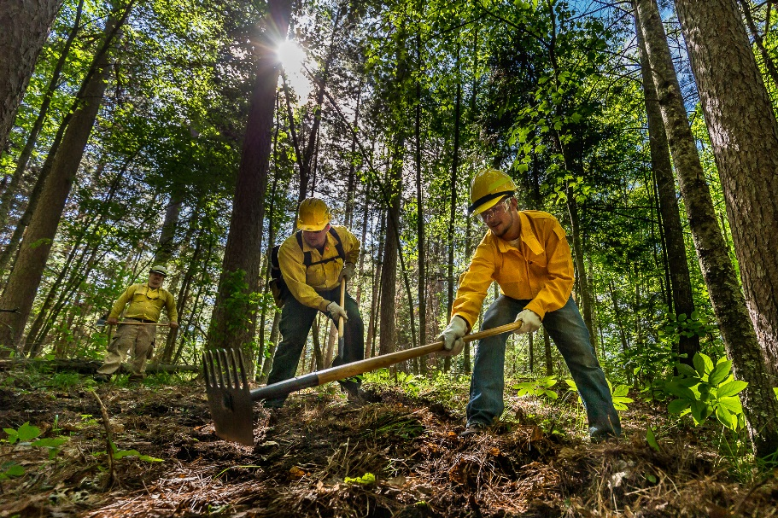
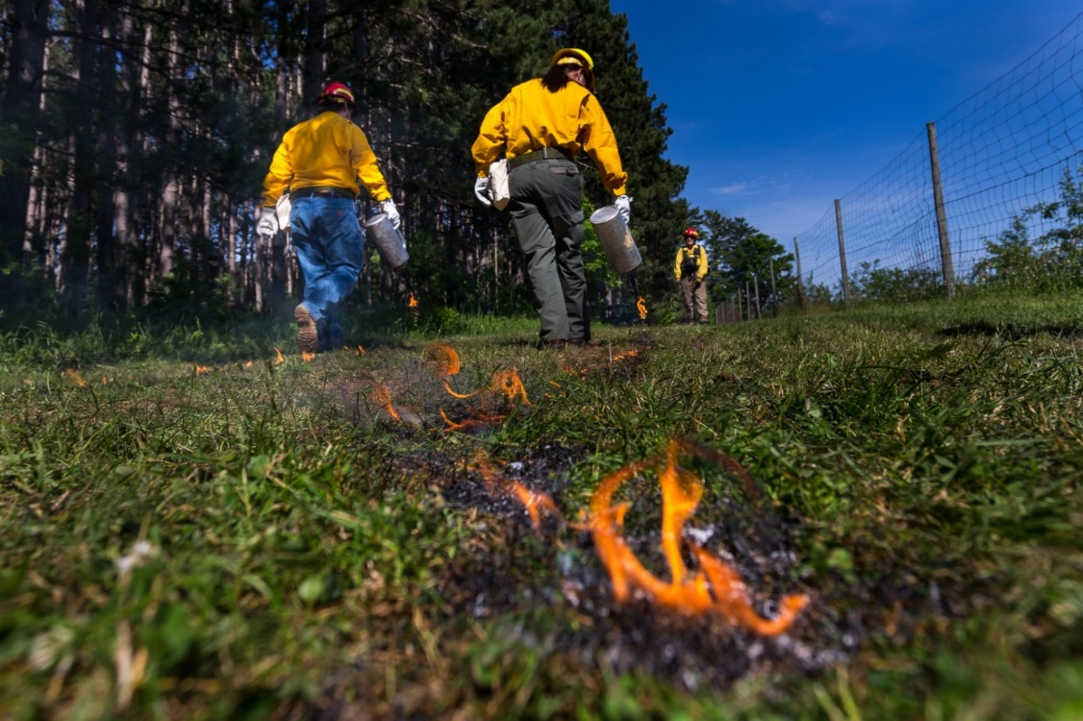
Photo Credit: Mark Erickson
Public Information Officer
I

WILDLAND FIRE ACADEMY
JUNE 5-9, 2017
Minnesota INCIDENT MANAGEMENT TEAM
Mike Aultman, INCIDENT COMMANDER

Wildland Fire Academy
June 5 - 9, 2017
MN Incident Management Team
Mike Aultman

COMMAND

Assigned Tasks:

What went well:

Opportunities for improvement:

…Mike Aultman

SAFETY / MEDICAL

Assigned Tasks:

What went well:

Opportunities for improvement:

…Doug Miedtke

LIAISON

Assigned Tasks:

What went well:

Opportunities for improvement:

…Dave Snetsinger

INFORMATION

Assigned Tasks:

What went well:

Opportunities for improvement:

…Tim Engrav

FINANCE

Assigned Tasks:

What went well:

Opportunities for improvement:

…Brenda Miles

LOGISTICS

The Academy was held at the Itasca Community College (ICC). The campus had plenty of room to support all IMT functions including classes, support trailers and supply area with room for field exercises on adjoining property of the U of M and Trout property.
The Logistic section operated with a fully functioning Facilities, Ground Support, Communications, Food and Supply units fully staffed by qualified individuals. In addition, the Logistics section had 2 LSC2 trainees, as well as a four person CCMI crew.

What went well:
Food Unit:
- Received timely 213’s for field lunches for the most part
- Outdoor tent is now an essential resource for this academy
Supply:
- Bringing in the Cache Van in support of the Academy was a good move. Greatly reduced the need for so many additional resource orders throughout the week.
Facilities:
- Very few facilities issues. This facility and all the resources available in the Grand Rapids area were a great asset.
- ICC, USDA, U of M staffs were extremely accommodating and great to work with.
Ground Support:
State locks on gates
- MIFC drivers and vehicles to support logistics
Communications:
- Communication trailer was well set-up
- During the IWI the radio patch with the county worked well
- Pre-briefing about the IWI scenario with the communications team members was helpful.
CCMI Crew:
Having a CCMI crew for use by Logistics Section is essential and they provided great support for Ground Support, Facilities and Food Units. Great Job.

Opportunities for improvement:
- Lead instructor pre-orders needs to get sent out earlier than this year and submitted back to MIFC in a more timely fashion. We should attach the electronic General Message forms so that all requests come in in the proper format. Requests should be broken down on the General Message so that Supplies needed, course materials needed and procurements are not all bunched up on one general message.
- Planning for the Academy should start a bit earlier than we got going this year.
- An additional 4 sand tables should be available for use at the Academy.
- Need to develop a more comprehensive map of the field locations that includes newly established drop points, toilet and wash station locations for field locations.
- Purchase of some rigid sign board materials would be helpful to improve some of our misc. signing needs.

OPERATIONS

Assigned Tasks:

What went well:

Opportunities for improvement:

…Kurt Schierenbeck

Air Operations

Assigned Tasks:

What went well:

Opportunities for improvement:

…Bill Schuster

PLANS

Incident Schedule
0630 Start of shift
0700 Operational Briefing
1200 Command and General Staff meeting
1530 Tactics/Pre-planning meeting
1700 Planning Meeting/Evening briefing

Assigned Tasks:

What went well:

Opportunities for improvement:

…Jeremy Fauskee

2016 Minnesota Wildfire Academy (MN-MNS-716055)
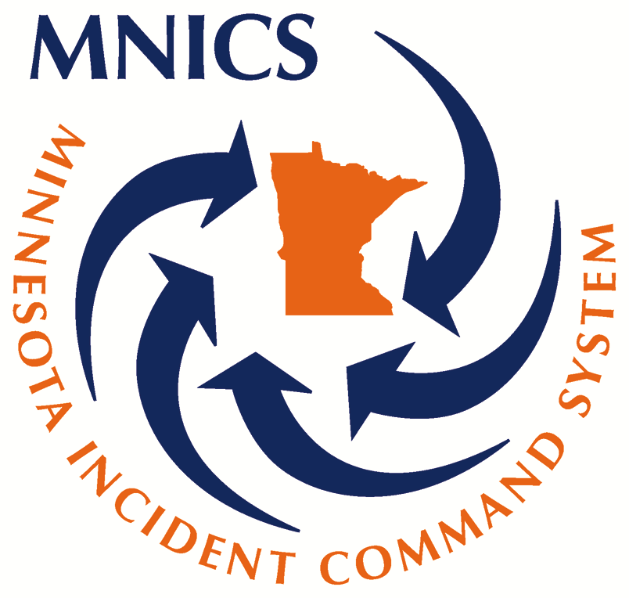
June 5, 2016 to June 10, 2016
Comments & Recommendations
- Academy provided an excellent opportunity for trainees to hone their skills, while working on Position Task Book
- Academy Coordinator did an excellent job by providing quality courses and opportunities for IMT trainees
- Inclusion of a Training Specialist (TNSP) on the IMT allowed Academy Coordination to focus on the academy needs
- Utilize the Eastern Area Priority Trainee List to identify more trainees for the Academy IMT
Matt Dillon, Incident Training Specialist (TNSP)
(610) 420-9911 Cell

Trainees by Position
Name | Position | Agency | * End PTB Rating | % of PTB Complete | Total Days Assigned
Bombeck, Ronald | MEDL | State | 2 | 91 | 8
Bourquin, Elizabeth | SCKN | State | 6 | 100 | 2
Calder, Nancy | COST | State | 2 | 59 | 5
Carlson, Robert W | MEDL | State | 2 | 98 | 6
Edelman, Donna | COST | State | 2 | 53 | 6
Edelman, Donna | TIME | State | 1 | 100 | 6
Eisenrich, Wendy | RADO | FS | 2 | 100 | 8
Engrav, Timothy J | PIO2 | FS | 2 | 25 | 5
Erickson, Markus | PIO2 | State | 1 | 100 | 6
Gaalaas, Karl J | MEDL | State | 2 | 91 | 8
Halvorsen, Marlyn J | LOFR | State | 2 | 71 | 6
Jenkins, Brian S | ICT2 | FS | 2 | 46 | 8
Johnson II, Joseph D | ITSS | State | 6 | 100 | 6
Larson, Juanita | RADO | State | 5 | 0 | 5
Lauer, Edward J | LSC2 | State | 2 | 100 | 8
Monroe, Lyn M | ABRO | State | 2 | 100 | 3
Mursu, Chris R | RESL | FWS | 6 | 100 | 6
Nelson, Dustin | ASGS | State | 2 | 98 | 6
Olsen, Shawn | HEB2 | State | 5 | 0 | 6
Pollard, Matthew T | RCDM | State | 1 | 100 | 6
Powers, Christi A | PIOF | State | 2 | 56 | 7
Rengo, Jeff | SOF2 | State | 2 | 29 | 8
Robertshaw, Becky | ORDM | FS | 2 | 81 | 8
Schlitz, Michael | SCKN | State | 1 | 100 | 5
Schumacher, Stephen | SCKN | FWS | 1 | 100 | 5

Trainees by Agency
 | Minnesota DNR | USDA Forest Service | US Fish & Wildlife | Grand Total
Command | 4 | 2 |  | 6
Finance | 3 |  |  | 3
Logistics | 6 | 2 |  | 8
Operations | 3 |  |  | 3
Plans | 3 |  | 2 | 5
Total | 19 | 4 | 2 | 25

* END PTB RATING
- The trainee has successfully performed all tasks in the PTB for the position.
- The tasks have been performed in a satisfactory manner. However, opportunities were not available for all tasks (or all uncompleted tasks) to be performed and evaluated on this assignment. An additional assignment is needed to complete the evaluation.
- The trainee did not complete certain tasks in the PTB in a satisfactory manner and additional training, guidance, or experience is recommended.
- The individual is severely deficient in the performance of tasks in the PTB for the position and additional training, guidance, or experience is recommended prior to another training assignment.
- Trainee/Trainer did not complete the training documentation package with the Training Specialist.
- Trainee completed PTB, but requests an additional assignment.

