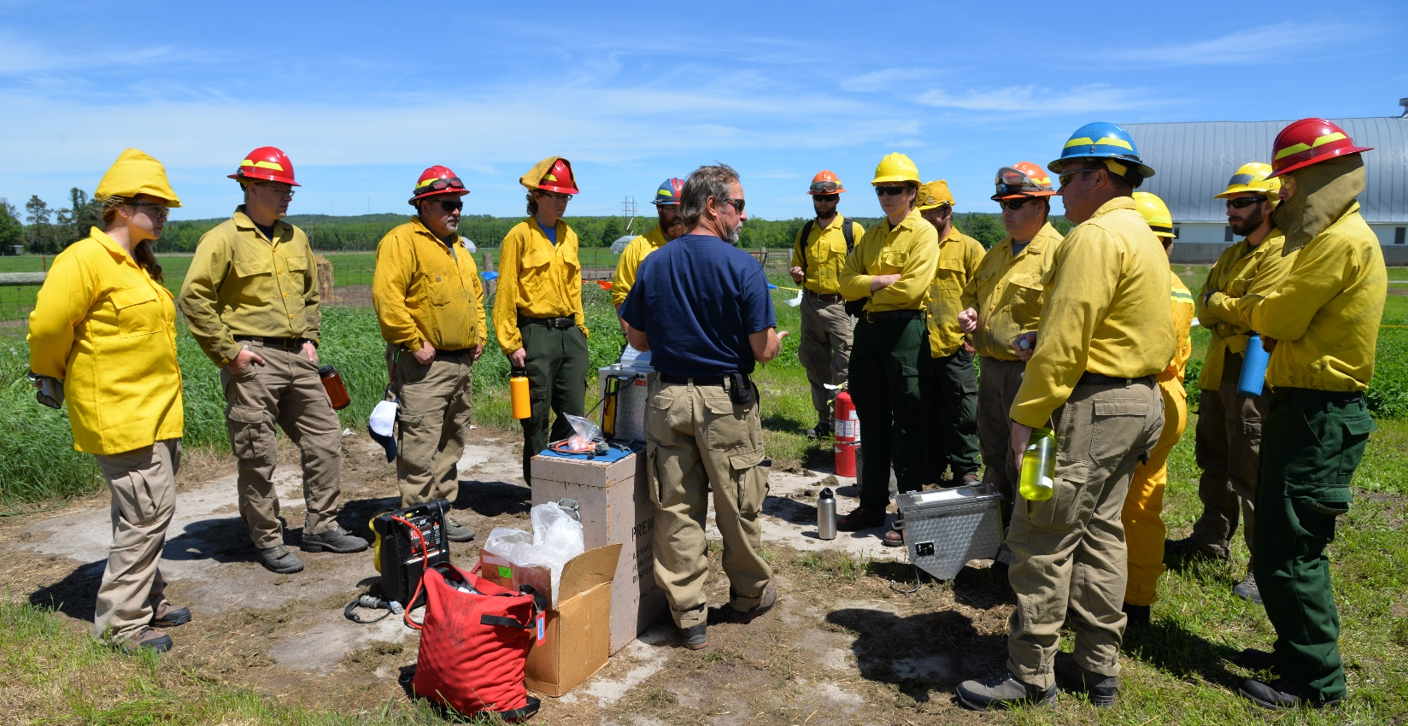
Minnesota Wildfire Academy
June 4-8, 2018
Minnesota Incident Management Team
Mike Aultman, Incident Commander
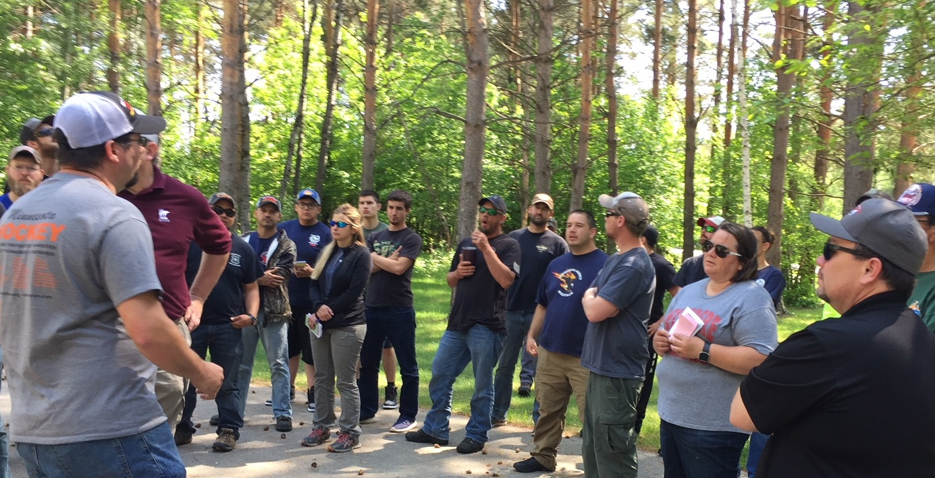

COMMAND
In-briefing was received at Minnesota incident fire center by Todd Manley MNICS Training Coordinator June 1th at approximately 0930. The Delegation of Authority was received from Todd Manley and signed by MN Incident Management Team IC Mike Aultman.

Academy classes began on June 5th and consisted of 31 separate classes which ran over the course of the week. Total Classroom Contact Hours (#students x course hours) totaled 11,576 hours and class registration was 69% of capacity (actual students/potential students: 685/1015).

There were 670 course registrations with a total of 500 different students that attended the Fire Academy. Participants from Minnesota included individuals from MN DNR (numerous Divisions), Chippewa and Superior National Forests, Voyageurs NP, Numerous Tribal entities and BIA, Numerous USFWS Units, Numerous MN Fire Departments, The Nature Conservancy, Conservation Corps of MN, Camp Ripley and MN Dept of Transportation. Out of state participants came from WI DNR, Ottawa NF (MI), Chequamegon-Nicollet NF (WI), Mark Twain NF (MO), USFWS – South Dakota, Florida, Virginia, Iowa, Texas and New York.

There were 91 instructors that led the 31 courses offered. Instructors came from MN DNR 53, USFS 26 (CPF, SUF, CNF), BIA/Tribal 1, MN HSEM 1, BLM 2, National weather service 2, FWS 5 and PVT 2.

During the course of the week, 29 trainees were utilized to fill the positions on the IMT. Sections with trainees Plans 5, Logistics 8, Operations 2, Air operations 4, Finance 3, Liaison 2, Public Information 4 and safety 1. Of the 48 positions assigned in the IMT, 1 also assisted as a classroom instructor and 2 of the IMT members were also students at the academy.

Total estimated cost of the 2018 Minnesota Wildfire Academy is $365,830.

The Delegation of Authority was transferred back to MNICS at 0900 Saturday, June 9th^{th} 2018.

What went well:
- The continued use of the IMT proved beneficial to the coordination of the Academy. Based on complexity indicators such as number of personnel and length of assignment, the Academy meets many of the indicators of a Type II.
- The use of parking flaggers in the morning reduced congestion and parking issues over the course of the week.
- The short haul exercise went well and was a good demonstration of the process. Considerable discussion occurred prior to the exercise regarding the planning process used for this exercise. Integrating the team into this exercise for the short haul on Tuesday and again on Thursday tested the team’s Incident Emergency Plan (IEP) and the team’s performance in the implementation of the plan.
- The Teams ITSS section in plans work well with Itasca community college in the loading of computer software needed to run each class
- Utilization of the Training room at University Of Mn. Work well.
- The new registration system at ICC using community ed. Work well.
- Dedicated tactical channels for the incident within an incident class and all other classes that requested them proved to be a good communication plan
- Placing the code of conduct in all classrooms was a success.
- Operations course summary chart replacing 215 work out very well.
- Housing the instruction boxes at MIFC adding material requested by instructor and instruction materials work well.

Opportunities for improvement:
- Instructors need to provide an outline for all field classes, giving locations and activities by day.
- Suggest 2 Division Supervisors or Division Supervisor trainees to be attached to operations.
- Match classrooms to class sizes and technology needed in the class.
- Some classrooms were marginal for the size of class and needs of instructor
- Fans needed for classrooms, especially Liberal Arts building, and the air conditioning needs to be activated on Sunday to cool the rooms off before students arrive.
- Prerequisites need to be checked by sending agency before students are accepted into the class.
- Three planning meetings for the team. One four weeks prior to academy, the second two weeks prior and final meeting the Friday before.
- The Instructor needs list will need to be given to Operations and logistics’ at the meeting 4 weeks before academy.
- Conference call needs to be conducted with Academy coordinator, IC and lead instructors
- Mandatory that Lead Instructors or a representative needs to attend each briefing
- Lead instructors need to take advantage of the opportunity to review the contents of their instructor bins before academy

…Mike Aultman ICT2

Safety
Assigned Tasks:
- A safety message was prepared for the IAP and communicated to the instructors at the daily operational briefings.
- Safety conducted incident briefings for 685 students in 32 classes.
- Monitored classroom and field course activities to ensure that safe practices were being followed.
- Worked with Logistics and Liaison to ensure that vehicles were following posted speed limits and parking in approved areas. CCM crew members directed incoming vehicles to parking areas. Identified lower parking area before dorms for Engines, Crew Carriers, and other large Agency vehicles. A vehicle speed indicator sign was set up to slow traffic.
- Coordinate with USDA-FS, Northern Research Station to identify employees from this on campus agency to allow traffic coordinators to remove barrier cones and wave them through to their office.
- Reviewed the medical plan .
- Emergency Response Procedures document was provided for IAP so that everyone was aware of procedures to follow in the event of severe weather, fire, or terrorist threat events.
- All assigned resources were briefed on expectations of conduct for all assigned personnel not only during operational periods but also during off-duty periods.
- No serious injuries or accidents were reported at the time this document was prepared.
- As per last year’s medical accident/injury issues hydration and tick bite prevention was stressed and bug dope and water were provided for field going classes.
- Safety monitored aviation briefings related to Incident Within Incident Management training and participated in the training scenario.
- Monitor weather and communicate severe weather alerts to the field through communications.

What went well
- Identification of USDS-FS Northern Research Station employees so they could smoothly get waved past parking control to their office. This was done with contacting Randy Kolka, Director, about the dates of the fire academy and recommending an eight by eight card for the employee to display as they approach the traffic control personnel. The Cards said: USDA-FS, Northern Research Station, Employee.
- Talk with lead instructors to verify date/time/location of field exercises and a description of planned activities. With a shortage of Safety Officers, we prioritized highest risk field exercises for Safety to monitor and assured medical support for lower priority field activity.
Opportunities for Improvement
- Spend more time pre-planning and coordinating events affecting field courses so that class instructors and the overhead team are fully supportive and informed.
- If possible, have more complete information from instructors regarding days in field, time/day for exercises, and location for field exercises.
- If possible, make sure personal computers can connect with team printers.
- Staff Safety with two fully qualified SOF2 and one trainee or if available use two SOF2 (t) and one fully qualified SOF2.
- Make sure ALL CLASSES doing simulated training exercises make sure OPS/SOF know the exercise is taking place and broadcast that their IWI is a training exercise.

….Scott Belknap – SOF2, Dan Nesgoda – SOFR (t)

Liaison

Assigned Tasks:
- Prepared and delivered a hand-out to area hotels that contained some brief information explaining the Academy, along with Liaison contact information if there was a problem with a student. Follow up visits were conducted. Any issues with student conduct were reported and issues were dealt with.
- Requested a Radar Sign for the entrance of the school from the Grand Rapids Police Department.
- Requested a Portable Changeable Message Sign from MNDOT to be place on Hwy 169 near the entrance of the school.
- Requested a Fire Department Water Tender to fill dump tanks. Also requested a Rescue Mannequin for the Incident within an Incident Class field exercise. A stokes basket and sked was requested from MEDS1 in Grand Rapids.
- Land Use Agreements were enacted with Wes Trout, University of Minnesota and Arbo Township. We provided Public Notification for the Urban Interface Class field exercise.
- Investigated and documented a hit and run parking lot accident. A report was prepared and delivered to Finance.

What went well:
- We had great cooperation with the City of Grand Rapids Police Department, Grand Rapids Fire Department, and the University of Minnesota North Central Research/Outreach Center. We also had great cooperation with Mn Dept. of Transportation and MEDS1.
- The interaction with the hotels was great. It shows that we care about the community.
- The Wildfire Academy was a great opportunity to provide training for team members.
- The IMT participation in the Incident within an Incident was a good experience for all.

Opportunities for improvement:
- Initiate the Land Use Agreements with Arbo Township earlier, preferably for their May meeting.
- Request the Portable Changeable Message Sign from MNDOT earlier.
- Request Forest Officers for patrol of NW 24th Street, road to the Trout Gravel Pit Gate.
- Initiate and coordinate with an independent group (ex. HSEM and other Subject Matter Experts) to assist with evaluating the IM team, Incident with-in an Incident teams exercise by following an (EEG) Exercise Evaluation Guide to create an AAR/IP for the exercise.

…Dave Snetsinger, Marlyn Halvorson and Jeff Mayer

Information
Staff: The Public Information Officer team was staffed with Jean Goad, Lead PIO2. Helen Cozzetto and Mary Nordeen, PIO2-Trainees, and Jenny Benes and Val Cervenka, PIOF-Trainees, made up the team. Michelle Heiker, PIO2-Trainee, assisted Thursday.

Assigned Tasks:
The Information office was set up in the Student Center one day prior to the start of the Academy. Computer access was checked, printers installed, sales area and bulletin boards set up. Goad provided orientation and direction for the week, setting up a rotating schedule of PIO duties. Identified tasks included morning briefing, writing daily update, attending meetings, photography and social media, news release, media contacts and tours. The team also shared duties covering the sale of MNICS t-shirts and hats.

Daily updates were posted on the mnics.org website and the team used the @mnics Twitter and Facebook accounts to post daily training exercises. Media contacts were made and two local media toured with a PIO team member, including KOZY radio and Lakeland television.

What went well:
The Wildfire Academy provided an excellent training opportunity for both PIO2- and PIOF-trainees. The team appreciated the rotating tasks to help cover task book elements, including setting up an Information Center, writing news releases and daily updates, and participating in ICT meetings.
The team was able to tie in with the Itasca Community College communications and post photos (via powerpoint) on the monitors located throughout campus. Photographs from the week were also compiled, burned to CDs and shared. This was a strong team in communicating with students, instructors and other team members.

Team provided updates and a news release every day, provided a media advisory and article for Grand Rapids Herald. Forrest Boe, MN DNR Director of Forestry, visited the Information Center. We counted hundreds of visitors coming through the Information Center with questions and to purchase items. Sold several thousand dollars in merchandise.
The Information Team appreciated all the interaction and cooperation of the other IMT sections.

Opportunities for improvement:
For future years, a specific person should be assigned to work with the t-shirt sales through MNICS and Minnesota Forest Employees Association. The store provided an opportunity to connect with students and instructors, but it also interrupted other PIO work and team meetings.
Bring in more posters, items for the bulletin board ahead of time to make it a quick update each morning. (Facts about the Academy, safety items, HR items, other training ops and local news clippings.)
Do a more concentrated media blitz the week before the training.
The 2017 narrative noted creating a trapline to the local hotels and Grand Rapids Chamber/Visitor Bureau. This is a good idea to pursue via sending email updates. A physical trapline would be great public relations in the community but would require additional personnel dedicated to the trapline.

…Mary Nordeen, PIO2 trainee

FINANCE

Assigned Tasks:
- Time was recorded for IMT members, Academy Lead Instructors and Unit Instructors, CCM crews
- CTR’s were turned in and entered into E-Isuite. All Instructors and Team members checked-in with Status Check-in Recorders.
- All instructors entered into E-Isuite as THSP’s and listed under a block of resource order numbers starting with 100. This worked well because we can run reports on just this position and get the cost of the instructors.
- OF-288’s printed only if requested
- Provided training opportunities for two PTRC trainees and one FSC with taskbooks.
- Costs were entered into e-isuite for IMT personnel, instructors, and 2 CCM crews. Other Support Costs were tracked separately on a spreadsheet for supplies purchased, IWIN Cadre, Cache consumed, Cache personnel time, portable toilets, tent, ice freezer, and food and Aircraft costs. Aircraft costs turned in but no charge so not included in e-Isuite costs.
- Daily Cost Summary submitted to IC daily
- Detailed Cost Summary at end of Incident
- Participated in one IWIN exercise
- No student/local vendor payment issues needed resolved
- No comp or claims issues needing resolved by Finance
What went well:
- Procedure in place for All Instructors and Team members to check-in through ICP was a good idea. It is much easier to enter them into e-Isuite to do time and costs. Agency is necessary to enter in e-Isuite.
- All Instructors came through check-in to demob so costs will not continue to roll over in e-Isuite.
- Finance Message was put in IAP with CTR instructions
- It really helped in Finance to have a dedicated PTRC the whole week. Last year I had 2 trainees but neither were able to be there the whole time so I ended up doing that job as well as COST and FSC.

Opportunities for improvement:
- CTR’s are put in the class folder so we are not receiving them before they demob. Then when we finally get the CTR, we have to go into e-Isuite and check them back in before we can enter the time and then demob them again. Recommend that CTR’s be turned in daily to Finance and NOT put in the folder outside the classroom.
- Lead instructors need to make sure all their Unit instructors actually do check-in.
- It seems that people aren’t treating this like an actual incident and they know they don’t need the OF-288’s to get paid, so they are lax in making sure CTR’s are signed.
- Would like to get known costs earlier in the week such as: CCM contract, tent, food, supplies purchased, portable toilets, ice freezer, IWIN cadre
…. Brenda Miles, FSC2

LOGISTICS
The Academy was held at the Itasca Community College (ICC). The campus had plenty of room to support all IMT functions including classes, support trailers and supply area with room for field exercises on adjoining property of the U of M and Trout property. The Logistic section operated with a fully functioning Facilities, Medical, Ground Support, Communications, Food and Supply units fully staffed by qualified individuals. In addition, the Logistics section had 1 LSC2 trainee, 1 ORDM and 2 RCDM trainees as well as an 8 person CCM crew.

The Medical Unit was opened on 6/4/18 and was staffed with 4-5 EMT’s each day. Two quick response vehicles equipped for trauma. There were 10 minor incidents of which 9 were walk ups. One incident was in the field. The Medical Unit had 1 eye irritant, 3 common cold, 1 nose-bleed, 1 sore throat, 1 toothache, 2 lacerations and 1 poison ivy. All were minor and non-reportable

Assigned Tasks:
- Order and set up meeting tent, portable toilets, cache vans, team trailers and ICP to support incident base
- Assemble and distribute course materials and ensure that classrooms are ready for classes to start
- Support ongoing logistical needs including supply, food, communications, facilities and ground support

What went well:
Food Unit:
- Received timely 213’s for field lunches for the most part
- Outdoor tent is now an essential resource for this academy
- 2800 meals were served (2450 hot meals)
Supply:
- Bringing in the Cache Van in support of the Academy was a good move. Greatly reduced the need for so many additional resource orders throughout the week.
Facilities:
- Very few facilities issues. This facility and all the resources available in the Grand Rapids area were a great asset.
- ICC, USDA, U of M staffs were extremely accommodating and great to work with.
Ground Support:
- State locks on gates.
- MIFC drivers and vehicles to support logistics
Communications:
- Communication trailer was well set-up
- Pre-briefing about the IWI scenario with the communications team members was helpful.

CCM Crew:
- Having a CCMI crew for use by Logistics Section is essential and they provided great support for Ground Support, Facilities and Food Units. Great Job.

Opportunities for improvement:
- Continue to emphasize that timely written General Messages are essential
- Meal tickets should be provided for all meals
…….William Lauer, LSC2 and Peter Pappas, LSC2-t

OPERATIONS

Assigned Tasks:
- Provide operational support for course instructors, support personnel, IMT, and all resources assigned to the academy.
- Monitor all classes, outdoor field exercises and aviation operations ensuring they are conducted efficiently and safely.
- Communicate with entire C&G to fully meet the requirements as requested and identify SOP’s since many tasks and responsibilities are not “classic” operational efforts.
- Fulfill Operational roles and responsibilities related to real and simulated incidents and scenarios.

What went well:
- Staffed with OSC2, OSC2 (t), 1DIVS, and 1 DIVS (t). Adequate but 1 additional DIVS would provide better coverage for instructor interaction.
- Briefing @ 0700, most of the instructor's attended 1 or more of these briefing.
- Obtaining complete roster information requiring student names, address, phone number and home agency for accountability purposes.
- Utilizing folders outside classrooms for academy correspondence worked exceptionally well. Provided for two way communications between instructors and IMT.
- Having the communications plan preloaded prior to this event eliminates last minute scrambling for frequencies etc.
- Updating the IAP as needed worked well.
- Great mix of agency instructors.
- The “tracking” spreadsheet worked well as a modified 215. The modified 215A also worked well.
- Incidents within the Incident scenarios went well and are extremely valuable to the students and the IMT.
- The “C&G” Staff Incident Emergency Action Plan & Check List” worked well.

Opportunities for improvement:
- Provide each lead instructor with meal tickets for their entire class. They can distribute accordingly based on daily number of students.
- Letter to all the students needs much improvement! The letter's failed to include correct start times, pre-work information, etc.
- One classroom, Davies 233, was determined to be unsuitable for class instruction that requires group exercises that require multiple tables together. D-312 Aircraft Dispatch, ICS 300 and ICS 400 submitted a 213 indicating this situation.
- Assign a pre-determined number of slots for each agency for all classes instead of first- come- first served. Hold for a specific length of time and then open to all agencies.
- Some instructors were asked late (springtime) concerning availability for instruction. Contacting potential instructors early allows for quality preparation time.
- Assign DIVS to specific Divisions (aka groups of classes) for the entire week. Each 204 would have one DIVS.
- The Tracking Spreadsheet (modified 215) worked well but can be easily improved and include added functionality for 2018.
- Identify more “back-up” or unassigned classrooms for the inevitable changes and unexpected issues.
- What is the true carrying capacity of ICC, Grand Rapids, and the MNICS Agencies to support the MN WF Academy? More analysis by Training WT and Task Force is needed.

…Submitted by Kurt Schierenbeck OSC2 and Ron Guck OSC2(t)

Air Operations
Assigned Tasks:
- Briefed/familiarized approximately 170 people (students, team members, visitors) on aviation operations.
- Conducted an All Risk Aviation Exercise that involved DNR Forestry, Enforcement, MN State Patrol, and LifeLink III aircraft. This included a short haul demonstration to support the IWI class exercise.
- Facilitated an after action review of the All Risk exercise with all parties involved. The AAR continues to provide good information and feedback from the aviation cooperators, which has been instrumental in safe, efficient operations.
- Air Operations participated/assisted in the Academy’s Initial Attack Drill utilizing Air Attack 1, 2 – Fireboss aircraft, and a Type 3 Helicopter, 19BH.
- Briefed D-312 class on coordination between dispatch and air ops.
- Performed a live external load field exercise with the helicopter to support A-219.

What went well:
- Opportunity for helibase setup on Friday June 1st.
- An All Hazard Aviation Exercise was conducted in support of the IWI class. The exercise involved DNR Forestry, Enforcement, MN State Patrol, and LifeLink III. This exercise continues to provide great value to all parties involved.
- This year we had three members of the MNARNG present to observe the aviation component of the IWI exercise on Tuesday.
- Coordination with U of M staff on use of facilities and grounds. U of M staff was a great help to our operation again this year.
- Having the grass mowed adjacent to the helibase to meet the needs of the classes for hands on training.
- Having a dedicated Aircraft Base Radio Operator (ABRO)
- Having the two port-a-johns and hand wash station at the helibase again for this year.
- Utilizing Interagency/USFS aviation staff to help provide staffing at the helibase.
- Coordination with Logistics was very effective and efficient.
- Posted a NOTAM D for the week of the academy to advise general aviation traffic utilizing Grand Rapids Airport of the academy aviation operations.
- Posted fliers at the Grand Rapids Airport to raise awareness of academy aviation ops.
- Completed a Project Aviation Safety Plan (PASP) for all academy aviation exercises.
Opportunities for improvement:
- Continued use of dedicated HEB2 and ABRO. The use of a carded aircraft dispatcher is also an option if an ABRO is not available.
- Begin planning process to pre-identify helibase staff earlier in the spring.
- Continued coordination with airport traffic for aviation exercises. Notams’, etc.
- Continued earlier communications with U of M staff on ground use and layout for the Helibase.
- Establish trigger points for the ordering of aircraft during the aviation based IWI exercise. This will ensure the exercise stays within the established timelines.

…Rob Johnson, ASGS(T)

Plans

Incident Schedule
0700 Operational Briefing
1200 Command and General Staff meeting
1530 Tactics/Pre-planning meeting
1700 Planning Meeting/Evening briefing

Assigned Tasks:
- Track all instructors, camp crews and IMT members in I-suite.
- Facilitate efficient meetings and briefings.
- Participate in Incident Within an Incident exercises and AAR.
- Set up and take down ICP network, printers and I-suite.
- Provided maps and technical support to instructors and IMT as needed.
- Complete IAP daily
- Organize IMT documentation
- Provide opportunity to trainees to participate on Type 2 IMT.

What went well:
- Begin setting up the ICP on Friday
- Meeting and IAP schedule continued to work well
- Section make up was ideal. (PSC, RESL, SCKN, 2 ITSS/GISS, TNSP)
- Good, quality training opportunities for Section staff. This year, all but the PSC was a trainee.
- Having instructors request IT needs through one ITSS using text message. ITSS can then contact ICC staff if needed.
- Checking in with each classroom to see if there are any IT needs.
- Having a separate room for meetings that can hold 25+ people and has a projector.
- Having a map plotter on site.
- Having a QR code on maps and class list for PIO/CCM
- Ensure ICC internet ports are open to allow for remote I-suite database and ROSS import
- Connecting I-suite to St. Paul server worked well.
- Using hardwire ICP network and not router.
- The event had 29 trainees with at least 1 receiving a final evaluation. The breakdown of trainees were as follows: Command Staff – 7, Operations – 6, Plans – 5, Logistics – 8 and Finance – 3

Opportunities for improvement:
- ITSS have ability to conduct ROSS “dump”.
- Better define and communicate who was to check in, and why, early in the week.
- Clearer understanding of Finance information needs at check in.
- Find a more reliable plotter to bring to ICP. Newer copier/printers in team kits.
- Get ability to scan to USB and print from USB
- Identify how missing or new Course Certificates are to be generated before Academy
- Use Intent Based Planning Process (L-481) well before the week of the Academy
- Have knowledgeable mentor available for all trainees.
… Jeremy Fauskee, PSC2

