Incident Name:  Highline  ID-PAF-000159 | IR Interpreter(s):  Tina Rotenbury  trotenbury@fs.fed.us | Local Dispatch Phone:  Payette Dispatch  208-634-2757 | Interpreted Size:  Highline 20,307 acres  Goat 21 acres  Growth last period:  Highline 1,914 acres  Goat – Initial Mapping
Flight Time:  0211 & 0223 MDT  Flight Date:  08/21/2017 | Interpreter(s) location:  Russellville, AR  Interpreter(s) Phone:  479-886-0878; 479-967-8681 | GACC IR Liaison:  GACC IR Liaison Phone: | National Coordinator:  Tom Mellin  National Coord. Phone:  208-387-5900  505-301-8167
Ordered By:  IDPDC | A Number:  A-17 | Aircraft/Scanner System:  N144Z /Phoenix | Pilots/Techs:  Pilot: Ramsey/ Boyce  Tech: Kaz
IRIN Comments on imagery:  Two flight paths for main fire. Clear, cloud free image. 1 flight path for smaller fire |  | Weather at time of flight: Clear | Flight Objective:  Heat detection
Date and Time Imagery Received by Interpreter:  08/21/2017 0311 & 0324 MDT |  | Type of media for final product:  PDF map, zipped shapefiles and KMZ files  Digital files sent to:  http://ftp.nifc.gov/incident_specific_data/great_basin/2017_Incidents/Highline/IR/201708121
Date and Time Products Delivered to Incident:
08/21/2018 0645 MDT
Comments /notes on tonight’s mission and this interpretation:
Started with IR perimeter from 20170820 IR files. Highline Main perimeter 20,307 Acres / Goat 21 Acres
Lots of activity on the east and south of perimeter, with areas of intense heat where burnout is occurring.
More spots of isolated heat on the north side of perimeter.
Scattered heat throughout interior of perimeter
Isolated heat between perimeters in the area north of Stone Breaker Ranch
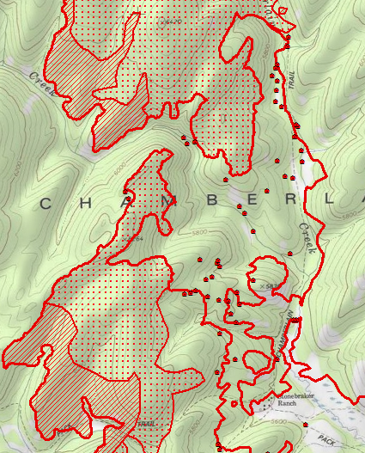

Goat – has intense heat around perimeter with some isolated heat as well.

