Incident Name:  Powerline  (ID-FHA-000158) | IR Interpreter(s):  Tammy Hocut  thocut@fs.fed.us | Local Dispatch Phone:  Missoula (406-829-7040) | Interpreted Size:  52,017 Acres  Growth last period:  (860) Acre decrease due to more accurate fire perimeter from incident
Flight Time:  2114 MDT  Flight Date:  08/07/2017 | Interpreter(s) location:  Jasper, AR  Interpreter(s) Phone:  870-446-5878 | GACC IR Liaison:  Nate Yorgason  GACC IR Liaison Phone:  435.590.1107 | National Coordinator:  Melinda McGann  National Coord. Phone:  208.387.5900
Ordered By:  Lance Brady | A Number:  105 | Aircraft/Scanner System:  N144Z/Phoenix | Pilots/Techs:  Nelson/Boyce/Mike Mann  (IR Tech)
IRIN Comments on imagery:  Good imagery – 3 Flight Lines |  | Weather at time of flight  Clear | Flight Objective:  Map heat perimeter, intense, scattered, and isolated heat
Date and Time Imagery Received by Interpreter:  August 7, 2017 @ 1022 MDT |  | Type of media for final product:  Pdf map, IR log, KMZ and shapefiles  Digital files sent to:  http://ftp.nifc.gov/incident_specific_data/great_basin/2017_Incidents/Powerline/IR/  email blm_id_eiifc_dispatc@blm.gov
Date and Time Products Delivered to Incident:
August 7, 2017 @ 1110 MDT
Comments /notes on tonight’s mission and this interpretation:
Started interpretation with shapefile provided by GISS at fire. Fire perimeter was updated with caused a reduction in acres due to more accurate mapping.
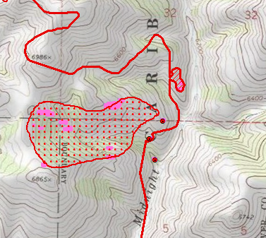
Light activity on the fire. There was only one small area of growth on the east side of the fire in sections 5 and 32 near Midnight Creek.

There are several isolated heat sources outside the main fire perimeter at the following coordinates:
East side of fire - 112°30'28.52"W 42°45'33.277"N
112°31'23.363"W 42°41'10.559"N
112°31'52.149"W 42°38'34.9"N
112°32'17.247"W 42°38'42.523"N
West side of fire - 112°34'58.545"W 42°37'11.942"N
112°34'54.806"W 42°37'25.718"N
112°35'13.976"W 42°39'31.166"N
112°39'17.15"W 42°45'5.884"N

