INFRARED INTERPRETER’S DAILY LOG

Incident Name:  Tappan  ID-SCF-017169 | IR Interpreter(s):  Tammy Hocut  thocut@fs.fed.us | Local Dispatch Phone: Central Idaho 208.756.5157 | Interpreted Size:  1350 acres  Growth last period:  0 acres
Flight Time:  2338 MDT  Flight Date:  08/11/2017 | Interpreter(s) location: Jasper, AR  Interpreter(s) Phone: 870.446.5878 | GACC IR Liaison: Nate Yorgason  GACC IR Liaison Phone: 435.590.1107 | National Coordinator: James Grace  National Coord. Phone: 208.870.5066
Ordered By:  Jessica Martin | A Number:  7 | Aircraft/Scanner System: N144Z/Phoenix | Pilots/Techs:  Pilot: Johnson Pilot: Boyce Tech: Mann
IRIN Comments on imagery:  Good imagery – one run. |  | Weather at time of flight:  clear | Flight Objective:  Identify and map Heat perimeter, Scattered Heat and Isolated Heat Sources
Date and Time Imagery Received by Interpreter:  08/12/2017 @ 0001 MDT |  | Type of media for final product:  Shape files, KMZ, PDF, and IRIN Log  Digital files sent to: http://ftp.nifc.gov/incident_specific_data/great_basin/2017_Incidents/Tappan/IR/  idcic@fs.fed.us
Date and Time Products Delivered to Incident:
08/12/2017 @ 0150 MDT

Comments /notes on tonight’s mission and this interpretation:
- Started interpretation with 08/10/2017 IR heat perimeter – No change in acres.
- Just a few isolated heat sources in the north – northwest part of the fire.
- An isolated heat source outside the main fire perimeter at 114°43'14.312"W 44°53'52.603"N and at 114°43'14.312"W 44°53'52.603"N. Both are on the northwest side of the fire 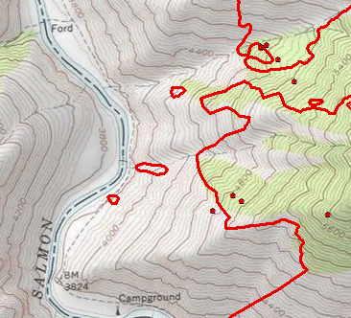
- There is also an isolated heat source on the northeast side of the fire that is outside the main fire perimeter at 114°41'57.633"W 44°54'26.986"N
- 