INFRARED INTERPRETER’S DAILY LOG

Incident Name:  Tappan  ID-SCF-017169 | IR Interpreter(s):  Tina Rotenbury  trotenbury@fs.fed.us | Local Dispatch Phone: Central Idaho 208.756.5157 | Interpreted Size:  1350 acres  Growth last period:  0 acres
Flight Time:  0159 MDT  Flight Date:  08/19/2017 | Interpreter(s) location: Russellville, AR  Interpreter(s) Phone: 479-886-0878 | GACC IR Liaison: Nate Yorgason  GACC IR Liaison Phone: 435.590.1107 | National Coordinator: James Grace  National Coord. Phone: 208.870.5066
Ordered By:  Ryan White | A Number:  A-10 | Aircraft/Scanner System: N144Z/Phoenix | Pilots/Techs:  Pilot: Ramsey Pilot: Boyce Tech: Kaz
IRIN Comments on imagery:  Good imagery – one run. |  | Weather at time of flight:  clear | Flight Objective:  Identify and map Heat perimeter, Scattered Heat and Isolated Heat Sources
Date and Time Imagery Received by Interpreter:  08/19/2017 @ 0213 MDT |  | Type of media for final product:  Shape files, KMZ, PDF, and IRIN Log  Digital files sent to: http://ftp.nifc.gov/incident_specific_data/great_basin/2017_Incidents/Tappan/IR/20170819  idcic@fs.fed.us
Date and Time Products Delivered to Incident:
08/19/2017 @ 0350 MDT

Comments /notes on tonight’s mission and this interpretation:
- Started interpretation with 08/12/2017 IR heat perimeter – No change in acres.
- Just a few isolated heat sources in the north part of the fire outside main perimeter.
- 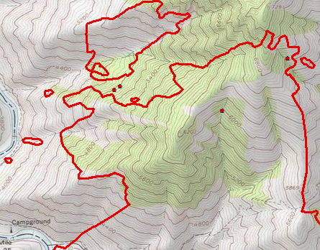
- No Scattered or Intense heat detected.

