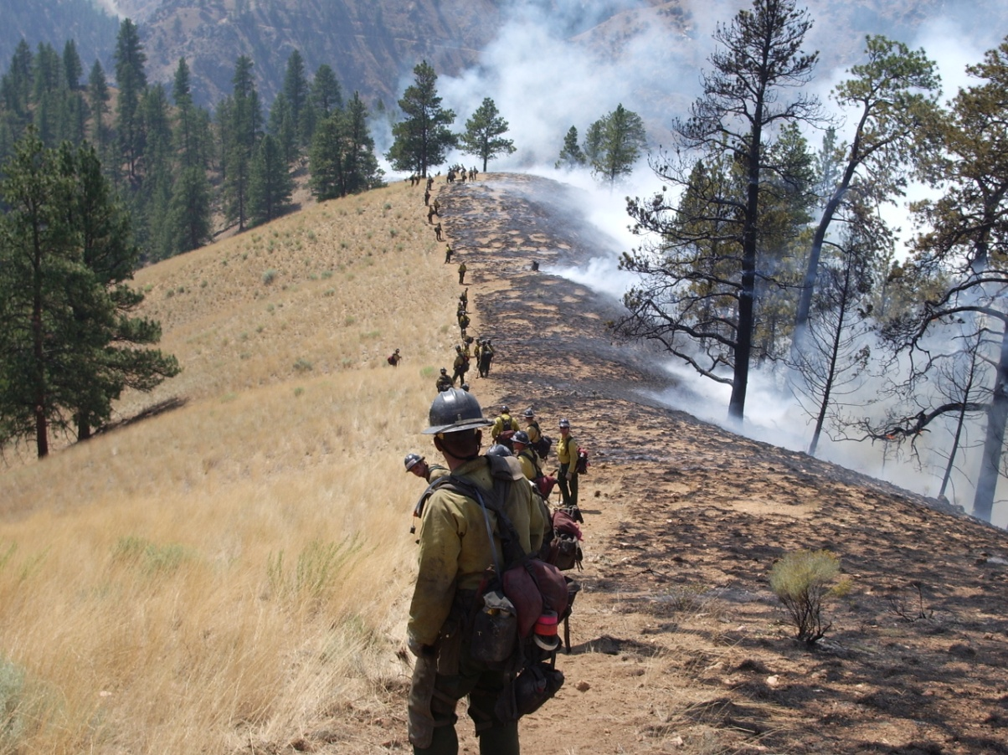
“Intent Based”
Objective(s) and Operational Task Writing

Example #1:
INCIDENT OBJECTIVES | 1. Incident Name | 2. Date 4/16/2016 | 3. Time 0700-1700
4. Operational Period
Hold the fire inside the established box. Look for opportunities to go direct.
5. General Control Objectives for the Incident (include alternatives)
Management Objectives :
1. Provide for firefighter and public safety at all times.
2. Protect real property, commensurate with assets at risk.
3. Minimize impact to watershed where possible
4. Maintain and foster relationships with cooperators and the public.
5. Utilize resources effectively according to incident needs and release excess resources promptly.
6. Maintain effective cost management based on incident needs and ensure all documentation is complete.

Operational Objectives :
Keep fire within the following box:
Keep fire South of lower Highway 84
Keep fire North of Alpine Road
Keep fire West of Highway 280
Keep fire East of upper Highway 35

Examples of the 204 connectivity:
7. Control Operations: Keep fire south of 302 Portola. Provide structure defense and perimeter as needed. Construct direct fire line.

8. Special Instructions: No firing without prior approval of Operations

7. Control Operations: Hold fire northeast of Valley Oak Street and Horseshoe Bend. Construct Direct Fire line.
Progressive hose-lay, provide structure defense and perimeter control.

8. Special Instructions: No firing without prior approval of Operations. LCES
Example #2:
INCIDENT OBJECTIVES (ICS 202)
1. Incident Name: | 2. Operational Period: |  | DAY
BRIANHEAD | Date/Time From:  06/25/2017 0600 SUN |  |  |  | Date/Time To:  06/25/2017 2000 SUN
3. Objective(s):

Course of Action Full Suppression

Core Values
• Ensure all actions reflect a commitment to incident response personnel and public safety through the development of tactical operations that are commensurate with the values at risk and probability of success.
• Ensure prompt and accurate communication that foster discussion and encourage interaction with hosting agencies.
• Focus public information actions to enhance relationships with landowners, cooperators and the public.
Incident Objectives

Prevent damage to:
*Infrastructure within the town of Brian Head, community of Panguitch Lake, remote townsites, and private in-holdings.
*City of Panguitch culinary water supply and associated infrastructure in and adjacent to Fivemile Hollow.
*Forest Service and BLM infrastructure, state highways, utility corridors and associated infrastructure.
*Conduct all fire management activities giving preference to using strategies and tactics that cause the least alteration of the landscape.

Desired End State:
The fire is suppressed and values at risk protected using the appropriate resources to implement tactics in locations with reasonable probabilities of success. When the last incident management team leaves, there will have been no serious accidents or injuries, all suppression damage will have been repaired, and cooperator and the public relationships will have been enhanced.

4. Operational Period Command Emphasis:

Stay on the leading edge of anticipated challenges.

Examples of the 204 connectivity:
6. Control Operations/Work Assignments:
Secure fire from Highway 143 to the A/B Division break to protect infrastructure on highway and structures in Second Left Hand Canyon.
Utilize natural barriers where possible.

6. Control Operations/Work Assignments:
Secure fire line from A/B break to the C/B break utilizing natural barriers, direct, and indirect line to protect Second Left Hand Canyon structures.
Take actions to protect values at risk that could be impacted by fire.

6. Control Operations/Work Assignments:
Secure fire to protect the town of Brian Head and the community Rainbow Meadows. Take actions to protect values at risk that could be impacted by fire. Prepare the area for return of the local residents by securing potential fire related hazards around structures.

7. Special Instructions:
Suppress burning chip piles and log decks to minimize smoke impacts and long term fire risk to the local area.
6. Control Operations/Work Assignments:
Secure fire from the W/T break to the X/A break to secure homes from fire impact and to stop fire spread to the South and West. Prepare the area for return of
the residents by securing potential fire related hazards around structures and Highway 143. Secure the fire on the West side of Highway 143 to the Division A break to protect homes to the west.

Example #3:
INCIDENT OBJECTIVES (ICS 202)

1. Incident Name: | 2. Operational Period: |  | DAY
JOLLY MOUNTAIN | Date/Time From:  09/01/2017 0600 FRI |  |  |  | Date/Time To:  09/01/2017 2000 FRI
3. Objective(s):

Course of Action Full Suppression utilizing direct, indirect and point protection

Core Values
• Ensure all actions reflect a commitment to incident response personnel and public safety through the development of tactical operations that are commensurate with the values at risk and probability of success.
• Ensure prompt and accurate communication that foster discussion and encourage interaction with hosting agencies and cooperators.
• Focus public information actions to enhance relationships with local communities, stakeholders, and the public.

Incident Objectives

Evaluate and implement reasonable measure to protect:
*Private residences, infrastructure and land within Cle Elum Lake communities, along the Cle Elum River and Middle Fork Teanaway River corridors and surrounding areas.
*Infrastructure on Forest Service, Washington DNR, Teanaway Community Forest, and Nature Conservancy lands including guard stations, campgrounds, trailheads and associated utilities
*State Route 903, Kittatas County Salmon La Sac and Teanaway road systems and adjacent utilities
*Utilize suppression strategies and tactics that will minimize impacts to ESA listed White Bark Pine, Bull Trout, and Steelhead species and habitat, Northern
Spotted Owl habitat, and cultural and archeological sensitive sites.
*Conduct all fire management activities giving preference to using strategies and tactics that safely reduce the impacts to recreation opportunities, timber, and grazing lands

Desired End State:
• The fire is contained and values at risk protected using the appropriate resources to implement tactics in locations with reasonable probabilities of success. When the incident management team leaves there will have been no serious accidents or injuries, all suppression damage will have been repaired, and cooperator and the public relationships will have been enhanced.
4. Operational Period Command Emphasis:

Balance high levels of activity with high levels of readiness.

6. Control Operations/Work Assignments:

Task: Complete preparations on indirect control line utilizing firefighting personnel and heavy equipment for implementation of future control actions.
Purpose: To protect residential and commercial structures along Lake Cle Elum corridor north of the Wish Poosh Camp.
End State: Fire is controlled, all control lines are secured and residents are allowed to resume their normal activities.

Task: Establish anchor point on NW corner of fire by constructing handline south along Sasse Ridge connecting to solid black near H-12
Purpose: To protect residential and commercial structures along Lake Cle Elum corridor north of the Wish Poosh Camp.
End State: Fire is controlled, all control lines are secured and residents are allowed to resume their normal activities.

Task: Initiate aerial and ground ignitions as needed.
Purpose: To minimize fire severity in order to protect associated values at risk.
End State: Fire severity is limited and values are protected.

