WFDSS steps for fires that require a decision

For fires that escape initial attack and fires that will be managed for multiple objectives.

This document is a guide for the steps required to complete a decision NOT a comprehensive how-to.

Table of Contents
Dispatcher Role ............................................................................................................................... 2

Author/Owner/Editor Role.............................................................................................................. 3

Incidents tab ................................................................................................................................ 3

Incident Information tab ............................................................................................................. 4

Situation tab ................................................................................................................................ 6

Objectives tab............................................................................................................................ 10

Courses of Action tab ................................................................................................................ 11

Validation tab ............................................................................................................................ 12

Decisions tab ............................................................................................................................. 13

Decision approver role .................................................................................................................. 17

Decision Editor ............................................................................................................................... 18

Identifies elements that are required before a decision can be submitted for review/approval

Dispatcher Role
There are two ways to enter incidents into WFDSS.

1. Intelligence tab
i. Push fire symbol button
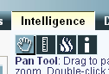

ii. Enter the incident name

iii. Enter lat/long in decimal degrees
OR click on fire’s location on map

iv. Push Next

v. Enter Fire Number (can be entered later)

vi. Enter Fire Code (can be entered later)

vii. Double check Unit Name

viii. Enter Incident Size

ix. Click radio button next to Incident
Cause

x. Change Incident Start Date – needs to be actual start date, not date WFDSS started

xi. Double check Affected Jurisdictions

xii. Click radio button next to “LANDFIRE Rapid Refresh” in Landscape Data Source box

xiii. Push Create

2. Information tab
i. Enter the incident name

ii. Enter lat/long in either decimal degrees or degrees/minutes/seconds

iii. Enter Fire Number (can be entered later)

iv. Enter Fire Code (can be entered later)

v. Double check Unit Name

vi. Enter Incident Size

vii. Click radio button next to Incident
Cause

viii. Change Incident Start Date – needs to be actual start date, not date WFDSS started

ix. Double check Affected Jurisdictions

x. Click radio button next to “LANDFIRE Rapid Refresh” in Landscape Data Source box

xi. Push Create

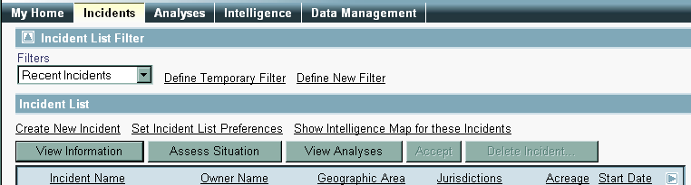

Author/Owner/Editor Role

Incidents tab
1. Navigate to incident: the list defaults to incidents started in the last 30 days.

i. You can sort the list by incident name, owner name, geographic area, jurisdiction, acreage, or start date by clicking on the column name. You can also define filters to speed up finding your incident.

ii. Temporary filters will last the length of the WFDSS session

a. Click Define Temporary Filter

b. Click blue arrows to expand filter categories

c. Set filter parameters

d. Date filters: start, contain, control, out

e. Other filters: incident privileges, unit ID, GACC, jurisdiction, decision status or national significance

f. Incident authors g. Incident names h. Click Apply
iii. Filters remain stored in your profile

a. Click Define New Filter

b. Click blue arrows to expand filter categories

c. Set filter parameters – same as for temporary filter

d. Click Apply

2. Click radio button to left of incident name

3. Click View information

Incident Information tab

1. Click Accept ownership button (top right hand side, above longitude). This is only necessary for incidents created by Dispatch.

2. Set Incident Privileges (left hand menu under Information)

i. Filter by name, GACC and/or agency to select Incident Editors, Reviewers and
Approvers

ii. At least one Approver is required iii. Check box under appropriate role iv. Click Save
v. Click Return to get back to main Incident Information page

3. People who would like to see the planning area, incident objectives and requirements, and course of action while the decision is being created need to have author privileges and be owners (see To create Group Ownership below). Editor or reviewer incident privileges are not enough.

To create Group Ownership:

1. Go to My Home tab

2. Click on Address Book

3. Check box next to users to whom you want to be able to transfer ownership

4. When all are selected, type a name into blank under Group Name

5. Click Create Group

6. Select My address book from address book drop down (top left corner of page)

7. New group should appear in list

a. Click on group name in User Name column to see group members b. Click on group name in Email address column to send email to all
members

8. Navigate back to Incident Information

9. Click Transfer Ownership

10. Select My address book from top Address Book drop-down list

11. Click radio button next to group name

12. Click Transfer Ownership at bottom

13. All members of the group will get an email letting them know that ownership of the incident has been transferred to them.

Situation tab

1. Create planning area polygon

i. Expand “Incident” list under Map tab (left side of screen)

ii. Click the green “Plus” sign next to “Planning Areas”
iii. Select the rectangle or polygon tool iv. Draw a polygon for the planning area v. Click Save

Strategic direction and management requirements for the FMUs within the planning
area will be brought in automatically

Drawing tools, from left to right:
point, line, rectangle, polygon
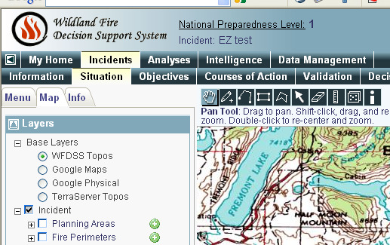

Extent tool

2. Other geographic features you can draw in on the Situation tab: All are drawn and saved the same way as planning areas.

i. Fire perimeter

ii. Fire barrier

iii. Landscape mask (will change fuel model within mask area)

iv. Points of interest

v. Management action point

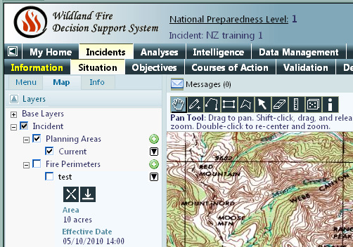

vi. You can download these shapefiles by clicking the black arrow to the right of the shape name to show the shape properties. Once the shape properties are visible, click the arrow pointing down.

Expand shape properties

Download shapefile

You can upload shapefiles for the fire perimeter, analysis ignition, barriers, landscape mask, and management action points under the Shape Upload section of the main menu. All shapefiles must be polygons and have a projection. Create a zip file for the four shapefile parts (.shp, .dbf, .prj, .shx) to load into WFDSS.

3. Additional tips for the Situation tab:
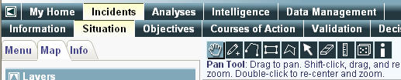

i. Zooming: select the pan tool (looks like a hand), then hold the shift key while you draw a box around the area you want to zoom in on with your mouse.

ii. The Identify tool (‘i’ button on tool bar above map).

Clicking this button and then clicking on a position on the map will bring up the position’s lat/long, LANDFIRE landscape characteristics and allow pulling the weather forecast, ERC-G chart and FMU strategic objectives for the point (all visible on Info tab)

iii. Menu tab

Shows the left-hand menu that accesses the FMU list, relative risk, shape and image upload, and incident privileges functions.

iv. Map tab

Clicking the “+” on the left side of the group layer names expands the options; clicking in the box next to the individual layer name turns the layer on.

v. Info tab – Map image capture

As long as “WFDSS topos” is the selected base layer on the Map tab you can capture the map showing on the situation tab, including the short term or basic fire behavior analysis results. Only WFDSS topos will work because of copyright issues with Google backgrounds.

a. Enter a name for the image and a description

b. Click Capture Image

c. Where does the image go??

i. Click Reports tab

ii. Click View Full Report

iii. Expand incident folder in table of contents on left, keep expanding folders until you get to Images and your map

iv. Click on the map name

To create Management Action Points:

From the Situation tab (easiest way for spatial M.A.P.s):

1. Expand “Incidents” list in table of contents

2. Draw point, line or polygon as you would for planning area

3. Click green plus sign next to Management Action Point in table of contents

4. Enter a name for the MAP and click Save

5. List of MAPs will open in a new window

6. Click Create M.A.P

7. Text editor will open; fill in text boxes. “Condition” and “Action” are required, “Estimated
Cost” and “Resources” are not

8. Note: the dropdown menu under “Associated Shape” should show the one you just created

9. Click Save

From the Menu:

1. Click Mgmt Action Points

2. Click Create Management Action Point

3. Text editor will open; fill in text boxes. “Condition” and “Action” are required, “Estimated
Cost” and “Resources” are not

4. Note: the dropdown menu under “Associated Shape” will show “<None>”. Either select a shapefile you have already created or uploaded or you will be able to edit this later.

5. Click Save

Objectives tab

At least one FMU is required. FMUs will come in automatically with the Planning Area shapefile.

1. To add FMUs for units without FMU shapefiles loaded, units outside Planning Area or to add Park-wide (GTP) or Forest-wide or DFC direction (BTF):

i. Click FMU List from the Menu on the left

ii. Select the Geographic Area, Agency and Unit so FMU list populates. You can pick FMUs for agencies in other GACCs .

iii. Select FMU (at least one required for all fires) and DFC (for resource benefit/multiple objective fires)

iv. Click Add FMU to Incident FMUs v. Click Return

2. Bring in strategic objectives, management requirements and create incident objectives and requirements.

i. Strategic objectives and management requirements will populate automatically based on FMUs in the planning area if the FMU shapefile was loaded (BTF and GTP FMUs are loaded) or if FMUs were selected from the FMU list

ii. Click Create Incident Objectives

iii. Type in objectives

iv. Click Save

v. Click Return when ready to go back to the main screen

vi. Click Create Incident Requirement

vii. Type in requirements

viii. Click Save then Return

To use pick list (under WFDSS/KDL link on TIDC website and on external hard drives):
i. Open pick list and navigate to objective/requirement you want to include ii. Select text and copy (right click, copy or Ctrl + C)
iii. In WFDSS, click Create Incident Objective or Create Incident
Requirement

iv. Click “Paste from Word” button:
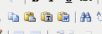

v. Click inside box that opens then paste (right click, paste or Ctrl +V)

vi. Click Save

vii. Click Return when you’re done to go back to the list of objectives and requirements.

Courses of Action tab
1. Provide cost estimate

i. Enter an estimated cost

ii. Check box next to method used to estimate
iii. Note: cost estimator spreadsheet is the same as the one from WFSA The TIDC website has historic costs, local resource costs, and a link to the
WFDSS cost estimator under the “WFDSS/KDL” tab

iv. Click Save Cost

2. Enter strategic direction (course of action) for the fire

i. Create Strategic Direction (directly below cost estimate box)

ii. Click Save

iii. Mark radio button next to created direction and click Include

iv. You can either Delete, Edit, or Exclude the two canned courses of action, “Follow the pre-planned response” and “Monitor the incident”

3. Complete relative risk assessment

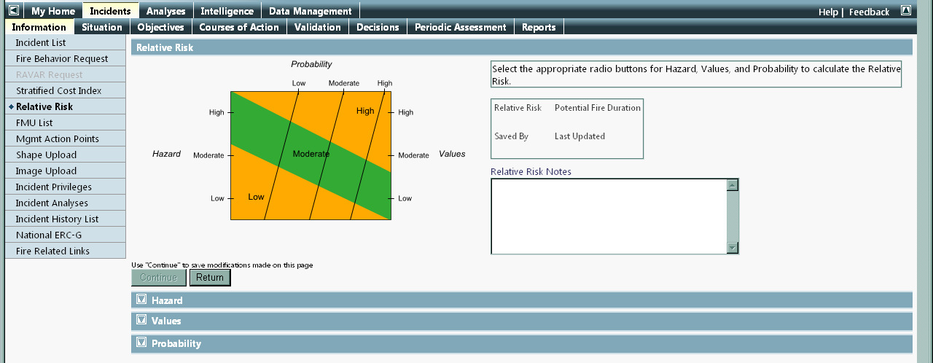

i. Click Relative Risk from left-hand menu

ii. Expand blue down arrows left of Hazard, Values, and Probability

iii. Click radio button next to appropriate rating and include a justification

iv. Click Continue when completed

v. Summary relative risk chart will show, check potential fire duration and adjust if necessary, click Continue

vi. Relative risk advice table will show; type in any additional notes in text box

vii. Click Save

The Course of Action tab is the place to document:

• What the actions on the fire will be
o Monitor, patrol, suppress, herd, etc
• How cost was estimated
• If there are enough resources available for the course of action
• If a cost share agreement is necessary
• If unified command is necessary
• If any air quality-related notifications need to be made
• If any specific public information strategies need to be followed

Validation tab
1. In comment box include information on:

i. OK to proceed with managing for resource benefit or suppressing candidate lightning strike or modified suppression

ii. Who gave preliminary OK to proceed with course of action and date

iii. GTP: date that Fire Management Committee met and agreed to course of action

iv. Short summary of relative risk assessment (ie low/moderate/high) v. Short summary of current and expected weather and fire behavior vi. Key safety concerns
vii. Key resource concerns

viii. Resource availability

2. Click Yes or No

i. Comment required if No – include information on resource availability, fire behavior, estimated costs

ii. “No” will trigger need to make new decision.

iii. You will have to click Yes one more time before requesting review/approval

Decisions tab

1. Click Create - to open new decision document for editing.
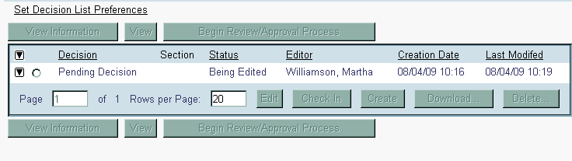

2. Click radio button next to “Pending Decision”

3. Click View Information to see

• Requirements that must be completed before a decision can be reviewed/approved

• Decision information (status, creator, editor)

• Decision reviewers and approvers

• Decision history

• Click Return to get back to main Decision screen

4. Click Edit to start editing information in decision document

i. If you only want to edit one part of the decision document at a time:

a. On the main Decision tab, click the black arrow to the left of
“Pending Decision”

b. Click the radio button next to the part of the decision you want to edit – assessment, objectives, course of action, validation, rationale

c. Click Edit

ii. Decision editor page opens

See page 17 for illustration of the Decision editor
iii. In left-hand side table of contents, top part contains all the information
that will show up in the approved (viewable by all) decision document and the bottom part is a ‘bin’ for all the information generated for the incident
(ERC charts, saved map images or pictures, relative risk assessment charts etc)

iv. Information entered on other tabs in WFDSS gets pulled into the decision automatically

5. Tips for editing the decision document:

i. To add information beyond what gets pulled in automatically:

a. Click on “Content” under topic you want to edit (Assessment, Incident Information, Weather etc) in the decision window (top table of contents)

b. Highlight the text that appears in the main editor window (will be the topic you’re editing) and hit ‘Enter’

c. Cursor will appear and you can type in what you want

d. Click the blue floppy disk button (top row, second from left) to
save

ii. To create a weather archive:

a. Only the most recent weather forecast gets pulled into the decision document

b. To archive weather, start editing the decision document and click on weather content in the Decision Content window.

c. Click floppy disk Save button

iii. To add images or maps uploaded to WFDSS:

a. Navigate to the decision document section you want to add the image or map to in top table of contents window

b. Click on “Content” under topic you want to edit (Assessment, Incident Information, Weather etc) in the decision window (top table of contents)

c. Highlight the text that appears in the main editor window (will be the topic you’re editing) and hit ‘Enter’

d. Navigate to the item you want to add in the bottom incident content window

e. Click “Add WFDSS content” button

f. Click the floppy disk save button

Add WFDSS
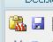

content
Save

iv. Decision Rationale:

a. Document why making this decision

b. Document any social or political concerns

Good places to put information in the decision document:

Assessment section
• Current and expected fire behavior
• Fire behavior modeling results (add WFDSS content)

Weather section
• Spot weather forecasts (copy and paste)

ii. How to upload images:

a. Click Menu on left hand side or click Information tab to get Menu to show up

b. Click Image Upload

c. Enter name (label) and description

d. Select image type from drop down (determines which folder in
Incident Content bin image gets stored in)

e. Browse to image f. Click Upload

6. When you are done editing, return to Decision tab

7. Click Check In

8. Click View Information to make sure all requirements are met

9. Click Begin Review/Approval Process

10. Click Continue to confirm. You will not be able to make any changes until decision is approved!

Decision approver role

1. Log in to WFDSS

2. Navigate to incident

3. Click View Information

4. Tab through and review Situation, Objectives, Course of Action, Validation, and Decision

5. On the Decision tab:

i. Click radio button next to “Pending decision”

ii. Click Review/Approve Decision

iii. Decision table of contents appears on left, approver can look through decision document

iv. Click Approve Decision (or Reject Decision)

v. If approving decision, click Publish Decision, set periodic assessment frequency, check box to send email reminder if desired

6. To print document once approved:

i. Click Download ii. Save zip file
iii. Open Decisionxx.html

iv. Set page to landscape before printing

v. Images need to be printed separately

7. Periodic Assessments:

i. Update assessment frequency if needed

ii. Include rationale for continuing with current course of action or changing to a new one in the “Comment” box. Including a comment does not trigger need for a new decision

iii. Click Yes or No to either confirm or reject that the current course of action is meeting the specified objectives. Clicking No will trigger the need for a new decision

iv. Adjust relative risk rating if necessary. This does not trigger the need for a new decision

2010

Decision Editor

Decision Content table of contents

Decision Content editor window

Highlight then hit
‘Enter’ to type in
additional
information

Incident Content table of contents

Incident Content viewer window- click “+” to expand and view content

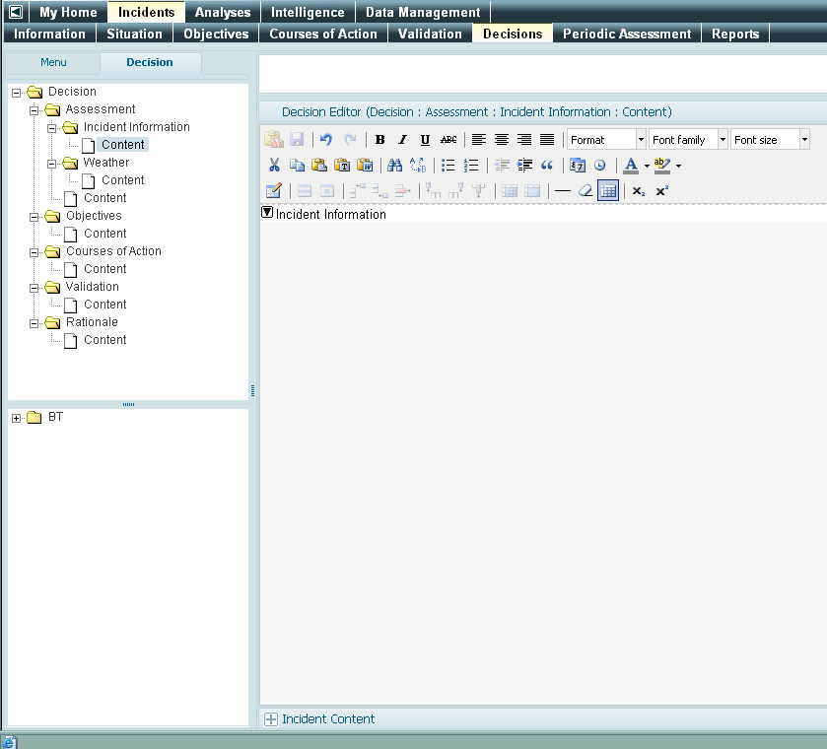

Page 18 of 18
Updated 5/12/2010 MW

