Cascade Area Command
Wildland Fire Contingency Plan

West Side of Idaho State Highway 55 Corridor

September, 2007
Valley County, Idaho

Prepared By

This Wildland Fire Contingency Plan, West Side of Idaho State Highway 55 Corridor was prepared for the Cascade Area Command in early September, 2007, in cooperation with many local, state, and federal agencies.

Following is a list of those who provided information or participated in preparation of this Contingency Plan:

- Roy Montgomery, Structure Protection Task Group Leader, Cascade Area Command
- Steven Miranda, Situation Unit Leader, Cascade Area Command
- Anne Jeffries, Public Information Officer, Cascade Area Command
- Dennis Lapcewich, Webmaster
- Members of Paul Broyles’ Great Basin Incident Management Team
  - Steve Raditz, Operations Section Chief
  - Mark Rabdau, Structure Protection Specialist
  - Rick Tholen, Situation Unit Leader
  - Shannon Theall, GIS Specialist
- Members of Rich Harvey’s Incident Management Team
  - Rich Harvey, Incident Commander
  - Greg Burch, Operations Section Chief
- Rick Stratton, Fire Modeling Analyst, Missoula Fire Sciences Lab
- James Hass, Disaster Coordinator, Valley County/Fire Chief, Cascade City & Cascade RFD
- Patti Bolen, Sheriff, Valley County
- Greg Malmen, Information Technology Administrator, Valley County
    - Juan Bonilla, Fire Chief, Donnelly Rural Fire District
    - Andrew Lemberes, Fire Chief, McCall Fire Department
    - Mark Woods, Fire Warden, Southern Idaho Timber Protective Association
    - Tim Flaherty, Executive Director, Tamarack Municipal Association

A key objective in the preparation of this document was to maintain as much commonality as possible with the Wildland Fire Contingency Plan for the East Side of Idaho State Highway 55 Corridor prepared for the Cascade Area Command in August, 2007, so that interpretation is consistent between the two documents where conditions are similar. To achieve this objective, this document utilizes the same format, and where applicable, language from the East Side Highway 55 Contingency Plan was utilized.

TABLE OF CONTENTS

PREPARED BY i
TABLE OF CONTENTS ii
INTRODUCTORY ITEMS iv
Acronyms and Abbreviations iv
PURPOSE 1
INTENT 1
LONG-TERM AND STRATEGIC ASSUMPTIONS 2
Wildland Fire Situation Analysis 2
GENERAL DESCRIPTION OF THE AREA 2
VALUES TO BE PROTECTED 3
Life and Property 3
Community Infrastructure 4
TACTICAL AREA DESCRIPTIONS 4
Wildland with Point Protection (WPP) 4
Wildland-Urban Interface (WUI) 4
SUPPLEMENTAL RESPONSE RECOMMENDATIONS
MANAGEMENT ACTIONS 5
Management Actions for Each Tactical Area 5
Maps and Aids 5
Tactical Management Area 1 8
Deer Trail 8
Tactical Management Area 2 10
Discovery 10
Tactical Management Area 3 12
Tamarack Falls 12
Tactical Management Area 4 14
Smylie 14
Tactical Management Area 5 16
Black Hawk 16
INCIDENT MANAGEMENT TEAM RESPONSE 17
ACTIVATION 18
Criteria to Consider 18
Steps for Activation: 18
EVACUATION NOTIFICATION LEVELS 19
Level 1: To Be Authorized by Valley County Sheriff or Her Designee 19
Level 2: To Be Authorized by Valley County Sheriff or Her Designee 19
Level 3: To Be Authorized by Valley County Sheriff or Her Designee, with Governor’s Proclamation and Approval 19
AGENCY DECISION-MAKING 20
INFORMATION MANAGEMENT 20
EVACUATION SHELTERS 20
Temporary Red Cross Evacuation Shelter Locations 20
EVACUATION AREA RE-ENTRY 21
KEY CONTACT NUMBERS 21
US Forest Service, Payette National Forest 21
US Forest Service, Boise National Forest 22
Idaho Department of Lands 22
Southern Idaho Timber Protective Association 22
Valley County 23
City of McCall 23
City of Donnelly 24
City of Cascade 24
American Red Cross 25
APPENDIX A A
HISTORICAL WEATHER AND FIRE MODELING ANALYSIS A
Background A
Historical Weather Analysis A
APPENDIX B F
RADIO FREQUENCIES F
APPENDIX C H
DELEGATION OF AUTHORITY TO INCIDENT COMMAND TEAM H

INTRODUCTORY ITEMS

Acronyms and Abbreviations

ERC – Energy Release Component. A calculated output of the National Fire Danger Rating System related to the available energy per unit area within the flaming front at the head of a fire. The ERC is considered a composite fuel moisture index as it reflects the contribution of all live and dead fuels to potential fire intensity.

IA – Initial Attack. The action taken by resources that are the first to arrive at an incident.

ICS – Incident Command System. A management system used to organize emergency responses.

IMT – Incident Management Team. The incident commander and appropriate general and
command staff personnel assigned to an incident.

M.A.P. – Management Action Point. An area focusing on the part of the fire that has the highest potential to impact the safety of lives, communities, private and government-owned structures/infrastructure and improvements, and identified natural resource values with political or social impacts.

RERAP – Rare Event Risk Assessment Process. A Windows-based computer program that helps calculate the time and probability of fire spreading to values to be protected.

RAWS – Remote Automated Weather Station. An apparatus that automatically acquires, processes, and stores local weather data via satellite for use in the National Fire Danger Rating System.

SITPA – Southern Idaho Timber Protective Association. A private, non-profit timber
protective association that has specialized in wildland fire suppression and hazard reduction
services for the past 100 years.

TMA – Tactical Management Area. A general description of an area where fire suppression actions may be influenced by the same geographic features or road systems.
WFSA – Wildland Fire Situation Analysis. A decision-making process that evaluates alternative wildfire suppression strategies against selected safety, environmental, social, political, and economic criteria, and provides a record of those decisions.

Purpose

The purpose of this Contingency Plan for the West Side of Idaho State Highway 55 Corridor is to provide for firefighter and public safety and to protect private property, community infrastructure, and natural resources in the event of encroachment of the Grays Creek Fire from the west. This plan was developed to complement the Wildland Fire Contingency Plan for the East Side of Idaho State Highway 55 Corridor prepared by the Contingency Task Group led by Joe Stutler in August 2007.

The plan was developed collaboratively with the Grays Creek and East Zone Incident Management Teams (IMTs), Valley County Sheriff, Valley County Disaster Coordinator, Donnelly Rural Fire Protection District (DRFPD), McCall Fire District, Southern Idaho Timber Protective Association (SITPA), and staff of the Boise and Payette National Forests. Consistent with the effort to maintain commonality with the Contingency Plan for the East Side of Idaho State Highway 55 Corridor, the plan identifies values to be protected and management actions required to minimize the threat to the values to be protected.

The plan will include Management Action Points (M.A.P.s), which will serve as triggers for implementing the defined management actions, and Tactical Management Areas (TMAs). The M.A.P.s will be designed to allow adequate time to complete the planned objectives within the TMAs. This Contingency Plan will be useful to the agencies in Valley County for educating the communities about actions they can take to better provide for public safety and protect homes, businesses, and infrastructure from wildland fire. The Contingency Plan will also be useful in future preparedness grant applications for both defensible space and hazardous wildland fuels treatment.

Each agency involved in the development of the plan will be provided with copies of the final document and a CD with GIS shape files to further refine the tactical areas and M.A.P.s.

INTENT

The Highway 55 Wildland Fire Contingency Plan is intended to provide a structured and organized strategic assessment should wildland fires threaten property or natural resource values west of Idaho State Highway 55. The plan identifies Management Action Points (in this case, evacuation notification levels) and suggested tactical assets necessary to protect both private property and natural resources.

During evacuations, the jurisdictional law enforcement agencies are legally charged with the responsibility of evacuation. In order for adequate planning and decision-making to occur before the situation becomes dire, it is important that the jurisdictional law enforcement have advance notice and be included in the earliest possible discussion regarding evacuation needs.

LONG-TERM AND STRATEGIC ASSUMPTIONS

Wildland Fire Situation Analysis

Through the Wildland Fire Situation Analysis (WFSA) process, the Forest Service has made the decision to implement a point protection strategy on several million acres of National Forest land in central Idaho. The fires currently burning under this management strategy will not be totally contained by constructed fireline and will continue to burn until season-ending events modify the fuel moisture. Identified improvements will be protected, and management strategies and tactics will emphasize firefighter and public safety.

A point protection strategy is not acceptable within those lands protected by SITPA and the fire protection districts of Valley County. Wildland fires must be contained on the federal, state, and private lands within the area covered by this West Side Idaho State Highway 55 Corridor Contingency Plan in order to protect life; communities; private and state- and local- government-owned structures/infrastructure and improvements; and identified natural resource values such as water, grazing lands, and timber resources. This difference in management objectives will dictate a fire suppression strategy based on containment and control, should any currently burning fire spread east/northeast toward the heavily populated areas along the Highway 55 corridor.

General Description Of The Area

Land ownership within the Contingency Plan area includes private residential lands, private agricultural lands, private timberlands, State of Idaho, Bureau of Reclamation, and Boise and Payette National Forests. The Boise National Forest, Payette National Forest, Donnelly RFPD, McCall Fire District, and SITPA have fire protection responsibilities within the Contingency Plan area.

Vegetative structure and composition in Valley County and along the Highway 55 corridor is closely related to elevation, aspect, and precipitation. The vegetation of the region varies with elevation gain, from grass meadows and agricultural crops in the valley bottoms to mature timber at higher elevations. Forests contain high fuel accumulations that have the potential to burn at moderate to high intensities. Highly variable topography coupled with dry, windy summers typical of the region is likely to create extreme fire behavior conditions.

The transition between developed agricultural land and timberlands occurs abruptly. Relatively moist valley vegetative patterns shift to dry forests dominated by ponderosa pine, western larch, and Douglas fir at the lower elevations, transitioning to lodge pole pine, sub-alpine fir, and grand fir at higher elevations. Engelmann spruce is commonly found in wet draws and frost pockets. There are more dead and down fuels in the timberlands than in the grasslands, in addition to more live fuels. Rates of fire spread tend to be lower than those in the grasslands; however, intensities can escalate dramatically, especially under the effects of slope and wind. Steep slopes and strong winds can lead to control problems, potentially endangering lives, structures/infrastructure, and other valued resources.

The Contingency Plan Area is characterized by very steep, densely timbered east facing slopes in the southern end of the planning area, and it transitions to more moderate timbered slopes as you move north through the area. The valley bottom is characterized by relatively flat terrain with a mixture of timbered areas and open grass meadows. The West Mountain Road runs from north to south through the Contingency Plan Area. The entire area is experiencing a boom in high value home construction on private lands. The Tamarack area on the southern end of the planning area has numerous residential and commercial structures and new development continues at rapid pace. Outside the Tamarack area several subdivisions of high density homes are being established in forested areas. Road access to many of the developed areas from the West Mountain Road is not ideal for fire protection due to narrow, steep, and winding roads.

Values To Be Protected

Life and Property

There are some 387 structures within the boundaries of West Side Highway 55 Corridor Contingency Plan Area identified on the TMA maps. While most of these are residential structures, there are a significant number of commercial structures, including the Tamarack Ski Lodge within the Tamarack Resort properties, and communication sites. Many of the residential structures are in subdivisions that are currently under development. These are values to be protected in addition to protecting firefighters and the public. Other values to be protected include agricultural crops and livestock grazing investments, primarily along the valley floor; natural resources, including timber stands; water resources, including water quality and quantity; and wildlife habitat, including aquatic.

Community Infrastructure

Infrastructure refers to the communication, transportation, energy transport supply systems, and water supplies that service a region and, generally, support the economy and way of life. Communication, transportation, water lines, and energy transport systems within the Contingency Plan Area would be at risk due to their existing locations or lack of defensible space currently provided. These are values to be protected.

Tactical Area Descriptions

The type and number of fire suppression resources necessary to extinguish a fire and protect adjacent improvements and resources is influenced by the density of these improvements. To maintain consistency with the Contingency Plan for East Side Highway 55 Corridor, the West Side Highway 55 Corridor Contingency Plan Area has been divided into 5 Tactical Management Areas (TMAs). There are zones within these TMAs that range from forested areas and grasslands with no structures where a point protection strategy may be appropriate (referred to as Wildland with Point Protection) to areas of dense high-value residential and commercial structures intermingled with forested areas (referred to as Wildland-Urban Interface). These 2 zone classifications are described below.

Wildland with Point Protection (WPP)

This zone is primarily wildland in makeup. There are very few or no structures or homes in the area. Tactics focus on utilizing topography and fuel breaks to check fire spread. Point protection areas are points to focus suppression efforts on, though are not necessarily structures or homes. Point protection areas could be high-value timberlands, community infrastructure components, recreation areas, or other natural resources such as water sources and grazing lands.

Wildland-Urban Interface (WUI)

Wildland-Urban Interface is a zone where structures and infrastructure meet or intermingle with undeveloped wildland or vegetative fuels. In a WUI zone, the vegetation carries the fire. Primary focus in WUI areas is to protect the structures, so tactics center on determining structure locations and their defendability.

The 5 TMAs for the Contingency Plan for the West Side Highway 55 Corridor are:

TMA 1. ----- Deer Trail
TMA 2. ----- Discovery
TMA 3. ----- Tamarack Falls
TMA 4. ----- Smylie
TMA 5. ----- Blackhawk

MANAGEMENT ACTIONS

Management Actions for Each Tactical Area

The term Tactical Management Area, as used in this document, is intended to describe geographical areas in terms known to local emergency management personnel. The TMAs used here are not intended to provide precise descriptions but rather a general description of an area where fire suppression actions may be influenced by the same geographic features or road systems.

Within each TMA are significant resource values, structures/infrastructure, and other improvements which will require protection from advancing wildland fire.

Maps and Aids

The following portion of the Contingency Plan describes the 5 TMAs in the West Side Idaho State Highway 55 corridor established for this plan with advice from local emergency services personnel. The next page displays the entire area of the West Side Idaho State Highway 55 corridor, displaying all 5 TMAs in context and shows the M.A.P.s for all TMAs based on the threat that existed from the Grays Creek Fire. Where threats may occur from future fires, new M.A.P.s may need to be strategically located based on the location and spread of the new fire. Subsequent pages review the TMAs area-by-area—on the left page of each section is a detailed map that shows each TMA; on the right side is additional information to aid in tactical actions. Additional information on tactical actions within this Contingency Planning Area is available from the Structure Protection Plan developed for the Donnelly Zone of the Grays Creek Fire.
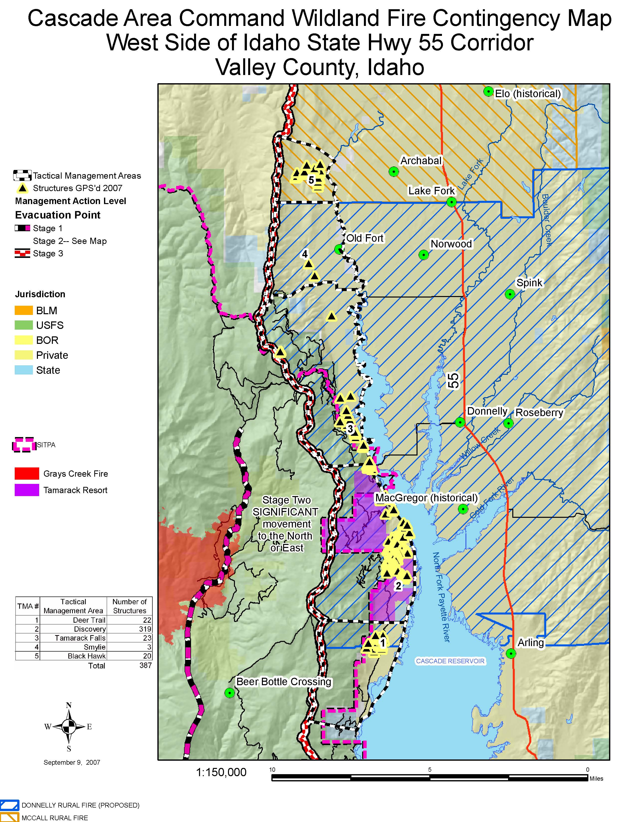
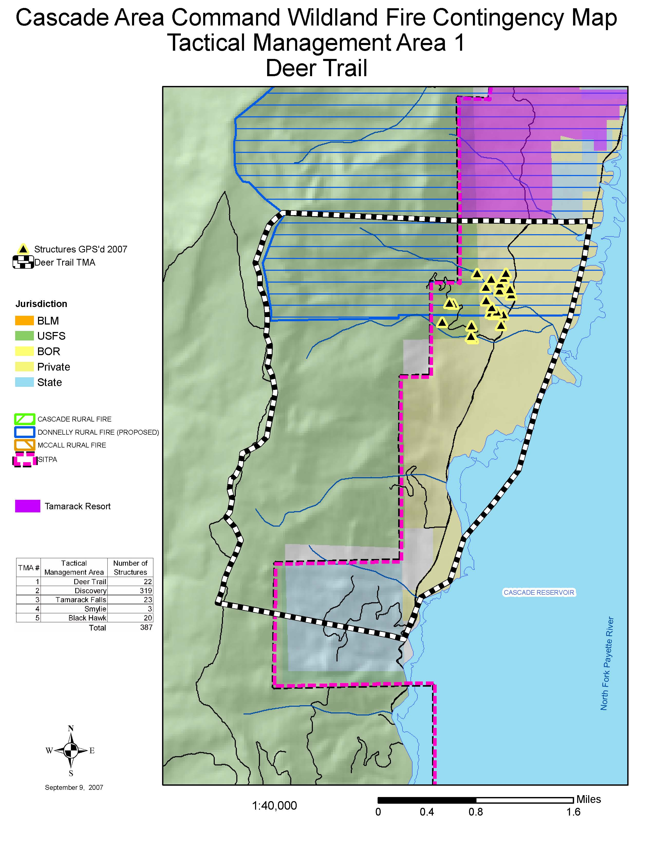
Tactical Management Area 1

Deer Trail
Verbal description
From Deer Trail on West Mountain Road, go west to Valley/Adams County line, then north to the southern boundary of Tamarack Resort properties (section line between section 1, T. 15 N., R. 2 E. and section 36, T. 16 N., R. 2 E.), then east to West Mountain Road, then south to Deer Trail.

Protection considerations for this TMA
- Multiple structures/residences/outbuildings
- Timber resources
- Powerlines
- If fire reaches M.A.P. 3, consider evacuations and closure of West Mountain Road
- Boise National Forest (BOF), SITPA and Donnelly RFPD protection responsibility

The evacuation personnel and fire suppression forces must evaluate the area for additional protection priorities.

Communication Plan/Radio Frequencies
Valley County fire and law enforcement personnel use the radio frequencies listed below. Listed are some primary frequencies for this TMA. Other frequencies may be designated or in use. Please refer to appendix B for additional frequencies; also refer to the Eastern Great Basin aviation tactical frequency guide.
Name | Rx Freq | Rx Tone | TX Freq | TX tone | Tone # | Band
Donnelly RFPD | 154.2050 |  | 154.2050 |  |  | W
911-North | 154.1750 | 88.5 | 158.9550 | 88.5 |  | N
SIS-Snowbank | 159.4500 |  | 151.3100 | 110.9 | 1 | N
Cascade RFD | 154.1450 |  | 154.1450 |  |  | W

Fire Suppression Resources for Consideration (Supplemental Response)
The resources listed in the chart below should be considered as supplements to the local agency response. Variables such as time of day, weather, and equipment availability will determine the specific components of each response.
Ground Equipment |  | Aviation Resources
Structure Group(s) | Containment Division(s)
1 ST Type 1 Engines  w/ STL  4 TFs Type 3-6 Engines  w/TFLs  1 ST Tenders w/STL | 2 Wildland TF  (4 Engines, 1 Tender w/TFLs)  3 STs Type 1 or 2 Crews  w/ STLs  4 Dozers w/2 TFLs | Heavy Air Tanker*  SEAT  Heavy Helicopter*  Medium Helicopter  Light Helicopter  Air Attack
*Resource not based in local area
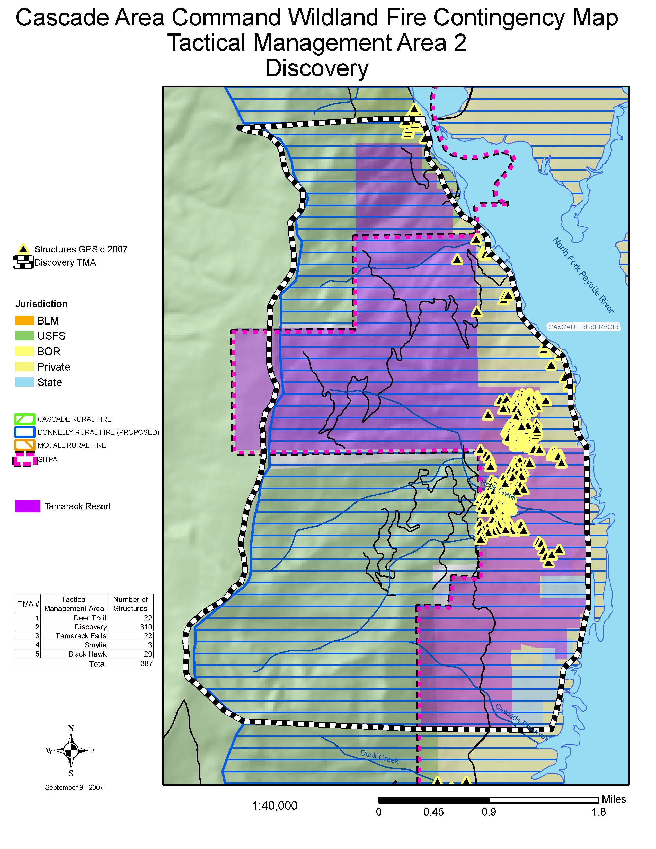

Tactical Management Area 2

Discovery
Verbal description
From the southern boundary of Tamarack Resort properties on West Mountain Road go west to Valley/Adams County line; then north to the center of section 24, Township 16 North, Range 2 East; then east to the intersection of West Mountain Road and Tamarack Falls Road; then south on West Mountain Road to the southern boundary of Tamarack Resort.

Protection considerations for this TMA
- Tamarack Resort
- Multiple structures/residences/outbuildings
- Campgrounds
- Timber Resources
- Powerlines
- SITPA and Donnelly RFD protection

The evacuation personnel and fire suppression forces must evaluate the area for additional protection priorities.

Communication Plan/Radio Frequencies
Valley County fire and law enforcement personnel use the radio frequencies listed below. Listed are some primary frequencies for this TMA. Other frequencies may be designated or in use. Please refer to appendix B for additional frequencies; also refer to the Eastern Great Basin aviation tactical frequency guide.
Name | Rx Freq | Rx Tone | TX Freq | TX tone | Tone # | Band
Donnelly RFD | 154.2050 |  | 154.2050 |  |  | W
911-North | 154.1750 | 88.5 | 158.9550 | 88.5 |  | N
SIS-Snowbank | 159.4500 |  | 151.3100 | 110.9 | 1 | N
Cascade RFD | 154.1450 |  | 154.1450 |  |  | W

Fire Suppression Resources for Consideration (Supplemental Response)
The resources listed in the chart below should be considered as supplements to the local agency response. Variables such as time of day, weather, and equipment availability will determine the specific components of each response.
Ground Equipment |  | Aviation Resources
Structure Group(s) | Containment Division(s)
12 STs Type 1 Engines  w/STLs  6 TFs Type 3-6 Engines  w/TFLs  12 STs Tenders w/STLs | 2 Wildland TF  (4 Engines, 1 Tender)  w/TFLs  12 STs Type 1 or 2 Crews  w/STLs  8 Dozers w/4 TFLs | Heavy Air Tanker*  SEAT  Heavy Helicopter*  Medium Helicopter  Light Helicopter  Air Attack
*Resource not based in local area
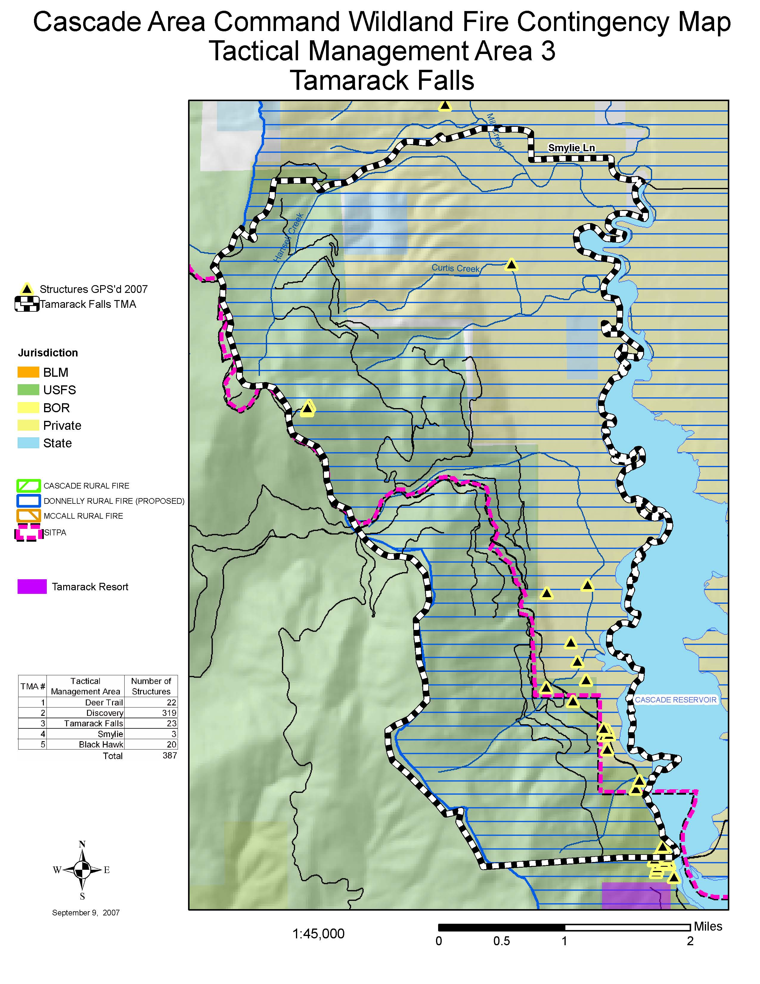

Tactical Management Area 3

Tamarack Falls

Verbal description
From the intersection of West Mountain Road and Tamarack Falls Road go west to the Valley/Adams County line, then north along the Valley/Adams County line to FAA Road in section 27, T. 17 N., R. 2 E., then northeast to West Mountain Road, then east and south on West Mountain Road to Smylie Lane, then east to the North Fork Payette River, then south along the North Fork Payette River and Cascade Reservoir to the intersection of West Mountain Road and Tamarack Falls Road.

Protection Considerations
- Multiple structures/residences/outbuildings
- Powerlines
- Timber
- Grass meadows
- SITPA and Donnelly RFPD protection
The evacuation and fire suppression personnel must evaluate the area for additional protection priorities.

Communication Plan/Radio Frequencies
Valley County fire and law enforcement personnel use the radio frequencies listed below. Listed are some primary frequencies for this TMA. Other frequencies may be designated or in use. Please refer to appendix B for additional frequencies; also refer to the Eastern Great Basin aviation tactical frequency guide.
Name | Rx Freq | Rx Tone | TX Freq | TX tone | Tone # | Band
Donnelly RFPD | 154.2050 |  | 154.2050 |  |  | W
911-North | 154.1750 | 88.5 | 158.9550 | 88.5 |  | N
SIS-Snowbank | 159.4500 |  | 151.3100 | 110.9 | 1 | N

Fire Suppression Resources for Consideration (Supplemental Response)
The resources listed in the chart below should be considered as supplements to the local agency response. Variables such as time of day, weather, and equipment availability will determine the specific components of each response.
Ground Equipment |  | Aviation Resources
Structure Group(s) | Containment Division(s)
1 ST Type 1 Engines  w/STL  2 TFs Type 3-6 Engines  (5 Engines w/TFLs)  1 ST Tenders w/STL | 2 Wildland TFs  (4 Engines, 1 Tender w/TFL)  1 ST Type 1 or 2 Crews  w/STL  2 Dozers w/TFL | Heavy Air Tanker*  SEAT  Heavy Helicopter*  Medium Helicopter  Light Helicopter  Air Attack
*Resource not based in local area
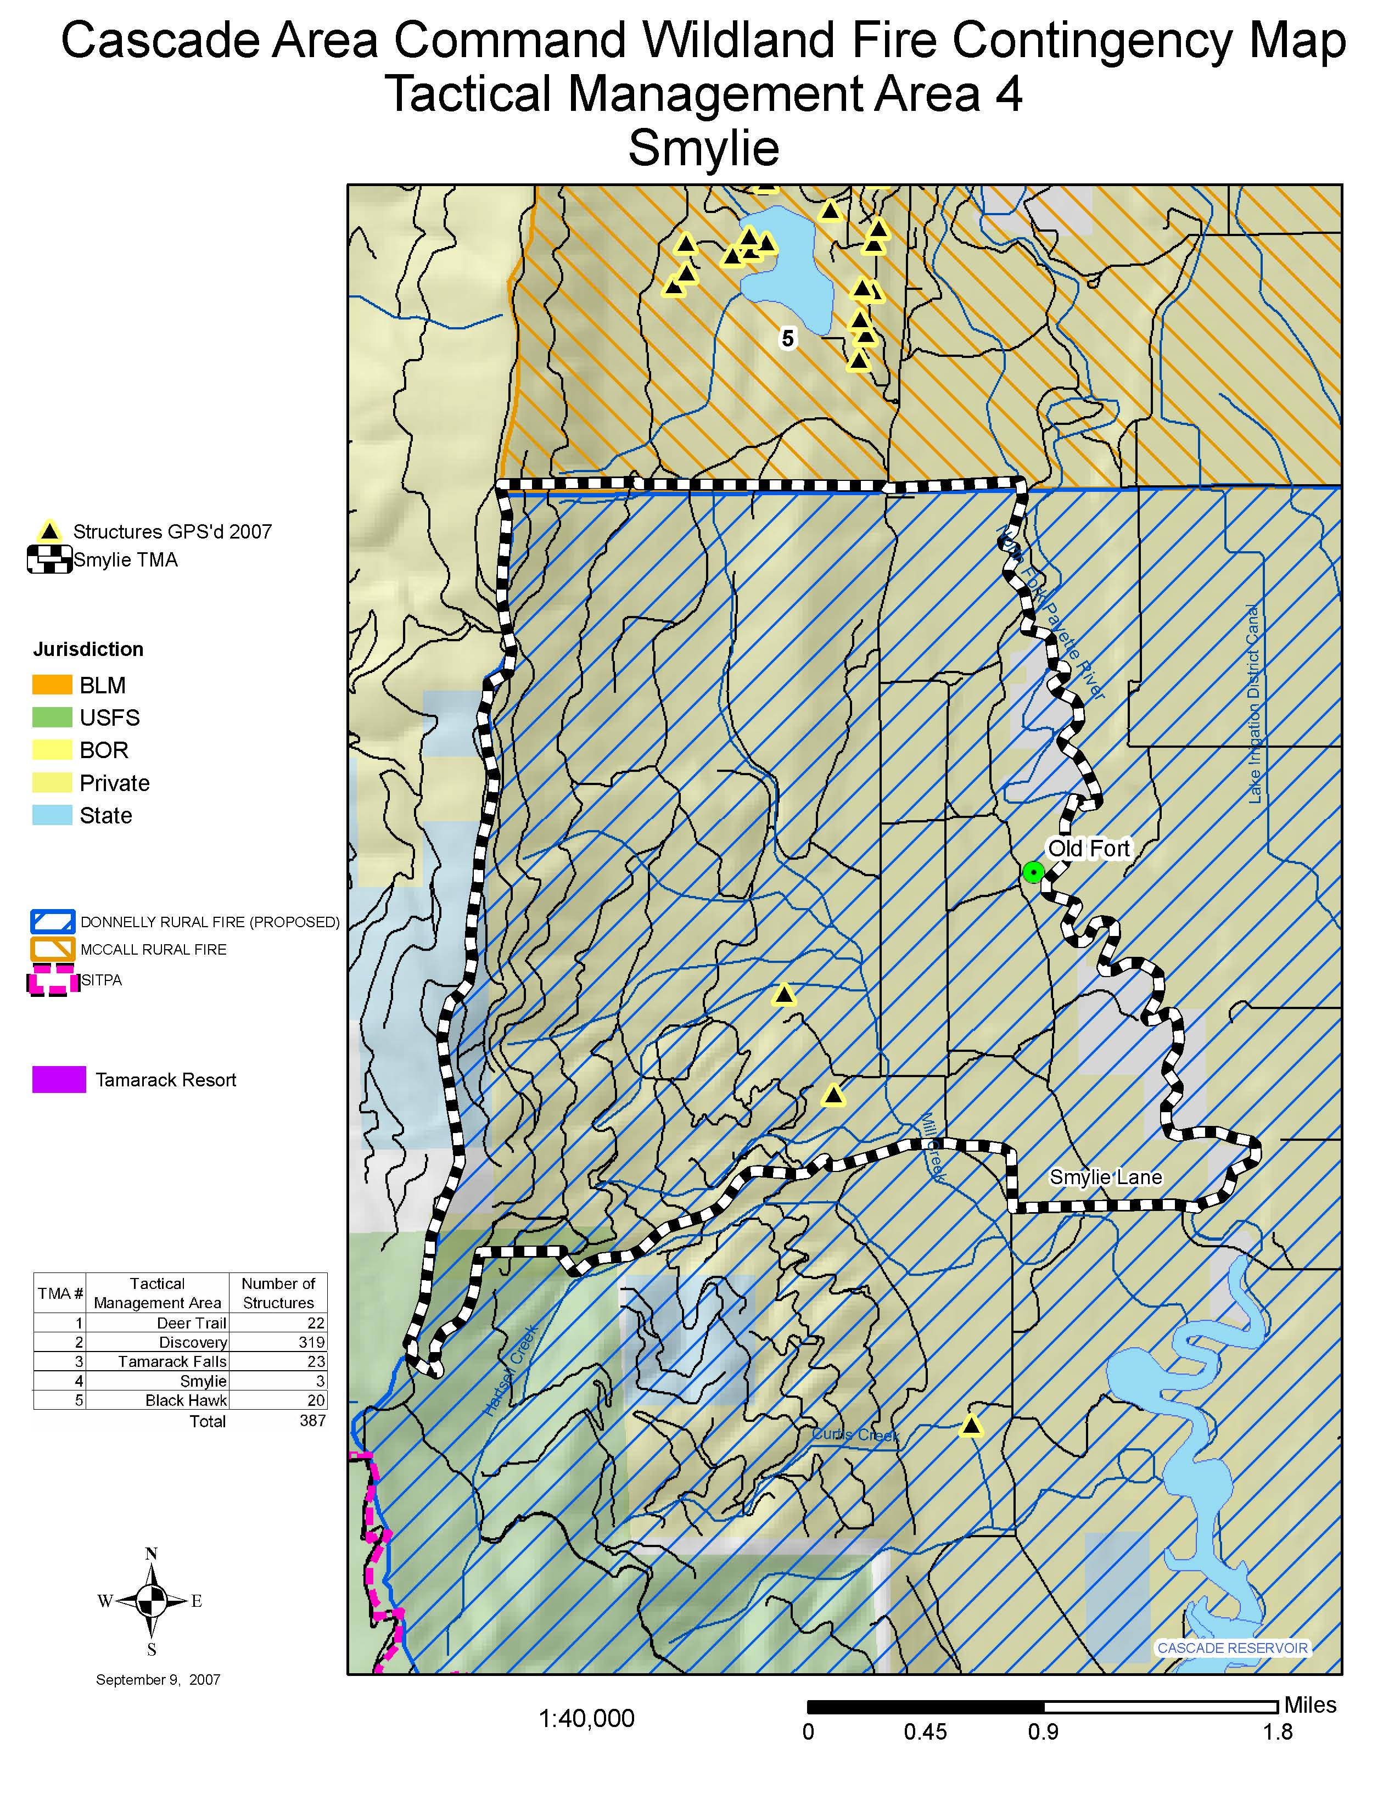

Tactical Management Area 4

Smylie

Verbal description
From the intersection of Smylie Lane on West Mountain Road go north to FAA Road, then go west to the Valley/Adams County line, then go north to the Donnelly RFPD northern boundary, then east to the North Fork Payette River, then south along the North Fork Payette River to Smylie Lane, then go west on Smylie Lane to West Mountain Road.

Protection Considerations
- Multiple structures/residences/outbuildings
- Powerlines
- Timber
- Grass meadows
- SITPA and Donnelly RFD protection

The evacuation and fire suppression personnel must evaluate the area for additional protection priorities.

Communication Plan/Radio Frequencies
Valley County fire and law enforcement personnel use the radio frequencies listed below. Listed are some primary frequencies for this TMA. Other frequencies may be designated or in use. Please refer to appendix B for additional frequencies; also refer to the Eastern Great Basin aviation tactical frequency guide.
Name | Rx Freq | Rx Tone | TX Freq | TX tone | Tone # | Band
Donnelly RFPD | 154.2050 |  | 154.2050 |  |  | W
McCall FD | 153.7700 |  | 153.7700 |  |  | W
911-North | 154.1750 | 88.5 | 158.9550 | 88.5 |  | N
SIS-Snowbank | 159.4500 |  | 151.3100 | 110.9 | 1 | N

Fire Suppression Resources for Consideration (Supplemental Response)
The resources listed in the chart below should be considered as supplements to the local agency response. Variables such as time of day, weather, and equipment availability will determine the specific components of each response.
Ground Equipment |  | Aviation Resources
Structure Group(s) | Containment Division(s)
3 TFs Type 3-6 Engines  (4 Engines, 1 Tender w/TFL) | 2 Wildland TF  (4 Engines, 1 Tender w/TFL)  2 Type 1 or 2 Crews  w/STL  2 Dozer w/STL | Heavy Air Tanker*  SEAT  Heavy Helicopter*  Medium Helicopter  Light Helicopter  Air Attack
*Resource not based in local area
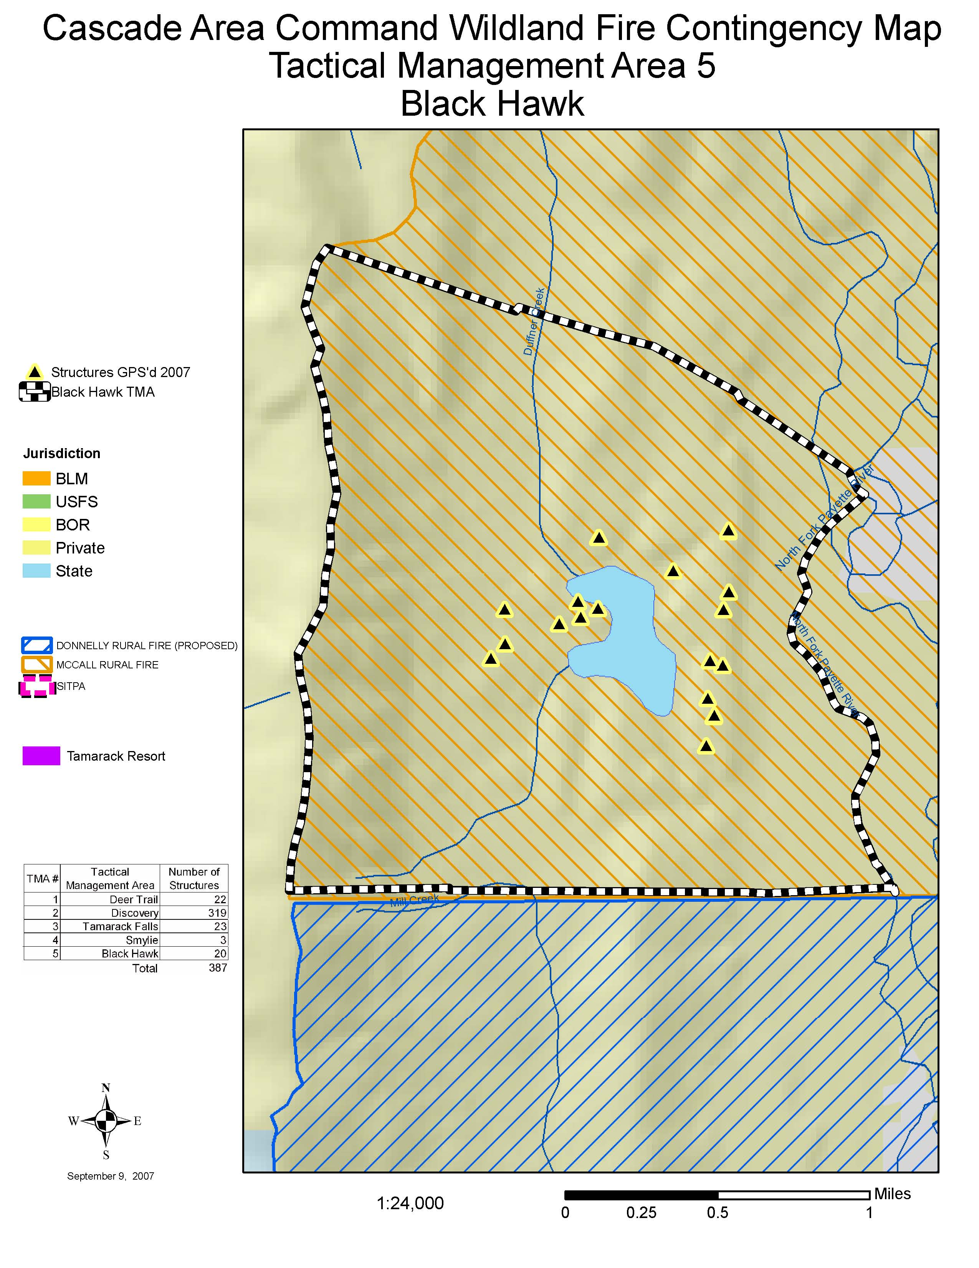

Tactical Management Area 5

Black Hawk

Verbal Description
From the Donnelly RFPD boundary on West Mountain Road go west to the Valley/Adams County line, then go north to Bell Saddle, then go east to the North Fork Payette River, then go south along the North Fork Payette River to the Donnelly RFPD boundary, then go west to West Mountain Road.

Protection Considerations
- Multiple structures/residences/outbuildings
- Powerlines
- Timber
- Grass meadows
- Payette National Forest, SITPA and McCall FD protection

The evacuation and fire suppression personnel must evaluate the area for additional protection priorities.

Communication Plan/Radio Frequencies
Valley County fire and law enforcement personnel use the radio frequencies listed below. Listed are some primary frequencies for this TMA. Other frequencies may be designated or in use. Please refer to appendix B for additional frequencies; also refer to the Eastern Great Basin aviation tactical frequency guide.
Name | Rx Freq | Rx Tone | TX Freq | TX tone | Tone # | Band
McCall FD | 153.7700 |  | 153.7700 |  |  | W
Donnelly RFPD | 154.2050 |  | 154.2050 |  |  | W
911-North | 154.1750 | 88.5 | 158.9550 | 88.5 |  | N
SIS-Snowbank | 159.4500 |  | 151.3100 | 110.9 | 1 | N

Fire Suppression Resources for Consideration (Supplemental Response)
The resources listed in the chart below should be considered as supplements to the local agency response. Variables such as time of day, weather, and equipment availability will determine the specific components of each response.
Ground Equipment |  | Aviation Resources
Structure Group(s) | Containment Division(s)
1 ST Type 1 Engines  w/STL  4 TFs Type 3-6 Engines  (5 Engines w/TFLs)  1 ST Tenders w/STL | 3 Wildland TFs  (4 Engines, 1 Tender w/TFL)  3 STs Type 1 or 2 Crews  w/STLs  3 Dozers w/TFL | Heavy Air Tanker*  SEAT  Heavy Helicopter*  Medium Helicopter  Light Helicopter  Air Attack
*Resource not based in local area

INCIDENT MANAGEMENT TEAM RESPONSE

If wildland fire begins encroaching on the M.A.P.s identified in the Contingency Plan from the Grays Creek Incident, or other incidents, west of the Valley/Adams County line, specific actions will be taken:

- If fire crosses M.A.P. 1, a breach which equates to Evacuation Level 1, the incident will make available tactical assets to suppress the fire at strategic points to be identified.

- If fire breaches M.A.P. 1 and continues an easterly progression toward identified M.A.P.s 2 or 3, the incident will provide additional tactical assets and form a unified command with the appropriate jurisdictional agency/organization.

- A revised delegation of authority will be issued by Area Command to the responsible Incident Commander for the appropriate suppression actions. A sample Delegation of Authority is located in Appendix C.

- If SITPA protection responsibility is involved, a cost-share agreement will be completed with SITPA and the federal agency.

- The appropriate management response from the federal agency will be full suppression to protect private property, infrastructure, and natural resource values.

- The respective fire districts and SITPA will respond to the wildland fire based on its location and the threat to respective jurisdictions, using existing mutual aid agreements. SITPA is the primary wildland fire responder.

- All aviation assets will be coordinated by aerial supervision with the Air Tactical Group Supervisors from the incident or the Payette or Boise National Forest Coordination centers.

- All aviation assets will communicate on appropriate IA zone frequencies.

- All evacuations will be coordinated with the appropriate law enforcement agencies. The Valley County Sheriff has the primary responsibility for evacuation and may request other assistance from appropriate agencies.

- Maps will be provided for the M.A.P.s to the incidents and the jurisdictional agencies within the Contingency Plan area.

ACTIVATION

Criteria to Consider

In the event of impending threat of wildland fire to the West Side Highway 55 Contingency Plan M.A.P.s, the following criteria will be considered before taking specific tactical actions or performing evacuation protocol:

- Fire activity
- Weather
- Sustained run vs. spot fires
- Fuels and fire behavior
- Time of day
- Probability of success with available resources

Steps for Activation:

- Operational personnel will identify the need for a possible evacuation.

- The Incident Commander or designee must approve a request for evacuation.

- The Incident Commander or designee will inform the appropriate law enforcement agency of the current and predicted situation. He or she will complete the following steps:

  - Identify the affected area,
  - Ask that a liaison from the affected agencies report to the Incident Command Post,
  - Ask that the appropriate evacuation be implemented, and
  - Ask for confirmation of shelter activation and for the location of Red Cross evacuation shelters.

EVACUATION NOTIFICATION LEVELS

In the event of wildland fires threatening a populated area of the West Side Highway 55 corridor, a system exercising 3 levels of evacuation notification will be utilized. These 3 levels and the actions which will be initiated are outlined below.

Level 1: To Be Authorized by Valley County Sheriff or Designee

Persons are warned that current or projected threats from hazards associated with an incident are severe. This is the time for preparation and precautionary movement of persons with special needs; mobile property; and, under certain circumstances, pets and livestock. If conditions change, every attempt will be made to notify residents and businesses.

Level 2: To Be Authorized by Valley County Sheriff or Designee

Conditions such as compromised ingress and egress routes indicate a good probability that hazards associated with an incident will severely limit the capability of providing emergency service protection. Dangerous conditions exist that may threaten life and the safety of residents or businesses. Information will be given on evacuation routes to be taken. Everyone must be prepared to leave at abrupt notice. This may be the only notice occupants receive, although attempts will be made to advise residents and businesses as the conditions change.

Level 3: To Be Authorized by Valley County Sheriff or Designee, with Governor’s Proclamation and Approval

Current conditions present specific and imminent threat to the life and safety of persons within the area, and by Section 46-1008 of the Idaho Code, with a Proclamation signed by the Governor of the State of Idaho, an immediate evacuation of the area is required. The Sheriff will use all reasonable means to evacuate residents from the area and maintain ingress and egress routes to and from the designated area. Residents will not be allowed to return until conditions are safe. If this evacuation level is ignored, occupants must understand that emergency services may not be available later.

The McCall Police Chief, along with the Valley County Sheriff, will make the determination of evacuation levels inside the McCall City limits.

The authority to downgrade levels of evacuation rests with the Valley County Sheriff or designee. The same authority rests with the Police Chief, McCall.

AGENCY DECISION-MAKING

If evacuation becomes necessary, the appropriate law enforcement agency will be the organization making the final decision about whether and when to initiate the notification process. In Valley County, this will be the responsibility of the County Sheriff, the Police Chief of McCall, or specific designees from each agency. Other agencies or Incident Management Teams will make recommendations to the appropriate law enforcement departments based on pre-identified M.A.P.s (and also evacuation notification lines) delineated on tactical area maps within the Wildland Fire Contingency Plan.

INFORMATION MANAGEMENT

If wildland fire breaches the M.A.P.s along the western side of the Contingency Plan into the tactical areas, a Joint Information Center will be staffed by jurisdictional agencies, managing information and serving as a single point of information dissemination. This will be in addition to a unified command structure for both evacuations and wildland tactical operations.

EVACUATION SHELTERS

Temporary Red Cross Evacuation Shelter Locations

Three primary locations for temporary evacuation shelters have been identified for Valley County:

- McCall
The Church of Jesus Christ of Latter Day Saints
400 Elo Road
McCall, Idaho

- Donnelly
Donnelly Elementary School
327 East Roseberry Road
Donnelly, Idaho

- Cascade
Cascade Community Church
109 West Pine Street
Cascade, Idaho

A determination of which temporary shelters are available will be made at the time of the incident by the Emergency Management Coordinator for Valley County.

EVACUATION AREA RE-ENTRY

After evacuation orders have been given and implemented, the following evaluation criteria will be used by wildland fire and law enforcement personnel to determine when and under what circumstances the public will be allowed to return home:

- Firefighter and public safety: Has the wildland fire activity permanently subsided to a level safe enough to prevent a recurrence of evacuations?

- Fire stabilization: Are there remaining hazards such as embers, burning trees, downed power lines, or rolling rocks and other gravity hazards that would threaten the safety of life or property?

- Fire traffic and activities: Do the remaining wildland tactical operations require equipment on travel corridors that would be compromised by additional traffic from the public?

- Utilities: Are utilities functioning sufficiently to provide power and water to populated areas?

- Community integrity: Is other community infrastructure, such as transportation routes, stores, and post offices, functional and able to sustain re-population?

- Economic consequences: Does the potential economic loss of continued evacuations outweigh the risk of re-entry of the evacuation area?

KEY CONTACT NUMBERS

The following are contacts for questions about this Contingency Plan:

US Forest Service, Payette National Forest

Brown, Gary R.
Title: PNF Fire Staff Officer
Office phone: 208.634.0710 / cell: 208.634.6790
E-mail address: grbrown@fs.fed.us

Jeffries, Shane
Title: McCall Ranger, PNF
Office phone: 208.634.0401 / cell: 208.634.9324
E-mail address: sjeffries@fs.fed.us

Rainville, Suzanne
Title: PNF Forest Supervisor
Office phone: 208.634.0701
E-mail address: srainville@fs.fed.us

Staats, Roger
Title: Central Zone FMO, PNF
Office phone: 208.634.0410 / cell: 208.634.6451
E-mail address: rstaats@fs.fed.us

US Forest Service, Boise National Forest

McCoy-Brown, Carrol
Title: Cascade Ranger, BNF
Office phone: 208.382.7400
E-mail address: cmccoybrown@fs.fed.us

Pence, Guy
Title: BNF Staff Officer
Office phone: 208.861.3471
E-mail address: gpence@fs.fed.us

Idaho Department of Lands

Keaffer, Sheldon
Title: McCall area contact
Office phone: 208.634.7125
E-mail address: skeaffer@idl.idaho.gov

Southern Idaho Timber Protective Association

Woods, Mark
Title: Fire Warden
Office phone: 208.634.2268
E-mail address: mwoods@sitpa.idaho.gov

Valley County

Bateman, Lori
Title: Valley County Road Department Secretary
Office phone: 208.382.7195
E-mail address: roaddept@co.valley.id.us

Bolen, Patti
Title: Valley County Sheriff
Office phone: 208.382.7150
E-mail address: pbolen@co.valley.id.us

Dispatch - Valley County 911
Office phone: 208.382.7151
E-mail address: dispatch@co.valley.id.us

Taylor, Kelly
Title: 911 Dispatch Supervisor
Office phone: 208.382.7151
E-mail address: ktaylor@co.valley.id.us

Winkle, Jerry
Title: Chairman of the Board, Valley County Commission
Office phone: 208.382.7100
E-mail address: jwinkle@co.valley.id.us

City of McCall

Appel, Jan
Title: McCall Hospital contact
Office phone: 208.634.2221
E-mail address: jappel@mccallhospital.org

Cochram, Jacquie
Title: McCall EMS Coordinator
Office phone: 208.634.7071
E-mail address: jacquie@mccallfireandems.com

Lemberes, Andrew
Title: McCall Fire Department Chief
Office phone: 208.634.7070
E-mail Address: andrew@mccallfireandems.com

Rittenger, Pete
Title: McCall Police Officer
Office phone: 208.634.7144
E-mail address: rittengerp@mccall.id.us

City of Donnelly

Bonilla, Juan R.
Title: Donnelly Rural Fire Protection District Chief
Office phone: 208.325.8619
E-mail address: dfc@frontiernet.net

City of Cascade

Coombs, Teri
Title: Cascade Medical Center contact
Office phone: 208.382.4242
E-mail address: tericoomb@cmchd.org

Hass, Jim
Title: Cascade Rural Fire Department Chief
Office phone: 208.382.3200
E-mail address: cascaderuralfire@frontiernet.net

Redman, Ryan
Title: Cascade City Chief of Police
Office phone: 208.382.4123
E-mail address: cscdpd@frontiernet.net

Wirtz, Bryan
Title: City Superintendent, Cascade City Public Works
Office phone: 208.382.4279
E-mail address: cascadepublicworks@frontiernet.net

American Red Cross

Marshall, Judie
Title: Red Cross of Idaho Regional Director
Office phone: 1.800.853.2570 / cell: 208.573.1980
E-mail address: marshallj@redcrossidaho.org

APPENDIX A

HISTORICAL WEATHER ANALYSIS

The following historical weather analysis section was taken from the Wildland Fire Contingency Plan for the East Side of Idaho State Highway 55 Corridor under the assumption that this analysis is also applicable to the area covered by the Wildland Fire Contingency Plan for the West Side of Idaho State Highway 55 Corridor relative to the probability of fire-slowing and season-ending weather events.

Background

Federal land management agencies are required to use the best available science in the decision-making and implementation process. The following is a summary of historical weather used in development of the East Side of Highway 55 Wildland Fire Contingency Plan.

Historical Weather Analysis

Historical weather data was used to investigate the probability of fire-slowing and season-ending events on the Boise National Forest. Weather information was downloaded from the NIFMID/KCFAST fire occurrence information retrieval site and imported into FireFamily Plus, using data from the Bearskin Remote Automated Weather Station (RAWS) (101221; 6700 ft). The analysis period was from June 1 to November 30, during the years of 1982-2006. Seasonal trends in precipitation and Energy Release Component (ERC) were analyzed. ERC is a number related to the available energy (BTU) per unit area (square foot) within the flaming front at the head of the fire.

Term Analyses - RERAP

The Rare Event Risk Assessment Process (RERAP) was used to develop two Weibull waiting-time distributions or termination events: one a fire-slowing event (i.e., >.35” of rain over a 3-day period) (Figure A.1), the other a season-ending event (i.e., ERC never recovering above the 80th percentile) (Figure A.2). Event criterion was selected based on discussions with fire personnel on the Boise National Forest and fire-weather associations. A fire-slowing event is defined as an event where sufficient moisture halts fire spread and significantly changes fire behavior 2-4 days after the precipitation event or events. Depending on the receptor fuel, canopy cover, and extent of the precipitation, a fire-slowing event may or may not extinguish the fire. On August 19-20, 2007, we received a fire-slowing event (an average, across six stations, of .40 inches of precipitation). A season-ending event consists of a fire-slowing event or events followed by a persistent combination of environmental factors that terminate the fire season (a Term event).

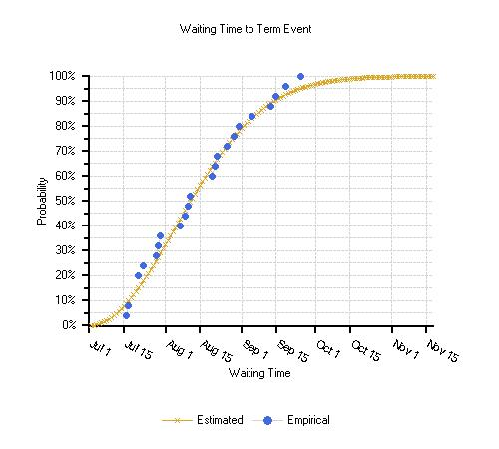
Figure A.1. Probability of a fire-slowing event (>.35” of rain over 3 days) using weather from Bearskin RAWS 1982-2006.
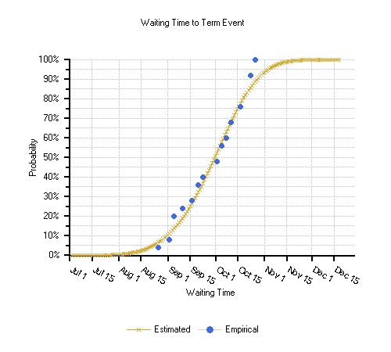
Figure A.2. Probability of a season-ending event—based on ERC recovery—using weather from Bearskin RAWS 1982-2006.

Analyses of season-ending events allow for each year to be grouped into 5 categories (Table A.1):

- No Season (ERC-G rarely exceeds 40 for the entire fire season);

- Early Term (event occurs the end of August or the first week of September);

- Mid-term (event occurs the middle of September or the first week of October);

- Fire-stopping event followed by a resurgent ERC (“Indian summer”) and ending with a Late-term event (Figure A.3); and

- Late-term (event occurs the end of October).

Year | Season Description | TermDate (ERC) | Occurrence (%)
1982 | “no season” | 9/5 | 12%
1983 | “no season” | 10/23
1984 | “no season” | 10/5
1985 | early Term | 8/26 | 16%
1986 | early Term | 9/2
1987 | late Term | 10/26 | 12%
1988 | late Term | 10/26
1989 | resurgent ERC | 10/17 | 36%
1990 | resurgent ERC | 9/20
1991 | resurgent ERC | 10/11
1992 | resurgent ERC | 10/23
1993 | mid Term | 10/2 | 24%
1994 | mid Term | 9/23
1995 | mid Term | 9/20
1996 | mid Term | 10/8
1997 | early Term | 9/5
1998 | early Term | 9/5
1999 | late Term | 10/23
2000 | resurgent ERC | 10/5
2001 | resurgent ERC | 10/2
2002 | resurgent ERC | 10/17
2003 | resurgent ERC | 10/23
2004 | resurgent ERC | 10/11
2005 | mid Term | 9/10
2006 | mid Term | 9/16

Table A.1. Fire seasons grouped into 5 main categories based on a season-ending event (ERC recovery) using weather from Bearskin RAWS.

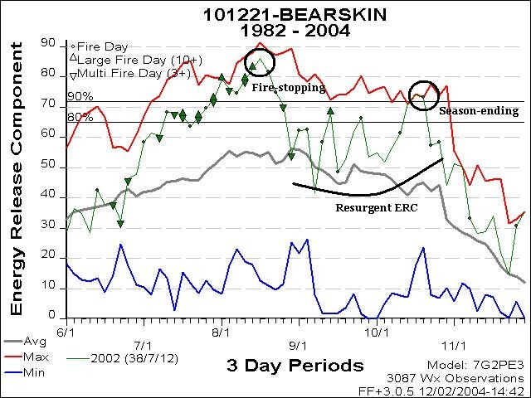
Figure A.3. Example (2002) of a fire-stopping or –slowing event, followed by a resurgent ERC, or “Indian summer,” and ending with a late-season Term event.

APPENDIX B

RADIO FREQUENCIES

Ch | Name | Rx Freq | Rx Tone | TX Freq | TX tone | Tone # | Band
1 | SIS- Snowbank | 159.4500 |  | 151.3100 | 110.9 | 1 | N
2 | SIS- Brundage | 159.4500 |  | 151.3100 | 146.2 | 5 | N
3 | SIS- Direct | 159.4500 |  | 159.4500 |  |  | N
4 | SIS- Tactical | 159.2250 |  | 159.2250 |  |  | N
5 | PAF Air to GROUND | 171.5500 |  | 171.1375 |  |  | N
6 | PAF East | 169.9000 |  | 169.9000 | 110.9 | 1 | N
7 | PAF Nick Pk | 169.9000 |  | 170.5500 | 123.0 | 2 | N
8 | PAF West | 171.5500 |  | 171.5500 | 110.9 | 1 | N
9 | PAF Indian Mt. | 171.5500 |  | 172.3500 | 136.5 | 4 | N
10 | BOF North - Direct | 171.4500 |  | 171.4500 | 123.0 | 2 | N
11 | BOF - Meadow Cr | 171.4500 |  | 164.6000 | 110.9 | 1 | N
12 | BOF - Thunderbolt | 171.4500 |  | 164.6000 | 123.0 | 2 | N
13 |  | 171.4500 |  | 164.6000 | 136.5 | 4 | N
14 |  | 171.4500 |  | 164.6000 | 146.2 | 5 | N
15 | BOF - Packer John | 171.4500 |  | 164.6000 | 167.9 | 7 | N
16 | BOF - Air to Ground | 168.1750 |  | 168.1750 |  |  | N
Table B.1. SITPA radio frequencies: Group 1, SITPA North.

Ch | Name | Rx Freq | Rx Tone | TX Freq | TX tone | Tone # | Band
1 | SIS- Snowbank | 159.4500 |  | 151.3100 | 110.9 | 1 | N
2 | SIS- Brundage | 159.4500 |  | 151.3100 | 146.2 | 5 | N
3 | SIS- Direct | 159.4500 |  | 159.4500 |  |  | N
4 | SIS- Tactical | 159.2250 |  | 159.2250 |  |  | N
5 | 911-South | 155.3550 | 88.5 | 158.9550 | 88.5 |  | N
6 | Cascade RFD | 154.1450 |  | 154.1450 |  |  | W
7 | Cascade City FD | 154.2350 |  | 154.2350 |  |  | W
8 | Donnelly RFD | 154.2050 |  | 154.2050 |  |  | W
9 | IDL - Direct | 159.4650 | 77.0 | 159.4650 | 77.0 |  | N
10 | IDL - Snowbank | 159.4650 | 127.3 | 151.2650 | 110.9 | 1 | N
11 | IDL - Tac | 159.2850 |  | 159.2850 |  |  | N
12 | IDL- Air to Ground | 151.1450 | 100.0 | 151.1450 | 100.0 |  | N
13 | BOF North - Direct | 171.4500 |  | 171.4500 | 123.0 | 2 | N
14 | BOF - Meadow Cr | 171.4500 |  | 164.6000 | 110.9 | 1 | N
15 | BOF - Packer John | 171.4500 |  | 164.6000 | 167.9 | 7 | N
16 | BOF - Air to Ground | 168.1750 |  | 168.1750 |  |  | N
Table B.2. SITPA radio frequencies: Group 2, SITPA South.

Ch | Name | Rx Freq | Rx Tone | TX Freq | TX tone | Tone # | Band
1 | SIS- Snowbank | 159.4500 |  | 151.3100 | 110.9 | 1 | N
2 | SIS- Brundage | 159.4500 |  | 151.3100 | 146.2 | 5 | N
3 | SIS- Tactical | 159.2250 |  | 159.2250 |  |  | N
4 | MFPD | 153.7700 |  | 153.7700 |  |  | W
5 | DRFD | 154.2050 |  | 154.2050 |  |  | W
6 | CRFD | 154.1450 |  | 154.1450 |  |  | W
7 | CFD | 154.2350 |  | 154.2350 |  |  | W
8 | PAF - Simplex | 169.9000 |  | 169.9000 | 110.9 | 1 | N
9 | PAF - Repeat | 169.9000 |  | 170.5500 | 110.9 | 1 | N
10 | PAF - Air to Ground | 171.1375 |  | 171.1375 |  |  | N
11 | VC Comm (911 North) | 154.1750 | 88.5 | 158.9950 | 88.5 |  | N
12 | VC Comm (911 South) | 155.3550 | 88.5 | 150.8050 | 88.5 |  | N
13
14
15 | NOAA | 162.5500 |  |  | 167.9 | 7
16 | NOAA | 162.4750
Table B.3. SITPA radio frequencies: Group 3, VIIG.

Ch | Name | Rx Freq | Rx Tone | TX Freq | TX tone | Tone # | Band
1 | SIS- Snowbank | 159.4500 |  | 151.3100 | 110.9 | 1 | N
2 | SIS- Brundage | 159.4500 |  | 151.3100 | 146.2 | 5 | N
3 | SIS- Direct | 159.4500 |  | 159.4500 |  |  | N
4 | SIS- Tactical | 159.2250 |  | 159.2250 |  |  | N
5 | PAF Air to GROUND | 171.5500 |  | 171.1375 |  |  | N
6 | PAF East | 169.9000 |  | 169.9000 | 110.9 | 1 | N
7 | PAF Nick Pk | 169.9000 |  | 170.5500 | 123.0 | 2 | N
8 | PAF West | 171.5500 |  | 171.5500 | 110.9 | 1 | N
9 | PAF Indian Mt. | 171.5500 |  | 172.3500 | 136.5 | 4 | N
10 | BOF North - Direct | 171.4500 |  | 171.4500 | 123.0 | 2 | N
11 | BOF - Meadow Cr | 171.4500 |  | 164.6000 | 110.9 | 1 | N
12 | BOF - Thunderbolt | 171.4500 |  | 164.6000 | 123.0 | 2 | N
13 |  | 171.4500 |  | 164.6000 | 136.5 | 4 | N
14 |  | 171.4500 |  | 164.6000 | 146.2 | 5 | N
15 | BOF - Packer John | 171.4500 |  | 164.6000 | 167.9 | 7 | N
16 | BOF - Air to Ground | 168.1750 |  | 168.1750 |  |  | N
Table B.4. SITPA radio frequencies: Group 4, Boundary.

APPENDIX C

DELEGATION OF AUTHORITY TO INCIDENT COMMAND TEAM

Date:

To: Incident Commander

You have been assigned as the Incident Commander for the (names of incidents or Complexes) on the (name of the agency units).

You have full authority and responsibility for the management and coordination of the incidents and managing all resources assigned.
_____________________________________________________________________

You will also facilitate the communication and coordination between the (names of Agency Reps. or Administrators and FMO’s or Chief Officers and agency representatives).

Your critical responsibilities include:
- Firefighter and public safety associated with the incidents.
- Ensure that incident objectives do not conflict and are met.
- The current signed WFSA direction, objectives and cost limits are met or amended.
- Established agency human resource policies are followed.
- Order, deploy and redeploy resources to meet the changing strategic needs within the incident.
- Identify and resolve conflicts as needed between, agencies and cooperators.
- Coordinate public information between with the agencies and/or establish a JIC if directed.

The Incident Management Team will work within all legal statues and current policy of the agencies and broad direction given by the Agency Administrators.

This Delegation of Authority will be amended within (show 36 or 48 hours) if more specific instruction or information is needed. Be prepared to assume command at (hours) on (date).

Signatures____________________ Date __________

The first in-text instance of each acronym is shown in bold for easy reference.

