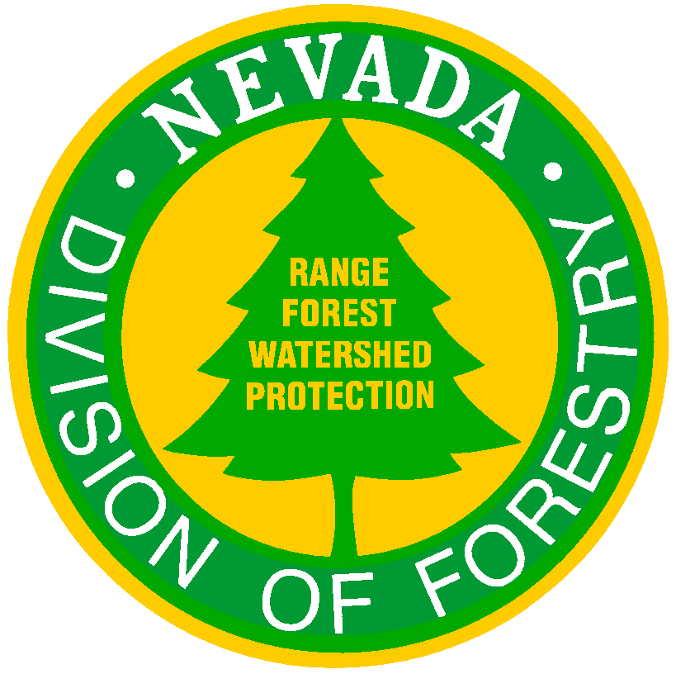
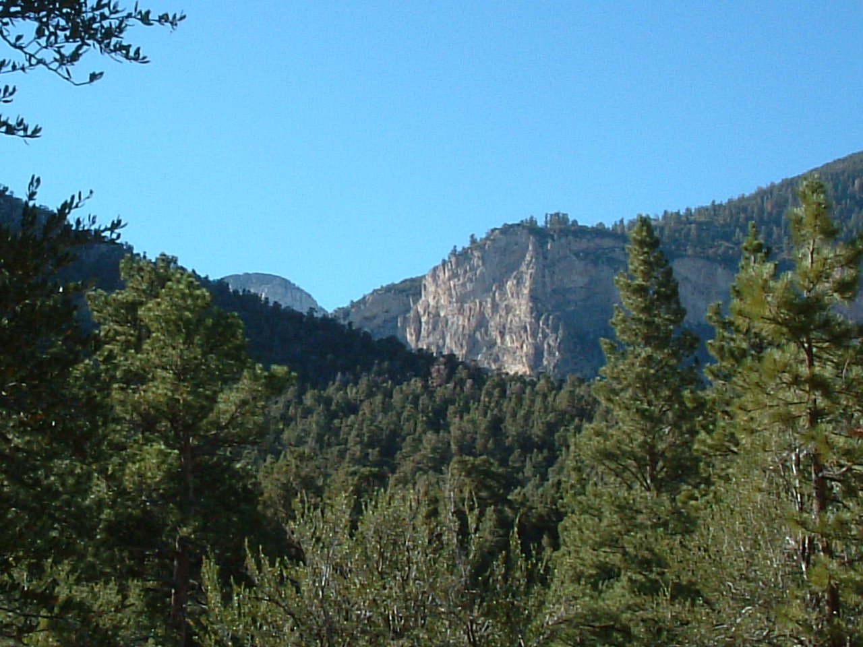
NDF Plan

Nevada Division of Forestry

Mt. Charleston F.P.D.

Strategic Structure Protection
Plan

2/22/12

Nevada Division of Forestry
Kyle Canyon

Structure Protection Plan

Foreword
The information contained in this strategic plan is a compilation of data taken from a variety of federal, state, and local government fire service and law enforcement resources and is designed solely as a strategic guideline to support operational fire suppression tactics as it relates to structure protection for the Mt. Charleston area.

We graciously thank the following agencies for their contributions towards the creation of this document. Their insight and professionalism have been both instrumental and invaluable:

- Nevada Division of Forestry
- Clark County Fire Department
- Mt. Charleston Volunteer Fire Department
- Las Vegas Metropolitan Police Department
- Nevada Highway Patrol
- United States Forest Service
- United States Bureau of Land Management
- Las Vegas Fire Department

Executive Summary
The objective of this report is to assess and report those projected factors that will
Influence your structure protection strategies in the event of a wildfire involving the communities of Rainbow, Echo, Cathedral Rock and Old Town. The document’s foundation is based on previous activity, current developments, present conditions and local influencing factors.

The intent of this document is to assist those firefighting agencies throughout Nevada in the training, preparation and development of operational strategies and tactics as it relates to structure protection in the wildland-urban interface environment present in the Mt. Charleston area.

Additionally this document will provide credible intelligence consisting of descriptive area overviews, structure density and construction, fuel types and environmental conditions, and residential utility infrastructure.

As public Safety agencies throughout Nevada should be keenly aware of the environmental and hazardous working conditions and the operational difficulties they posed when responding to incidents within the Mt. Charleston area this document also provides generalized safety considerations and recommendations for taking safe aggressive action to mitigate the threats of wildfire.

Nevada Division of Forestry
Kyle Canyon
Structure Protection Plan

Executive Summary (continued)

Finally, it is important to remember that firefighter safety is and will continue to be the first priority. Take time to review and practice the 10 Standard Fire Orders, 18 Watch-Out Situations, Common Denominators of Fire Behavior on Tragedy Fires, and LCES. Unfortunately history has reflected that most wildland fire fatalities have been directly related to violations of these directives.

Take the time to review this document thoroughly. It should provide an excellent source
Of information for training at the Company level. Ensure and promote a safe working
Environment at all times and remember the importance of awareness, safety, and
Responsibility…it works.

Nevada Division of Forestry
Kyle Canyon

Structure Protection Plan

RAINBOW SUB-DIVISION

Area Description:

The Rainbow sub-division consists of a mix of various construction types, both new and old consisting of wood frame and block form construction. Roof construction consists of some wood-shake shingles but the majority of the structures possess non-combustible roofs. Many residences have combustible materials located throughout their properties.

At the end of Rainbow Canyon Road there is a maintained access road leading to 30 summer cabins. Adjacent to that access road is a maintained firebreak for the ladder fuels only.

Approximately 230 single-family dwellings exist within the entire Rainbow sub-division. There is a gated area of three homes available for safe staging near the entrance of Rainbow Canyon Road; however, gate access will need to be provided and this area only serves those three homes.

The topography throughout the Rainbow sub-division is mostly flat with steep terrain to the south. The north-end is bordered by State Route 157 with only 1 ingress/egress route to and from the subdivision.

Throughout the entire sub-division terrain becomes steep with mixed light fuels laddering into heavier fuels and timber.

Water Resources:

The Rainbow sub-division water supply consists of a gravity-fed closed-loop system supported by two reservoirs. There are approximately 23 hydrants with flow-rates ranging between 300-800 GPM located throughout the sub-division. There is the possibility that some of those may be intermittently non-functional and the system as a whole should not be relied upon for a constant water supply.

Tactical Challenges:

- Limited access/steep narrow roads
- Residential density
- Numerous Propane tanks
- Mixed continuous fuel types
- Poor fuel clearance around structures
Nevada Division of Forestry
Kyle Canyon
Structure Protection Plan

RAINBOW SUB-DIVISION
p.2

Suggested Resource List:

- Air Support
- 3 Type I Engine Strike Teams
- 1 Type III Engine Strike Team
- 2 Water Tenders

Recommendations:

- Consider the utilization of experience fire suppression personnel
- Consider the use of foam applications and/or agents, i.e. CAFS, or blocking gels
- Use of pre-event evacuation plans
- Coordinate pre-event traffic plans with local law enforcement
- Pre-established trigger points for operational tactics
- Due to limited ingress/egress routes consider the use of pre-deployed Structure Protection Group(s) in order not to hamper evacuation routes with responding equipment.

Nevada Division of Forestry
Kyle Canyon
Structure Protection Plan

CATHEDRAL ROCK SUB-DIVISION

Description:

Cathedral Rock is a small sub-division containing both moderate and heavy fuel types. There are approximately 35 single-family dwellings, 20 cabin rentals, and the Mt. Charleston Lodge on the far-east end. The homes are generally built very close together with combustible materials located throughout the properties. Narrow streets exist with tight turning radius (i.e. Knotty Pine road narrows to Type 1 Engine width at the upper end).

It should be noted that the northern edge of the sub-division is situated above a steep hillside laden with heavy fuels and that there are several wide turnouts located adjacent to the Lodge that may accommodate limited staging of apparatus.

Water Resources:

The sub-division water supply consists of a gravity-fed closed-loop system supported by one reservoir. There are 3 hydrants with flow-rates ranging between 100-500 GPM located throughout the sub-division. There is the possibility that some of those may be intermittently non-functional and the system as a whole should not be relied upon for a constant water supply.

Tactical Challenges:

- Limited access/steep narrow roads
- Residential density
- Numerous Propane tanks
- Mixed continuous fuel types
- Poor fuel clearance around structures

Suggested Resource List:

- Air Support
- 1 Type I Engine Strike Team (Lodge and rental cabins, CAFS, or gel application capable)
- 2 Type III Engine Strike Teams (residential)
- 1 Water Tender

Nevada Division of Forestry
Kyle Canyon
Structure Protection Plan

CATHEDRAL ROCK SUB-DIVISION
p.2

Recommendations:

- Consider the utilization of experience fire suppression personnel
- Consider the use of foam applications and/or agents, i.e. CAFS, or blocking gels
- Use of pre-event evacuation plans
- Coordinate pre-event traffic plans with local law enforcement
- Pre-established trigger points for operational tactics
- Due to limited ingress/egress routes consider the use of pre-deployed Structure Protection Group(s) in order not to hamper evacuation routes with responding equipment.

Nevada Division of Forestry
Kyle Canyon
Structure Protection Plan

OLD TOWN SUB-DIVISION

Description:

The Old Town sub-division is an older sub-division laced with approximately 75 wood-sided structures, one library, a volunteer fire station (possible staging area) and an approximate 10,000 sq. ft. brick constructed elementary school (possible staging area) with metal roofing on the east end. Most of the single-family dwellings have wood shake-shingle roofs with the homes being built close together with combustible materials located throughout the properties.

Throughout the sub-division light flashy fuels exist with some ladder fuels bordering the east- end. The topography throughout the Old Town sub-division is mostly flat with steep terrain to the south.

The northern-end is bordered by State Route 157 with the sub-division possessing only 1 looped road consisting of one half paved and one half gravel. It is extremely narrow requiring a single ingress/egress route to and from the subdivision.

Water Resources:

The sub-division water supply consists of a gravity-fed closed-loop system supported by two reservoirs requiring the opening of a pressure relief valve in order to charge the system (please contact the local water authority). This operation is necessary in order to prevent excessive back flow thereby reducing potential damage to the residences. There are a total of 7 hydrants (3 on the paved and 3 on the gravel sections of road, and 1 at the elementary school) with flow-rates ranging between 100-250 GPM. The system as a whole should not be relied upon for a constant water supply.

Tactical Challenges:

- Limited access/narrow road
- Residential density
- Numerous Propane tanks
- Mixed continuous fuel types
- Poor fuel clearance around structures

Suggested Resource List:

- Air Support
- 1 Type I Engine
- 1 Type III Engine Strike Team
- 2 Water Tenders

Nevada Division of Forestry
Kyle Canyon
Structure Protection Plan

OLD TOWN SUB-DIVISION
p.2

Recommendations:

- Consider the utilization of experienced fire suppression personnel
- Consider the use of foam applications and/or agents, i.e. CAFS, or blocking gels
- Use of pre-event evacuation plans
- Coordinate pre-event traffic plans with local law enforcement
- Pre-established trigger points for operational tactics
- Local fire representation
- Due to limited ingress/egress routes consider the use of pre-deployed Structure Protection Group(s) in order not to hamper evacuation routes with responding equipment.

Nevada Division of Forestry
Kyle Canyon
Structure Protection Plan

ECHO SUB-DIVISION

Description:

The Echo sub-division consists of approximately 110 predominately new upscale wood-framed structures built into the hillside and surrounded by mountain mahogany. Most structures consist of wood shake-shingle roofs with combustible materials located throughout the properties.

The subdivision has only one ingress/egress that also serves as an access to popular hiking trails and campsites. Some roads within the sub-division are extremely steep and access to homes may be difficult due to the terrain. All roads within the sub-division are mid-slope.

Water Resources:

The Echo sub-division water supply consists of a gravity-fed closed-loop system supported by two reservoirs. There are a total of 9 hydrants with flow-rates ranging between 750-1000 GPM. The northwestern end of the sub-division has few hydrants. The system as a whole should not be relied upon for a constant water supply.

Tactical Challenges:

- Limited access/narrow roads
- Residential density
- Numerous Propane tanks
- Mixed continuous fuel types
- Poor fuel clearance around structures

Suggested Resource List:

- Air Support
- 2 Type I Engine Strike Teams
- 1 Type III Engine Strike Team
- 2 Water Tenders
- 1 Type I Crew Strike Team
Nevada Division of Forestry
Kyle Canyon
Structure Protection Plan

ECHO SUB-DIVISION
p.2

Recommendations:

- Consider the utilization of experienced fire suppression personnel
- Consider the use of foam applications and/or agents, i.e. CAFS, or blocking gels
- Use of pre-event evacuation plans
- Coordinate pre-event traffic plans with local law enforcement
- Pre-established trigger points for operational tactics
- Consider the use of aggressive operational tactics due to mid-slope environment accompanied with potential for high-value dollar loss.
- If backing fire is approaching development consider the use of Kris Kringel Street as an anchor point for firing operations.
- Due to limited ingress/egress routes consider the use of pre-deployed Structure Protection Group(s) in order not to hamper evacuation routes with responding equipment.

Nevada Division of Forestry
Kyle Canyon

Structure Protection Plan

Urbanized Forest Communities
A rapidly spreading wildfire coupled with a lack of defensible space may result in many structures burning simultaneously. Structure protection may not be possible. Sizing up each situation and triaging structures will be extremely important before committing to any structure protection. Fire behavior will be influenced not only by forest fuels but also by the extreme intensity of multiple burning structures. Expect extreme fire behavior conditions with the potential of homes being a carrier of fire. Hazardous materials, electric and gas lines, and propane tanks will also be a factor.

Safety
Make it a priority to review the Wildland-Urban Watch-outs, the LCES Checklist, the Structure Go-No Go/Protection Reference, the Common Denominators of Fire Behavior on Tragedy Fires and utilize the Pre-Incident Assignment Checklist (see attachments).

Take the time to ensure, and promote a safe working environment, review the following safety points and remember; “Sheltering- in-Place” procedures (both civilian and fire personnel)

- Remain mobile, no supply lines unless crew safety is compromised. When employing protection tactics always back-in apparatus and always employ a backup person.

- Structure Protection requires the use of appropriate structure personal protective
Equipment (PPE).

- Observe vertical hazards (power lines, falling trees, etc.)

- Strike Team Leaders should scout high danger areas prior to deploying engines/equipment

- Exercise extreme caution when deployed to areas of limited ingress/egress, limited or poor water resources, etc.

- Wood constructed structures with shake roofs may burn intensely and extremely
Quick. Flying brands from burning roofs may continue downwind igniting additional structures.

- Situations involving crowning, large flame heights and erratic fire behavior can
Extend in an unpredictable manner, beyond the control of any number of fires
Suppression personnel.
Nevada Division of Forestry
Kyle Canyon

Structure Protection Plan

Safety (continued)
- Do not overextend your personnel, or resources. Anticipate resource needs, and
Order early.

- Winds of 25+ mph increase the chance of spotting over the heads of firefighters,
and trapping them between both fire areas. Winds also cause greater preheating of fuels in the path of a fire front.

- When necessary and if time permits attempt to create a defensible space around
Structures; remember that structures on slopes will require greater clearance.

- Snags are one the overall top killers of Wildland Firefighters in the U.S. Snags by themselves are quite hazardous; when on fire they become extremely dangerous. Do not attempt to fall a snag unless you are qualified to do so. When performing structure protection in and around snags you should post additional lookouts. Place equipment in a position that it will not be blocked or hit by falling snags. Prior to engine placement size up all snags and mark accordingly, either with the standard green and white “Killer Tree” flagging or by yellow and black hazard tape.

- Evacuation responsibilities can task firefighters from their fire suppression activities, and may distract attention from fire behavior at a time when that focus may be most critical. If possible, utilize law enforcement resources for evacuation needs, especially when establishing perimeter controls.

- When faced with canyon slopes or "chimneys" with slopes of 30% or more and
Continuous, flashy fuels the rate of spread of any fire can quickly extend beyond
Initial containment.

- Reduced or poor access with narrow, one-way roads could trap apparatus and
Personnel before they can safely egress the area. Ensure that you always
Provide for exits. Do not block ingress/egress to others.

- Always maintain a reserve water supply sufficient to protect your apparatus and
Personnel. Anticipate the need for additional water resources and evaluate the
availability of such.

- Deploy no more than 300’ of hose

- Use a minimum of 1 1/2 “ hose

Nevada Division of Forestry
Kyle Canyon

Structure Protection Plan

Safety (continued)
- Heavy fire apparatus may exceed the normal capacity of rural bridges. Apparatus Operators need to remain alert to changing road and vehicle conditions, and pay close attention to posted load limits.

- When employing safety zones they should be large enough so that the distance
between the firefighters and flames is at least four times the maximum flame
height in all directions per firefighter. This is for radiant heat only. There are
no studies for convective heat generated from slope, wind gusts, fire whirls, and
turbulence. Safety zones in these areas would have to be much larger.

Attachments:
Kyle Canyon Water District Map
10 Standard Fire Orders
18 Watch-out Situations
Wildland-Urban Watch-outs
LCES Checklist
Structure Go-No Go / Protection Reference
Common Denominators of Fire Behavior on Tragedy Fires
Pre-Incident Assignment Checklist

Kyle Canyon Water District Map

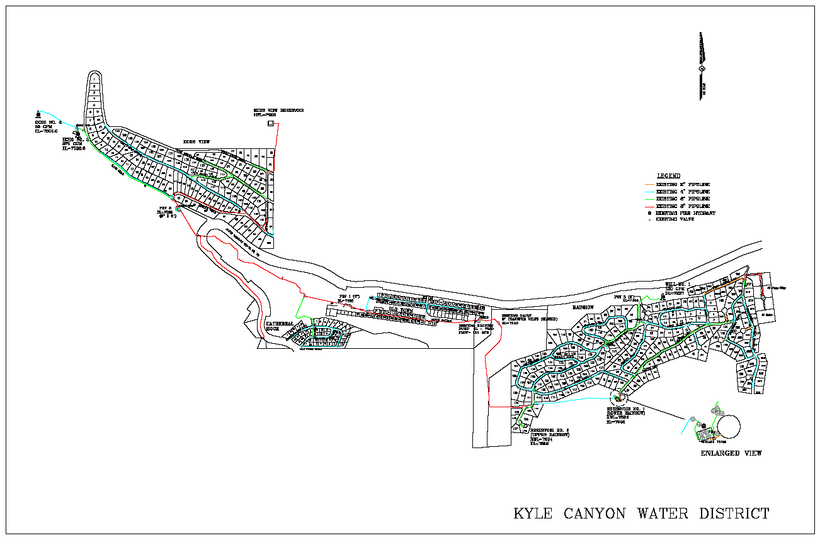

h-outs Situations
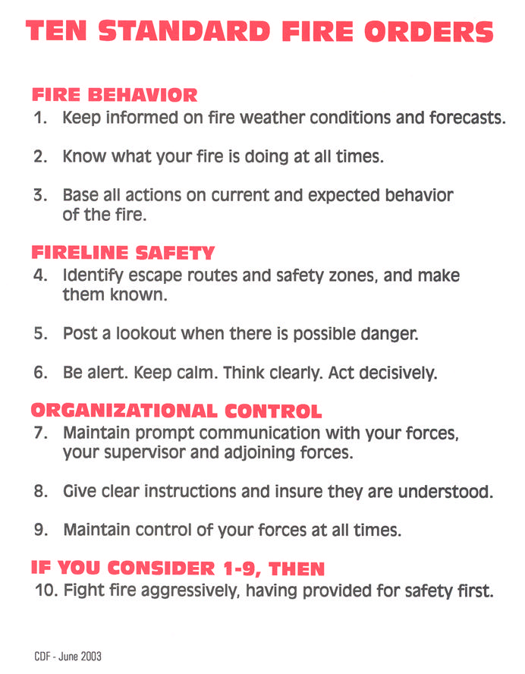
1. Fire not scouted and sized up.

2. In country not seen in daylight.

3. Safety zones and escape routes not identified.

4. Unfamiliar with weather and local factors influencing fire
behavior.

5. Uninformed on strategy, tactics, and hazards.

6. Instructions and assignments not clear.

7. No communication link with crewmembers/supervisors.

8. Constructing line without safe anchor point.

9. Building fireline downhill with fire below.

10. Attempting frontal assault on fire.

11. Cannot see main fire, not in contact with anyone who can.

12. Unburned fuel between you and the fire.

13. On a hillside where rolling material can ignite fuel below.

18 Watch-outs Situations

- Fire not scouted and sized up.

2. In country not seen in daylight.

3. Safety zones and escape routes not identified.

4. Unfamiliar with weather and local factors influencing fire
behavior.

5. Uninformed on strategy, tactics, and hazards.

6. Instructions and assignments not clear.

7. No communication link with crewmembers/supervisors.

8. Constructing line without safe anchor point.

9. Building fireline downhill with fire below.

10. Attempting frontal assault on fire.

11. Cannot see main fire, not in contact with anyone who can.

12. Unburned fuel between you and the fire.

13. On a hillside where rolling material can ignite fuel below.

14. Weather is getting hotter and drier.

15. Wind increases and/or changes direction.

16. Getting frequent spot fires across line.

18 Watch-outs Situations (continued)

17. Terrain and fuels make escape to safety zones difficult.

18. Taking a nap near the fire line.
Wildland-Urban Watch-outs

- Poor access and narrow one-way roads.

- Bridge load limits.

- Wooden construction and wood shake roofs.

- Inadequate water supply.

- Natural fuels 30’ or closer to structures.

- Structures in chimneys, box canyons, narrow canyons, or on
steep slopes (30% or greater).

- Extreme fire behavior.

- Strong winds.

- Evacuation of public (panic).

LCES Checklist

LCES must be established and known to ALL firefighters BEFORE needed.
---------------------------------------- Lookout(s) ----------------------------------------
Experienced/Competent/Trusted
Enough lookouts at good vantage points
Knowledge of crew locations
Knowledge of escape and safety locations
Knowledge of disengagement trigger points
Map/Weather Kit/Watch/IAP
------------------------------------- Communication(s) --------------------------------
Radio frequencies confirmed
Backup procedures and check-in time established
Provide updates on any situation change
Sound alarm early, not late
------------------------------------------ Escape Route(s) ---------------------------------
More than one escape route
Avoid uphill escape routes
Scouted: Loose soils/Rocks/Vegetation
Timed: Slowest person/Fatigue and Temperature factors
Marked: Flagged for day or night (NFES 0566)
Evaluate: Escape time vs. Rate of spread
Vehicles parked for escape
----------------------------------------- Safety Zone(s) -----------------------------------
Survivable without a fire shelter
Back in clean burn
Natural Features: Rock Areas/Water/Meadows
Constructed Sites: Clearcuts/Roads/Helispots
Scouted for size and hazards
Upslope?
Downwind? More heat impact ----- Larger safety zone
Heavy Fuels?
Escape time and safety zone size requirements will change as fire behavior changes.
Source: USFS Incident Response Pocket Guide
January 2002
Common Denominators of Fire
Behavior on Tragedy Fires

These are four major common denominators of fire behavior
on fatal and near-fatal fires. Such fires often occur:

On relatively small fires or deceptively quiet areas of large
fires.

- In relatively light fuels, such as grass, herbs and light brush.

- When there is an unexpected shift in the wind direction or in wind speed.

- When fire responds to topographic conditions and runs uphill.

- Note: Alignment of topography and wind during the burning period should always be considered a trigger point to reevaluate strategy and tactics.

Structure Go/No-Go
Protection Reference

Factors That May Make A Structure Too Dangerous To Protect: If You Answer, “Yes” To Any Of The Below, Don’t Attempt To Protect That Structure, Move On To The Next.

- Fire is making a sustained run and there is little or no clearance.
- Water supply will not last as long as the threat.
- Fire’s intensity dictates leaving the area immediately.
- The roof is more than one-quarter involved.
- There is fire inside the structure or windows are broken.

If The Conditions Listed Above Allow For A Structure Protection Effort To Be Made Then:

- Check roads before the fire arrives. Know turnouts, and bridge limits.
- Check each home for an adequate defendable space.
- Stay mobile; keep vehicle engine running and red lights on.
- Back in equipment for a quick escape.
- Brief resources on strategies, tactics, hazards, and LCES.
- Coil a short 1½ “ charged line with a fog nozzle on your engine for safety and
quick response.
- Use short hose- lays.
- Keep at least 10% gallons of water in your tank.
- Determine if residents are home.
- Advise residents of escape routes, safety zones, evacuation plans and centers.
- Ask residents to evacuate threatened livestock or pets.
- Leave home lights on inside and out, day and night.
- Place owners ladder at a corner of the structure least threatened by the fire.
- Coil and charge garden hoses.
- Turn on sprinklers.
- Identify hazards. (HazMat, gas lines, power lines, etc.)
- If a home becomes involved, leave it and move to one you can save.

Firefighter safety and survival are the number one priority.

