Plotting the BAM
Since there are numerous options for plotting different size BAMs, there are multiple combinations of sizes and settings. This document provides some general settings and an example, but you may need to adjust based on your desired BAM size. For this example we’ll create a 72” x 80” BAM on two sheets of paper (assuming the plotter paper width is 36” wide).
- In Adobe Acrobat select your plotter from the drop-down menu and open the Properties dialogue window.
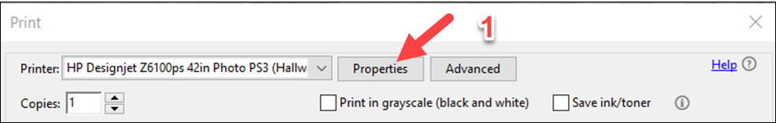
- Select the Paper/Quality tab and then select Custom to create the custom page size of 36” x 80”.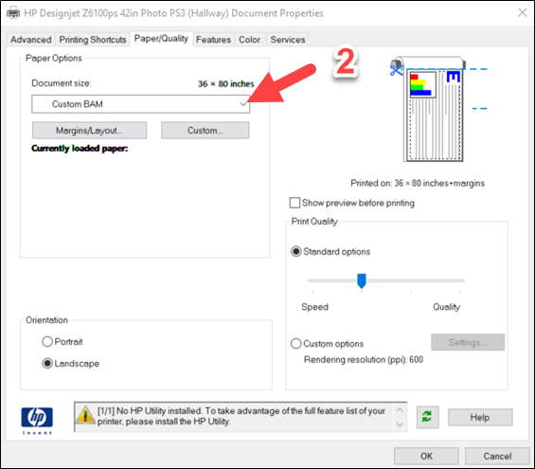 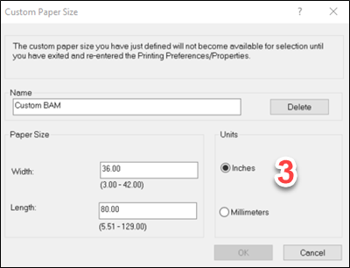
- Name your custom document size (e.g., Custom BAM) and save it. Use the drop-down to select your custom document size. You may need to select “More…” and scroll to the bottom of the list.
- On the main print dialogue box, under the Page Sizing & Handling select Poster and set the scaling at 166% and the Overlap to 1 in.
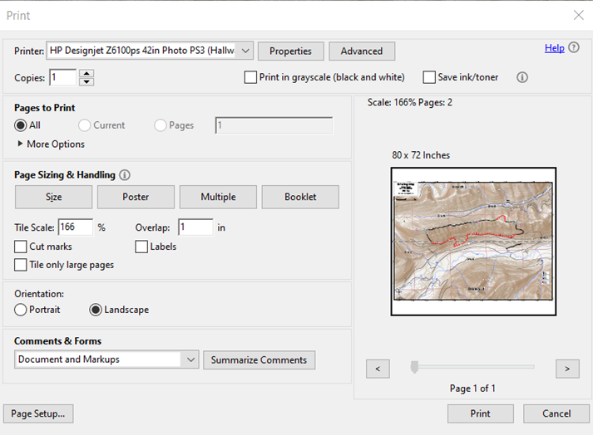
- You may need to adjust your Orientation settings to switch between Landscape/Portrait.
- Print and tape together the two pages.
42-Inch Plotters Information
- To print an Arch E (36” x 48”) on a 42” plotter, create a custom page size of 42” x 56” and select “Fit to Print”.
- To Print a BAM on a 42” plotter, create a custom page size of 41” x 112” and print as a poster at around 228% scaling.
- There are numerous size options for creating BAMs, so adjust these settings as needed.

