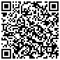
Current IR Map from ftp.nifc.gov

