**ZSSUpdated:** 9/17/12

**General Location:**  south central Dixie, E. of Crooked Creek, down road that takes off to SE from near Silver Spur Lodge

**Assessor’s Parcel #:** 0095000J0070

**Address:** 191 Airway Drive

**GPS COORD’s: LAT:** 45 32.972 **LONG:** -115 27.651

**Forest Service Structure ID # (s): BE-54**

**Description:**  1 log cabin with metal roof, 1 all wood outhouse

**Protection Measures:**  move firewood away

**Suppression Hazards:**

**Suggested Safety Zone:**

**Access:** no driveway, but adequate space to turn around in front-rd dead ends just to S.

**Actions Taken During Incident:** plumbed

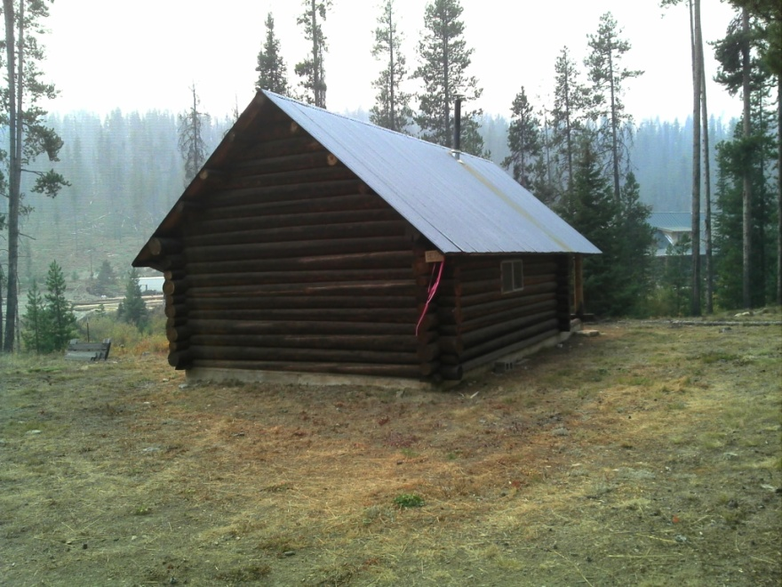m