Incident Name:  Chute Creek  ID-NCF-000582 | IR Interpreter(s):  Tina Rotenbury  trotenbury@fs.fed.us | Local Dispatch Phone:  208-983-6800 | Interpreted Size:  1,172 acres  Growth last period:  510 acres
Flight Time:  0014  Flight Date:  20170817 | Interpreter(s) location:  Russellville, AR  Interpreter(s) Phone:  479-886-0878 | GACC IR Liaison:  Tim Stauffer  GACC IR Liaison Phone:  406-529-6366 | National Coordinator:  Jim Grace  National Coord. Phone:  208-870-5066
Ordered By:  Adam Warren | A Number:  A-3 | Aircraft/Scanner System:  N144Z | Pilots/Techs:  Ramsey/Boyce/Kaz
IRIN Comments on imagery:  2 paths, good image, no issues |  | Weather at time of flight:  clear | Flight Objective:  Map Heat Perimeter/Isolated, Scattered and Intense Heat Sources
Date and Time Imagery Received by Interpreter:  20170816 at 1114 PDT |  | Type of media for final product:  IR log, PDF maps, KMZ, shapefiles  Digital files sent to:  /incident_specific_data/n_rockies/2017_fires/2017_ChuteCreek/IR/20170817
Date and Time Products Delivered to Incident:
20170817 at 0200 PDT
Comments /notes on tonight’s mission and this interpretation:
Started interpretation with IR perimeter from night of 08/15/2017.
Large area of perimeter growth to the east, with intense heat throughout the area.
Small areas of perimeter growth to the south along the East Fork Moose Creek with possible spotting across the creek in Sections 36 and 31. Sources of isolated heat outside perimeter to the east in sec 32 to east toward Dead Elk.
Small areas of perimeter growth to the north toward Dead Elk Point with intense heat along the edges.
Small Perimeter of intense heat to the north west of Dead Elk Point @ 114 30’ 12.086”W 46 15’ 42.952”N
Lots of scattered heat in original perimeter with sources of isolated heat outside perimeter to the west.
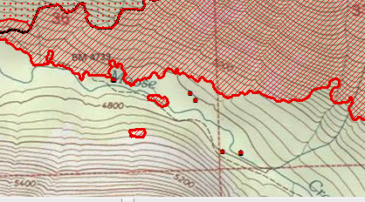 Possible spotting across East Fork Moose Creek (south perimeter)

