Incident Name:  Lolo Peak  MT-LNF-001288 | IR Interpreter(s):  Tammy Hocut  thocut@fs.fed.us | Local Dispatch Phone:  Missoula Dispatch Center  406-829-7070 | Interpreted Size:  49,910 Acres  Growth : 787 Acres
Flight Time:  0052 (MDT)  Flight Date:  09/08/2017 | Interpreter(s) location:  Jasper, AR  Interpreter(s) Phone:  870-446-5878 | GACC IR Liaison:  Tim Stauffer  GACC IR Liaison Phone:  406-529-6366 | National Coordinator:  Jan Johnson  National Coord. Phone:  208-387-5900
Ordered By:  Valentijn Hoff SITL  884-710-0597 | A Number:  A-147 | Aircraft/Scanner System:  N144Z / Phoenix | Pilots/Techs:  Boyce/Johnson/Kazimir
IRIN Comments on imagery:  2 passes, Ortho and Color, Clean imagery |  | Weather at time of flight:  Clear | Flight Objective:  Identify and map Heat perimeter, Scattered Heat and Isolated Heat Sources.
Date and Time Imagery Received by Interpreter:  09/08/2017 – 0340 MDT |  | Type of media for final product:  Shape files, KMZ, PDF, and IRIN Log  Digital files sent to: NIFC FTP @  /incident_specific_data/n_rockies/2017_fires/2017_LoloPeak/IR/20170908
Date and Time Products Delivered to Incident:
09/08/2017 – MDT
Comments /notes on tonight’s mission and this interpretation:

- Started interpretation 09/07/2017 fire perimeter provided by the incident and located on the NIFC ftp site.

- Some growth on the southwest side of fire at Skookum Butte and Elk Meadows.
- Some growth on the southeast side of fire north of South Fork Sweeney Creek. Just south of this creek is a couple new fire polygons with extreme heat.
- A couple of isolated heat sources are outside the new heat polygon on the very south tip of the fire south of Bass Creek.
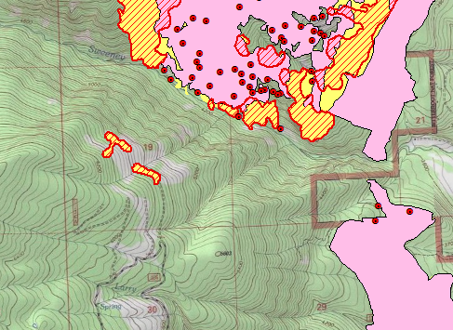
- An isolated heat source at Sweeney Lake.
- A couple isolated heat sources outside the main fire polygon just northwest of Sweeney Peak.

