LEGEND

Flight Following

Air to Air Fixed Wing

Air to Air Helicopter

Air to Ground Tactics

Command

T.O.L.C.

National Flight Following

AIR TACTICAL
GROUP SUPERVISOR
NATIONAL F.F.
168.650
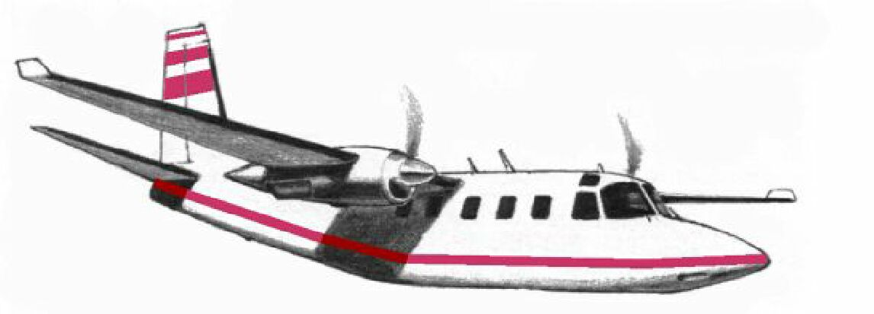
DISPATCH CENTER

AIR to AIR- F/W
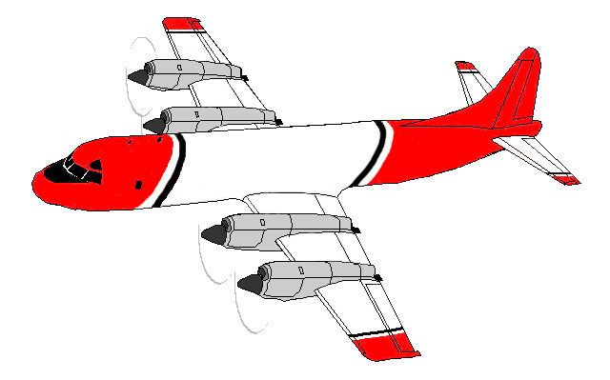

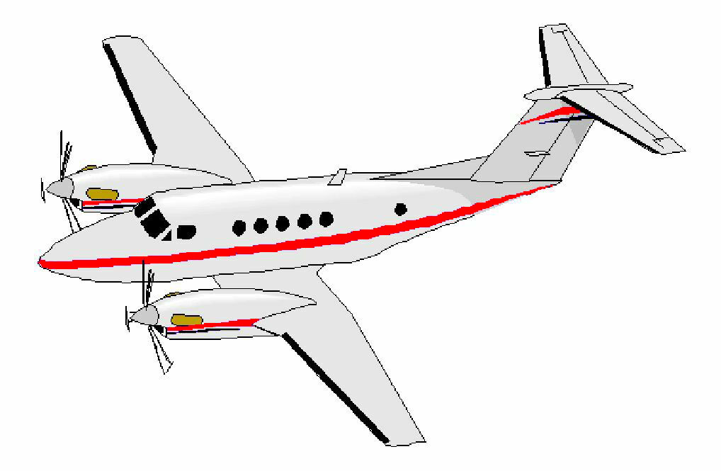

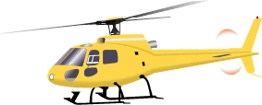
LEAD PLANE

FLIGHT FOLLOWING
HELICOPTER COORDINATOR

HELIBASE
AIR to GROUND

AIR to AIR- R/W

DECK
T.O.L.C.
DIVS/ BRANCH

OCS/ AOBD
AIR to GROUND
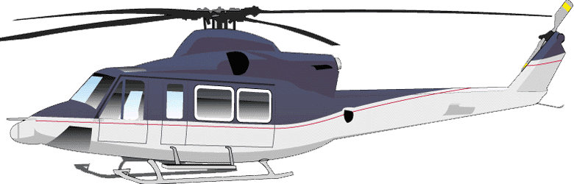
COMMAND/ REPT.
Rx.
Tx.

ICP COM CENTER

ICP

