Appendix C – Regulatory Issues, Transportation Requirements and Inspection Checklists
Additional helitorch documents are available on the NWCG website at: https://www.nwcg.gov/committees/interagency-aerial-ignition-unit
- DOT Concerns and Transportation Requirements
- Aerial Ignition Standards and Guidelines
- Compliance Criteria
- Helitorch Tanks/Barrel Compliance
- Helitorch Operational Criteria
- Helitorch Operational Training Criteria
- Transporting Class 3 Flammable Liquids
- Mix Transfer System Drum Configuration
- Simplex 5400 and Fire Spec 2000 Helitorch Configuration
- Helitorch Inspection Checklist
- Batch Mixer Inspection Checklist
- Mix-Transfer System Inspection Checklist

Aerial Ignition Standards and Guidelines
 | Barrels or Tanks  Less than 119 gallons | Tanks  119 gallons or greater
Markings | Tested and marked with DOT Performance Orientated Packaging Rating (POP) that usually starts with a UN1A1 or UN1A2 designation or has appropriate DOT designation. | Bulk Tank specification plate (MC306 or DOT406) or IBC.
Label | Labeled as “FLAMMABLE LIQUID” and marked “UN1203 – GASOLINE”. | Placarded as “FLAMMABLE LIQUID” and Marked “UN1203”
Color | Painted RED. | No color requirement.
Sealed | Designed so that there is no leakage in case of rollover or accident.  Not filled over 90% of volume.  DOT approved Vacuum / Pressure Bypass valve NOT PERMITTED during transport (unless approved to POP standards).  DOT approved Vacuum / Pressure Bypass valve REQUIRED during use and storage.  Shut off valves are protected and not protruding from the vehicle. | Designed so that there is no leakage in case of rollover or accident.  Shut-off valves that are protected and not protruding from the vehicle.  Have appropriate fittings to accommodate bypass for vacuum and pressure (must meet DOT and NFPA Tank Standards).  Have appropriate fittings to accommodate vapor removal or recovery.
Filling | Vapor control required either by removal or recovery.  For tanks over 60 gallons, fill spout extends within 6 inches of bottom. Splash filling not permitted. | Vapor control required either by removal or recovery.  Fill spout extends within 6 inches of bottom. Splash filling not permitted. Bottom filling configuration is the preferred method.
Delivery and Static Control | Have approved (DOT, NFPA and within the scope of OSHA 29CFR 1910.106) petroleum fuel dispensing and vapor recovery / removal hoses and static bonding wire. | Have approved (DOT, NFPA and within the scope of OSHA 29CFR 1910.106) petroleum fuel dispensing and vapor recovery / removal hoses and static bonding wire.
Thickening Agents | A written procedure for dispensing thickening agent to comply with OSHA general requirements for minimizing inhalation / exposure as listed on the chemical’s Safety Data  Sheet. Dumping powder through manhole is not acceptable, use appropriate dispensing mechanism for dispensing powder. | A written procedure for dispensing thickening agent to comply with OSHA general requirements for minimizing inhalation / exposure as listed on the chemical’s Safety Data Sheet. Dumping powder through manhole is not acceptable, use appropriate dispensing mechanism for dispensing powder.

Compliance Criteria
 | Barrels or Tanks  Less than 119 gallons | Tanks  119 gallons or greater
By March 1, 2001 and Annually Thereafter | Visually inspect tanks yearly for degradation and compliance. | Visual Leak Inspection (VK) performed by DOT registered vendor.
By March 1, 2001 and Every 5 Years Thereafter | None. | Internal Pressure Test (IP) performed by DOT registered vendor.
Post Inspection Labeling | None. | Inspector will apply label with VK and IP expiration dates.
Tank Modification Criteria | None. | Alteration of the (tank) original design specification (MC306 or DOT406) must be accomplished at DOT registered vendor.
Tank Modification  Inspections | If required, re-inspected by local Highway Patrol Hazmat enforcement officer. | Inspected by local Highway Patrol Hazmat enforcement officer.
General | Compliance with STANDARDS and GUIDELINES. | Permanent 2” cam lock fitting with recovery removal hose at least 50 feet in length and 2” in diameter.  Compliance with STANDARDS and GUIDELINES.
Compliance | Tanks and Barrels that do not comply with the STANDARDS and GUIDELINES and the COMPLIANCE CRITERIA, and which cannot be modified by a registered vendor to meet those requirements, shall be taken out of service no later than March 1, 2001. | Tanks that do not comply with the STANDARDS and GUIDELINES and the COMPLIANCE CRITERIA, and which cannot be modified by a registered vendor to meet those requirements, shall be taken out of service no later than March 1, 2001.

Helitorch Operational Criteria
 | Barrels or Tanks Less Than 119 Gallons
Helitorch Filling or Emptying | Vapors shall be recovered or routed down wind from the operation a distance of 50 feet using petroleum rated hose. (Use 2-inch cam lock hose connected between the supplies and receiving tanks. Place cam lock plugs in hose and tanks fittings when not in use.
Transportation of Helitorch Barrels | Must be DOT approved and meet the STANDARDS and GUIDELINES.  Must be located in a protected area on the vehicle and securely fastened to prevent moving within the vehicle in case of accident or rollover.  Must contain less than 1 gallon of residual fuel.  Must comply with local and state Highway Patrol Hazmat regulations.
Transportation of  Non-Complying Helitorch Barrels | All non-complying tanks and barrels should be inspected by state authorities (in most states this will be the state police) for approval prior to transportation.  Without prior approvals, any citations issued by state authorities for lack of compliance are the responsibility of the driver of the vehicle.  All non-complying barrels and tanks must be disposed of by March 1, 2001, or taken out of service sooner if practical.  Transportation of non-complying barrels may be accomplished by following GUIDELINES and STANDARDS for packaging, markings, securing and POP standards.  Non-complying barrels MUST be triple rinsed to insure no flammable residue or flammable vapors are present. Rinse liquid must be captured into an approved DOT container and may be used in a batch of gel, or disposed at an EPA approved Hazwaste disposal site or by hazardous material removal contractor.

Helitorch Operational Training Criteria

Training | Written programs that apply and shall be in place under OSHA:  Right To Know – Hazardous Materials Awareness (Hazardous Waste and Toxic Substances)  Safety Data Sheet compliance with dry and wet chemicals in use  Personal Protective Equipment (PPE) for the chemicals in use  General Health and Safety Standards (1910)  Hand and Power Tools Use  Fire Safety (extinguishers, prevention and survival)  Machine (moving pump shaft, belt and wheel) Guarding  Confined Space (if entering tanks)  Respiratory Protection (if required on SDS) and Fitting Program  Lock Out Tag Out Program (control of unexpected equipment movement and power sources during repair, use, modification or cleaning).  Ergonomics (proper body position, equipment use and lifting)  Remember! All training must be documented with the trainer’s name, date of training, subjects covered, attendee’s full name, signature and date. The key is “If the training was not documented, then it did not occur.”  Additional training is required for all employees that fall outside of the “Materials of Trade” exceptions delineated by the DOT.  For flammable liquids, this includes any container larger than 8 gallons or any load larger than 440 pounds total aggregate weight including the containers. DOT has designated this training as “HM-126F” which includes four basic parts:  General Awareness  Safety Training  Function Specific Training and  Drivers Training.  Loads greater than 119 gallons or 1000 pounds automatically require a commercial driver’s license with a hazardous materials endorsement, and extensive drivers training which may include the requirement for a tank endorsement.

Transporting Class 3 Flammable Liquids
Requirements of the Department of Transportation
 |  | Required Training |  |  |  | Required Documentation
Class 3 Flammable Liquid PG II or III (Gasoline, Drip-Torch Fuel, Paint) Container Sixe and Cargo Weight Thresholds | DOT Designation and Packaging | HAZCOM-GEN-JHA | ERG EMERGENCY  RESPONSE | HM-126F HAZMAT | EXTENSIVE DRIVER TRNG | MSDS SHEETS | EMERGENCY RESPONSE GUIDE | HAZMAT BILL OF LADING | CDL LICENSE | LABEL | REMARKS
Containers less than 8 gallons 930 liters) and total cargo weight is less than 440 lbs. (200 kg)  OR  OSHA 5 gallon (max) containers and total cargo weight is less than 440 lbs. | Materials of trade exceptions: Performance oriented packaging ( less than 8 gallons)  OR  OSHA approved (5 gallon max) containers. | X  X |  |  |  | X  X |  |  |  | “Flammable Liquid” or “Gasoline”  “Gasoline” | DOT performance-oriented packaging has United Nations I.D. system  OSHA-approved container has “Gasoline” label and has laboratory approval (Underwriter’s Lab oratory), and is stored in 5 gallon (max) containers)
Containers less than 8 gallons (30 liters) and total cargo weight is more than 440 lbs. (200 kg), but less than 1001 lbs. (454 kg). | Performance oriented packaging (less than 8 gallons) |  | X | X |  | X | X | X |  | “Flammable Liquid” or “Gasoline” | DOT performance-oriented packaging has United Nations I.D. system
Containers from 8 to 119 gallons (30 to 450 liters), and cargo weight is less than 1001 lbs. (454 kg). | Non-bulk packages DOT designation: Performance-oriented packaging  OR  Portable DOT tanks up to 119 gallons. |  | X  X | X  X | R  R | X  X | X  X | X  X |  | “Flammable Liquid” and “1230” gasoline labels  (Same as Above) | Containers over 8 gallons must be performance oriented packaging (DOT).  (Same as above)
More than 119 gallons (454 kg), or more than 1001 lbs. (454 kg) cargo weight. | Bulk packaging requires DOT tank standards- MC406 or 119 to 660 gallons. |  | X | X | X | X | X | X | X | “Flammable Liquid” label and “1230” placard. | Bulk packaging must have relief valves, rollover protection, and automatic shutoff valves, Tanks over 119 gallons require regular inspection.
Abbreviations: DOT = Department of Transportation; OSHA = Occupational safety and Health Administration; ERG = Emergency Response Guide;
CDL = Commercial Driver’s License with HazMat and tank endorsements; X = Required; R = Recommended; HM-126F training:
A = General awareness; B = Safety; C = Function specific; D = Driver; and PG = Packing group.
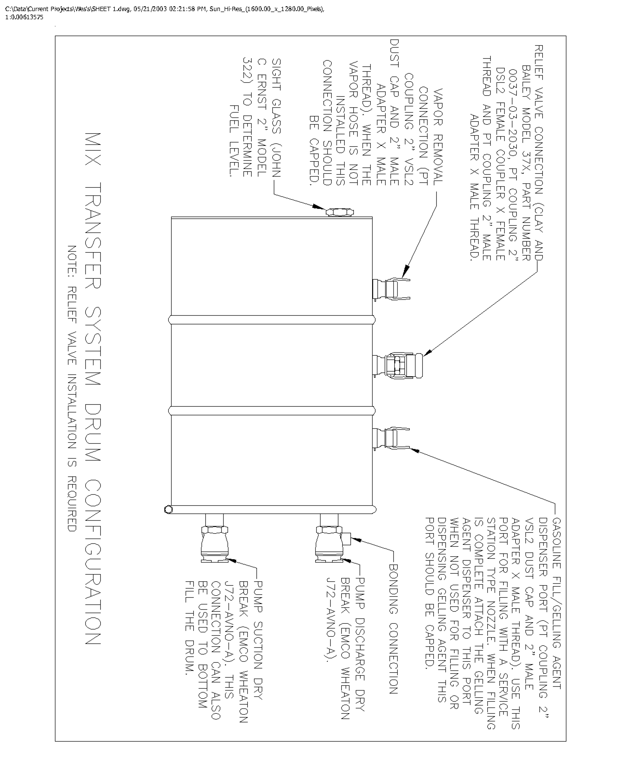
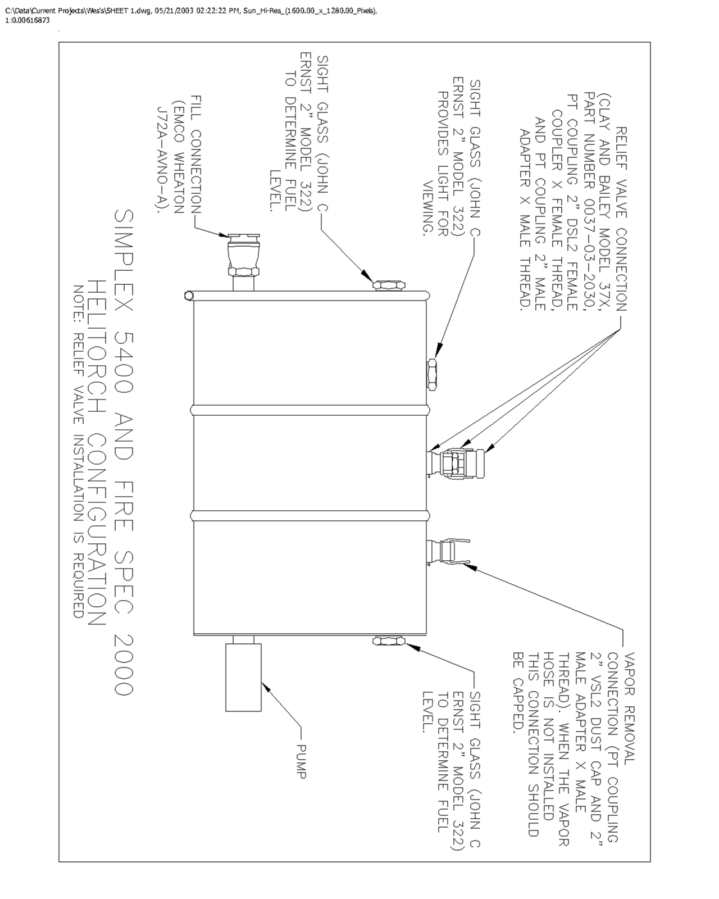

HELITORCH INSPECTION CHECKLIST
Company Name:

Helitorch Identification:

Inspection Location:

Date:

Inspector:

Tank (55 to 70 Gallons)
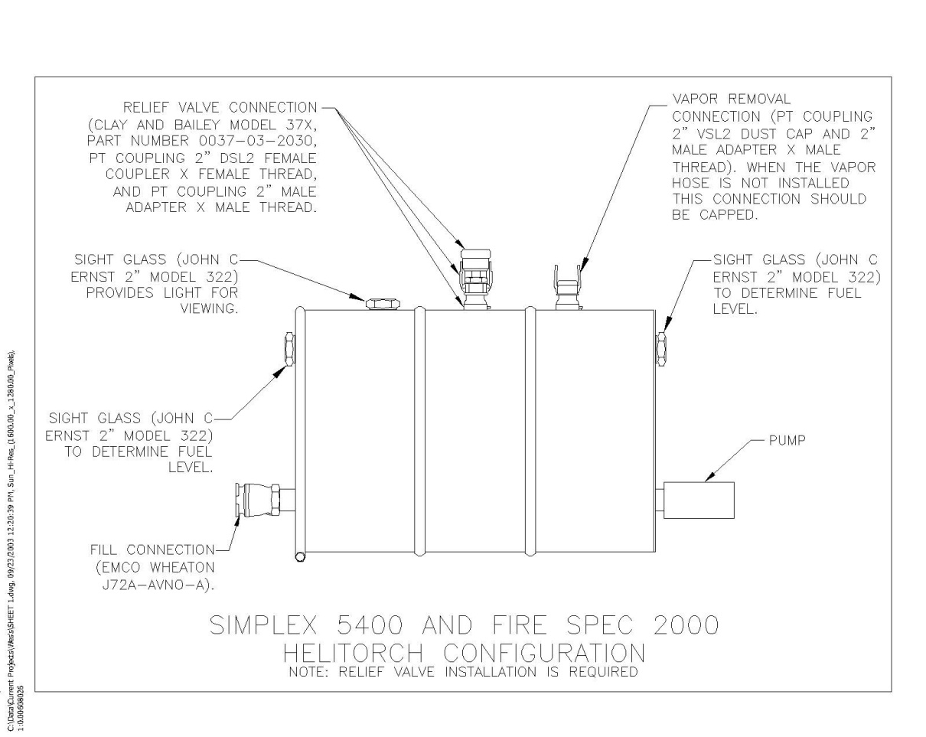

HELITORCH INSPECTION CHECKLIST (Continued)
DOT Specification Drum (UN1A1 or UN1A2) or Exemption for Non-DOT Fuel Tank
_______ (Drum Spec or Exemption Number______________________________________________)
Flammable Liquid” Label, “UN 1203” Marking, “Gasoline” Marking and Exemption
_______ Number (As Required) Applied to Drum or Tank
_______ 2” Male Cam & Groove Fitting Installed for Vapor Removal/Recovery (Per Sketch for Fire Spec & Simplex)
Relief Valve Installed and Mounted on Cam and Groove Fittings to Prevent Clogging of Valve
_______ by Gel (Per Sketch for Fire Spec & Simplex)
_______Cam and Groove Fitting Levers Secured with Safety Pins or Self Locking Levers Are Installed
2” Emco Wheaton Dry Break Adapter Installed for Fueling of Drum or Tank
_______ (Per Sketch for Fire Spec & Simplex)
Filling of Drum of Tank by Bottom Filling – Either by Installation of Dry Break at Bottom of
Drum or by a Fill Spout That Extends to
_______ within 6” of Tank Bottom– Splash Filling Not Permitted
_______ Sight Glasses Installed to Determine Fuel Level in Drum or Tank
_______ Drum or Tank is Not Damaged and No Leakage is Visually Detectable
Comments:

HELITORCH INSPECTION CHECKLIST (Continued)
Suspension
_______ Wire Ropes Have No Physical Damage (Broken Strands, Kinks, Etc.)
Aviation Grade Bolts Installed – The Bolt Shoulders are long enough So That the Cable Ends
_______ Contact Only the Shoulder of the Bolts and the Bolt Threads are not a Load Bearing Surface
The Pear Link Adapter Spacer is Installed So That the Pear Link Contacts Only the Spacer and
_______ Not the Bolt
Comments:
Electrical
_______ Power Cable in Good Condition – No Cuts or Gaps in Insulation
Comments:
Misc.
_______ Propane Hose - Hose is Compatible with Propane and has a Braided Metal Cover
Comments:

BATCH MIXER/ BATCH TRUCK INSPECTION CHECKLIST
Company Name:

Batch Mixer / Tank Identification:

Vehicle Identification Number (VIN) (if applicable):

Inspection Location:

Date:

Inspector:

Trailer Mounting
_______ Tank Connected to Trailer Frame Not Expanded Metal Decking
_______ Trailer Equipped With Brakes if Trailer Rating is 1500 lbs. or more
_______ Trailer Wiring Protected from Abrasion
Comments:
Engine Installation
_______ Fuel Tank Located to Reduce Spillage of Gasoline on Hot Engine
_______ Shielding Installed Between Pump and Engine to Prevent Leaks from Contacting Hot Engine
_______ Shielding Installed Between Piping and Engine to Prevent Leaks from Contacting Hot Engine
Comments:

BATCH MIXER/ BATCH TRUCK INSPECTION CHECKLIST (Continued)
Tank (Greater Than 119 Gallons)
MC 306 or DOT 406 Specification Cargo Tank or IBC
_______ (Type_____________________________)
Emergency Shutoff Lever Accessible and Remotely Actuated More Than 10 Feet Away From _______Shutoff Valve or At End of Tank Furthest From Valve
Tank and/or Vehicle Placarded on 4 Sides as “Flammable Liquid” and Marked on 4 Sides as _______ “UN 1203”
_______Shut Off Valves are Protected and Do Not Protrude from Vehicle
_______2” Cam & Groove Fitting Installed for Vapor Removal/Recovery
_______Fill Spout extends to within 6” of Tank Bottom – Splash Filling Not Permitted
_______Visual Inspection (VK) Up To Date
_______Internal Pressure Inspection (IP) Up to Date
Comments:
Electrical
Electrical Connections near Pump and Piping Sealed to Prevent Connections Coming Loose
_______ And Sparking
_______Switch Housings Covered to Reduce Sparking
_______Battery Located Away From Piping Joints and Pump
Comments:

BATCH MIXER/ BATCH TRUCK INSPECTION CHECKLIST (Continued)
Hoses
_______Hoses Designed for Use with Gasoline (Hose Make & Model __________________________)
Vapor Recovery/Removal Hose Designed for Use with Gasoline Vapor
_______ (Hose Make & Model _________________________________________________________)
_______Swaged Hose Ends
_______Electrically Conductive
_______Live Reel Installed
Comments:
Pump
_______Pump Internals are Non-Sparking
_______Pump Seals are Compatible with Gasoline (Viton or Buna N)
Comments:
Misc.
_______Safety Pins Installed on Camlok Fittings or Self Locking Camlok Fittings Installed
_______Pressure Gage Isolated from Gel
_______Valves Labeled as to Function and Flow Direction
_______Fire Extinguisher Mounted in Accessible Location
Comments:

MIX-TRANSFER SYSTEM INSPECTION CHECKLIST
Company Name:

System Identification:

Inspection Location:

Date:

Inspector:

Drums
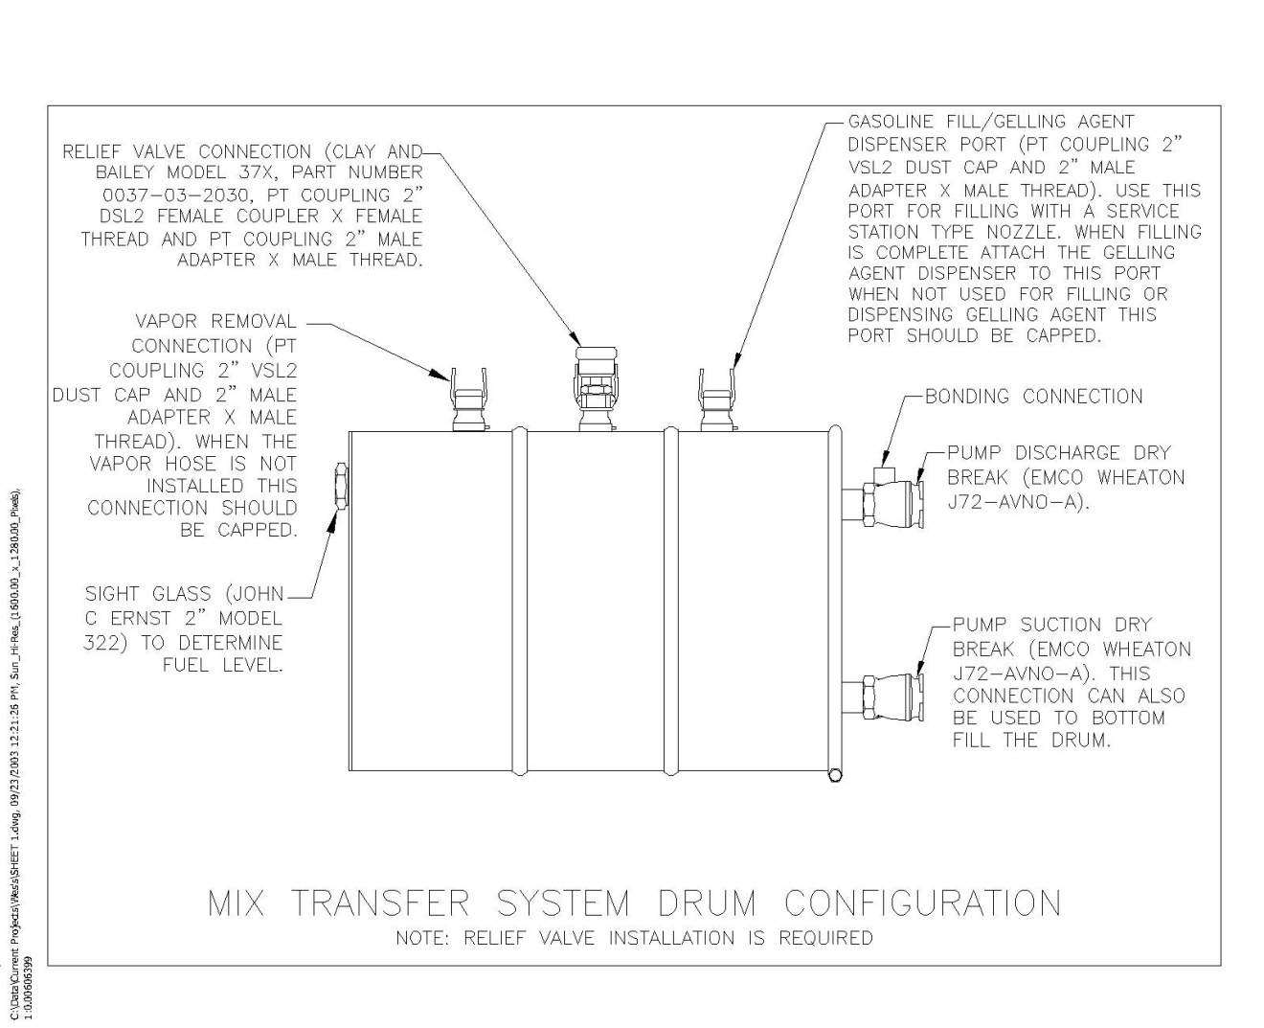

MIX-TRANSFER SYSTEM INSPECTION CHECKLIST (Continued)
_______DOT Specification Drums
“Flammable Liquid” Label, “UN 1203” Marking, “Gasoline” marking and Exemption Number
_______ (As Required) Applied to Each Drum
_______2” Male Cam & Groove Fitting Installed for Vapor Removal/Recovery (Per Sketch)
2” Male Cam & Groove Fitting Installed for Gelling Agent Dispenser and Gasoline Fill Port
_______ (Per Sketch)
Relief Valve Installed and Mounted on Cam and Groove Fittings to Prevent Clogging of Valve _______ by Gel (Per Sketch)
_______Cam and Groove Fitting Levers Secured with Safety Pins or Self Locking Levers Installed
2” Emco Wheaton Dry Break Adapter Installed for Pump Discharge and Pump
_______ Suction Connections (Per Sketch)
_______Bonding Lugs Installed on Pump Discharge Dry Breaks
_______Sight Glass Installed to Determine Fuel Level in Drum per Sketch
_______Drum is Not Damaged and No Leakage is Visually Detectable
Comments:
Engine Installation
_______Shielding Installed Between Pump and Engine to Prevent Leaks from Contacting Hot Engine
Comments:

MIX-TRANSFER SYSTEM INSPECTION CHECKLIST (Continued)
Hoses
_______Hoses Designed for Use with Gasoline (Hose Make & Model __________________________)
_______Vapor Recovery/Removal Hose Designed for Use with Gasoline
_______Vapor (Hose Make & Model ____________________________________________________)
_______Swaged Hose Ends
_______Electrically Conductive
Comments:
Pump
_______Pump Internals are Non-Sparking (Pump Make and Model _____________________________)
_______Pump Seals are Compatible with Gasoline (Viton or Buna N)
Comments:
Misc.
_______Pressure Gage Isolated from Gel
_______Valves Labeled as to Function and Flow Direction
Comments:

