ZAZA FIRE TRAFFIC AREA (FTA)
ATGS ALT. ALTITUDE
+1000’ Approx. 2500’ AGL
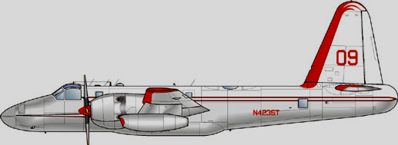
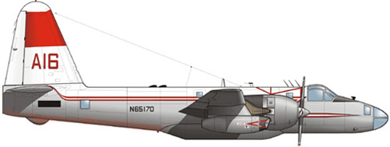
3 C’S:
COMMUNICATIONS
CLEARANCE
COMPLY
NOCOM
IF COMMUNICATIONS ARE NOT ESTABLISHED, HOLD AT THE 7NM RING UNTIL THEY ARE ESTABLISHED!!!
500 AGL
TANKER MANEUVERING ALTITUDE +500’
500 AGL APPROX

TANKER ENTRY ALTITUDE +500’
7nm NOCOM HOLDING RING
DO NOT PENETRATE THE FTA IF YOU CANNOT COMPLY WITH A CLEARANCE
12NM Initial
Contact Ring

