AIRCRAFT PRE-FIRE PLAN

AIRCRAFT TYPE: Bell 209 / AH-1P Cobra (Fire Snake) Reference: NAVAIR 00-80R-14-1
& T.O. 00-105E-9

AIRCRAFT DESCRIPTION: The Florida Department of Forestry operates three former U.S. Army Bell AH-1P Cobra helicopters. These are circa 1970 attack/close support helicopters. They are now called Fire Snakes. It will usually fly with a 320-gallon Bambi Bucket. These helicopters fly without ordnance.

Length (ft) | Rotor Dia. | Bucket Size (gals) | 1.5 Hour Fuel Load (gallons) | Fuel Consumption (gal/hrs) | Cruise Speed (Kts/mph) | Typical Equip. Wt. (lbs.) | Fixed Wt. Reduction (lbs.) | Pax Seats | ICS Type
53.05 | 44’ | 320 | 150 | 100 | 190/210 | 10,000 | N/A | 1

AIRCRAFT DIAGRAM: Civilian versions do not carry ordnance!

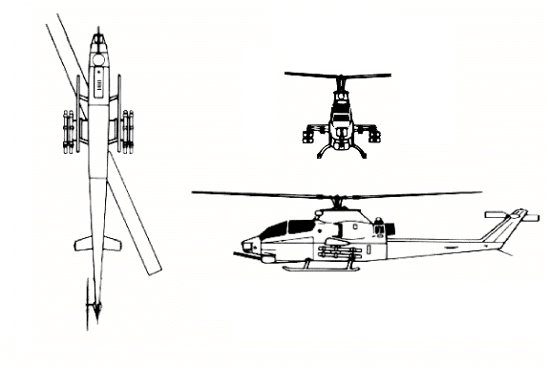

HAZARDS:
- 262 gallons / 1781 pounds of jet fuel on-board (fully loaded), located in fuselage.
- One battery located in nose of aircraft, accessible through front cockpit.
- Inlet suction danger area is 6 feet.
- Turbine blade failure – 300 feet
- Engine exhaust –24 feet.
- Rotor minimum ground clearance – Main = 7 feet 10 inches. Tail = 5 feet 2 inches. (The main rotor disc diameter is 44 feet and the tail rotor disc diameter is 8 feet 6 inches.)
- Engine oil – 2.25 gallons
- Hydraulic oil – 6.4 pints for each of the three systems, 3.2 in each of three reservoirs.
- Transmission oil – 2.25 gallons
- Aircraft is constructed of aluminum, steel, Titanium and composite materials
- Canopy Safety: Canopies have a linear explosive system used to cut the windows from support structure for emergency entrance or exit. Jettison Handle: To safety canopy, INSERT safety pins in pilots and co-pilots Canopy Jettison Handle.

APPROACH TO ENTRY POINT: (Engines running 80%+)
1. Approach directly from the side, exercising extreme caution around rotors.

PRE-DESIGNATED RESCUEMAN ACTIONS:
- GAIN ENTRY
a. Normal entry
The pilot canopy door opening is on the right hand side and the observer/instructor door is on the left side. Both doors are pneumatically opened and closed from outside. To open either door, TURN door handle and it will automatically raise to full open position, depending on charge in opening strut.
b. Emergency entry
Canopy jettison handle is accessible only through the front or rear cockpits. Pull pin, rotate 90 degrees then pull handle.
WARNING!: Do not shatter canopies with fuel in cockpit area, fire or explosion may result. Ensure personnel are clear of cockpit area before utilizing jettison system.
WARNING!: Personnel within 50 feet of aircraft could be injured by debris when jettison system is used.
c. Forcible Entry/Cut-in NOTE: Break out knife in front cockpit, breakout axe in rear cockpit.
Canopies are made of acrylic plastic and may be cut using a power rescue saw or crash axe. CUT along canopy frames
ENGINE
a. Normal Engine Shutdown
I. IDLE STOP RELEASE SWITCH / THROTTLES – Press Idle Stop Release Switch and CLOSE throttle by TURNING grip to the right. NOTE: Battery must be on!
II. FUEL SHUTOFF SWITCHES – PLACE Fuel Shutoff Switch in OFF position. Located on engine control panel at pilots left side.
III. BATTERY SWITCH – PLACE battery Switch in OFF position. Located on pilots left hand console.
b. Emergency Engine Shutdown
I. BATTERY SWITCH – PLACE Battery Switch in OFF position.
3. AIRCREW EXTRACTION
a. The pilot and co-pilot are attached to the seat by shoulder harnesses secured to a lap belt equipped with a quick disconnect buckle.
I. RESTRAINTS – LIFT quick disconnect lever to release shoulder harness and lap belt
II. MICROPHONE CORD – Disconnect microphone cord prior to lifting crewmember from seat.

OTHER FACTORS:
- Special tools/equipment: Power rescue saw and crash axe.
- Location of switches and equipment and emergency shutdown procedures may vary for individual aircraft. Crews should be briefed prior to aircraft dispatch.

COMMUNICATIONS PLAN: National Air Tanker Frequency – 123.975. This is the frequency used by all air tanker bases, air tankers, and air tanker support aircraft during fire fighting operations. State of Florida will utilize 122.925

