AIRCRAFT PRE-FIRE PLAN

AIRCRAFT TYPE: Aerospatiale AS 332L Super Puma Reference: IHOG (1/98)
& T.O. 00-105E-9

AIRCRAFT DESCRIPTION: These helicopters are not very common. This is an advanced version of the Puma. They are used by various militaries throughout the world and on platform oil operations as an airbus. They require a crew of two and may occasionally used on incidents.

Length (ft) | Rotor Dia. (ft) | Bucket Size (gals) | 1.5 Hour Fuel Load (gallons) | Fuel Consumption (gal/hrs) | Cruise Speed (Kts/mph) | Typical Equip. Wt. (lbs.) | Fixed Wt. Reduction (lbs.) | Pax Seat | ICS Type
43 | 35 | 108-144 | 69 | 46 | 108/124 | 2800 | 190 | 4 | 3

AIRCRAFT DIAGRAM
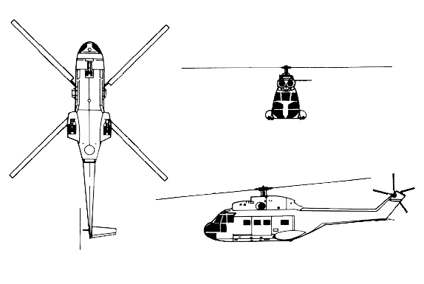

HAZARDS:

Main rotor blades can dip close to the ground. Avoid the tail rotor.

1581 Gallons / 10593 pounds of Jet fuel located in floor.

Battery is located in the nose and is very difficult to access.

APPROACH TO ENTRY POINT: (Engines running 80%+)
1. Approach directly from the side, exercising extreme caution around rotors, which can dip to within four feet of the ground.

PRE-DESIGNATED RESCUEMAN ACTIONS:
- GAIN ENTRY
a. Normal entry – NOTE: Symmetrical doors to access and exit of passengers and crew.
I. Enter the flight deck using the external opening handle for the pilot door on right side and the ATO door on the left side of the fuselage.
II. Enter the cabin using the external opening handle for the passenger compartment on the right or left sides of the fuselage
b. Emergency entry –
I. Use external door handles on all doors for emergency entry or exit.
II. For the cargo door emergency exit; use the internal access by pulling the ring and push exit door outward.
c. Forcible Entry/Cut –
I. Cut-in flight deck or cabin doors or windows as required.
2. ENGINE SHUTDOWN
a. Pull aft on battery switch, located on the overhead control console, to OFF position.
b. Pull aft on alternator switches, located on the overhead control console, to OFF position.
c. Pull aft on the fuel shut-off levers, (marked red) located on the overhead control console, to OFF position.
d. In case of engine fire, on the fire control warning panel, push buttons for 1 or 2 engines extinguishers. Extinguishers are single shot type.
3. AIRCREW EXTRACTION
a. Release crew from lap belt and shoulder harness.
b. Release passengers from restraints as required.

OTHER FACTORS:
- Special tools/equipment: Power rescue saw and crash axe.
- A crash axe is located on the flight deck.
- Location of switches and equipment and emergency shutdown procedures may vary for individual aircraft. Crews should be briefed prior to helicopter dispatch.

COMMUNICATIONS PLAN: National Air Tanker Frequency – 123.975. This is the frequency used by all air tanker bases, air tankers, and air tanker support aircraft during fire fighting operations.

