AIRCRAFT PRE-FIRE PLAN

AIRCRAFT TYPE: Aerospatiale AS-350D-1 A-Star, AS-350 B-2 Ecureuil Reference: IHOG (1/98)

AIRCRAFT DESCRIPTION: The D-1 A-Star is a common single engine French built helicopter. It has been replaced by the 350 B-2 Ecureuil (Squirrel). The B-2 is a common helicopter built and test flown in France, then disassembled and shipped to Texas were they are re-assembled. The AS 355 F-1 TwinStar is the twin engine version of the B-2.

Model | Length (ft) | Rotor Dia. (ft) | Bucket Size (gals) | 1.5 Hour Fuel Load (gallons) | Fuel Consumption (gal/hrs) | Cruise Speed (Kts/mph) | Typical Equip. Wt. (lbs.) | Fixed Wt. Reduction (lbs.) | Pax Seat | ICS Type
350 D-1 | 43 | 35 | 108-144 | 69 | 46 | 108/124 | 2800 | 190 | 4 | 3
350 B-2 | 43 | 35 | 240 | 68 | 45 | 125/144 | 2800 | 190 | 5 | 3

AIRCRAFT DIAGRAM

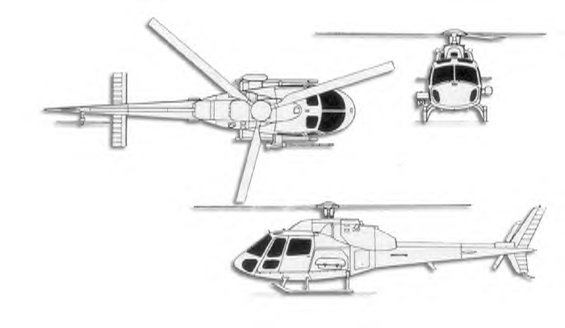

HAZARDS:

Two Batteries are located inside of compartment, left side of fuselage.

Fuel tanks are internally located, under cabin.

Rotor Blades.

268 Gallons / 1795 pounds of jet fuel.

Tail rotor is located extremely close to the ground.

APPROACH TO ENTRY POINT: (Engines running 80%+)
1. Approach directly from the side, exercising extreme caution around rotors, which can dip to within four feet of the ground.

PRE-DESIGNATED RESCUEMAN ACTIONS:
- GAIN ENTRY
a. Normal entry – Crew doors: Rotate door handles down and aft, swing doors open.
b. Emergency entry
c. Forcible Entry/Cut- Cut around windows and door frames.
- ENGINE SHUTDOWN
a. Pull back throttle(s), located center over head console (outside levers), aft past the detent (Yellow handles).
b. Pull two fuel levers, located inside of throttle levers on center overhead console, aft.
c. Pull rotor brake lever, located between fuel levers on center overhead console, aft.
d. Press battery button, located left upper corner of center overhead panel to OFF.
3. AIRCREW EXTRACTION

OTHER FACTORS:
- Special tools/equipment: Power rescue saw and crash axe.
- Location of switches and equipment and emergency shutdown procedures may vary for individual aircraft. Crews should be briefed prior to helicopter dispatch.

COMMUNICATIONS PLAN: National Air Tanker Frequency – 123.975. This is the frequency used by all air tanker bases, air tankers, and air tanker support aircraft during fire fighting operations.

