AIRCRAFT PRE-FIRE PLAN

AIRCRAFT TYPE: Schweizer (Grumman) AgCat Reference: Eastland Air Service

DESCRIPTION: The design of the AgCat was originally developed by Grumman, with Schweizer building 1,730 of them as part of a sub-contract. The aircraft was first built in 1957. In 1981, Schweizer obtained the rights to the aircraft. The aircraft has a bi-wing configuration with a tail-wheel. It is a very durable aircraft. The cockpit is enclosed and pressurized to prevent over-spray from entering the cockpit. The aircraft is commonly found in the radial engine configuration, but also is available with a turboprop. The windmill under the front of the engine is used to power the spray system.

Length (ft) | Wing Span (ft) | Turn Radius (ft) | Cruise Speed (mph) | Range Loaded  (St. miles) | Gross Weight (lbs) | Contract Op. Wt. (lbs) | Retardant Load (gallons) | Number Gates (Doors) | ICS Type
24’ 6” | 42’ 5” |  | 115 |  | 7,020 | 7,020 | 300 | 1 | 4

AIRCRAFT DIAGRAM

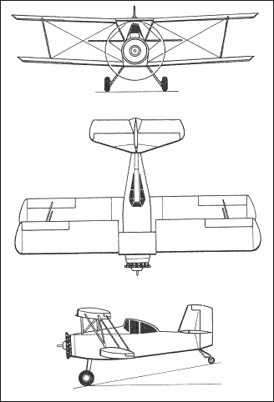

HAZARDS:
- Propeller on front of aircraft.
- Contains 80 gallons of Avgas in a center wing tank in the top wing, over the engine.
- Will contain either fungicides or pesticides. Pesticides are the more hazards of the chemicals used and can be absorbed through the skin. Full protective clothing and SCBA should be worn within 100 feet of the aircraft during an emergency. Primary hazard is an inhalation hazard.
- Battery is inaccessible without special tools.

APPROACH TO ENTRY POINT: (Engines running 80%+)
1. Approach from the left side of aircraft to avoid propeller.

PRE-DESIGNATED RESCUEMAN ACTIONS
- GAINING ENTRY
a. NORMAL ENTRY/ EMERGENCY ENTRY
I. Standing on the left lower wing, rotate handle on top edge of side window, up. Swing side window out and down.
II. Pull cable, located on inside left edge of top window, down. Swing hatch up and to the right.
b. CUT-IN
I. Cut windows and windshield to gain entry.
- ENGINE SHUTDOWN
a. Pull throttle, located left side of cockpit, closest to the side wall, full aft to the CLOSED position.
b. Pull fuel mixture, located next to the throttle, to the full aft CLOSED position.
3. AIRCREW EXTRACTION
a. Unlatch lap belts and remove shoulder harness from crewmember.

OTHER FACTORS:
- Special tools/equipment: Power rescue saw and crash axe.
- Location of switches and equipment and emergency shutdown procedures may vary for individual aircraft. Crews should be briefed prior to aircraft dispatch.

COMMUNICATIONS PLAN: National Air Tanker frequency – 123. 975. This is the frequency used by all air tanker bases, air tankers, and air tanker support aircraft during fire fighting operations.

