AIRCRAFT PRE-FIRE PLAN

AIRCRAFT TYPE: Air Tractor AT-802 Reference: Mfg. Info.

AIRCRAFT DESCRIPTION: The Department of the Interior and various States are currently contracting for Single-Engine Ag-Tankers. Single-engine ag-tankers have been approved by the Interagency Airtanker Board as airtankers. They are very maneuverable and are useful for hitting hot spots, plugging holes in line, reinforcing line, and making short line extensions. These aircraft are not initial attack carded. They are a useful addition at times but are not replacements for large airtankers. There are a few aircraft, designated Agricultural Aircraft by the Interagency Airtanker Board, that are used by some state agencies for wildland suppression but are not approved as single-engine ag-tankers by the board.

Length (ft) | Wing Span (ft) | Turn Radius (ft) | Cruise Speed (mph) | Range Loaded (St. miles) | Gross Weight (lbs.) | Contract Op. Wt. (lbs.) | Retardant Load (gallons) | Number Gates (Doors) | ICS Type
36.2 | 59.5 | 35 | 196 | 630 | 16,000 | 16,000 | 800 | 1 | 4

AIRCRAFT DIAGRAM
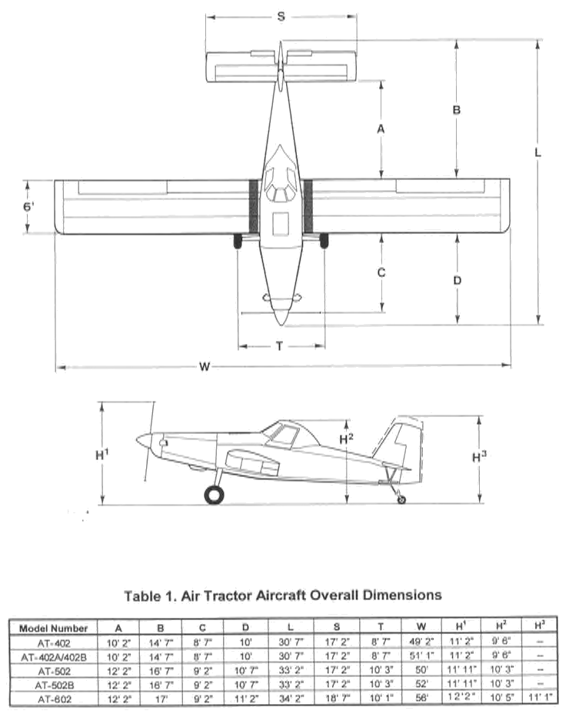

HAZARDS
- Crew of one or two – depending on model of aircraft.
- 380 gallons / 2546 pounds of jet fuel on-board (fully loaded), located in wings.
- Battery located on the firewall.
- Fire extinguisher located under pilot’s seat.
- Propeller danger zone 25 feet
- Turbine blade failure 300 feet.
- Engine exhaust 30 feet.
- Oil capacity - 10 quarts
- Hydraulic fluid capacity – 2.5 gallons

APPROACH TO ENTRY POINT: (Engines running 80%+)
- Approach directly from the side, aft of wing, avoiding the propeller for a ten-foot radius.

PRE-DESIGNATED RESCUEMAN ACTIONS
- GAIN ENTRY
a. Normal entry – Turn door handles located at the top of each door, ¼ turn. Doors are located each side of aircraft. Doors swing out and down.
b. Emergency entry – emergency door release is located at the bottom of the left side doors. Pull the emergency door release cable will release the door from its hinge and allow it to fall to the ground.
c. Cut-In – Cut around Plexiglas window frame or break out Plexiglas on door windows.
- ENGINE SHUTDOWN
a. Depress the start control stop on the red Start Control Knob, and move the Start Control Knob back (aft). The Start Control Knob is located to the left side of the pilot .
3. AIRCREW EXTRACTION
a. Aircraft is equipped with a military-style four-point harness with a single release point.

OTHER FACTORS
- Special tools/equipment: Power rescue saw and crash axe.
- Locations of switches and equipment and emergency shutdown procedures may vary for individual aircraft. Crews should be briefed prior to aircraft dispatch.

COMMUNICATIONS PLAN: National Air Tanker frequency – 123.975. This is the frequency used by all air tanker bases, air tankers, air tanker support aircraft during fire fighting operations.

