AIRCRAFT PRE-FIRE PLAN

AIRCRAFT TYPE: B-727 Reference: Boeing Rescue and Fire Fighting Info.

AIRCRAFT DESCRIPTION: The Boeing 727 is a large transport jet that may be contracted by natural resource agencies for passenger and cargo transportation. Updated versions can carry larger numbers of passengers.

Length (ft) | Wing Span (ft) | Gross Weight (lbs) | Turn Radius (ft) | Cruise Speed (kts/mph) | Payload (lbs) | Number of Pax Seats
133 | 108 | 161,000 | 72 | 417/480 | 23,000 | 128

AIRCRAFT DIAGRAM
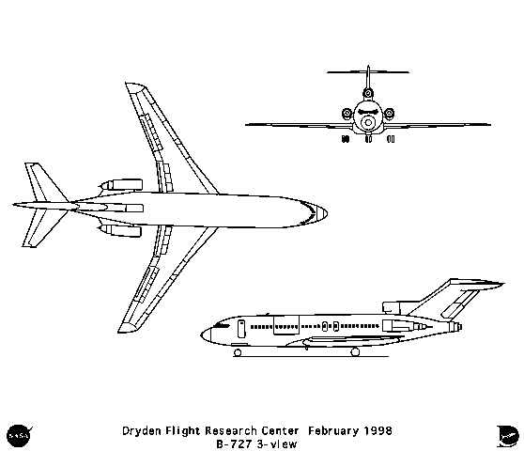

HAZARDS:
- 10330 gallons / 69211 pounds of jet fuel on-board (fully loaded), located in wings and fuselage.
- Oxygen cylinders in various locations throughout aircraft.
- Auxiliary Power Unit (APU) is located in main gear wheel well.
- Battery located in electrical compartment below flight deck. APU battery located in same general area.
- Avoid front of engines – ingestion hazard, rear of engine – high exhaust speeds.
- Wheels are equipped with fusible plugs designed to melt and deflate the tire when the temperature is excessive. WARNING! Approach landing gear truck from forward or aft when fighting a wheel fire as wheels and tires may explode. Use of Halon is preferred if tires are pressurized, but dry chemical, fog or foam are acceptable. If all tires are deflated any fire-extinguishing agent may be used.

APPROACH TO ENTRY POINT: (Engines running 80%+)
- Approach directly from the nose, avoiding the front on the engines

PRE-DESIGNATED RESCUEMAN ACTIONS:
- GAIN ENTRY
a. Normal entry – Pilot’s Sliding Windows = (NOTE: Right and left hand side of cargo aircraft, right hand side only on passenger planes.) Push in external access door, pull external release handle and slide window open. Forward Entry Door External Handle = Pull handle outward, rotate counter clockwise and pull door outward. Mid/Forward Galley Door external = Pull handle outward, rotate counter-clockwise and pull door outward. Aft Exit Doors External Handle = Pull outward lower end of handle and rotate forward. Pull door outward. WARNING! Passenger and service doors, chute may automatically deploy when doors are opened from the outside. Aft Airstairs = Aft entry door opens from inside of the aft airstairs area. Airstairs must first be lowered. The aft airstair exterior control panel, located left hand side of aircraft under engine on fuselage, has operating instructions on access panel.
b. Emergency entry – Emergency Overwing Exit Hatches Push Panel = Push in panel, push hatch inward and upward.
c. Cut-in – Cut-in areas are located on each side of fuselage, near top, over aft exit doors, and are not marked. Cut-in can also be accomplished around over wing hatches and entry doors. Cut-in areas require metal cutting portable power equipment. Because of type of structure and possible injury to personnel within, it is recommended that major effort to gain access be directed to hatches and doors. Urgency of situation will dictate necessity for cut-in.
NOTE: When the aircraft is resting on it’s wheels, it is 9 feet, 1 inches to floor level. When the landing gear is retracted, it is 5 feet 8 inches to floor level.
2. ENGINE SHUTDOWN
a. Retard engine thrust levers, located on center console, to the full aft position.
b. Retard engine start levers, located on center console, to the CUTOFF position.
c. Pull fire emergency shut-down T-handles, located on center console, to the aft position.
d. Pull APU fire switch – if APU fire.
e. Place Master Switch, located on the bulkhead right of Flight Engineers console to the OFF position.
f. Lift guard and place battery switch, located on the rear of the overhead Flight Engineers console, to the OFF position.
3. AIRCREW EXTRACTION
a. Unlatch lap belt and remove shoulder harness from crewmember(s). If seat track is not damaged during crash landing, use adjustable seat control to move seat in aft position when removing crewmembers. Passenger seats do not have shoulder harness.

OTHER FACTORS:
- Special tools/equipment: Power rescue saw, 24-foot extension ladder.
- Location of switches and equipment and emergency shutdown procedures may vary for individual aircraft. Crews should be briefed before aircraft dispatch.

COMMUNICATIONS PLAN: National Air Tanker Frequency – 123.975. This is the frequency used by all air tanker bases, air tankers, and air tanker support aircraft during fire fighting operations.

