AIRCRAFT PRE-FIRE PLAN

AIRCRAFT TYPE: 737 Reference: Boeing Rescue and Fire Fighting Info.

AIRCRAFT DESCRIPTION: The Boeing 737 is a large transport jet that may be contracted by natural resource agencies for passenger and cargo transportation. Updated versions can carry larger numbers of passengers.

Length (ft) | Wing Span (ft) | Gross Weight (lbs) | Turn Radius (ft) | Cruise Speed (kts/mph) | Payload (lbs) | Number of Pax Seats
100 | 93 | 110,000 | 58 | 417/480 | 15,000 | 81

AIRCRAFT DIAGRAM
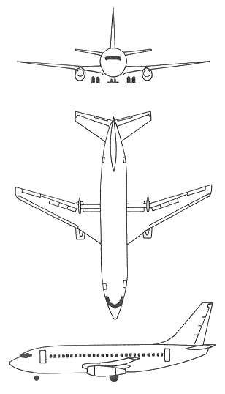

HAZARDS
- 6875 gallons / 46062 pounds of jet fuel on-board (fully loaded), located in wings and fuselage of the –200 and -800. The Business Jet version, with auxiliary tanks, can carry up to 10,725 gallons.
- Oxygen cylinders in various locations throughout aircraft.
- Battery located in electrical compartment below flight deck.
- Avoid front of engines – ingestion hazard, rear of engine – high exhaust speeds.
- Wheels are equipped with fusible plugs designed to melt and deflate the tire when the temperature is excessive. WARNING! Approach landing gear truck from forward or aft when fighting a wheel fire as wheels and tires may explode.

APPROACH TO ENTRY POINT (Engines running 80%+)
- Approach directly from the nose, avoiding the front on the engines

PRE-DESIGNATED RESCUEMAN ACTIONS
- GAIN ENTRY
a. Normal entry – Pilot’s Sliding Windows = Push in external access door, pull external release handle and slide window open. Forward and Aft Entry Door External Handle (Left Hand Side) = Pull handle outward, rotate clockwise and pull door outward. Forward and Aft Service Door external Handle (Right Hand Side) = Pull handle outward, rotate counter-clockwise and pull door outward. WARNING! Passenger and service doors, chute may automatically deploy when doors are opened from the outside.
b. Emergency entry – Emergency Overwing Exit Hatches Push Panel = Push in panel, push hatch inward and upward.
c. Cut-in – Cut-in areas are located on each side of fuselage, near top, forward of wing and aft of wing, and are not marked.
NOTE: When the aircraft is resting on it’s wheels, it is 8 feet, 6 inches to floor level. When the landing gear is retracted, it is 5 feet to floor level.
2. ENGINE SHUTDOWN
a. Retard engine thrust levers, located on center console, to the full aft position.
b. Retard engine start levers, located on center console, to the CUTOFF position.
c. Pull fire emergency shutdown T-handles, located on center console, to the aft position. If not illuminated, push and hold the button under the switch to release.
d. Place APU Master Switch, located on the overhead center console to the OFF position.
e. Lift guard and place battery switch, located on the rear of the overhead center console, to the OFF position.
3. AIRCREW EXTRACTION
a. Unlatch lap belt and remove shoulder harness from crewmember(s). If seat track is not damaged during crash landing, use adjustable seat control to move seat in aft position when removing crewmembers. Passenger seats do not have shoulder harness.

OTHER FACTORS
- Special tools/equipment: Power rescue saw, 24-foot extension ladder.
- Location of switches and equipment and emergency shutdown procedures may vary for individual aircraft. Crews should be briefed before aircraft dispatch.

COMMUNICATIONS PLAN: National Air Tanker frequency – 123.975. All air tanker bases, air tankers, and support aircraft use this frequency during fire fighting operations.

