AIRCRAFT PRE-FIRE PLAN

AIRCRAFT TYPE: Eurocopter (MBB) BO-105 Reference: Interagency Helicopter Operations Guide T.O. 00-105E-9

AIRCRAFT DESCRIPTION: This is a German helicopter that is manufactured in Germany and Canada. MBB stands for Messerschmitt-Bolkow-Blohm. They are used for search and rescue, as air ambulances, and occasionally for fire fighting. They have also been used for rappelling.

Length (feet) | Rotor Diameter (feet) | Bucket Size (gals) | 1.5 Hour Fuel Load (gals) | Fuel Consumption (gals / hr) | Cruise Speed (kts / mph) | Typical Equipment wt. (lbs) | Fixed Wt. Reduction (lbs) | PAX Seats | ICS Type
39 | 32 | 120 | 82 | 55 | 110 / 127 | 3150 | 180 | 4 | 3

AIRCRAFT DIAGRAM
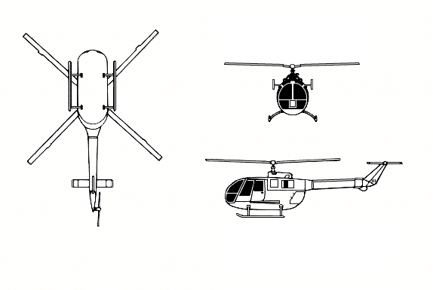

HAZARDS:
- Beware of rotating main rotor blades and tail rotor blades.
- 257gallons / 1722 pounds of Jet fuel.
- Hydraulic oil – 25 pounds
- Battery is located in nose.

APPROACH TO ENTRY POINT: (Engines running 80%+)
1. Approach from side of aircraft to avoid main rotor blades. WARNING! Rotor blades can dip several feet. Firefighters should remain in a crouching position as they approach.

PRE-DESIGNATED RESCUEMAN ACTIONS:
- GAINING ENTRY
a. NORMAL ENTRY NOTE: Special double sliding doors are located on both sides of fuselage. Each section can be opened separately.
I. Press down exterior handle of cockpit door for release, turn door outwards.
II. Press down exterior handle of cabin door for release, pull doors outwards and slide backwards.
NOTE: Both front doors are droppable. b. CUT-IN
I. Cut cabin enclosure as required.
- ENGINE SHUTDOWN
a. EMERGENCY SHUTDOWN
I. Lift cover of fuel shutoff switches, located on pilot’s center console, and place switches in the EMERGENCY position.
II. Press down spring loaded idle detent stop, located inside throttles on pilot’s overhead panel, and move throttles to the OFF position.
III. Lift master switches, located on pilot’s center console, and move aft to the AFT position.
IV. Place battery switch, located on center console, to the OFF position..
3. AIRCREW EXTRACTION NOTE: Safety belts, shoulder harnesses, and crotch straps of crewmembers are equipped with a restraint quick release box.
a. Pull red release snap from restraint quick release box until all restraint straps are released. b. Set all straps aside to prevent entanglement and remove crewmember.

OTHER FACTORS:
- Special tools/equipment: Power rescue saw and crash axe.
- Additional fuel tanks, having an additional capacity of 158 gallons / 1062 pounds can be installed.
- Location of switches and equipment and emergency shutdown procedures may vary for individual aircraft. Crews should be briefed prior to helicopter dispatch.

COMMUNICATIONS PLAN: National Air Tanker frequency – 123.975. This is the frequency used by all air tanker bases, air tankers, and air tanker support aircraft during fire fighting operations.

