AIRCRAFT PRE-FIRE PLAN

AIRCRAFT TYPE: Boeing Vertol 107/CH-46 Sea Knight Reference: NAVAIR 00-80R-14-1

AIRCRAFT DESCRIPTION: The Vertol was designed in the early 60’s for the US Marines as an assault aircraft. The original design was amphibious. Contract Vertols will not float because they have been stripped down for weight reduction. The Vertol has tandem rotors, is turbine powered, and requires a crew of two. It is smaller and not as complex as the Chinook and is less costly to operate.

Length (ft) | Rotor Dia. (ft) | Bucket Size (gals) | 1.5 Hour Fuel Load (gallons) | Fuel Consumption (gal/hrs) | Cruise Speed (Kts/mph) | Typical Equip. Wt. (lbs.) | Fixed Wt. Reduction (lbs.) | Pax Seats | ICS Type
84’4” | 51 | 900-1000 | 247 | 165 | 120/138 | 11,000 | N/A | 25 | 1

AIRCRAFT DIAGRAM:
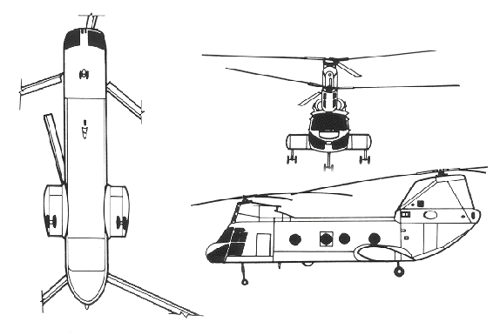

HAZARDS:
- Standard fuel load of 660 gallons / 4488 pounds of jet fuel on-board (fully loaded), located in fuselage. An additional three tanks of 235 gallons / 1574 pounds of jet fuel each may be carried inside cabin.
- 2 oxygen cylinders can be located in the cockpit. Some aircraft may not carry oxygen tanks.
- One battery located in left main landing gear well.
- Inlet suction danger area is 4 feet.
- Turbine blade failure
- Engine exhaust – 12 feet.
- APU exhaust – 12 feet.
- Rotor minimum ground clearance – Main = 9 feet 11 inches. Tail = 14 feet 10 inches. (The main rotor disc diameter is 84 feet 4 inches and the tail rotor disc diameter is 51 feet.)
- Hydraulic system may be pressurized to 3500 psi.
- Engine Oil – 5.5 gallons
- Hydraulic fluid – 5.77 gallons.
- Transmission fluid – 9.8 gallons, plus approximately 2 additional gallons in lines and cooler.

APPROACH TO ENTRY POINT: (Engines running 80%+)
1. Approach directly from the side, exercising extreme caution around rotors, which can dip to within four feet of the ground.

PRE-DESIGNATED RESCUEMAN ACTIONS:
- GAIN ENTRY
a. Normal entry – Normal entry is through main cabin door on the right hand side. The door has an upper and lower door, which operate separately. To open the upper portion, PUSH handle to expose, TURN HANDLE CLOCKWISE, MOVE door INWARD slightly and ROLL UP until the uplock is engaged. The lower door opens out and down. To open, PUSH handle, TURN handle COUNTERCLOCKWISE and pull door OUT and DOWN.
b. Emergency entry – Emergency entrance may be gained through pilot/copilot jettisonable windows, three fuselage windows, the emergency access hatch, and the cargo ramp/hatch.
I. To open pilot/copilot’s jettisonable window PUSH handle, TURN handle CLOCKWISE and PULL.
II. Three windows, two on the right hand side and one on the left hand side. (May be marked RESCUE.) To open, PULL tape OUT (upper left-hand corner of window), and PUSH panel INWARD.
III. To open the Emergency Access Hatch (left hand side of the “E” model and may be marked RESCUE), PULL tape OUT and Push panel Inward.
IV. The Cargo Ramp/Hatch Controls are located on the right hand side, above stub wing (rear). To access controls PUSH button on access door. The system consists of three control levers. With hydraulic pressure, actuate both ramp and hatch by PUSHING Ramp Control Handle and Cargo Hatch Control Handle AFT. Without hydraulic pressure, only ramp will operate. To lower ramp, PUSH Ramp Control Handle AFT then PUSH Ramp Auxiliary Control Handle AFT.
c. Forcible Entry/Cut-in – Windows are made of acrylic plastic and may be cut or broken. Areas marked on fuselage CUT HERE also may be cut out. CUT along window frames and marked fuselage only.
- ENGINE SHUTDOWN
a. PULL Condition levers, located center console between crewmembers, fully AFT to STOP position. PLACE Power Off Switch in OFF position. PLACE Power Control Master Switch in OFF position. PLACE APU Switch in STOP position. Deactivate electrical system by PLACING Battery Switch in the OFF position. (All switches located on Electrical Control Panel, located in the overhead console.) NOTE: Fire handles may be pulled to secure fuel and oil to engines.
3. AIRCREW EXTRACTION
a. The pilot and copilot are attached to the seats by shoulder harnesses secured to lap belts with quick disconnect buckles. Passengers and crewmembers have lap belts only.
I. For Pilot and Copilot, LIFT quick disconnect lever to release shoulder harnesses and lap belt.
II. For passengers, LIFT buckle cover to release lap belt (airline type).

OTHER FACTORS:
- Special tools/equipment: Power rescue saw and crash axe.
- Location of switches and equipment and emergency shutdown procedures may vary for individual aircraft. Crews should be briefed prior to helicopter dispatch.

COMMUNICATIONS PLAN: National Air Tanker Frequency – 123.975. This is the frequency used by all air tanker bases, air tankers, and air tanker support aircraft during fire fighting operations.

