AIRCRAFT PRE-FIRE PLAN

AIRCRAFT TYPE: Boeing Vertol 234/CH-47 Chinook Reference: T.O. 00-105E-9

AIRCRAFT DESCRIPTION: The 234 requires a crew of two. It has two rotors in tandem, no tail rotor, and turbine engines. It was designed for the Army in the late 50’s as an all weather transport and heavy lift. It evolved from the smaller piston driven Flying Banana that had wooden rotor blades. Its military name is CH-47 or Chinook and it was extensively used in Vietnam. The rotors, rotating in opposite directions, make it very stable and maneuverable, and there is no loss of control in crosswinds or tailwinds. They are expensive to operate but have a large bucket capacity and can make quick turnarounds.

Length (ft) | Rotor Dia. (ft) | Bucket Size (gals) | 1.5 Hour Fuel Load (gallons) | Fuel Consumption (gal/hrs) | Cruise Speed (Kts/mph) | Typical Equip. Wt. (lbs.) | Fixed Wt. Reduction (lbs.) | Pax Seats | ICS Type
99 | 60 | 3000 | 600 | 400 | 135/155 | 24,000 | N/A | 46 | 1

AIRCRAFT DIAGRAM:
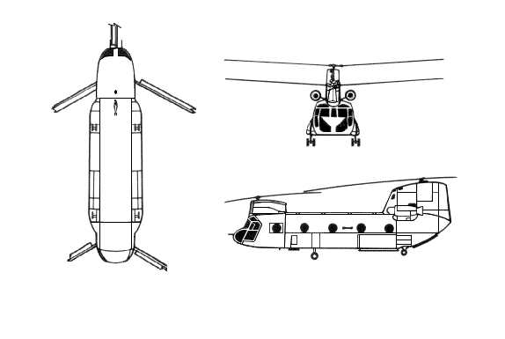

HAZARDS:
- 621 gallons / 4160.7 pounds of jet fuel on-board (fully loaded), located in wings and fuselage.
- One battery located in left main landing gear well.
- Inlet suction danger area is 4 feet.
- Turbine blade failure
- Engine exhaust – 12 feet.
- APU exhaust – 12 feet.
- Rotor minimum ground clearance – Main = 10 feet 11 inches. Tail = 15 feet 10 inches. (The main rotor disc diameter is 84 feet 4 inches and the tail rotor disc diameter is 51 feet.)
- Pneumatic system pressurized to 3000 psi.

APPROACH TO ENTRY POINT: (Engines running 80%+)
1. Approach directly from the side, exercising extreme caution around rotors, which can dip to within four feet of the ground.

PRE-DESIGNATED RESCUEMAN ACTIONS:
- GAIN ENTRY
a. Normal entry – NOTE: The pilot’s and co-pilot’s doors are jettisonable doors only. The cabin entrance door is a two-section door. The upper half of the door rolls up, the lower half swings out and down forming a step.
I. Rotate handle located on upper half of cabin door, roll door up.
II. Rotate handle, located on lower half of cabin door, pull door out and down.
b. Emergency entry –
I. Push trigger button in center of handle and rotate emergency release handle, located below and aft of pilot’s and co-pilot’s jettisonable doors, pull door out..
II. Pull emergency release tab in lower corner of escape hatches, located on upper cabin door, left forward of side of fuselage and cargo door out and push panels in.
III. NOTE: Sufficient hydraulic pressure must be available to actuate cargo ramp uplocks. When uplocks are released, cargo ramp will free fall slowly. Open ramp control access door, located aft right side of fuselage, near ramp, place ramp control lever to DOWN position.
c. Forcible Entry/Cut-in – Cut-in areas are in center of upper fuselage between windows on both sides.
- ENGINE SHUTDOWN
a. Position engine condition levers, located on control pedestal or overhead switch panel to STOP.
b. Position fuel valve or pump switches, located on overhead switch panel, to CLOSE or OFF.
c. Position battery switch, located on overhead switch panel, to OFF.
NOTE: If engines fail to shutdown, pull fire pull fuel shutoff T-handles, located at top center of instrument panel, OUT.
3. AIRCREW EXTRACTION
a. Unlatch seat belts and remove shoulder harness from crewmember(s).

OTHER FACTORS:
- Special tools/equipment: Power rescue saw and crash axe.
- Location of switches and equipment and emergency procedures may vary for individual aircraft. Crews ahould be briefed prior to helicopter dispatch.

COMMUNICATIONS PLAN: National Air Tanker Frequency – 123.975. This is the frequency used by all air tanker bases, air tankers, and air tanker support aircraft during fire fighting operations.

