AIRCRAFT PRE-FIRE PLAN

AIRCRAFT TYPE: Bell 204B / UH-1A,B,C “Huey” Reference: T.O. 00 105E-9, NAVAIR 00-80R-14-1
& Interagency Helicopter Operations Guide (1/98)

AIRCRAFT DESCRIPTION: The extremely rare Bell 204B was originally designed for a variety of military applications. Its military designation is UH-1B. The 204B is shorter than the 205 and it has an 1100 horsepower engine. The Bell Super 204 is a re-built 204 with a 205 engine installed. Super 204s are rare, but more common than the stock 204s. These aircraft have excellent lifting capability and are well suited for external load applications

Model | Horse power | Length (feet) | Rotor Dia. (feet) | Bucket Size (gals) | 1.5 Hour Fuel Load (gals) | Fuel Consumption (gals / hr) | Cruise Speed (kts / mph) | Typical Equip Wt. (lbs) | Fixed Wt. Reduction (lbs) | PAX Seats | ICS Type
204 | 1100 | 55 | 48 | 240 | 114 | 76 | 90 / 104 | 4820 | 200 | 10 | 2
Super 204 | 1300 | 55 | 48 | 324 | 105 | 70 | 90 / 104 | 5000 | 200 | 10 | 2

AIRCRAFT DIAGRAM
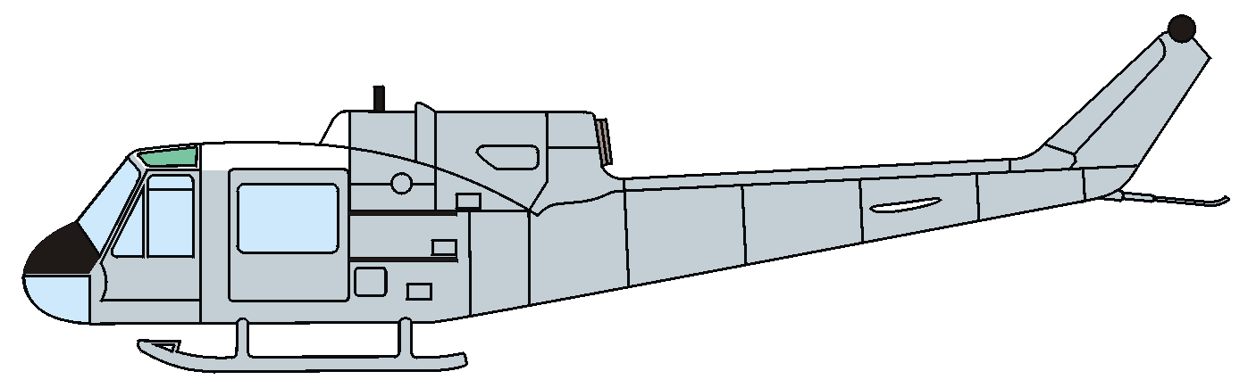

HAZARDS:
- Rotor blades.
- 242 gallons / 1621 pounds of fuel located at rear of fuselage and under passenger/cargo area.
- Inlet suction – 6 feet.
- Turbine blade failure – 300 feet.
- Engine exhaust – 23 feet.
- One battery is located in compartment left aft of the cargo door aircraft.
- Rotor minimum ground clearance – Main 6’7” Tail 5’4”, Rotor disc diameter – 44’ Tail 8’6”.
- Pneumatic system is pressurized to 1500 psi.
- Engine Oil – 3.25 gallons.
- Hydraulic Fluid – 4 pints.
- Transmission Oil – 2.35 gallons. (Some located in the tail.)

APPROACH TO ENTRY POINT: (Engines running 80%+)
1. Approach from side of aircraft to avoid main rotor blades. WARNING! Rotor blades can dip as low as five feet. Firefighters should remain in a crouching position as they approach.

OTHER FACTORS:
- Special tools/equipment: Power rescue saw and crash axe.
- Location of switches and equipment and emergency shutdown procedures may vary for individual aircraft. Crews should be briefed prior to helicopter dispatch.

PRE-DESIGNATED RESCUEMAN ACTIONS:
- GAINING ENTRY
a. NORMAL ENTRY
I. Rotate crew door handle, located left and right forward fuselage, down to unlatch door. Pull out and forward to open position.
II. Rotate passenger-cargo door handle, located left and right fuselage, down to unlatch and release door. Slide door aft to open position.
b. EMERGENCY ENTRY
I. If the pilot/copilot crew exits are jammed and access cannot be gained through the passengers’ exits, SLIDE or BREAK the pilot or copilot window, REACH FORWARD and PULL jettisonable door release. Jettison handles are located forward of right and left crew doorframes, aft to jettison doors. Pull doors outward.
c. CUT-IN
I. Windows are made of acrylic plastic and may be cut using a power saw or crash axe. CUT along window frames.
- ENGINE SHUTDOWN
a. Push the Collective Pitch Lever DOWN into DOWN LOCK.
b. CENTER the Cyclic Control Stick and HOLD.
c. ENGAGE Engine Idle Release Stop Switch (on pilots collective only) then CLOSE Throttle by TWISTING grip to RIGHT.
d. PLACE Main Fuel, Start Fuel, and Fuel Transfer Switches, located on pedestal console, to OFF position.
e. Place battery switch, located on overhead console, to OFF position.
f. PULL DOWN on Rotor Brake Actuator Handle, located overhead on right side of cabin roof, down and forward to lock and hold until rotor stops turning. WARNING! Do not apply rotor brake above 130 RPM. Doing so could cause brake disc failure resulting in uncontrolled movement of the aircraft or disintegration of the brake disc. Application of the rotor brake when the aircraft is on ice may also result in uncontrolled movement.
3. AIRCREW EXTRACTION – NOTE: Aircrew seats are equipped with shoulder harness and lap belts. Troop seats fitted with safety belts (lap belts) only.
a. Unlatch lap belts and remove shoulder harness from crewmember(s).
b. Unlatch safety belts in troop compartment.

COMMUNICATIONS PLAN: National Air Tanker Frequency – 123.975. This is the frequency used by all air tanker bases, air tankers, and air tanker support aircraft during fire fighting operations.

