AIRCRAFT PRE-FIRE PLAN

AIRCRAFT TYPE: Bell 205 A-1 / Bell 214B-1 / UH-1H Iroquois Reference: T.O. 00 105E-9 & Interagency Helicopter Operations Guide (1/98)

AIRCRAFT DESCRIPTION: The 205 is the pickup truck of helicopters. The military version, the UH-1H, was used extensively in Vietnam and nicknamed the Huey there. The 205 is longer than the 204 and has three windows along the side where the 204 has one. There are several commercial variations of the 205. Common names for these variations include the “Super 205” and “Super Duper 205 listed below.

Model | Horse power | Length (feet) | Rotor Dia. (feet) | Bucket Size (gals) | 1.5 Hour Fuel Load (gals) | Fuel Consumption (gals / hr) | Cruise Speed (kts / mph) | Typical Equip Wt. (lbs) | Fixed Wt. Reduction (lbs) | PAX Seats | ICS Type
205 | 1300 | 57 | 48 | 324 | 129 | 86 | 90 / 104 | 5700 | 260 | 14 | 2
Super 205 | 1800 | 57 | 48 | 324 | 130 | 86 | 96 / 110 | 5680 | 260 | 14 | 2
Super Duper 205 | 1800 | 57 | 48 | 324 | 130 | 86 | 96 / 110 | 5660 | 260 | 14 | 2
214 |  | 62 | 52 | 660-800 | 240 | 160 | 140 / 160 | 8250 | 380 | 15-20 | 1

AIRCRAFT DIAGRAM
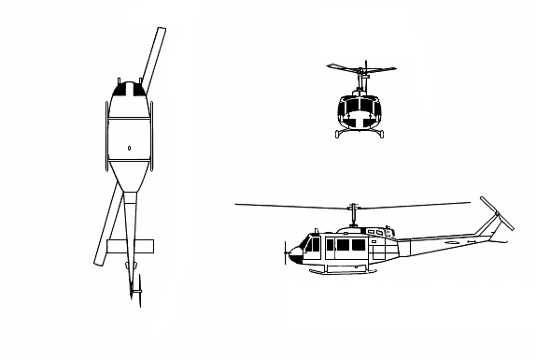

HAZARDS:
- Rotor blades.
- 1218 gallons / 8160.6 pounds of fuel located at rear of fuselage and under passenger/cargo area.
- Inlet suction – 6 feet.
- Turbine blade failure – 300 feet.
- Engine exhaust – 23 feet.
- One battery is located in compartment in nose of aircraft. Some models may require a Phillips Head screw driver to open compartment door.

APPROACH TO ENTRY POINT: (Engines running 80%+)
1. Approach from side of aircraft to avoid main rotor blades. WARNING! Rotor blades can dip several feet. Firefighters should remain in a crouching position as they approach.

PRE-DESIGNATED RESCUEMAN ACTIONS:
- GAINING ENTRY
a. NORMAL ENTRY
I. Turn crew door handle clockwise and pull door open. NOTE: On some models, a Door Emergency Release handle may be located near the hinges on the inside of the door. PULL release handle to release door from hinges.
II. Turn passenger door handle clockwise and slide door aft.
b. EMERGENCY ENTRY
I. Turn external crew door jettison handle clockwise and remove complete door.
II. Turn window external emergency release handle clockwise and push window into cabin area.
c. CUT-IN
I. Shatter windshield around edge of frame with axe or hammer.
II. Shatter glass around frame of passenger compartment windows with axe or hammer.
- ENGINE SHUTDOWN
NOTE: If unable to shutdown aircraft using normal shutdown procedures, engine may be shutdown by expelling extinguishing agent into the engine intake.
a. Rotate throttle located on collective stick clockwise to idle position, press and hold detent button located on collective head, rotate throttle again to CUT-OFF position. NOTE: If unable to rotate throttle, proceed to the next step.
b. Place fuel switch, located on pedestal console, to OFF position.
c. Place battery switch, located on overhead console, to OFF position.
3. AIRCREW EXTRACTION – NOTE: Aircrew seats are equipped with shoulder harness and lap belts. Troop seats fitted with safety belts (lap belts) only.
a. Unlatch lap belts and remove shoulder harness from crewmember(s).
b. Unlatch safety belts in troop compartment.

OTHER FACTORS:
- Special tools/equipment: Power rescue saw and crash axe.
- Location of switches and equipment and emergency shutdown procedures may vary for individual aircraft. Crews should be briefed prior to helicopter dispatch.

COMMUNICATIONS PLAN: National Air Tanker Frequency – 123.975. This is the frequency used by all air tanker bases, air tankers, and air tanker support aircraft during fire fighting operations.

