AIRCRAFT PRE-FIRE PLAN

AIRCRAFT TYPE: Bell206B-III JetRanger / OH-58 Kiowa Reference: T.O. 00 105E-9 & Interagency Helicopter Operations Guide (1/98)

NAVAIR 00-80R-14-1 (3/94)

AIRCRAFT DESCRIPTION: The 206 is very common. With an efficient fuel burn, it is economical to operate, and is light and extremely maneuverable. Parts are plentiful and maintenance can be done quickly and easily. It can carry a respectable payload at most elevations and has a fair sized baggage compartment. It is used for bucket work, recon, passenger transport, and medi-vac.

Length (feet) | Rotor Diameter (feet) | Bucket Size (gals) | 1.5 Hour Fuel Load (gals) | Fuel Consumption (gals / hr) | Cruise Speed (kts / mph) | Typical Equip Wt. (lbs) | Fixed Wt. Reduction (lbs) | PAX Seats | ICS Type
39 | 33 | 96-108 | 40 | 26 | 97 / 112 | 1850 | 130 | 4 | 3

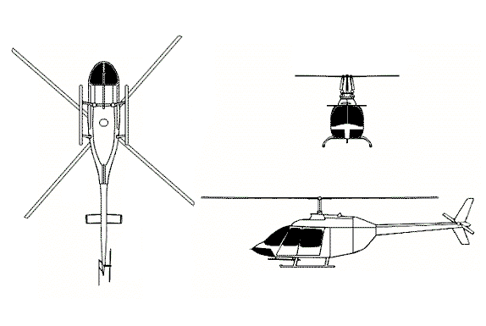
AIRCRAFT DIAGRAM

HAZARDS:
- Rotor blades.
- 91 gallons / 609.7 pounds of fuel.
- Battery located in the aft portion of the baggage compartment, accessible through baggage door on left hand side of aircraft. Some aircraft may have a second battery located in the nose and accessible through a hinged door (TH-57C)
- Pneumatic system pressurized to 650 psi.
- Engine oil – 1.4 gallons.
- Hydraulic oil – 2.25 pints.
- Transmission oil – 1.2 gallons.
- Turbine blade failure – 300 feet.
- Engine exhaust – 20 feet
- Rotor minimum ground clearance = Main – 6’5”, Tail 1’7” Rotor disc diameter = Main – 33’4”, Tail – 5’5”.

APPROACH TO ENTRY POINT: (Engines running 80%+)
1. Approach from side of aircraft to avoid main rotor blades. WARNING! Rotor blades can dip several feet. Firefighters should remain in a crouching position as they approach.

PRE-DESIGNATED RESCUEMAN ACTIONS:
- GAINING ENTRY
a. NORMAL ENTRY
I. Rotate door handles, located on aft edge of each door, swing doors forward.
b. EMERGENCY ENTRY
I. Cut windows in crew doors.
II. Pull crew door jettison handles, located inside on crew door forward support, aft and pull door out.
III. Cut windows in passenger doors.
IV. Rotate passenger door jettison handles, located inside on passenger door forward support, and pull door out.
c. CUT-IN
I. Cut windows and windshield to gain entry.
- ENGINE SHUTDOWN
a. Rotate throttle, located on pilot’s collective pitch stick, to OFF position.
b. Pull fuel shutoff valve, located overhead in crew compartment, aft to OFF position.
c. Place battery switch, located on overhead switch panel, in OFF position.
3. AIRCREW EXTRACTION
a. Unlatch lap belts and remove shoulder harness from crewmember(s).

OTHER FACTORS:
- Special tools/equipment: Power rescue saw and crash axe.
- Location of switches and equipment and emergency shutdown procedures may vary for individual aircraft. Crews should be briefed prior to helicopter dispatch.

COMMUNICATIONS PLAN: National Air Tanker Frequency – 123.975. This is the frequency used by all air tanker bases, air tankers, and air tanker support aircraft during fire fighting operations.

