AIRCRAFT PRE-FIRE PLAN

AIRCRAFT TYPE: Bell 212 / 412 / UH-1N Reference: T.O. 00 105E-9 & Interagency Helicopter Operations Guide

NAVAIR 00-80R-14-1 (3/94)

AIRCRAFT DESCRIPTION: The Bell 212 is based on the 205 fuselage. The military designation is UH-1N. It has twin turbine engines that burn roughly three times the fuel of a JetRanger. Many 212s are equipped for IFR operations and the equipment adds weight that decreases useful payload. Operations at high-density altitudes may be limited. These aircraft are used for passenger and cargo transport, longline and bucket work, and have been used for rappelling. The Bell 412 is a twin turbine engine helicopter. The 412 has a hingeless rotor system and it has four main rotor blades, unlike the two bladed 212. Like the 212, these aircraft are used for passenger and cargo transport, longline and bucket work, and have been used for rappelling. The Bell 214s are not common. They were built specifically for heavy lift operations and are popular for logging and many types of heavy sling work.

Model | Length (feet) | Rotor Diameter (feet) | Bucket Size (gals) | 1.5 Hour Fuel Load (gals) | Fuel Consumption (gals / hr) | Cruise Speed (kts / mph) | Typical Equip Wt. (lbs) | Fixed Wt. Reduction (lbs) | PAX Seats | ICS Type
212 | 58 | 48 | 324 | 145 | 95 | 100 / 115 | 6800 | 390 | 13 | 2
412 | 56 | 46 | 420 | 172 | 115 | 110 / 127 | 7250 | 390 | 13 | 2

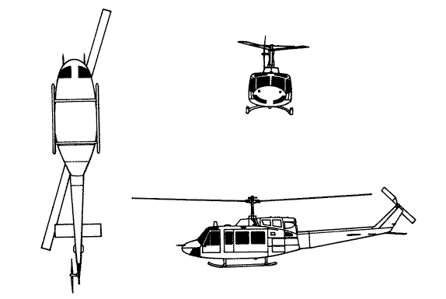
AIRCRAFT DIAGRAM:

HAZARDS:
- Rotor blades.
- 325 gallons / 2177 pounds of fuel.
- Turbine blade failure – 300 feet.
- Engine exhaust – 23 feet.
- Battery is located in the nose. On some models, may need a Phillips Head screwdriver to open compartment door.

APPROACH TO ENTRY POINT: (Engines running 80%+)
1. Approach from side of aircraft to avoid main rotor blades. WARNING! Rotor blades can dip several feet. Firefighters should remain in a crouching position as they approach.

PRE-DESIGNATED RESCUEMAN ACTIONS:
- GAINING ENTRY
a. NORMAL ENTRY
I. Rotate crew door handle, located left and right forward fuselage, down to unlatch door. Pull out and forward to open position. NOTE: On some models, a Door Emergency Release handle may be located near the hinges on the inside of the door. PULL release handle to release door from hinges.
II. Rotate passenger-cargo door handle, located left and right fuselage, downward and forward to full down position and hold, while pulling door aft, to unlatch and release door. Slide door aft to open position.
b. EMERGENCY ENTRY
I. Slide, break or cut crew door window, located left and right forward fuselage. Pull jettison handles, located forward of right and left crew door frames, aft to jettison doors. Pull doors outward.
c. CUT-IN
I. Cut windows and windshield to gain entry.
- ENGINE SHUTDOWN
NOTE: If unable to shutdown aircraft using normal shutdown procedures, engine may be shutdown by expelling extinguishing agent into the engine intake.
a. Pull Fire T-handles, located upper center instrument panel.
b. Place fuel switches, located on pedestal console, to OFF position. WARNING! Do not apply rotor brake above 130 RPM. Doing so could cause brake disc failure resulting in uncontrolled movement of the aircraft or disintegration of the brake disc. Application of the rotor brake when the aircraft is on ice may also result in uncontrolled movement.
c. Apply rotor brake (if installed), located overhead on right side of cabin roof, down and forward to lock.
d. Turn battery switch to OFF position.
3. AIRCREW EXTRACTION
a. Unlatch lap belts and remove shoulder harness from crewmember(s).
b. Passengers will have only lap belts.

OTHER FACTORS:
- Special tools/equipment: Power rescue saw and crash axe.
- Location of switches and equipment and emergency shutdown procedures may vary for individual aircraft. Crews should be briefed prior to helicopter dispatch.

COMMUNICATIONS PLAN: National Air Tanker Frequency – 123.975. This is the frequency used by all air tanker bases, air tankers, and air tanker support aircraft during fire fighting operations.

