AIRCRAFT PRE-FIRE PLAN

AIRCRAFT TYPE: Bell 222 Reference: Mercy Air

AIRCRAFT DESCRIPTION: The Bell 222 first flew on 13 August 1976. Versions have been built for executive transport, offshore oil well support and the utility twin (222UT). This light commercial helicopter is powered by twin turbine powerplants. Depending on the model, it is designed to carry up to eight occupants including the pilot. Approximately 200 models of this helicopter have been built and are used around the world. It is used by Mercy Air as an air ambulance in southeastern Kern County.

Length (ft) | Rotor Dia. (ft) | Bucket Size (gals) | 1.5 Hour Fuel Load (gallons) | Fuel Consumption (gal/hrs) | Cruise Speed (Kts/mph) | Typical Equip. Wt. (lbs.) | Fixed Wt. Reduction (lbs.) | Pax Seat | ICS Type
50.5 | 42 |  |  |  | 135/155 |  |  | 8

AIRCRAFT DIAGRAM
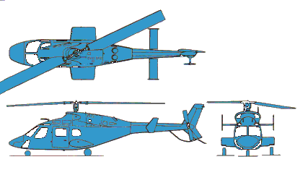

HAZARDS:

Main and tail rotor blades.

246 Gallons / 1670 pounds of Jet A fuel, located under seat and floor and winglets.

One battery is located in the avionics bay in the nose of the aircraft. Flat-head screwdriver of Dzus key is required to unlock access panel.

1 gallon of 5605 hydraulic fluid – system pressurized to 1500 psi.

Oxygen cylinders located one in baggage compartment and one behind attendant seat in passenger compartment.

Composite materials located in main rotor blades and in some cowlings.

APPROACH TO ENTRY POINT: (Engines running 80%+)
1. Approach directly from the side, exercising extreme caution around rotors, which can dip to within four feet of the ground.

PRE-DESIGNATED RESCUEMAN ACTIONS:
- GAIN ENTRY
a. Normal entry/Emergency entry Pull handle out and swing door forward.
b. Forcible Entry/Cut- around Plexiglas windows and door frame.
2. ENGINE SHUTDOWN
a. Rotate throttles, located on collective, to the OFF position after releasing Idle Stop Switch.
b. Place fuel valves, located on overhead console, to the OFF position. NOTE: If battery power is not available, fuel valves may be manually shut-off at firewall location.
c. Place battery switch, located overhead console, to the OFF position.
3. AIRCREW EXTRACTION
a. Flight crew uses shoulder harness and lap belt with single connection – rotate clockwise to release.
b. Passengers use lap belt, lift buckle on latch to release.

OTHER FACTORS:
- Special tools/equipment: Power rescue saw and crash axe.
- Location of switches and equipment and emergency shutdown procedures may vary for individual aircraft. Crews should be briefed prior to helicopter dispatch.

COMMUNICATIONS PLAN:
- National Air Tanker Frequency – 123.975. This is the frequency used by all air tanker bases, air tankers, and air tanker support aircraft during fire fighting operations.

