AIRCRAFT PRE-FIRE PLAN

AIRCRAFT TYPE: Bell 47 Soloy Reference: IHOG (1/98) NFPA Aircraft Familiarization Charts
T.O. 00 105E-9 (“Old”)

AIRCRAFT DESCRIPTION: This is a modified Bell 47. The original piston engine has been replaced with a turbine engine. These helicopters make excellent observation aircraft but are a little slow. The increased horsepower from the turbine engine gives them excellent performance.

Length (ft) | Rotor Dia. (ft) | Bucket Size (gals) | 1.5 Hour Fuel Load (gallons) | Fuel Consumption (gal/hrs) | Cruise Speed (Kts/mph) | Typical Equip. Wt. (lbs.) | Fixed Wt. Reduction (lbs.) | Pax Seats | ICS Type
44 | 37 | 96-108 | 37 | 23 | 75 / 86 | 1800 | 120 | 2 | 4

AIRCRAFT DIAGRAM

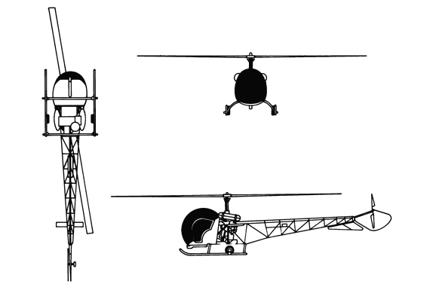

HAZARDS:

Rotor Blades.

55 gallons / 368 pounds of fuel carried in a tank mounted on each near the engine.

Oil capacity - 4 gallons.

4. Hydraulic fluid capacity - .3 gallons

APPROACH TO ENTRY POINT: (Engines running 80%+)
1. Approach directly from the side, exercising extreme caution around rotors, which can dip to within four feet of the ground.

PRE-DESIGNATED RESCUEMAN ACTIONS:
- GAIN ENTRY
a. Normal entry: Rotate external release door handle, located on rear edge of each door, downward and pull door open.
b. Emergency
I. Rotate external release door handle, located on rear edge of each door, downward and pull door open.
II. If external release door handle does not open door, leave handle in open position and pull jettison release rods, located forward edge of door to disengage hinges.
c. Forcible Entry/Cut-in: Cut cabin enclosure as required.
2. ENGINE SHUTDOWN
a. Emergency Shutdown:
I. Rotate throttle, located on collective pitch lever, left side of left seat, to CLOSED position.
II. Move mixture control lever, located on instrument panel, to OFF position.
b. Normal Shutdown:
I. Rotate throttle, located on collective pitch lever to the left of the left seat, to the CLOSED position.
II. Move mixture control lever, located on left side of instrument panel, to the IDLE CUTOFF position.
III. Rotate ignition switch, located on instrument panel, to OFF position.
IV. Place battery switch, located on instrument panel, to the OFF position.
- AIRCREW EXTRACTION
a. Unlatch lap belt and remove shoulder harness from crewmember(s).

OTHER FACTORS:
- Special tools/equipment: Power rescue saw and crash axe.
- Additional fuel tanks, having an additional capacity of 85 gallons / 570 pounds can be installed.
- Location of switches and equipment and emergency shutdown procedures may vary for individual aircraft. Crews should be briefed prior to helicopter dispatch.

COMMUNICATIONS PLAN: National Air Tanker Frequency – 123.975. This is the frequency used by all air tanker bases, air tankers, and air tanker support aircraft during fire fighting operations.

