AIRCRAFT PRE-FIRE PLAN

AIRCRAFT TYPE: C-130 Hercules Reference: Air Force Technical Order 00-105E-9

AIRCRAFT DESCRIPTION: The C-130 is a military transport with four turboprop engines. As an airtanker it has two applications – conventional and MAFFS. Conventional operations utilize the older A-model and have installed gated and variable flow bottom discharging tank systems. MAFFS, or Modular Airborne Fire Fighting System, temporarily converts military C-130s (E, H, and J models) to airtankers. They have been used since the early 70’s but only when civilian airtankers are overburdened. The system slides in the back and two large pipes hang behind the open cargo door. Pressurized air forces retardant out the pipes. MAFFS coverage levels are very light and once a drop is started the entire load is released. Two MAFFS systems are designed to be incremental, but have had limited success. A leadplane is always required with MAFFS as military pilots do not possess airtanker qualifications, but do train with leadplane pilots annually. The C-130 can be identified by the four-turbo prop engines with four blade propellers, high wing; rear cargo door below the tail section and in-line main dual landing gear wheels. (The H-model has under–wing fuel tanks and the J-model has a six bladed propeller.) Conventional airtankers fly with a three person crew while the military flight crew includes one to two additional personnel in the rear of the aircraft to operate the MAFFS equipment.

Class | Length (ft) | Wing Span (ft) | Turn Radius (ft) | Cruise Speed (kts/mph) | Range Loaded (st miles) | Gross Weight (lbs) | Contract Op. Wt. (lbs) | Retar-dant Load | Number Gates | ICS Type
Conv. | 99 | 133 | 80 | 239/275 | 1500 | 124,200 | 108,553 | 3000 | 1 to 8 | 1
MAFFS | 99 | 133 | 80 | 239/275 | 1500 | 156,000 | 105,553 | 3000 | 1 | 1

AIRCRAFT DIAGRAM

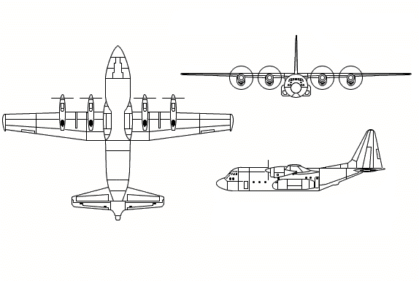

HAZARDS:
- Up to 12,500 gallons / 83750 pounds of jet fuel on-board (fully loaded), located in wings and fuselage.
- 13 oxygen cylinders in front half of fuselage – various locations. The civilian version will have 1 to 3 bottles in various locations. (Forward bulk head, aft side or under flight deck.)
- “H” models carry liquid oxygen.
- Battery located in left side of nose.
- Propeller danger zone 10 feet. Arc can be 4 to 6 feet from the ground.
- Turbine blade failure – 300 feet to the side.
- Propeller blast and engine exhaust. (69 knots 500 feet aft of propellers, 800 degrees 4 feet aft, 100 degrees 100 feet aft.)
- GTC exhaust area, left side mid-fuselage, forward of left wheel well. Temperatures can exceed 1000 degrees.
- Hydraulic system pressurized to 3000 psi.
- Engine oil – 48 gallons
- Hydraulic fluid 25.59 gallons. Located inside in two containers, one on each side of fuselage in front of wheel well area.
- Shrouds on wheel wells keep heat from brakes inside. This can cause tires / wheels to explode.
- Aircraft engines will drip fuel when they are shutdown.
- Avionics bay is located under flight deck. Access by removing ladder to flight deck. Oxygen may be in this area.
- Absence of fire stops in cargo bay floor and walls can cause fuel and fire to spread undetected.

APPROACH TO ENTRY POINT: (Engines running 80%+)
- Approach directly from the nose, avoiding the propellers for a ten-foot radius.

PRE-DESIGNATED RESCUEMAN ACTIONS:
- GAIN ENTRY
WARNING! Forward hatch, left side of fuselage, is in close proximity of right side turbo propeller. Avoid if propeller / engine is running. This hazard could cause loss of life! Not for entry or crew extraction until engine is shutdown. Same for left side if applicable model in use.
a. Normal entry – Rotate crew entry door handle, located forward left side of fuselage, counterclockwise and open door outward and down. WARNING: If aircraft is still pressurized, door may explode outward. Rotate troop door handle, located aft on both sides of fuselage, clockwise and push door inward and up until locked in open position. NOTE: The retardant tanks can block access to the forward areas of the aircraft.
b. Emergency entry – Pull release handle and push inward on four hatches located forward, center, and aft top of fuselage, and fuselage forward right side.
c. Cut-in – Cut-in areas are located on each side of fuselage, above and forward of each troop door.
- ENGINE SHUTDOWN
WARNING! To avoid the hazards in approaching running aircraft, enter through rear troop doors. NOTE: DO NOT remove battery power before activating emergency T-handles.
a. Position condition levers, located on control pedestal between forward crew seats, aft to FEATHER position. Open safety guard of bus-tie switch (on military version). Turn switch to OFF position. Bus-Tie is located on overhead panel above pilot’s right seat armrest.
b. Pull fire emergency shutdown T-handles, located on overhead panel, to the aft position.
c. If APU / GTC is operating, pull GTC T-handle.
d. Disconnect battery, located forward of crew entrance door or turn off battery switch, located on overhead control panel, to OFF position.
- AIRCREW EXTRACTION
a. Unlatch lap belt and remove shoulder harness from crewmember(s). If seat track is not damaged during crash landing, use adjustable seat control to move seat in aft position when removing crewmembers. Passenger seats do not have shoulder harness.
b. NOTE: Access to the MAFFS equipment operators in the rear of the aircraft can be difficult!

OTHER FACTORS:
- Special tools/equipment: Power rescue saw and 12 foot ladder.
- Skin penetration points – 2 on right side and one on left side of each engine.
- Location of switches and equipment and emergency shutdown procedures may vary for individual aircraft. Crews should be briefed before aircraft dispatch.
- Can land with two engines out.

COMMUNICATIONS PLAN: National Air Tanker Base Frequency – 123.975. All air tanker bases, air tankers and air tanker support aircraft monitor this frequency during fire fighting operations.

AIRTANKER CALL-SIGNS: MAFFS 1 through MAFFS 8, 30, 31, 32, 63, 64, 67, 81, 83, 88, 131, 133.

