AIRCRAFT PRE-FIRE PLAN

AIRCRAFT TYPE: Transall C. 160 Reference: NATO AEP-11

AIRCRAFT DESCRIPTION: The C.160 is a military multi-role transport with two turboprop engines and is flown almost exclusively outside of the United States (Germany, Turkey, South Africa, France, and Indonesia). The aircraft also has a pressurized interior. As a fire fighting air tanker it has a MAFFS-type system installed. MAFFS, or Modular Airborne Fire Fighting System, temporarily converts military C-130s and potentially other aircraft into airtankers. The system slides in the back and two large pipes hang behind the open cargo door. Pressurized air forces the retardant out of the pipes. MAFFS coverage levels are very light and once a drop is started the entire load is released. The C-160 can be identified by the two-turbo prop engines with four blade propellers, high wing, rear cargo door below the tail section and in-line main dual landing gear wheels. It resembles a twin engine C-130 Hercules.

Length (ft) | Wing Span (ft) | Turn Radius (ft) | Cruise Speed (kts/mph) | Range Loaded (st miles) | Gross Weight (lbs) | Contract Op. Wt. (lbs) | Retardant Load | Number Gates | ICS Type
106’ 3” |  |  | 513/319 | 1,150 | 112,436

AIRCRAFT DIAGRAM

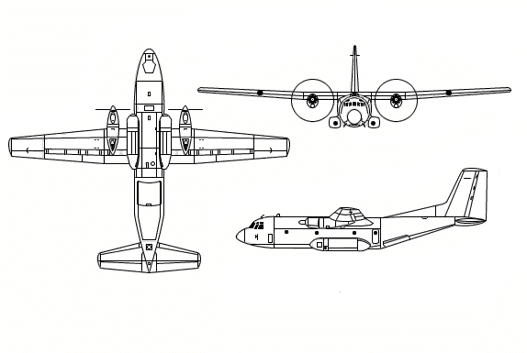

HAZARDS:
- Up to 4500 gallons / 30150 pounds of jet fuel on-board (fully loaded), located in wings.
- 4 oxygen cylinders in front half of fuselage – various locations.
- Battery located in left and right side of nose.
- Propeller danger zone 10 feet.
- Turbine blade failure – 300 feet to the side.
- Propeller blast and engine exhaust.
- Hydraulic system pressurized to 3000 psi.
- Shrouds on wheel wells keep heat from brakes inside. This can cause tires / wheels to explode.
- Aircraft engines will drip fuel when they are shutdown.
- Avionics bay is located under flight deck. Access by removing ladder to flight deck. Oxygen may be in this area.
- Absence of fire stops in cargo bay floor and walls can cause fuel and fire to spread undetected.

APPROACH TO ENTRY POINT: (Engines running +80%)
- Approach directly from the nose, avoiding the propellers for a ten-foot radius.

PRE-DESIGNATED RESCUEMAN ACTIONS:
- GAIN ENTRY
WARNING! Beware of rotating propeller blades
a. Normal entry –
i. Normal entry is left side of fuselage behind the cockpit. Push access door of locking lever, located left side forward of entry door. Pull locking lever and extend entry door downwards and slide to stop position. WARNING! Do not stand in front of door during release. Sudden extension of door resulting from high pressure could cause injury.
ii. Remove cover of locking levers to aft cargo doors located on both sides of fuselage. Press red button, pull lever downwards and lift door upwards to stop position.
b. Emergency entry –
i. Escape hatch is located on right side of fuselage below cockpit. Remove cover, press red button. Pull red lever to stop position and remove escape hatch outwards.
ii. Escape hatches are located on top of fuselage, over cockpit and over aft compartment section. Remove cover, press red button, pull lever for release and remove escape hatches outward.
NOTE: Do not drop hatches inside cockpit or aft compartment section. Falling hatches can endanger crewmembers or passengers.
- ENGINE SHUTDOWN
a. Place yellow/black marked crash bar, located left side pilot’s overhead, downwards to stop position.
b. Place red marked fuel shut-off valves, located right and left side pilot’s overhead panel, upwards to top position.
- AIRCREW EXTRACTION
NOTE: Navigator and loadmaster, sitting right beside staircase, are secured by seat belts. All other crewmembers are secured by a seat belt and harness strap combination.
a. Unlatch quick releases of seat belts and remove belt straps from navigator and loadmaster.
b. In the cockpit, pull seat lock control release lever, located right side of flight engineer’s seat aftwards, to release seat from its locked position. Move seat aftwards to stop position. Pull red release snap from harness quick release box until straps are released. Lift left armrest upwards and extract flight engineer.
c. Unlatch seat lock control release pedal, located left side of co-pilot’s seat, to release seat from locked position. Move seat aftwards to stop position. Pull red release snap from harness quick release box until straps are released. Lift left armrest upwards and extract co-pilot.
d. Pull seat lock control release lever located left side of pilot’s seat, aftwards to release seat from locked position. Move seat aftwards to stop position and rotate seat to the left towards the staircase. Pull red release snap from harness quick release box until straps are released. Lift left armrest upwards and extract pilot.

OTHER FACTORS:
- Special tools/equipment: Power rescue saw and 12 foot ladder.
- Skin penetration points – In front of both cargo area troop doors
- Location of switches and equipment and emergency shutdown procedures may vary for individual aircraft. Crews should be briefed before aircraft dispatch.

COMMUNICATIONS PLAN: National Air Tanker Base Frequency – 123.975. All air tanker bases, air tankers and air tanker support aircraft monitor this frequency during fire fighting operations.

AIRTANKER CALL-SIGNS:

