AIRCRAFT PRE-FIRE PLAN

AIRCRAFT TYPE: Casa C-212 Aviocar Reference: T.O. 00 105E-9

AIRCRAFT DESCRIPTION: The Casa company has been designing and building aircraft for the Spanish military since 1923. The 212 was designed in the late 1970’s as a commuter airliner to carry up to twenty-six passengers. The Casa has been used extensively in Alaska for smokejumping, paracargo, and passenger and cargo transport. They are rarely seen in the lower 48 states except during high activity fire years. The Casa is a turbine powered, fixed gear airplane. The interior is very roomy, and can carry a respectable cargo load. It is a good solid aircraft and is very maneuverable.

Length (ft) | Wing Span (ft) | Cruise Speed (Kts/mph) | Range (St. miles) | Payload | Number of Pax Seats
50 | 62 | 169/195 |  | 3400 | 19 (10 jumpers)

AIRCRAFT DIAGRAM
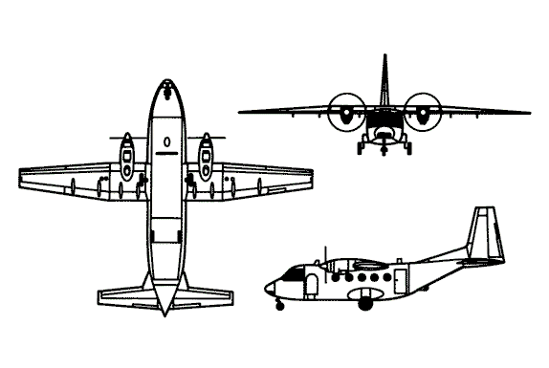

HAZARDS
- 792 gallons / 5306.4 pounds of jet fuel on-board (fully loaded), located in wings.
- 1 oxygen cylinder located aft of cockpit.
- One battery located in right wheel well.
- Propeller danger zone 25 feet
- Turbine blade failure 300 feet.
- Engine exhaust 1500 feet.

APPROACH TO ENTRY POINT (Engines running 80%+)
- Approach directly from the nose or to the aft of the wing on the left hand side, avoiding the propellers for a ten-foot radius.

PRE-DESIGNATED RESCUEMAN ACTIONS
- GAIN ENTRY
a. Normal entry –
I. One passenger access door is located in the rear left hand side of the main cabin. It opens inward and to the rear.
II. Two crew access doors are symmetrically located in the front of the main cabin. They open outward and forward.
b. Emergency entry –
I. One emergency door is located in the rear right hand of main cabin.
II. One roof escape hatch is located in the front fuselage.
III. Two rear side windows located at front of fuselage are of the sliding type to be used as an emergency exit for the pilots.
IV. Rear cargo door, which opens inward, is hydraulically operated. If hydraulic system is inoperative, do not try to operate cargo door during rescue procedures.
- ENGINE SHUTDOWN
a. Retard feathering levers, located on overhead console, aft to the shut-off position.
b. Switch engine shutdown switches, located on overhead console, to the OFF position.
c. Switch master switch, located on overhead console, to the OFF position.
d. If engine fire has been detected (see WARNING light), activate Fire Extinguishing System. There are two discharge switches for each engine.
3. AIRCREW EXTRACTION
a. Aircrew seats are equipped with shoulder harnesses and lap belts.
b. Troop seats are fitted with safety belts only.

OTHER FACTORS
- Special tools/equipment: 12-foot ladder, power rescue saw and crash axe.
- Location of switches and equipment and emergency shutdown procedures may vary for individual aircraft. Crews should be briefed prior to aircraft dispatch.

COMMUNICATIONS PLAN: National Air Tanker frequency – 123.975. This is the frequency used by all air tanker bases, air tankers, air tanker support aircraft during fire fighting operations.

