AIRCRAFT PRE-FIRE PLAN

AIRCRAFT TYPE: Canadair CL-215 / CL-415 “Super Scooper” Reference: Mfg. Info.

AIRCRAFT DESCRIPTION: The CL-215 is a Canadian aircraft built specifically for fire suppression. It is also used for maritime search and rescue. It first flew in 1967 and is an amphibian – can operate from land or water. It can be used for mixed retardant delivery or as a “water scooper” from lakes. The latest version is the CL-215T turbine model. It has foam injection on board that has proven to be successful on wildfires. The CL-215 has also been adapted for pest control spraying and has been used for dropping foam on oil fires. Canadian airtankers may be used in the U.S. under special arrangements when specific criteria have been met. An updated version of this aircraft is the CL-415, also with turbine engines. Two CL-415’s from Quebec work under contract to Los Angeles County during fire season. Emergency procedures for the CL-215, CL-215T and CL-415 are basically the same.

Model | Length (ft) | Wing Span (ft) | Turn Radius (ft) | Cruise Speed (Kts/mph) | Range Loaded (St. miles) | Gross Weight  (lbs.) | Contract Op. Wt. (lbs.) | Retardant Load | Number Gates | ICS Type
CL-215 | 65 | 94 | N/A | 164 / 189 | 550 | 43,000 | N/A | 1300 | 2 | 3
CL-415 | 65 | 94 | N/A | 203 / 233 | 1,310 | 43,850 | N/A | 1621 | 4 | 3

AIRCRAFT DIAGRAM: (CL-415)
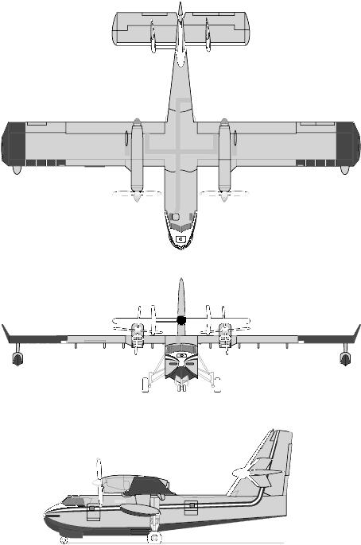

COMMUNICATIONS PLAN: National Air Tanker Base Frequency – 123.975. All air tanker bases, air tankers and air tanker support aircraft monitor this frequency during fire fighting operations.

AIRTANKER CALL-SIGNS: Super Scoopers on contract to Los Angeles County Fire Department will use the call-sign of either Quebec 1 or Quebec 2. They may also use a 200 series number, i.e., 238 or 245.

HAZARDS:
- 1530 gallons / 10,250 pounds of jet fuel on-board (fully loaded), located in wings.
- Fire extinguishers are located over the right crewmember and near the right side aft emergency exit.
- Emergency crash axe is located on aft side of forward bulkhead near front (main) exit.
- Aircraft can fly with one engine out.
- 2 oxygen cylinders are located one behind each crewmember seat. 11.3 cubic feet.
- 2 batteries located in the electrical compartment on the aft side of the forward bulkhead, on the right side. They can be found on the floor of this compartment.
- Propeller danger zone 25 feet, Turbine blade failure 300 feet.
- Engine exhaust 1500 feet.
- Pneumatic system pressurized to 3000 psi.
- Engine Oil: Turbine – 5 gallons, Piston – 36 gallons.
- Hydraulic fluid – 3.4 gallons of Mil-H-5606.
- Isopropyl alcohol/water windshield cleaner - 1 gallon.
- Aircraft normally flies fire missions with two crewmembers. It may fly fire missions with a third crewmember seated between the flight crew. It is also capable of transporting eight passengers on non-fire missions in the forward cargo area.
- Personnel must stay clear of water doors to prevent injury in event of inadvertent opening.
- Fusible plugs in brakes will melt at 312 degrees Fahrenheit.

APPROACH TO ENTRY POINT: (Engines running 80%+)
- Approach directly from the nose, avoiding the propellers for a ten-foot radius.

PRE-DESIGNATED RESCUEMAN ACTIONS:
- GAIN ENTRY
a. Normal entry – Door located left side forward of wing, rotate handle clockwise to open. Swing door forward to locking position. NOTE: Base of door is 5’ 6” above ground with wheels down.
b. Emergency entry – A 12-foot ladder will be needed to gain access to all entry points.
I. Door located aft of left wing, rotate handle counter-clockwise (UP) to open. Swing door inward and aft. NOTE: The lower portion of the door can be opened from the inside by reaching in and pulling aft the handle located near the forward edge of the door. CAUTION: If the upper and lower doors are located together, the upper door can not be opened from the outside of the aircraft.
II. Emergency cockpit access hatch is located in the top of the nose of the aircraft, forward of windshield. Break Plexiglas covering. PUSH red handle, which will cause door to swing down and forward.
III. Emergency escape hatch is located over the right crewmember. PULL red handle. Hatch swings up/out and towards centerline of aircraft. NOTE: A 24 foot extension ladder will be required to gain access to this point when the aircraft is on it’s wheels. On some aircraft, the handle must be rotated counterclockwise to open position.
IV. Emergency Exit is located aft of right wing. PULL red handle and door will swing out and down.
c. Cut-in / Forcible Entry –
I. All windows, except for the forward facing windshield, are made of Plexiglas and can be broken for emergency access.
II. Cut around all windows and doors.
- ENGINE SHUTDOWN
a. Move fuel mixture control levers, located on the center pedestal, to the full aft OFF position. NOTE: Levers must be lifted to clear détentes to reach the full OFF position.
b. Move throttles, located on center pedestal, aft to the OFF position.
c. On the 415, move two battery toggle switches, located on the Electrical Control overhead panel between crewmembers, forward (down) to the OFF position. On the 215, place ignition master switch and electrical master switch to the OFF position.
d. NOTE: There are individual engine fire buttons located at the top of the forward console (dashboard). In the event of an engine fire, lift the cover of the appropriate engine fire button. Press the button and then press the extinguisher button immediately above this button.
e. The APU can be shutdown using the control panel located just aft on the main entry door. Set the ON/OFF/RESET GENERATOR switch to the OFF position, then set the ON/OFF POWER switch to the OFF position.
3. AIRCREW EXTRACTION
a. Unlatch lap belt and remove shoulder harness from crewmember(s). If seat track is not damaged during crash landing, use adjustable seat control to move seat in aft position when removing crewmembers. Passenger seats have shoulder harness.

OTHER FACTORS:
- Special tools/equipment: Power rescue saw, 12-foot ladder, and crash axe.
- Some crewmembers on Quebec aircraft may have difficulty in understanding English.
- Location of switches and equipment and emergency shutdown procedures may vary for individual aircraft. Crews should be briefed prior to aircraft dispatch.

