AIRCRAFT PRE-FIRE PLAN

AIRCRAFT TYPE: Aero Commander 500B/U/S “Shrike” Reference: T.O. 00-105E-9
& Mfg. Manual

AIRCRAFT DESCRIPTION: The Aero Commander series are high wing twin-engine aircraft that are used for passenger and cargo transportation. The Forest Service has also used them for aerial photography. Many agencies are using the Commander in the Air Tactical Group Supervisor role. The most common type is the Shrike 500B. Some other aircraft can be equipped with either piston engines or turboprop engines.

Length (ft) | Wing Span (ft) | Cruise Speed (Kts/mph) | Range (St. miles) | Payload | Number of Pax Seats
31 - 44 | 39 - 49 | 170-210 / 200-240 | 900 - 1300 | 900-1800 | 6

AIRCRAFT DIAGRAM

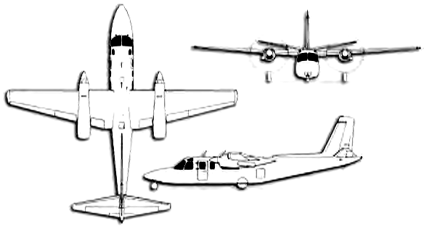

HAZARDS:
- 159 gallons / 1065 pounds of aviation gasoline on-board (fully loaded), located in wings and fuselage.
- One large or two small batteries located in aft section of aircraft, accessible via battery compartment door on left side of aircraft, aft of wing.
- Propeller danger zone 25 feet
- Hydraulic system pressurized to 900 to 1075 psi.
- Hydraulic fluid – 3.2 quarts.

APPROACH TO ENTRY POINT: (Engines running 80%+)
- Approach directly from the tail, avoiding the propellers for a ten-foot radius. (When aircraft is resting on it’s wheels, bottom of door frame is 18.5 inches off of the ground.)

PRE-DESIGNATED RESCUEMAN ACTIONS:
- GAIN ENTRY
a. Normal entry – Cabin Door - located left side of aircraft under wing, rotate handle clockwise one quarter turn and swing door out and forward. Crew Door – located left forward portion of fuselage near pilot seat, rotate handle clockwise one quarter turn and swing door out and forward.
b. Emergency entry – Break windshield or windows if entrance cannot be gained through cabin door.
c. Cut-in – Cut cabin enclosure as required.
- ENGINE SHUTDOWN
a. Emergency Engine Shutdown
I. Retard power levers, located left side of center pedestal, to full CLOSED position.
II. Retard mixture levers, located right side of center pedestal, full aft to IDLE CUTOFF.
III. Place Engine Shut-Off Switches, located in guard on center of overhead panel, to OFF position.
IV. Rotate ignition switches, one each located on left and right overhead switch panel, to OFF position.
V. Place battery switch, located left edge of left overhead panel, to the OFF position.
b. Normal Engine Shutdown
I. Retard power levers, located left side of center pedestal, to full CLOSED position.
II. Retard mixture levers, located right side of center pedestal, full aft to IDLE CUTOFF.
III. Rotate ignition switches, one each located on left and right overhead switch panels, to OFF position.
IV. Place battery switch, located upper left corner of left overhead switch panel, to the OFF position.
3. AIRCREW EXTRACTION
a. Unlatch lapbelts from crewmembers.

OTHER FACTORS:
- Special tools/equipment: Power rescue saw and crash axe.
- There is an emergency exit under the right wing. There is no external handle for this exit and it can only be opened from the inside. Fire fighters should be aware that personnel could be exiting through this exit in an emergency.
- Location of switches and equipment and emergency shutdown procedures may vary for individual aircraft. Crews should be briefed prior to aircraft dispatch.

COMMUNICATIONS PLAN: National Air Tanker frequency – 123.975. This is the frequency used by all air tanker bases, air tankers, and air tanker support aircraft during fire fighting operations.

