AIRCRAFT PRE-FIRE PLAN

AIRCRAFT TYPE: Douglas Turbine DC-3 / C-117C / BT-67 Reference:

AIRCRAFT DESCRIPTION: Original DC-3’s were designed and built by Douglas Aircraft in the late’30’s. They were used extensively during World War II as military transports and for delivery of airborne paratroopers. After the war they became on of the most common airliners. The DC-3 was the first airplane to fly enough safe seat/miles to satisfy an insurance company. Original DC-3’s were powered by radial engines. In 1991 two Forest Service DC-3’s were given new life with turbine engines. This aircraft is used for smokejumping, paracargo, passenger and cargo transport, and can land on unpaved airstrips. It has excellent short and soft field takeoff and landing characteristics. DC-3 that have been updated with turbo-prop engines, five blade propellers and a 40 inch fuselage plug forward of the wing, are referred to as BT-67’s.

Length (ft) | Wing Span (ft) | Cruise Speed (Kts/mph) | Range (St. miles) | Payload | Number of Pax Seats
58 | 96 | 182/210 | 1150 | 9000 | 20–30 (12-20 jumpers)

AIRCRAFT DIAGRAM
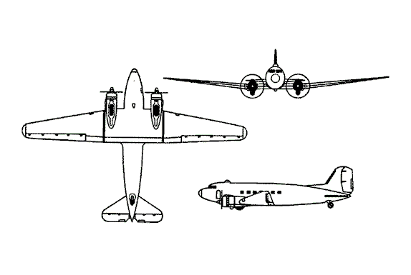

HAZARDS
- 2,374 gallons / 15,905.8 pounds of jet fuel on-board (fully loaded), located in wings and fuselage.
- 9 oxygen cylinders in various locations. (4 fixed under fuselage near wing roots, and 5 portable cylinders in the forward section and cockpit of the aircraft.)
- Two batteries located forward of the wing, underside of fuselage.
- Propeller danger zone 25 feet
- Turbine blade failure 300 feet.
- Pneumatic system pressurized to 3000 psi.

APPROACH TO ENTRY POINT: (Engines running 80%+)
- Approach directly from the left hand side, aft of the wing, avoiding the propellers for a ten-foot radius.

PRE-DESIGNATED RESCUEMAN ACTIONS
- GAIN ENTRY
a. Normal entry –
I. Rotate main cabin entrance door handle, located on main cabin entrance door, clockwise. Open door outward.
II. PULL pilot’s cargo door handle, located on pilot’s cargo door, DOWN. Open door outward.
b. Emergency entry –
I. PULL emergency exit external handle, located on emergency hatch aft of wing, each side of fuselage, to unlock and PULL emergency exit hatch outward.
II. Rotate pilots escape hatch handle, located forward top center of fuselage, CLOCKWISE. PULL hatch up and aft.
c. Cut-In – Cut-in areas are located at normal and emergency entrance points and at pilot’s windows, left and right side of cockpit.
- ENGINE SHUTDOWN
a. Power levers, located on pedestal between crewmembers, to OFF.
b. Generators located on triangular panel over right crewmembers seat, to OFF.
c. Condition levers, located pedestal between crewmembers, to STOP.
d. Main & Standby fuel pumps, located on the right side of the center overhead panel, to OFF.
e. Battery switch located on triangular panel over right crewmembers seat, to OFF.
AIRCREW EXTRACTION
a. Unlatch lap belt and remove shoulder harness from crewmember(s). NOTE: If seat tracks are not damaged during crash landing use adjustable seat control to retract seats to aft position in removing crewmember(s).

OTHER FACTORS
- Special tools/equipment: Power rescue saw and crash axe.
- Location of switches and equipment and emergency shutdown procedures may vary for individual aircraft. Crews should be briefed prior to aircraft dispatch,

COMMUNICATIONS PLAN: National Air Tanker frequency – 123.975. This is the frequency used by all air tanker bases, air tankers, and air tanker support aircraft during fire fighting operations.

